Pending Return Inquiry (PRI): Use Pending Return Inquiry (PRI) to find an existing Return.

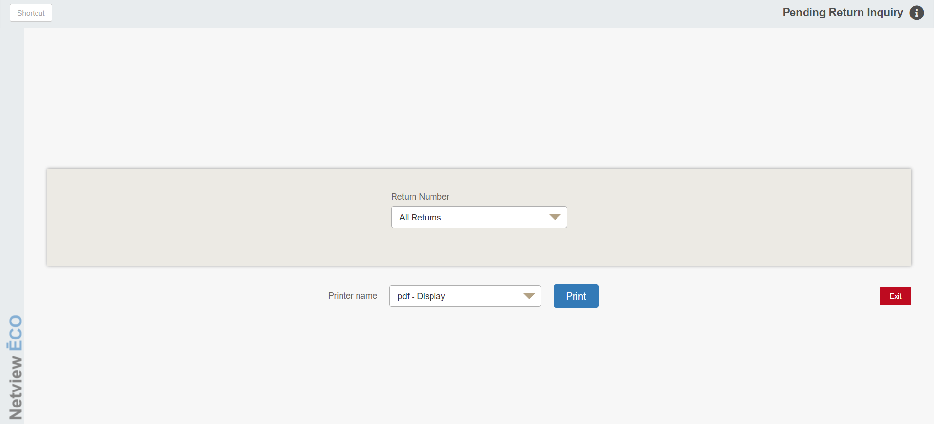

To access this function, you can either:

- Select “Inventory” from the menu. Choose the “Returns” submenu and click “Pending Return Inquiry.”
- Type “PRI” in the Shortcuts Bar.

Screen Fields

Return Number: Choose All Returns to view all Returns or select a Return Number from the drop-down menu.

Printer Name: Select the printer to receive the printout. A default printer name is pre-filled but can be changed as necessary using the drop-down menu. Use the pdf printer to view the report on the screen without printing a copy of it.

Print: To print your inquiry, press this button.

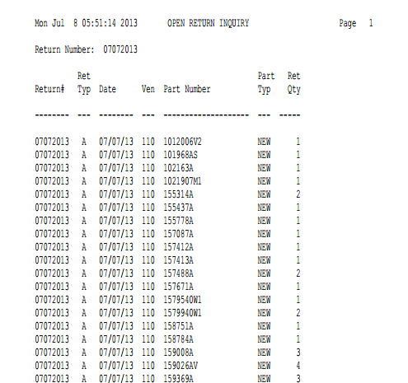

PRI gives you a “quick” look at open Parts Returns.

Report Columns

Return#: This column lists the Return number selected.

Ret Type: This column lists the Return Type:

A=Annual

S=Special

C=Close Out

T=Dealer Trade

Date: This column lists the date for the Return.

Ven: This column lists vendor number for the part number.

Part Number: This column lists the part numbers found on this Return.

Part Type: This column lists the Part Type:

Core

Memo

New

Reman

Used

Ret Qty: This column lists the quantity to be returned to the manufacturer.

