Parts Return Report (PRRT): Parts Return Report (PRRT) lists every part number that meets the following criteria for a selected vendor number:

- Must have stock on-hand.
- Must have zero sales (or fewer sales than the number you selected for the report) in the selected number of months.
- Must contain an acceptable “Return Code” (these codes are part of the Manufacturer’s Price File, and the system automatically updates your inventory records with these codes.)
- Must have a total extended dollar amount that equals to the vendor’s specified minimum figure.

PRRT also lets you sort the part numbers by bin location, making shelf counts easier. You can also print a part’s cost and other details. PRRT generates either a “suggested” return or a Return for the specified vendor.

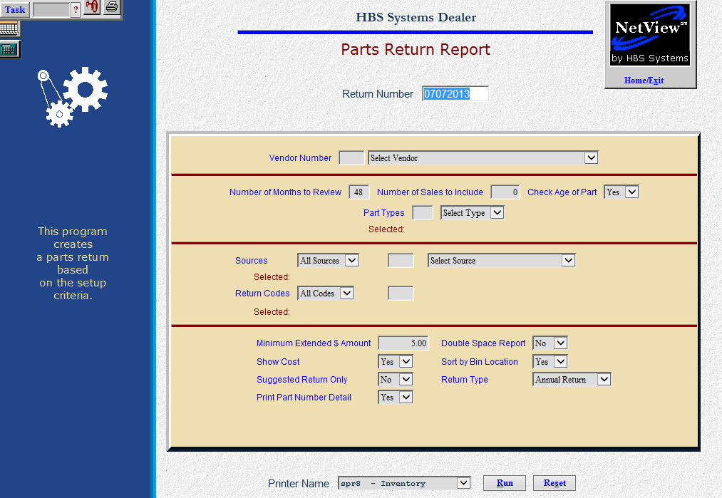

STEP 1—Create the Return through Parts Return Report (PRRT): The first step in the Parts Return Process is to produce a Return using this function.

- To access this function, you can either:
  - Select “Inventory” from the menu. Choose the “Returns” submenu and click “Parts Return Report.”
  - Type “PRRT” in the Shortcuts Bar.

Field Definitions

Return Number: PRRT will pre-fill the current date as a Return Number. Press “Enter” to accept it or type in your own Return Number.

Vendor Number: Type the Vendor Number or choose it from the drop-down menu.

Number of Months to Review: Enter the number of months to review.

48 defaults here, but you may change it as needed.

If you want to review sales history for more than 48 months, PRRT will review only the yearly history fields.

Number of Sales to Include: Enter the number of sales to examine. This number will be used as a maximum number of sales over the number of months entered above. For example, if you enter “1” in this field and “48” in the Number of Months to Review field, PRRT flags all part numbers for return if it has 1 or less sales within 48 months of sales history.

Check Age of Part:

- Choose Yes to check the Entry Date (the date the part was entered) against the number of months to review. This means that if the part is less than a year old according to the Entry Date and the number of months to review is 48, the part is not flagged for return.
- If you have been on the system less than the number of months to review, type No in this field

Part Type: This field shows what types of parts to include in this report:

Core

Memo

New

Reman

Used

NOTE: In most cases you would include only New parts, but you may select another value from the drop-down menu. Choices will display as selected.

Sources:

- Choose All Sources to examine all sources within the vendor selected.
- Choose Include or Exclude to select up to 10 sources for either action. Choices will display as selected.

Return Codes:

- Choose All Codes to examine all return codes for the vendor.
- Choose Include or Exclude to select up to 10 codes for either action.
- You will also have the chance to include or exclude Blanks. Choices will display as selected.

Minimum Extended $ Amount: The amount you enter in this field determines the minimum amount for any part selected for the return. The part’s extended cost must be at least the amount entered here. The formula is Unit Cost times the Quantity On-Hand.

Double Space Report:

- Choose Yes to produce a double-spaced report. The double-spaced version might be easier to read or provide space for notes on the pages.
- Choose No to keep it single-spaced.

Show Cost:

- The Printout includes the cost (as “Item”) if you choose Yes here.
- Choose No here to exclude the cost from the Printout.

Sort by Bin Location:

- Choose Yes to sort the parts by Bin Location. This may make reviewing and preparing the return easier.
- Choose No to sort the selected parts in part number order.

Suggested Return Only:

- Choose Yes to print a “suggested” Parts Return. With this option, nothing is permanently stored in the system.
- Choose No to generate a “live” parts return. You may then:
  - Edit this return
  - Send it to the specified Vendor
  - Receipt it when you have received your Return confirmation from the vendor

Return Type: Choose the Return Type from the drop-down menu. Choose from:

Annual

Closeout

Monthly

Special

Dealer Trade

Print Part Number Detail:

- Choose Yes to see the part number detail for the parts selected.
- Choose No to generate only the totals for each Return Indicator.

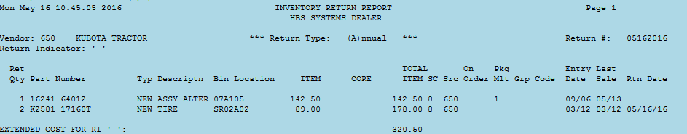

Report Detail: The report includes the following information:

Ret Qty: This column shows the Return Quantity for the part number - the full amount of any currently on hand.

Part Number: This column lists the numbers of the parts selected for this return.

Typ: This column lists Part Types for the part numbers listed. It could be:

New

Used

Reman

Core

Memo

Description: This column lists the Description of the selected part.

Bin Location: The Primary Bin Location shows here.

Item: This column shows individual cost for the part number.

Core: If a Core Charge is applicable to this part number, the value prints in this column.

Total Item: The extended cost is shown in this column. It is calculated by multiplying the Return Quantity by the individual Cost.

SC: The Stock Class for the part shown appears in this column.

Src: This field shows the Parts Source.

On Order: The On Order quantity for this part, if any, is shown here.

Pkg Mult: If the part shown has a Package Multiple, it will appear in this area. This information may be handy in determining the best quantity to return.

Grp Code: The Group Code, if present, will appear in this spot.

Entry Date: This column lists the date when the part was entered into the system.

Last Sale: Here you will find the date of the Last Sale of this item.

Rtn Date: This column lists the dates of the Return you are processing when you generate a “live” return.

Extended Cost: Totals are provided for each return code as well as a grand total for all return codes.

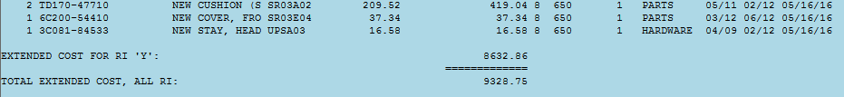

No Detail Version: Notice that there is no part number detail on the “No Detail” version of the Inventory Return Report, as shown below.

