Parts Sales Report (PSR)

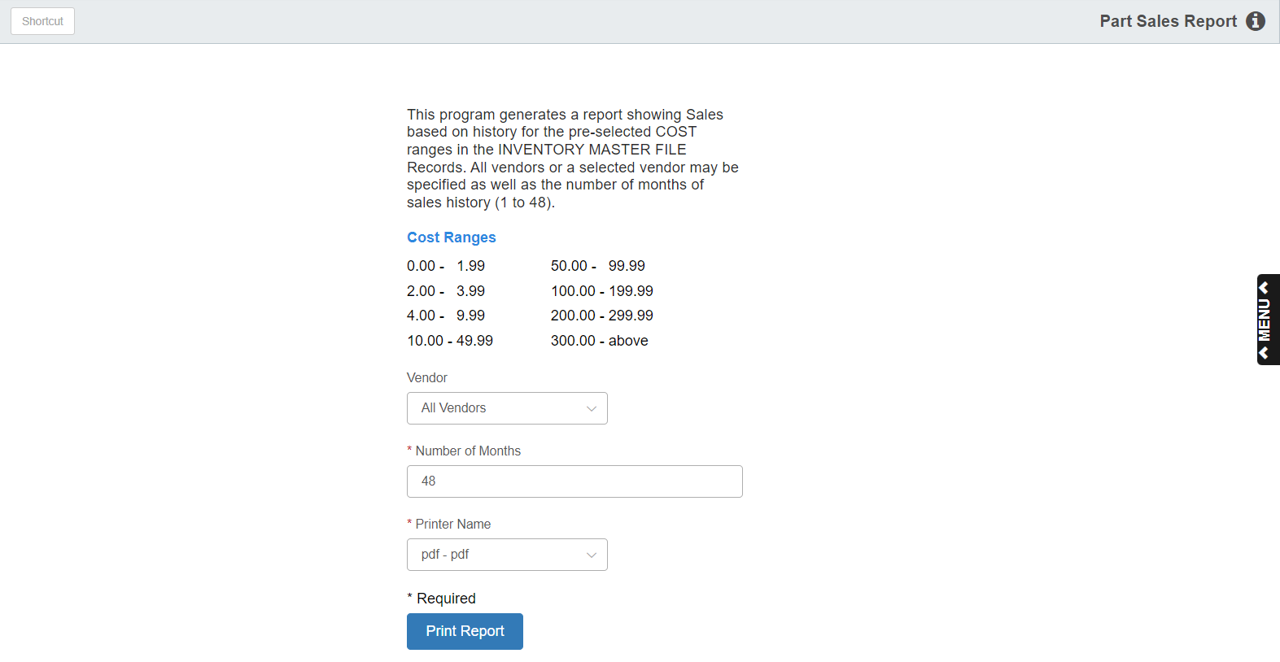

This report provides sales activity by defined dollar ranges. It shows the values (cost) by vendor in the defined dollar ranges, shows the movement of your parts inventory by those ranges, and lets you specify the time frame to examine how your inventory moved.

To access the Parts Sales Report, you can:

- Select “Inventory” from the menu. Choose the “Reports” submenu and click “Parts Sales Report.”
- Type “PSR” in Shortcuts Bar.

Field Definitions

Vendor: Choose “All Vendors” or select a specific vendor for the report.

Number of Months: Specify the number of months (1–48) that you wish to include.

Printer Name: Select the printer to receive the printout. A default printer name is pre-filled but can be changed as necessary. Use the pdf printer to view the report on the screen without printing a copy of it.

Print Report: Press this button to print your report.

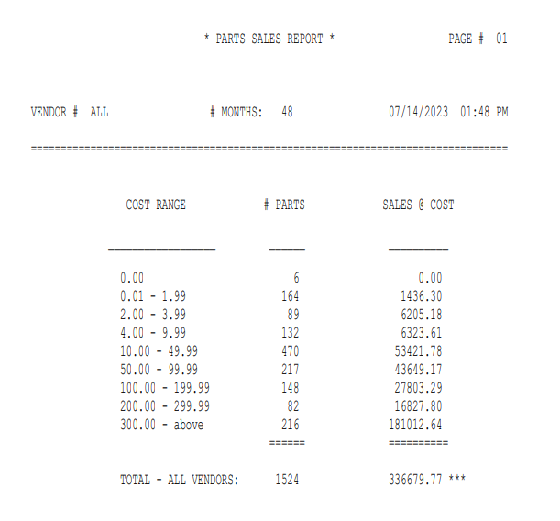

Report Details: This report shows the following information:

Vendor #: This is the vendor number you selected for the report. If you chose “All Vendors,” it will show “All.”

# Months: This is the number of months covered by the report.

Cost Range: These are pre-defined cost ranges of parts.

# Parts: This is the number of unique part numbers that fall in the listed cost ranges.

Sales @ Cost: This is amount of sales for the specified vendor at Cost for the number of months requested.

Report Totals: Totals appears at the bottom of the report for the “# Parts” and “Sales @ Cost” columns.

