Picking Ticket List Report (PTL)

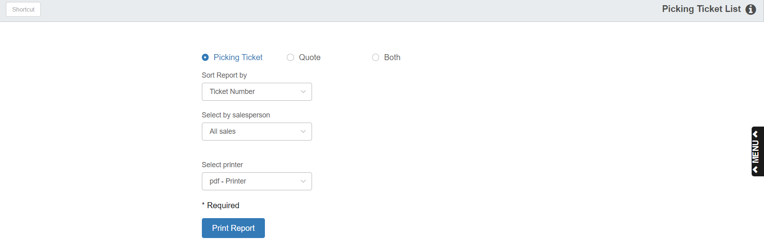

The Picking Ticket List Report shows the detail of every open Picking Ticket. Usually, this report is only printed or viewed whenever you need to make changes to correct the picking ticket information. You can also use this report to find discrepancies in price codes, tax and sales codes, pricing, etc.

To access this report, you can either:

Select “Inventory” from the menu. Choose the “Reports” submenu and click “Picking

Ticket List.”

Type “PTL” into the Shortcuts Bar.

Field Definitions:

Picking Ticket: Select this option to print a report of only open Picking Tickets.

Quote: Select this option to print a report of only open parts quotes.

Both: Select this option to print a report of all open picking tickets and parts quotes.

Sort Report By:

- Choose Ticket Number to sort the report by picking ticket number.
- Choose Customer Name to sort the report by customer. NOTE: If you choose this option, the tickets sort based on the customer’s name on the ticket as opposed to the customer’s alpha-sort in their Customer Master record.

Select By Salesperson:

- Choose All Sales to include all sales on the report.
- Choose Select Salesperson to print a report of only those sales made by a specific salesperson.
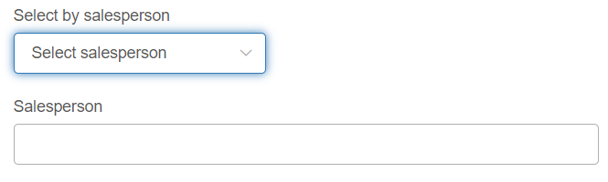

Salesperson: This field appears if you choose “Select Salesperson.” Enter the initials of your desired salesperson.

Printer Name: Select the printer to receive the printout. A default printer name is pre-filled, but can be changed as necessary. Use the pdf printer to view the report without printing it.

Print Report: Click this button to print your report.

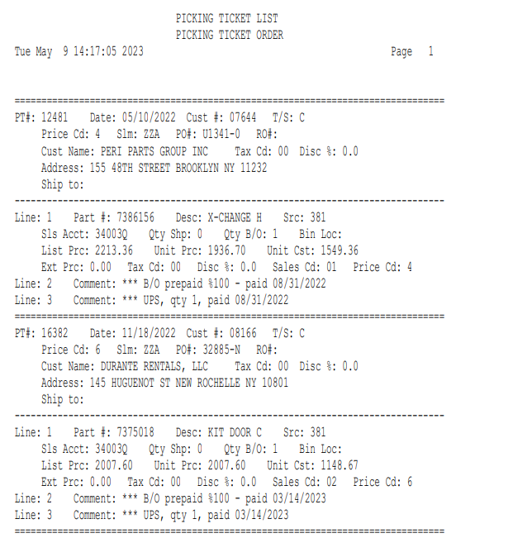

Report Details: The report lists the picking ticket number and header information first. A single dash line separates the header data from the line entry information. Each line forms a paragraph. After the last line paragraph on that picking ticket, a double dash line marks the beginning of the next picking ticket. At the end of the report, a total line lists the number of open picking tickets in your system. The following fields of the picking ticket are printed or displayed:

- Part Number, part description, source number
- Sales account number
- Quantity shipped, quantity on back order
- Unit list price, unit price, extended list price
- Tax code, discount rate, sales code, price code

