POS Transaction Report (PTRR)

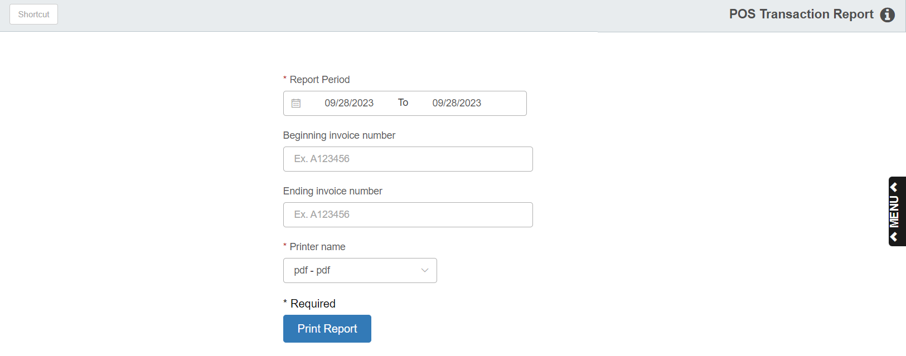

The POS Transaction Report Program provides you a printout that lists all invoices written or voided through POS Invoicing. It is more like a "log book." This printout does not include invoice detail.

To access this report, you can:

- Select “Inventory” from the menu. Choose the “Reports” submenu and click “POS Transaction Report.”
- Type “PTRR” in the Shortcuts Bar.

Field Definitions

Report Period: Select the beginning and ending transaction dates for the report. You can also select the dates from a calendar.

Beginning Invoice Number/ Ending Invoice Number: Type in the beginning and ending invoice numbers for the report.

If you are searching for a specific invoice, skip the date fields and enter the invoice number in both the Enter the BEGINNING Invoice field and the Enter the ENDING Invoice field.

To search a range of invoices, enter the first invoice number in the BEGINNING Invoice field and the last one in the ENDING Invoice field.

Printer Name: Select the printer to receive the printout. A default printer name is pre-filled but can be changed as necessary.

Print Report: Press this button to print the report.

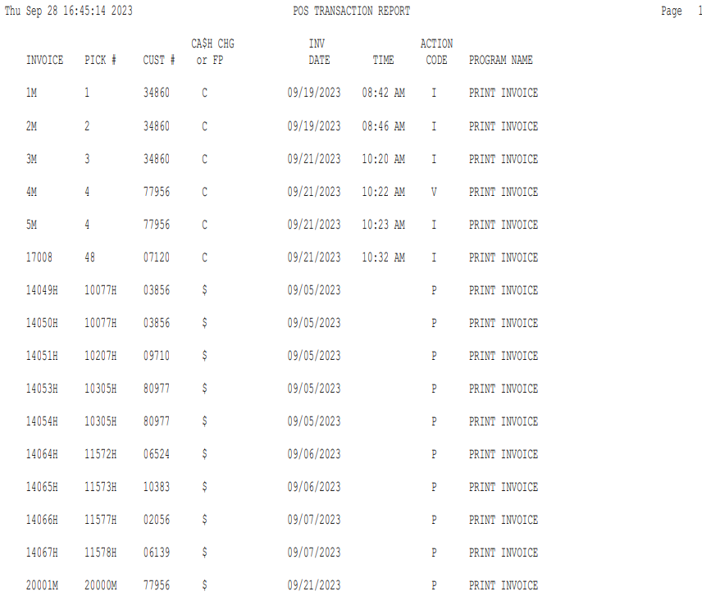

Report Definitions

INVOICE: This is the invoice number assigned by the system when the picking ticket was written.

PICK #: This is the Picking Ticket Number before it was closed and written as an invoice.

CUST #: This is your customer’s account number.

CASH CHG or FP: This is the type of sale that was on the POS Invoice, which could be:

Cash

Charge

Farm Plan

Visa

Mastercard

Other credit cards

Invoice Date: This is the date of the invoice.

TIME: This is the time the invoice was written.
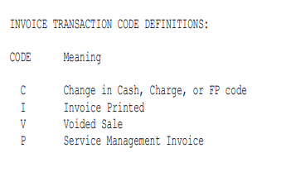

ACTION Code: These Action Codes are listed on the first page of the printout or display:

- C=Change in the cash, charge, or Farm Plan Codes (indicates there was a change made to alter the type of sale)
- I=Invoice Printed (indicates the invoice was printed)
- V=Voided Sale (indicates the sale was voided)
- P=Service Management Invoice (the transaction is an SMS invoice)

