Price Update and Variance (PUV)

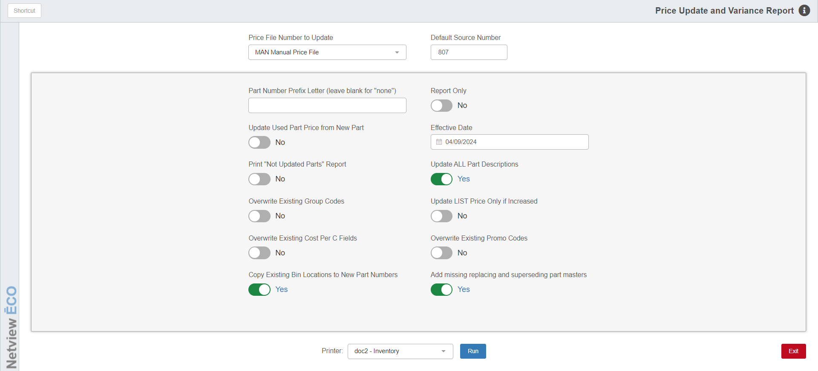

Price Update and Variance (PUV) must be run every time there is an updated price file loaded into your HBS System. PUV updates various fields of the Parts Masters found on the vendor’s price file. PUV provides a number of options when updating parts information from a new price file.

Parts found in inventory are updated when the “Update Code” field in the Part Master is set to “Yes” (update enabled). The process updates parts based on vendor number. If you have more than one source for a vendor’s parts, the additional sources will be updated as long as the vendor number matches. If you do not want the parts in the separate sources to be updated with the price file, then you will have to indicate that choice in the “Update Code” field in the Parts Masters for the affected parts.

This can be an automated process. If the Vendor Master Maintenance (VMM) record for the price file vendor is set to automatically run when a new price file is available, then this process runs after hours and provides notification via email or a printed report.

To access this function, either:

- Select “Inventory” from the menu. Choose the “Price Files” submenu and click “Price Update and Variance.”
- Type “PUV” in the Shortcuts Bar.

Field Definitions

Price File Number to Update: Type or select the vendor number to be updated. The vendor’s name and the effective date of the price file will then display.

Default Source Number: The pre-filled source is used for any new parts added in the price file update process. It defaults to the vendor number, but may be changed as needed.

Part Number Prefix: This field is no longer used. Many reasons to have parts with prefixes can be more effectively handled as duplicate parts within Parts Inventory.

Report Only: Set this option to “Yes” if you want a report of the changes in the price file without running the update process.

Update Used Part Price from New Part:

- Set this option to “Yes” to have PUV update used parts.
- Set it to “No” to keep the used parts pricing as it is.

Effective Date:

For vendor-supplied price files, the effective date of the prices is shown.

For a manual price file update, it will show the current date.

Print “Not Updated Parts” Report: This field offers you the choice to print a report that identifies parts that have not been updated from the price file because the “Update Code” field is set to “No” (no update). The report will also identify parts in inventory that were not found in this price file.

Set the option to Yes to receive the Parts Not Updated Report.

Set it to No to skip the report.

Update ALL Part Descriptions: This field offers the choice of updating the Description field in the Parts Master.

Set the option to Yes to have the descriptions on the Part Master updated from the price file.

Set it to No if you do not want the descriptions updated, especially if you have customized or manually maintained the descriptions for this vendor’s parts.

Overwrite Existing Group Codes: Some vendors provide information in the group codes (“Group ID” field) that assists in ordering.

Choose Yes to have the “Group ID” field updated.

Choose No to not update the group codes. NOTE: Be sure to choose this option if you have manually put codes in the “Group ID” fields.

Update LIST Price Only if Increased: This option updates the LIST price (manufacturer’s suggested selling price, saved in the system as Price Code 2) ONLY if the price has increased.

Set the option to Yes to update ONLY those parts whose LIST price has increased.

Set it to No to update all LIST prices whether they have increased or decreased.

Overwrite Existing Cost Per C Fields: This field offers the option to update the “Cost Per C” fields in the Parts Masters.

Set the option to Yes to update the “Cost Per C” field for the vendor’s parts.

Set it to No to keep the existing information in the field as is, especially if you have manually maintained this field and prefer to keep your own settings.

Overwrite Existing Promo Codes: This field offers the option to update the promo codes in the Parts Masters.

Set the option to Yes to update the promo codes for this vendor’s parts.

Set it to No to leave the existing promo codes as is.

Copy Existing Bin Locations to New Part Numbers:

- Set this option to Yes to copy the bin location from an “old” part number to a “new” number being added as its replacement.
- Set it to No to build the “new” part with a blank bin location. NOTE: In this case, you have to manually enter the bin location at a later time. We do NOT recommend blank bin locations.

Add missing replacing and superseding part masters: This option lets you specify if you want to add replacing and superseding part masters that are available from the manufacturer that may not already be present in your inventory.

Special Note for Case and New Holland Dealers: When you are running the PUV process for Price File 198 (Case) or 140 (New Holland), an additional prompt appears depending on the selected price file.

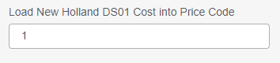

Load Case–IH DS01 COST into Price Code: This field asks where to load DS01 figures in your Parts Masters for Case-IH parts. Enter the Price Code (1-6) where you have chosen to identify DS01 cost. The code selected in the past pre-fills in this field.

Load New Holland DS01 COST into Price Code: This field asks where to load DS01 figures in your Parts Masters for New Holland parts. Enter the Price Code (1-6) where you have chosen to identify DS01 cost. The code selected in the past pre-fills in this field.

Run: Select the printer you want to receive the report(s), then click this button to run
the process and print.

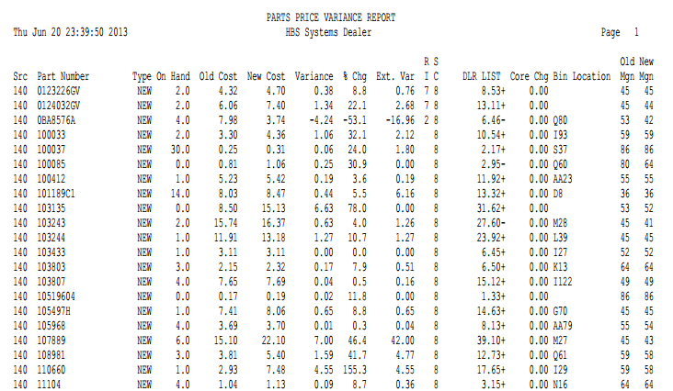

PUV Reports: The PUV process generates up to three reports, depending on your responses to the setup screen. The reports that can be produced are:

Parts Price Variance Report

Parts Added Report

Parts Not Updated Report

Parts Price Variance Report:

Src: This shows the part’s source number.

Part Number: This is the part number updated.

Type: This shows the part type. It could be:

New

Used

Reman

Core

Memo

On Hand: This column shows the current quantity on hand.

Old Cost: The old cost is the value before the update was applied.

New Cost: The new cost is the value after the update was applied.

Variance: The variance is the difference between the old and new cost values (dollar amount).

% Chg: This shows the percentage of change between the old and new cost (percentage).

Ext Var: The extended variance is the dollar amount of difference in value for this part (variance amount times the on hand quantity).

RI: This column lists the part’s return indicator.

SC: Here you will find the part’s stock class.

List: This column shows the factored list price (selling price) for the part number.

If it shows “+” after the number, it indicates the price has increased.

If it shows a “-“ after, then the price has decreased.

Core Chg: The part’s core charge amount, if any, shows here.

Bin Location: Here you will find the part’s primary bin location.

Old Mgn: This is the margin percentage BEFORE the new pricing was applied (list minus cost divided by list).

New Mgn: This is the margin percentage AFTER the new pricing was applied (list minus cost divided by list).

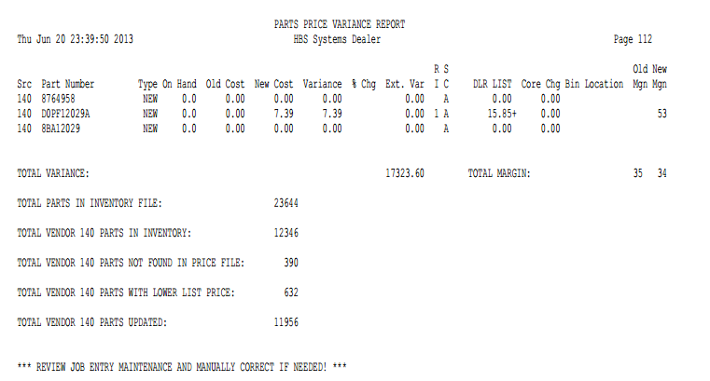

Totals are provided for:

Total Variance (Amount, Mgn and New Mgn)

Total Parts in Inventory

Total Vendor XXX Parts in Inventory

Total Vendor XXX Parts Set for ‘NO’ Update

Total Vendor XXX Parts Not Found in Price File

Total Vendor XXX Parts With Lower List Price

Total Vendor XXX Parts Updated

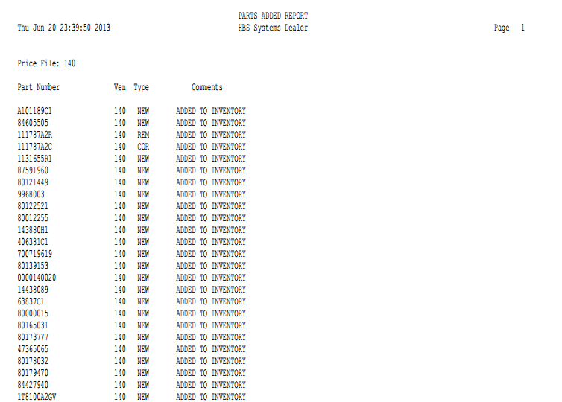

Parts Added Report:

Part Number: This is the part number added.

Ven: This is the part’s assigned vendor number.

Type: This is the part’s type. It could be:

New

Used

Reman

Core

Memo

Comments: Typically you will see the ADDED TO INVENTORY message in this column.

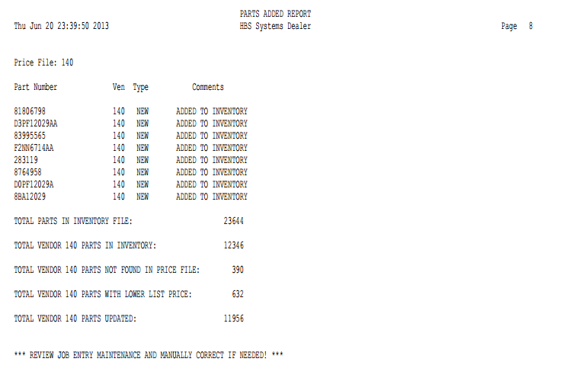

Totals are provided for:

Total Variance (Amount, Mgn and New Mgn)

Total Parts in Inventory

Total Vendor XXX Parts in Inventory

Total Vendor XXX Parts Set for ‘NO’ Update

Total Vendor XXX Parts Not Found in Price File

Total Vendor XXX Parts With Lower List Price

Total Vendor XXX Parts Updated

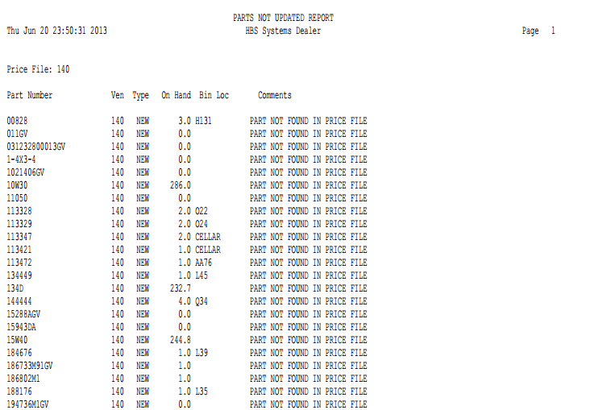

Parts Not Updated Report:

Part Number: This column lists the part number that was not updated.

Ven: This column lists the vendor number.

Type: This column lists the part’s type. It could be:

New

Used

Reman

Core

Memo

On Hand: This column shows the current quantity on hand.

Bin Location: Here you will find the primary bin location of the part.

Comments: Typically you will see the PART NOT FOUND IN PRICE FILE message.

Manual Price File Updates: If you use MPU to make adjustments to prices for a manual price file, choose “MAN Manual Price File” to apply the changes to the parts in inventory for the vendor.

