Parts Value Based on Sales (PVBS)

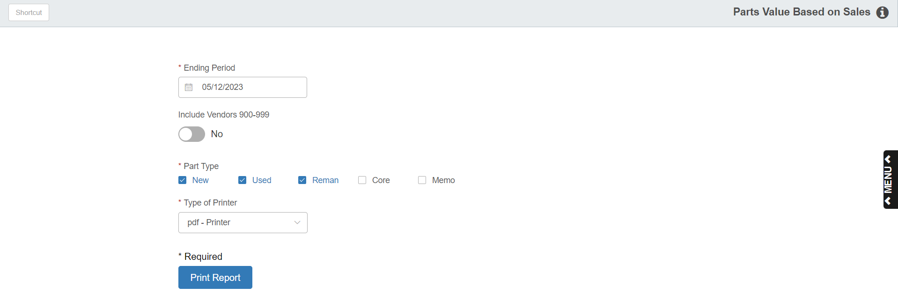

The Parts Value Based on Sales report shows how fast your inventory is moving. It details value by the last time a sale was made.

- To access this report, you can either:
  - Select “Inventory” from the menu. Choose the “Reports” submenu and click “Parts Value Based on Sales Report.”
  - Type “PVBS” in the Shortcuts Bar.

Field Definitions

Period Ending Date: Enter the date for the report.

Include Vendors 900 – 999: If you want to include the vendor numbers (900-999) typically used for Labor, set this option to Yes. To exclude these vendors, choose No.

Part Types: Select the part types you want included on the report. The default selection is New, Used, and Reman, but you may select up to all 5 part types.

Printer Name: Select the printer to receive the printout. A default printer name is pre-filled, but can be changed as necessary. Use the pdf printer to view the report on the screen without printing a copy of it.

Print Report: Click this button to print your report.

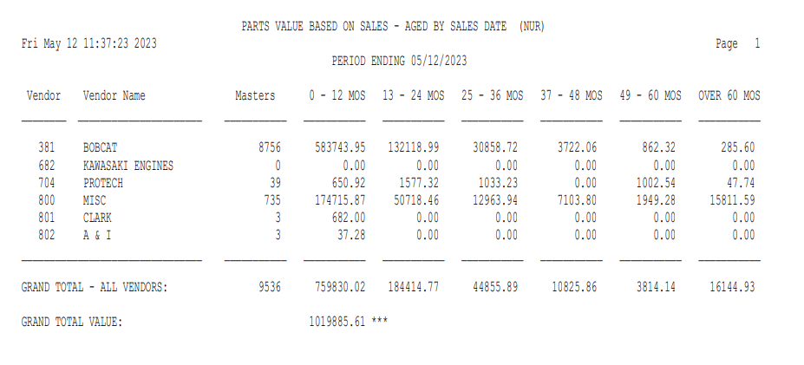

Report Detail: This report contains the following information:

Vendor / Vendor Name: The vendor name and number appear here as long as there is at least one part master for the vendor.

Masters: This is the total number of unique part number for the specified vendor number.

0-12 MOS/13-24 MOS/25-36 MOS/37-48 MOS/49-60 MOS/OVER 60 MOS: These five columns show the value (cost) of inventory for the vendor based on the last sales date. For example, the 0-12 MOS column shows inventory dollars for parts that sold in the last 12 months. Likewise, the 37-48 MOS column indicates the inventory value of those parts that last sold over three years ago (between 37 and 48 months ago).

NOTE: The report also has a second part showing the parts value based on no sales, as well as an error report that will print instead of the report if you have part number(s) in your system whose cost cannot be found by the program.

