Parts with Core Charges

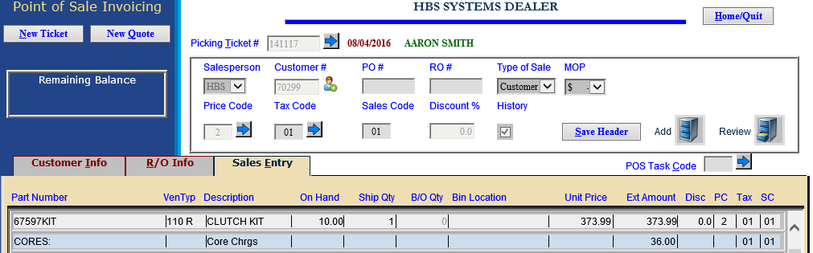

POS simplifies the process of charging and refunding core charges for parts with returnable cores. The price POS charges for a part with a returnable core depends on whether or not a core is returned, and how many cores are returned.

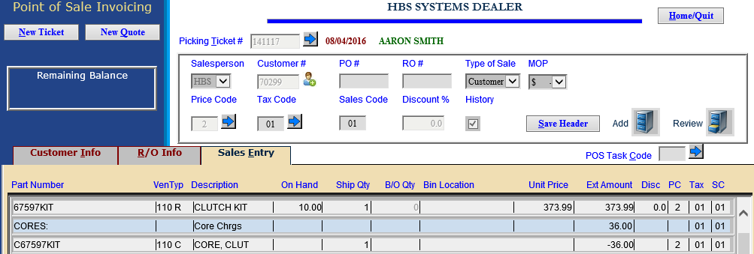

Core Returned: If a core is returned at the time of the sale, the core charge is offset by one core credit on the ticket.

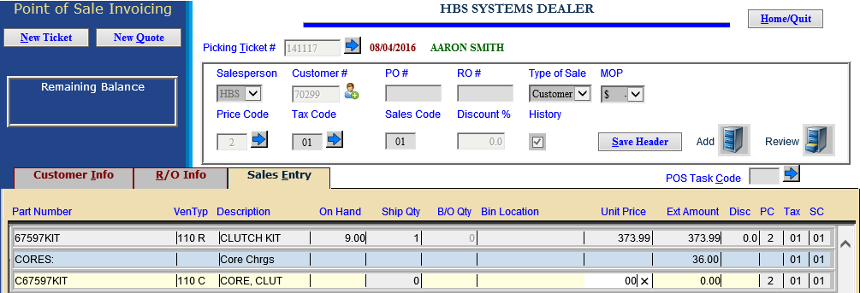

No Core Returned: When no core is returned at the time of sale, a core charge (as set in the Part Master) is added to the ticket, but no core credit is applied. The ticket (invoice) can now be written and closed.

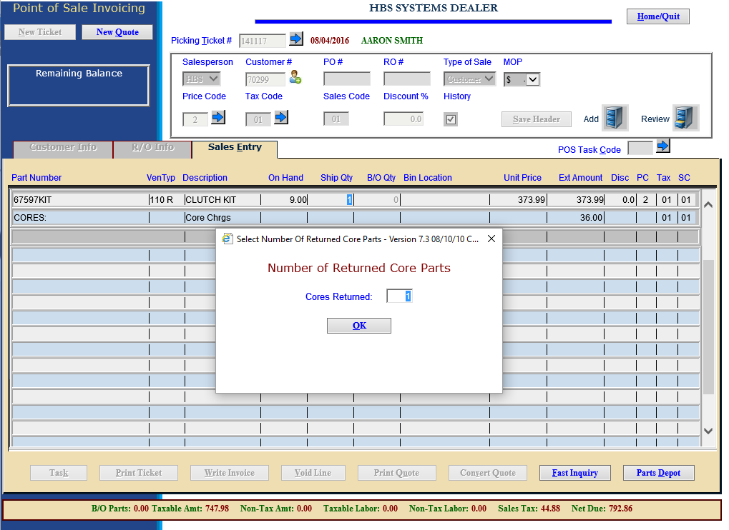

When the customer returns the core, open a new ticket for the same part. On the new ticket, enter “0” in the Ship Qty field and then enter “1” at the Number of Returned Core Parts screen. A part amount of 0.00, a core charge of 0.00, and a core charge credit are added.

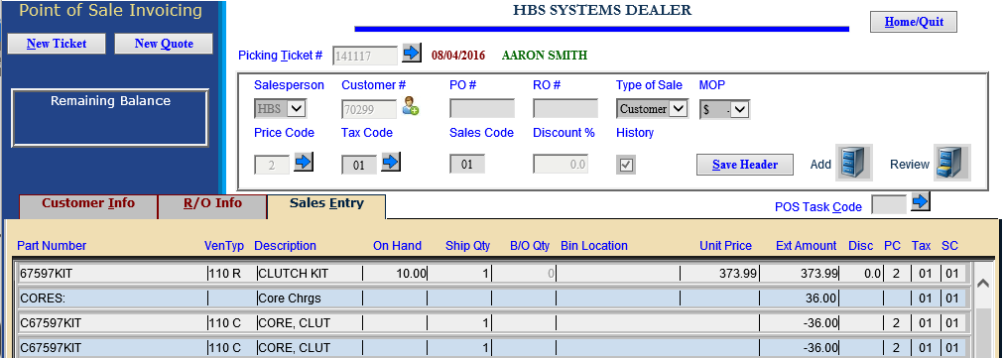

Multiple Cores Returned: If a customer returns more than one core at the time of sale, the part price is reduced by the core credits from returning two cores.

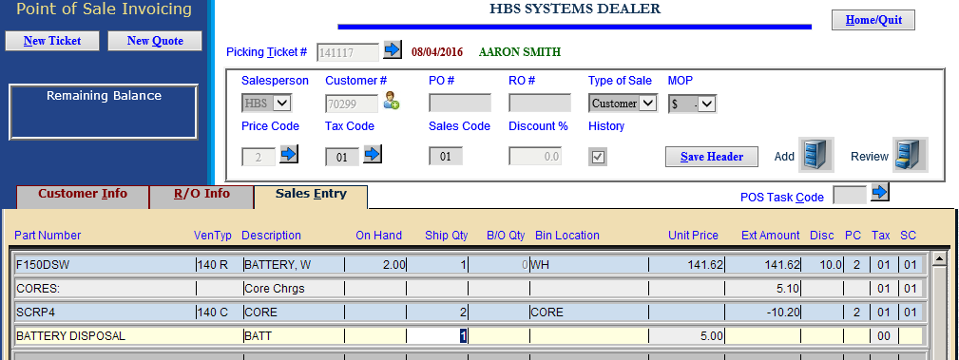

Multiple Core Part Numbers: If there is a single core number associated with the part, that number is added to the invoice. When the quantity is entered and there are multiple cores present, the system will add each core part in turn, adding one line for each to the invoice. The quantity of cores will be shown on the part master of the core number as negative sales history.

