Parts With Environmental Charges

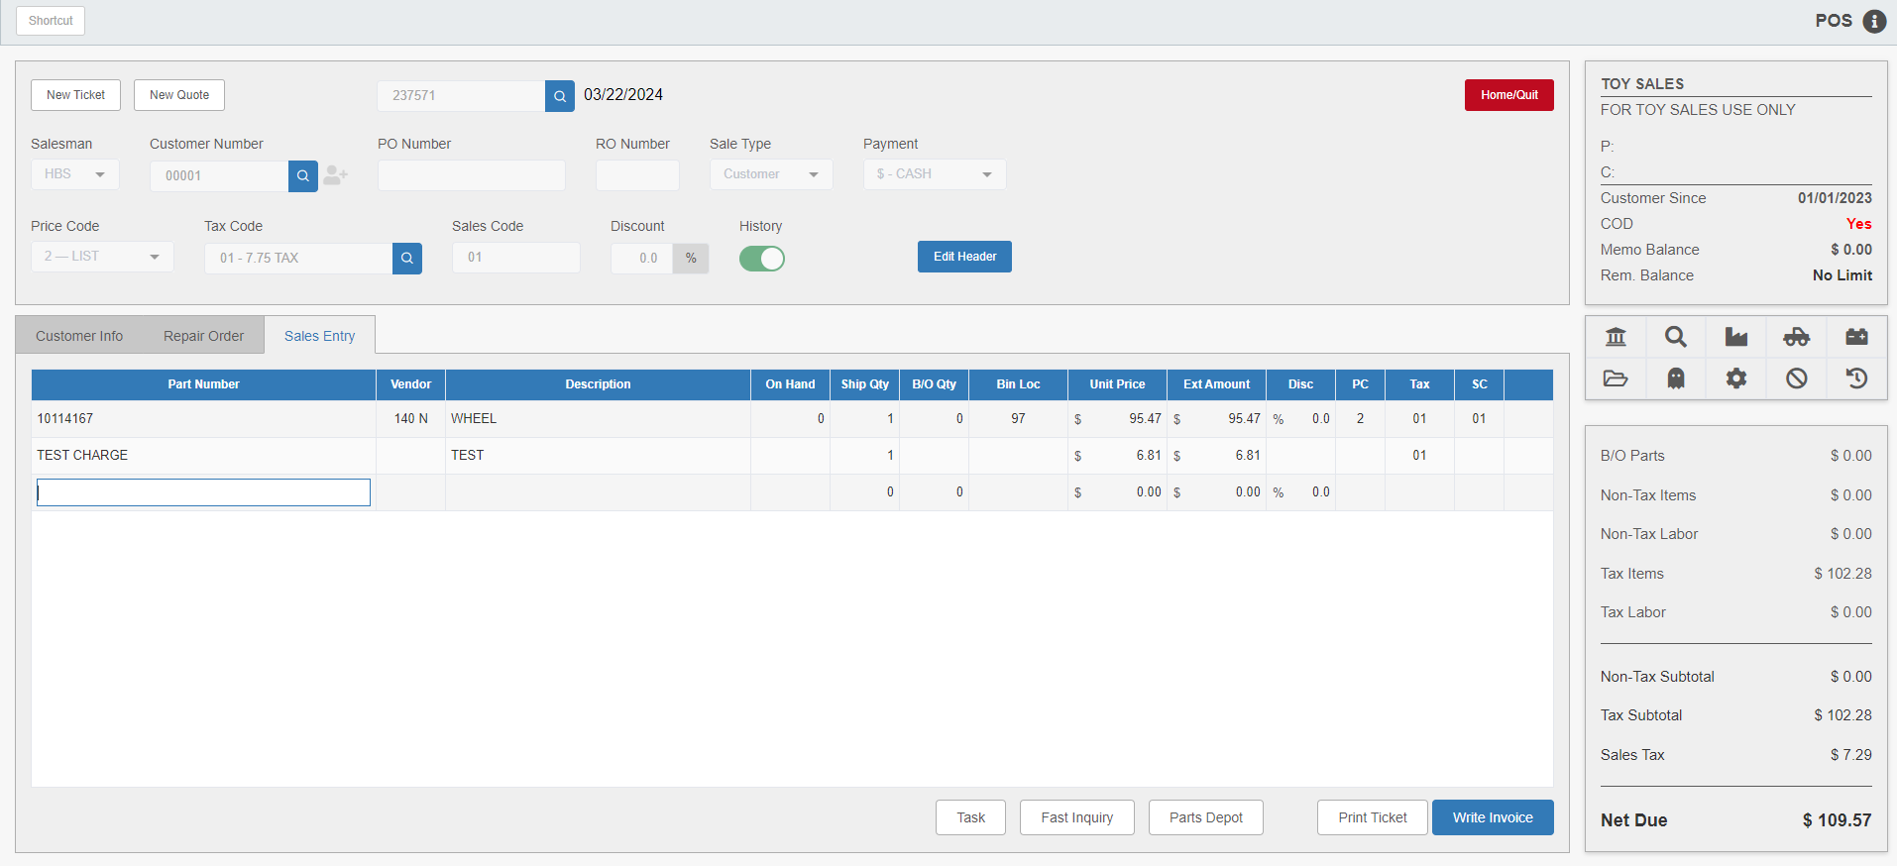

There are regulations in some areas that require environmental fees or disposal fees on certain products such as oil, fuel, or waste. These fees are created in Environmental Charge Maintenance (ECM) and may be attached to the Part Master record for any part in the system. Each time one of these parts is sold in POS, it will automatically add the charge to the part on the invoice. If multiple units of the part with the charge are sold, POS will suggest the same number of environmental charges, but this can be changed as necessary.

In POS, part numbers with environmental charges may be added to any picking ticket. As soon as the part number is added to the picking ticket, POS checks the master record field for an environmental charge.

Environmental Charge Ticket Line: The following fields make up an environmental charge line on the ticket:

Part Number: Rather than showing the part number, this field will show the environmental charge’s name.

Description: This field will show the charge’s description from ECM.

Environmental Charge Quantity (Ship Qty): The number entered in the “Ship Qty” column on the line displays as the environmental charge quantity. This quantity will be multiplied by the actual environmental charge to arrive at the total environmental amount. The quantity will default to match the part’s ship quantity, but may be changed as needed.

Environmental Charge Amount (Unit Price/Ext Amount): The environmental charge amount (displayed in the Unit Price and Ext Amount fields) may be a flat rate amount or a percentage of the part number’s total list (or cost) amount.

If the code is a flat dollar amount, POS multiplies the flat dollar amount by the quantity entered to find the extended amount.

If it is a percentage, that percentage is calculated against the list or cost as specified on the code’s ECM record, and then multiplied by the quantity entered for the charge.

Core and Environmental Charges: If a part number has both a core part and an environmental code, POS displays the core information. After entering the information for the core, POS proceeds to handle the environmental charge.

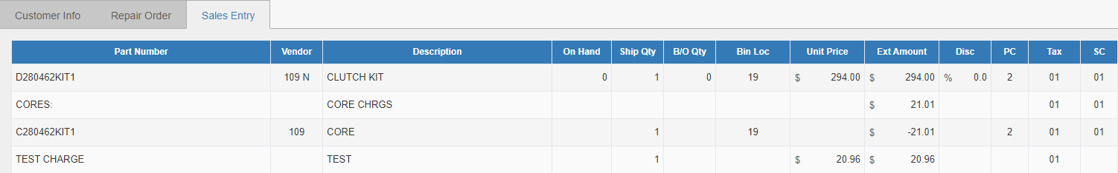

Placing a Part with an Environmental Charge on Back Order: If the part number placed on back order has an environmental charge (or a core charge), POS asks for the quantity of the environmental charge. The full amount of the environmental fee is calculated and shown on the screen. Even if a prepaid percentage less than 100% is selected, the customer is still charged for the total amount of the environmental fee at the time the back order picking ticket is created. However, the customer IS NOT charged another environmental fee after the back order is receipted through Quick Receipts (QR) and updated on the stored picking ticket file.

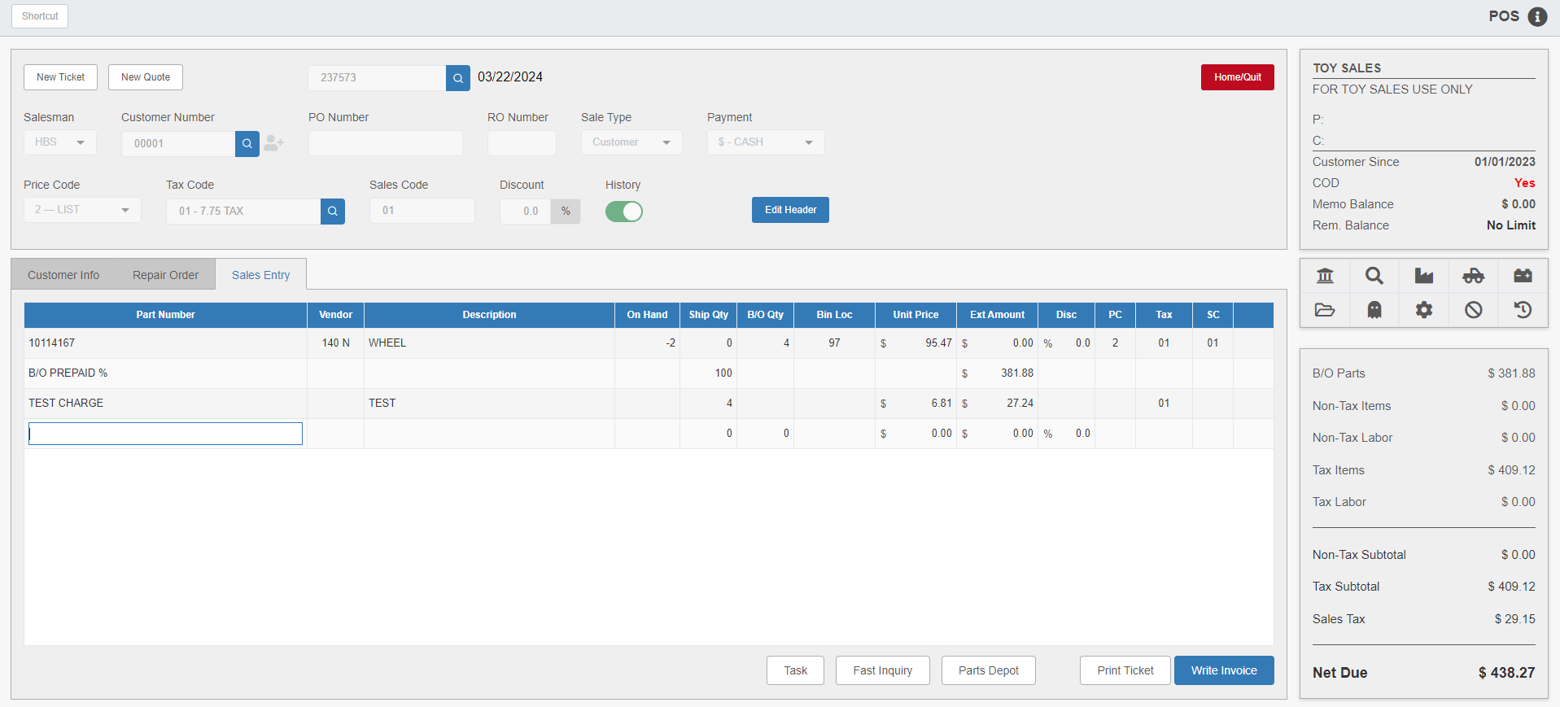

NOTE: If answering No at Re-use Picking Ticket with B/O? in Inventory Point of Sale Defaults (IPOS), the picking ticket containing the back-ordered part is NOT stored after writing the invoice. This is why it is important for POS to charge the full amount of the environmental fee (as well as the core charge, if applicable) on the original picking ticket.

Writing the Invoice with Environmental Charges: If all charges have been entered on the picking ticket, it can be invoiced using the Write Invoice button.

Shipping Info Tab: If freight is needed, open the Shipping Info tab in the invoice screen.

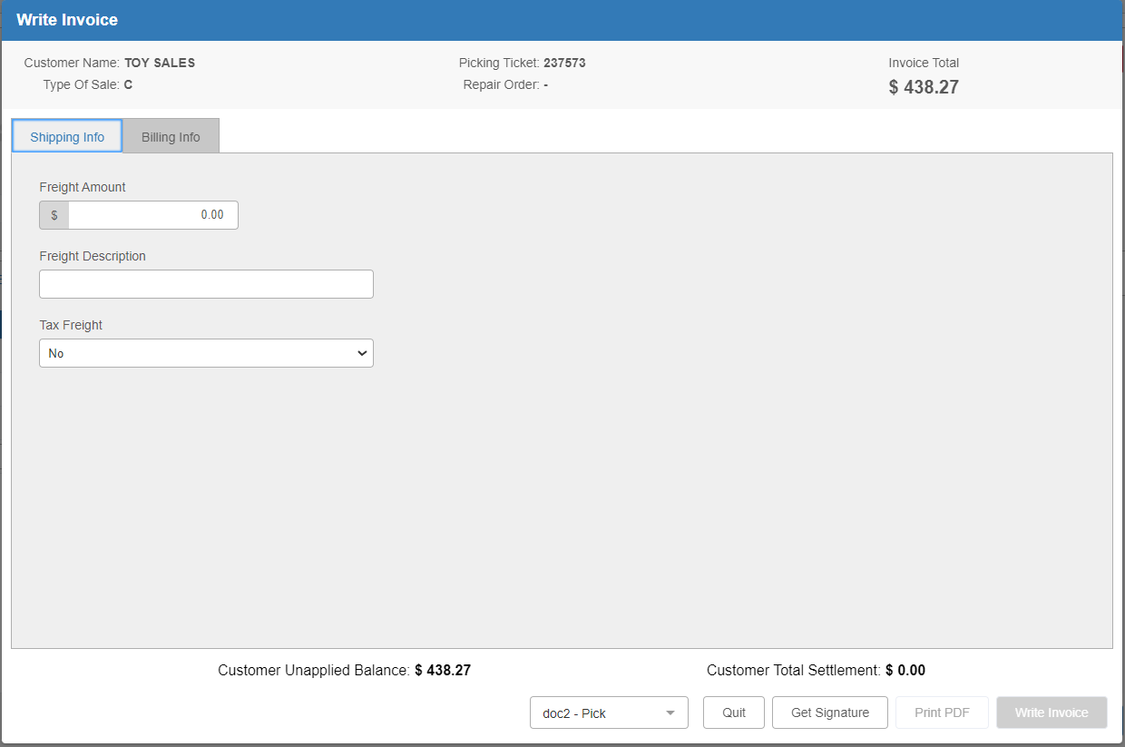

Enter the amount, a Freight Description, and the freight’s taxable status.

Billing Info Tab: Go to the Billing Info tab to process the invoice as normal.

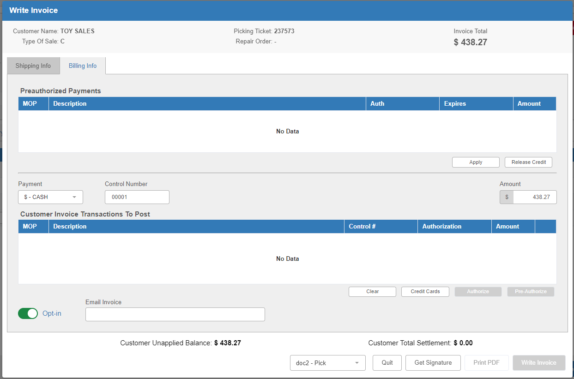

Add the payment by tabbing through the “Payment,” “Control Number,” and “Amount” fields. Print the invoice by pressing the Write Invoice button. If the invoice did not print correctly, reprint. Otherwise, click Yes in the invoice confirmation screen.

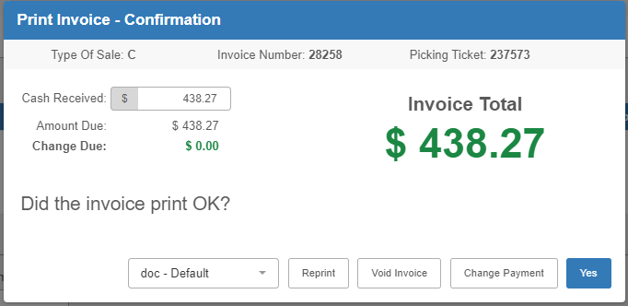

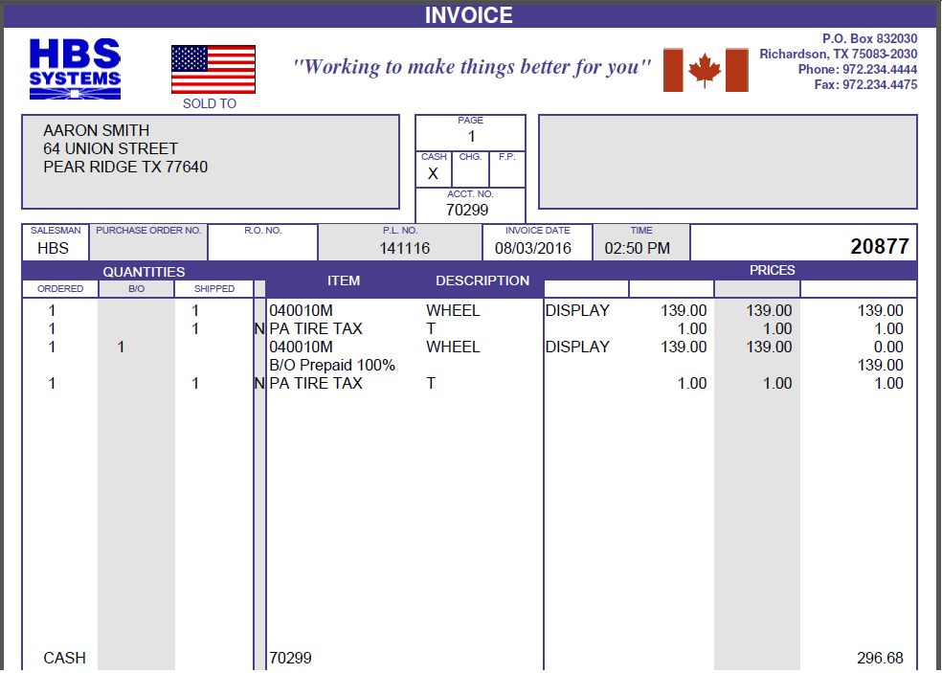

Invoice Printout: If the picking ticket contained part number records with environmental charges, the invoice printout will look similar to the one shown above. Any environmental fees "collected" may be viewed or printed on the Environmental Charges Report (ECR).

