Quick Order Adjustments (QOA)

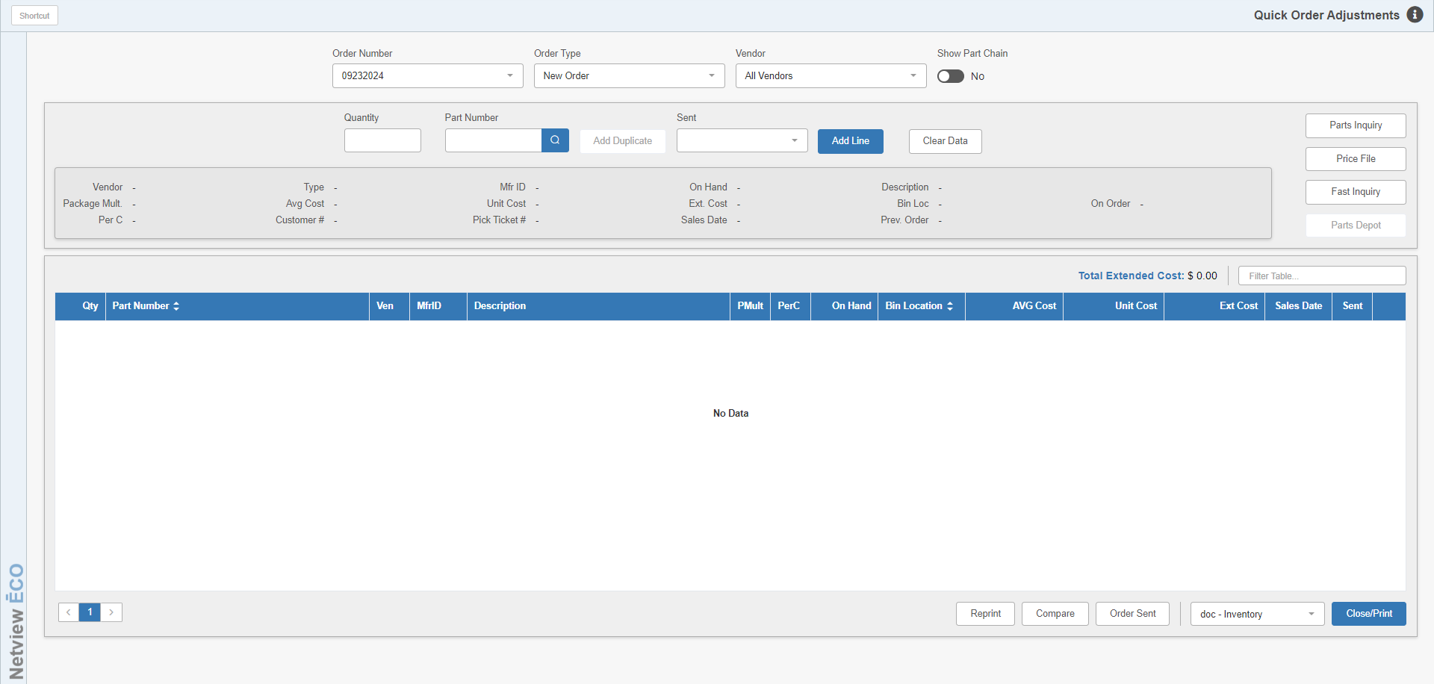
Quick Order Adjustments is used to make adjustments to an existing order or create a new order here.

To access this function, you can:

- Select “Inventory” from the menu. Choose the “Orders” submenu and click “Quick Order Adjustments.”
- Type “QOA” in the Shortcuts Bar.

Header Fields:

Order Number: Enter the Order Number to adjust or create. Type in the number or select it from the drop-down menu. If you wish to create a new order, a default order number will automatically generate when the program opens, based on the current date (i.e. 09232024 for September 23, 2024).

Order Type:

- If you are adjusting an existing order, this field defaults to the Order Type used when the order was created.
- If you are creating a new one, choose the order type that fits the situation from the order type box displayed. Choices are:
  - New
  - Customer
  - Emergency
  - Backorder
  - Transfer

Vendor: This defaults to all vendors, but you can select a particular vendor to limit all parts added from that point on to just that vendor.

Show Part Chain: This option impacts the Part Search attached to the “Part Number” field. If it is set to “Yes,” then the search will not only look up your desired part, but also any part supersession chain it may be part of. If it finds any supersession information, it will then display it so you can choose a newer part number in the chain if desired:

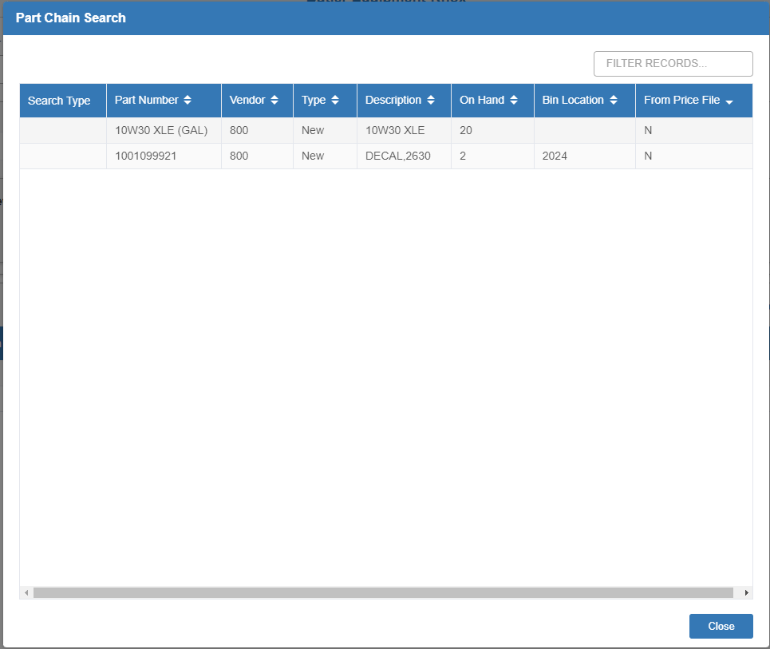

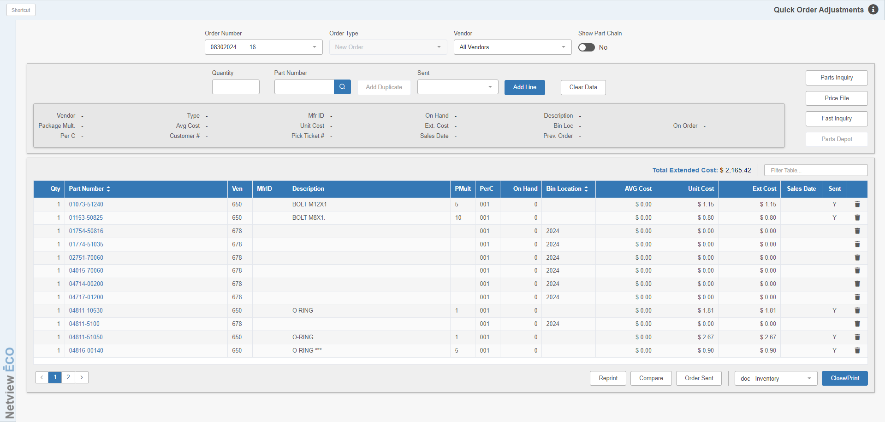

Once you select/start an order, the parts on the order will display in the grid. Selecting any line will allow you to edit that part line in the fields above the grid, unless the line represents parts on backorder. In that case, you will be blocked from selecting the line and receive the following warning:

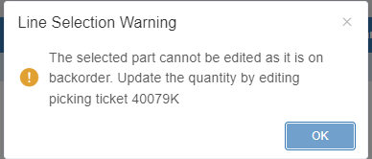

NOTE: The exact picking ticket/RO number listed on the warning will change depending on where the backorder was placed.

Part Number Order Fields: Use these fields above the grid to add new part lines to the order or edit a selected existing line (which will populate the fields with data once you select it).

Quantity: Enter or adjust the quantity of the part number for this order.

Part Number: Type in the part number to be added to or changed for this order. You can also use the Part Search to look it up (and see its supersession chain if you have “Show Part Chain” set to “Yes”).

Part Information: Once a part number is selected, the following information about the part may display if available:

- Vendor
- Type
- Mfr ID
- On Hand Quantity
- Description
- Package Multiple
- Average Cost
- Unit Cost
- Extended Cost
- Bin Location
- On Order Quantity
- Cost Per C (Per C)
- Customer Number
- Picking Ticket Number
- Last Sales Date
- Previous Order

NOTE: The Average Cost and Unit Cost (Replacement Cost) for the part number selected only appear for dealers using Average Cost (such as the one in the image above).

Add Duplicate: After you have called up an existing part number in the “Part Number” field, you have the option to click this button to add a duplicate of the part number that does not currently exist in inventory. The following window will open:

[INSERT IMAGE ONCE FIXED]

You will see a list of all existing parts in the system that have the same number as the part you looked up. Use this list to make sure that the duplicate part you want to add is not already in the system. If you do not see it, set the “Vendor” and “Type” fields at the top of the window to the vendor and type you want for the new duplicate part number. NOTE: Make sure the vendor for the new part is completely different from all the vendors of the existing duplicate parts, or the system will not let you add the part.

Click Okay to open the Manufacturer Price File Lookup and see if there are any price files that your desired duplicate might be listed in.

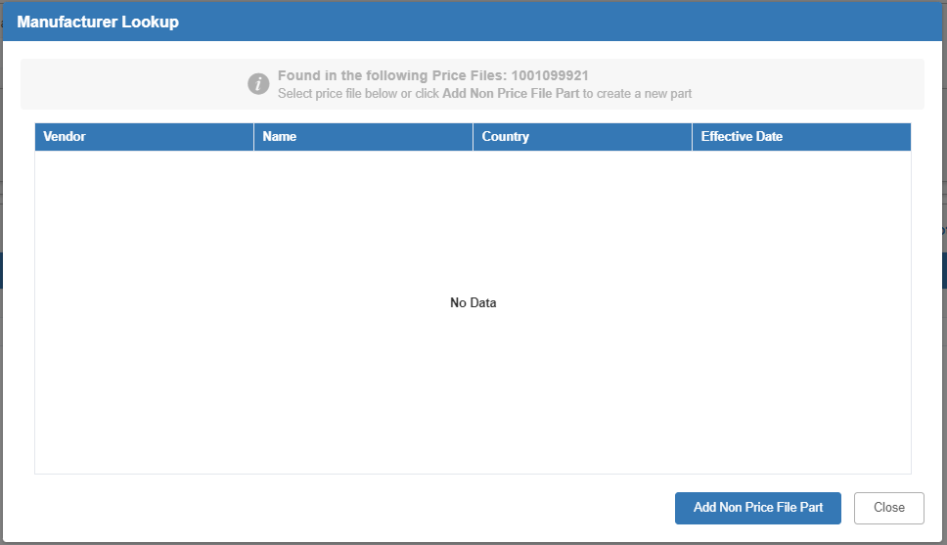

If the part cannot be found, as in the example above, click Add Non Price File Part to open Custom Part Maintenance (CPM) and add the new part. If the part is found in the system, click on it to view its information, then click Add Part to go to CPM and add it.

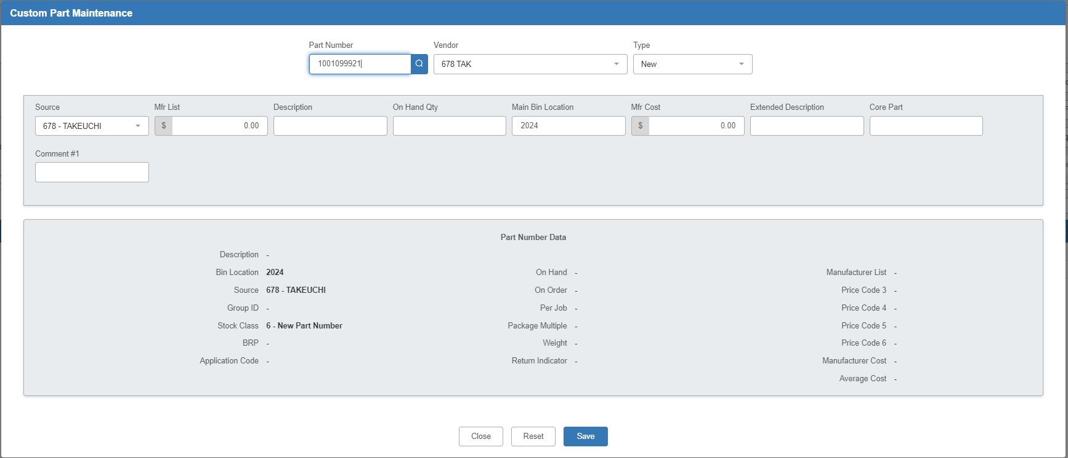

Once you have added the part, you will be returned to the main QOA screen, where the duplicate part will auto-fill and show via the Duplicate Part Search screen that the part is now in the system. Click on the part in the Duplicate Part Search window to select it for your order. You can then proceed to add the line as desired.

Sent: Use this field to set a status for a particular line on the order. Once you select the line, use the dropdown to choose one of the following options:

Sent: Marks the line as having been sent, which will place a “Y” in the line’s “Sent” column on the grid. This will lock the line’s part number from being changed, as it indicates the particular line has already been submitted to the manufacturer, though you can still adjust the line’s quantity.

Not Sent: Indicates the line has not been sent in yet, which will put an “N” in the “Sent” column. Note that this is just an optional indicator and has the same impact on the line as leaving the line’s status blank.

Adjusted: Indicates an adjustment has been made to the line, which will put an “A” in the “Sent” column. A line already marked as “Sent” will automatically have its status changed to “Adjsuted” should any changes to the line’s quantity occur.

Add/Update Line: Press this button to save the new or changed information.

Clear Data: Press this button to clear this section of any new or selected part line information.

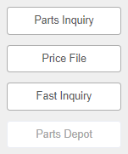

Additional Features: These buttons allow you to perform additional actions while working on your order.

Parts Inquiry: Click this button when you have a part line selected to view the chosen part in Parts Inquiry (PI). NOTE: You can also access this screen for a part on the order by clicking on the hyperlinked part number in the grid.

Price File: Click this button to acces Price File Inquiry (PFI) while working in QOA.

Fast Inquiry: Click this button to start a Fast Inquiry for CNH dealers (Case, New Holland, Kobelco, Flexicoil). Note that this function will only work if you have a part selected that has a CNH vendor.

Parts Depot: This button is reserved for future use.

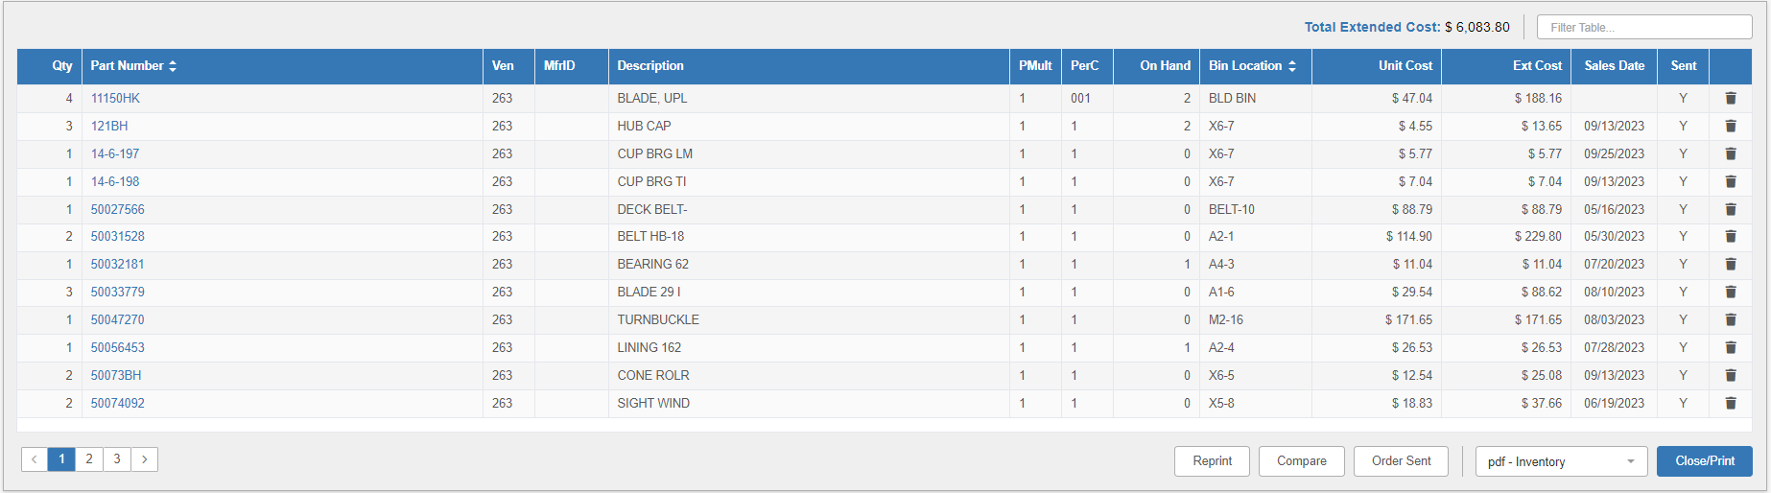

Order Display Grid Features: The grid offers additional features for viewing and modifying the part order.

Total Extended Cost: This field shows the running total for the order. It is calculated by multiplying the order quantity by the individual cost.

Filter: This field allows you to filter the part lines on the order by typing in information from the line. The grid will then adjust to only show you the lines with matching information.

Grid Sorting: You can use the “Part Number” and “Bin Location” column headers to sort the grid by either the part number or the bin location. Click on the headers to resort the order. Click each header once to sort in ascending numeric order, twice to sort by descending numeric order, and three times to return the grid to its default listing.

Delete Line: To delete a line on the order, click the trash can icon at the very end of the line. The line will be removed from the grid and the order will update accordingly. NOTE: If the line is on backorder, then you will not be able to delete it.

Page Numbers: If there are more than 12 parts on the order, use the page numbers in the bottom left-hand corner of the screen to move between the pages of order lines.

Footer Buttons: These buttons located at the bottom of the screen provide further features.

Reprint: Click this button to open Stock Order Reprint (RPO) to print a copy of the entire order. You can also click it when no order is on screen to open RPO and reprint any order of your choice.

Compare: This button is for multi-location dealers to compare open orders between selected locations using Multi-Store Inventory/Order Comparison (MIC). You can choose one or more locations to compare with this order. NOTE: The program will only open properly from QOA if you have an order selected when you click the button.

Order Sent: This button can be pressed to mark the full selected order as sent. The automated order submission programs change the Order flag to “Sent” once it is submitted to the manufacturer. This prevents anyone from changing the part numbers on any of the order lines.

Close/Print: Press this button when done and it will generate a proof sheet of any changes made to the order. Use the printer selection field next to the button to designate the printer to receive the printout.

QOA Functions:

- When you edit a line of a lengthy order and save it with the changes, the screen retains your position in the order.
- When you delete all the lines in an order, the focus returns to the “Order Number” field so you can edit another order.
- If the part number added to the order has a manufacturer ID, QOA displays this information at the time it is added to the order and whenever the existing order is accessed.
- When you add a part number to the order that is already on the order, the new entry is placed on a line of its own. This will aid in the receipting of the order when some lines are related to picking tickets or repair orders and others are general stock items.
- When you edit a part number line and click “Update Line,” the focus automatically goes to the next line. If you edit the last part line on the order, then the “Quantity” and “Part Number” fields simply are cleared.
- If you copy and paste an order number that contains spaces, the program displays the message "Spaces not allowed in order number!" when you tab, enter, or click off the “Order Number” field. You will have to remove the space in order to proceed.
- If you copy and past an order number with lower-case alpha characters, the field will automatically capitalize them when you tab, enter, or click off the “Order Number” field, as you can only have upper-case alpha characters in your order number.
- If you enter or paste an order number that is shorter than 8 characters, the field will pad the number with leading zeroes so that the order number is always 8 characters long.
- When you add parts to an order, they remain in the same order as they are added to the order while you are in that editing session. When you save, exit, and return to the order, they appear in part number order for easier editing.

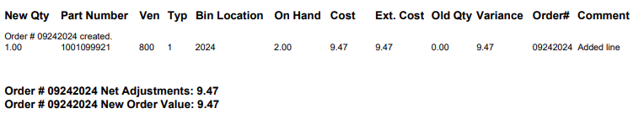

Printout Detail: Upon exit, you will receive a proof sheet detailing your actions taken during your session, including stating if a new order was made or not. However, the report primarily focuses on detailing additions and adjustments on orders, including the following information:

New Qty: This column shows the existing or adjusted order quantity for the part number shown (depending on the action taken).

Part Number: The part number column shows the part on order.

Ven: This is the part’s vendor number.

Typ: This is the part’s type. This could be:

- New
- Used
- Core
- Reman
- Memo

Bin Location: The primary bin location from the Part Master shows here.

On Hand: This column shows the part’s current on hand quantity.

Cost: This column shows individual cost for the part number.

Ext Cost: The Extended Cost for the order line appears here. It is calculated by multiplying the ordered quantity by the part’s individual cost.

Old Qty: This column shows the previous order quantity, if any.

Variance: This column shows the difference in cost value between the previous order quantity and the current order quantity.

- If you increased the quantity, this will show a positive number.
- If you decreased the quantity, it will show a negative number.

Order #: This field shows the order number.

Comment: Here you will find an explanation of what action was taken on the part number.

Net Adjustments: This is the net dollar value of the order adjustments.

New Order Value: Here you will find the new value of the order after the adjustments have been made.

