Quick Receipts (QR)

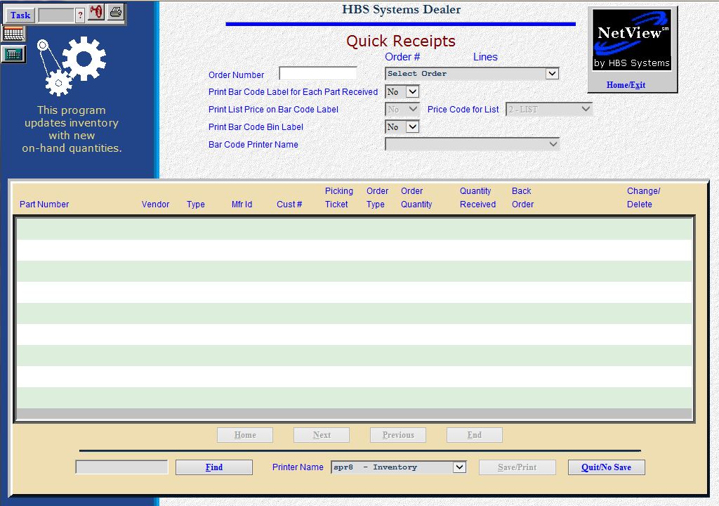

This program offers the ability to make quick adjustments to any outstanding order and receipt the received quantities. You can also print barcode labels for all parts received in on the order (NOTE: use of this feature requires a specialty barcode printer.)

- To access this function, you can:
  - Select “Inventory” from the menu. Choose the “Orders” submenu and click “Quick Receipts.”
  - Type “QR” in the Shortcuts Bar

Field Definitions

Order Number: Type or select the order number to be reprinted. Use the pull down menu to select the order number from a list.

Print Bar Code Label For Each Part Received: This option lets you print a barcode label for each part you are receipting on the order.

Choose Yes to print a label based on the quantity received field. For example, if you choose “Yes” and you receipt 7 of an item on order, you’ll get 7 labels for that part number.

If you select No here, you receive no labels per part number receipted.

Print List Price On Bar Code Label: You can include the List Price (factored selling price) on the label(s).

Select Yes to have the List Price print.

Select No to exclude the List Price from the label.
- Price Code for List: This field is accessible only when you print the list price. It is pre-filled with the choice from Bar Code Defaults but can be changed as needed. Select “Yes” to accept the one shown or type in a price code to be used.

Print Bar Code Bin Label:

- Select Yes to have an additional label printed for the bin itself. This label will be over and above any other labels printed to satisfy the other choices you make.
- Choose No here to bypass printing the barcode label for the bin.

Bar Code Printer Name: The printer drop-down menu will display available printers, but it will pre-select the barcode printer.

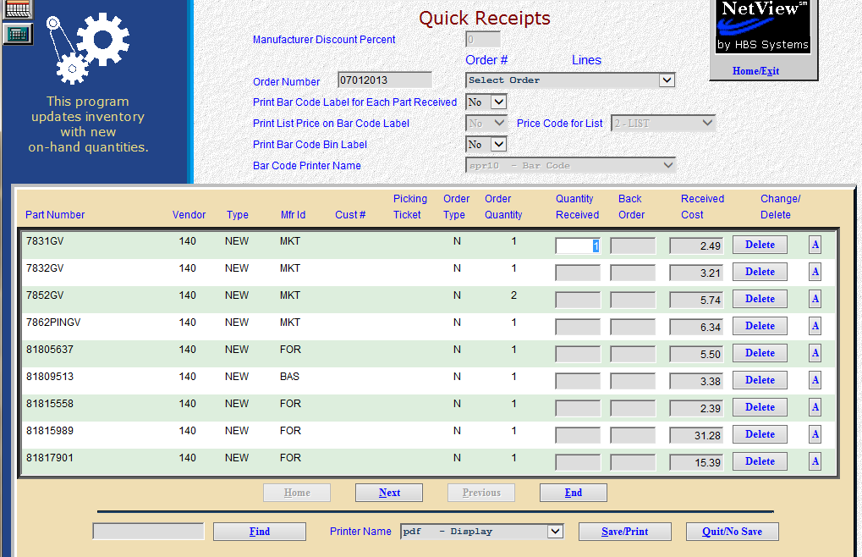

Order Fields: Each line of the order will show in this area. Maneuver through the line items and record the quantities received.

- Full quantities received - The full quantity ordered pre-fills in the quantity received field. You can press “Enter” to accept that quantity or change it as needed.
- For items not received – Zero out the pre-filled quantity and put the quantity on back order in the back order column. If none are to be received, press the “Delete Line” button to remove the item from the order.

Part Number: This shows the part number on this order.

Vendor: Here you will find the vendor number associated with this part number.

Type: This field lists the part type:

New

Used

Core

Reman

Memo

Mfr ID: This is the manufacturer ID for this part.

Cust #: This field contains the customer number for the ordered part if this order was created in POS or Service.

Picking Ticket: If the order was created in POS or Service, that picking ticket number will appear here.

Order Type: This could be:

New

Customer

Emergency

Backorder

Order Quantity: This is the number of units on order for this part number.

A: The A button to the right of the “Delete” button means you have the ability to receive parts from this stock order to a back order ticket. When you receive parts that are on a customer back order, the program will open a 2nd screen, asking you if you would like to receive against a particular picking ticket. In doing so, your back order for the customer parts remain open, however, and the parts received from stock order will update shipping quantity on picking ticket, allowing you to invoice and complete your invoice.

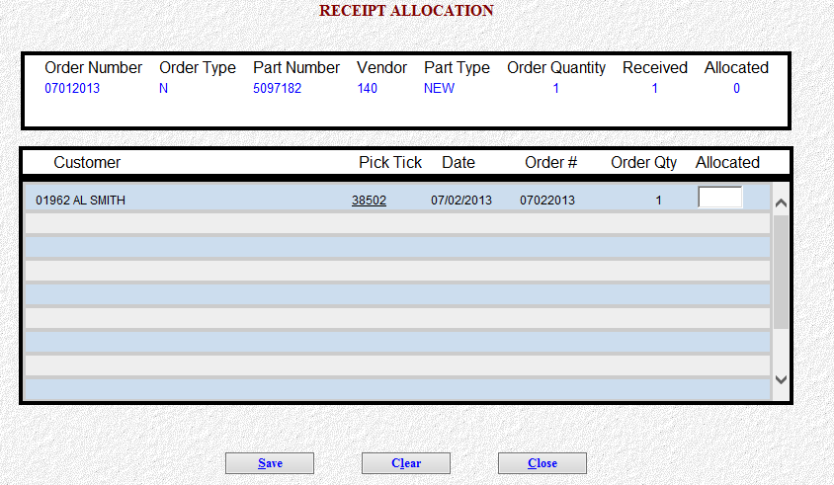

You also have the ability to close the receipt allocation screen, leaving the customer back order open and placing all received parts into stock.

The Quick Receipts printout will identify what picking ticket your stock order was allocated for.

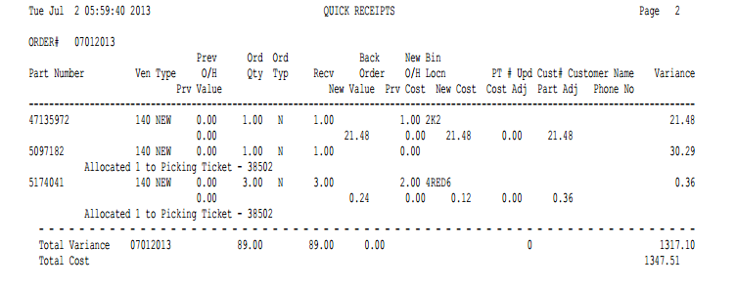

Find (Alt F): Press this button to find a part number in the order.

Save/Print (Alt S): This choice will save changes to the order and creates a proof sheet.

Quit/No Save (Alt Q): This choice discards any changes made to the order.

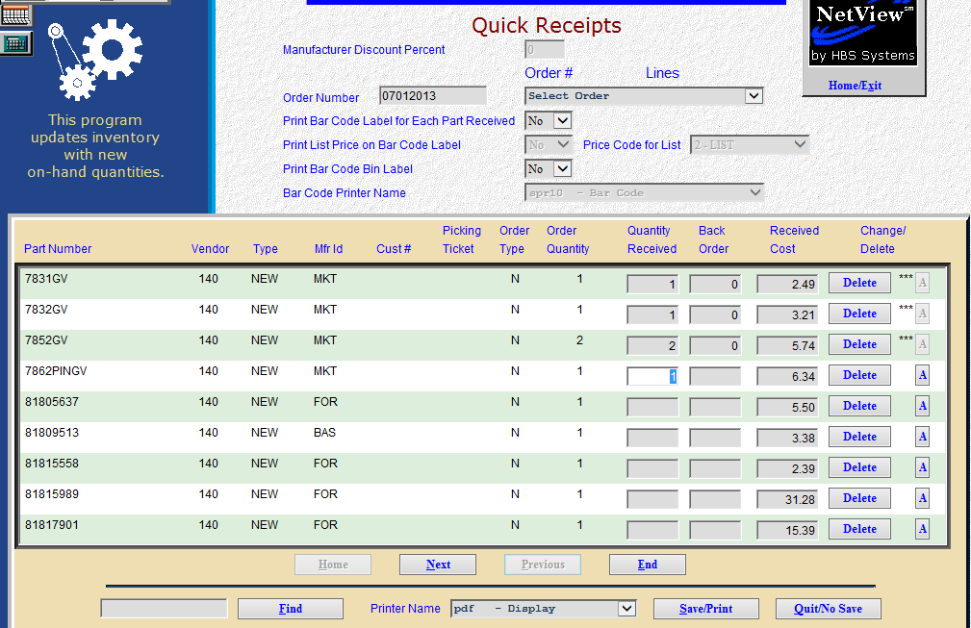

Change/Delete: This field records a quantity change made to the order when it is receipted.

If the quantity you receive is higher or lower than the order quantity or if you move the current on order quantity to backorder, a *** will display here, and appear on the printout of the receipted order.

If the quantity received and backordered is zero, or if you press the “Delete” key in either the Quantity Received or Back Order field, the Change/Delete field will display “DELETED” here.

A message “Order Qty Canceled” will appear on the printout each time you zero out or remove a part number from the order.

Report Detail: After you have made all appropriate entries to the Quick Receipts Screen, you may select a printer and press the “Save/Print” (Alt S) button. The results are printed on this report.

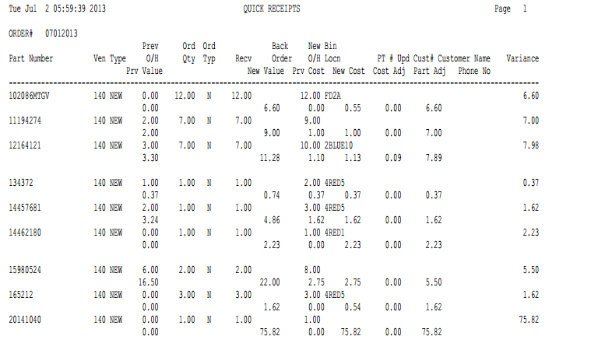

Order#: This is the order that was receipted in.

Part Number: This is the part number that was ordered.

Ven: Here you will find the vendor number associated with this part number.

Type: This field lists the part type from the part master. This could be:

N=New

U=Used

C=Core

R=Reman

M=Memo

Prev O/H: Previous on hand is the quantity of the part number that was on hand before the order was receipted.

Ord Qty: The order quantity is the quantity ordered on this order.

Ord Typ: This field shows the type of order. This could be:

N=New

C=Customer

B=Backorder

E=Emergency

Recv: Received is the quantity of this part number that was receipted on this order.

Back Order: Here you will find the quantity of this part number that is still outstanding on this order.

New O/H: The new on hand is the amount that you now have after receipting the order.

Bin Locn: This is the primary bin location of this part number.

PT #: If this part was placed on back order for a customer, this shows the picking ticket number it was ordered on.

Upd: A * in this field means the picking ticket for a customer order was updated.

Cust #: If this part was placed on back order for a customer, this is shows the customer number that was referenced on the order.

Cust Name: This shows the customer name for a customer back order.

Phone No: This is the phone number of the customer who ordered the parts.

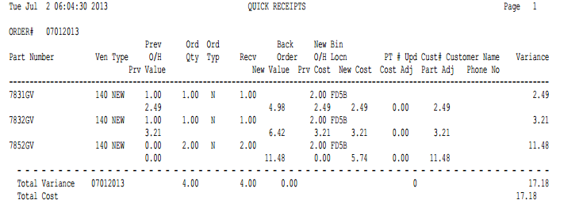

Ext Cost: The extended cost is the quantity receipted times the part cost from the part master.

Totals for Order: Here you will find the totals for the following:

Quantity ordered

Quantity received

Number of picking tickets updated with the receipted order

Extended cost

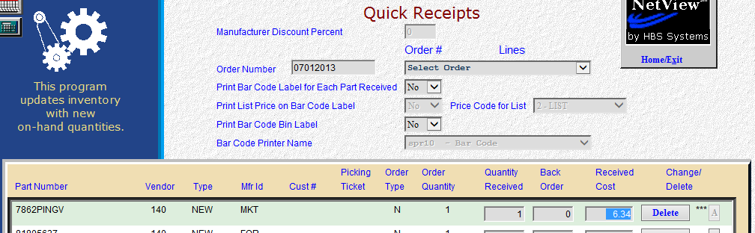

Average Cost fields

Manufacturer Discount Percent: This field is active when Average Costing is in effect. In this case you can put in a discount percentage that applies to the order being receipted. The discount is applied to each line’s cost and reduces it by the percentage indicated. The system will use this in recalculating the average cost for each affected part number.

Received Cost: This field is available when Average Costing is in effect. Here you fill in the cost of the items being received if it differs from the one shown. The system will use this in recalculating the average cost for each affected part number.

