Quick Returns (QRET)

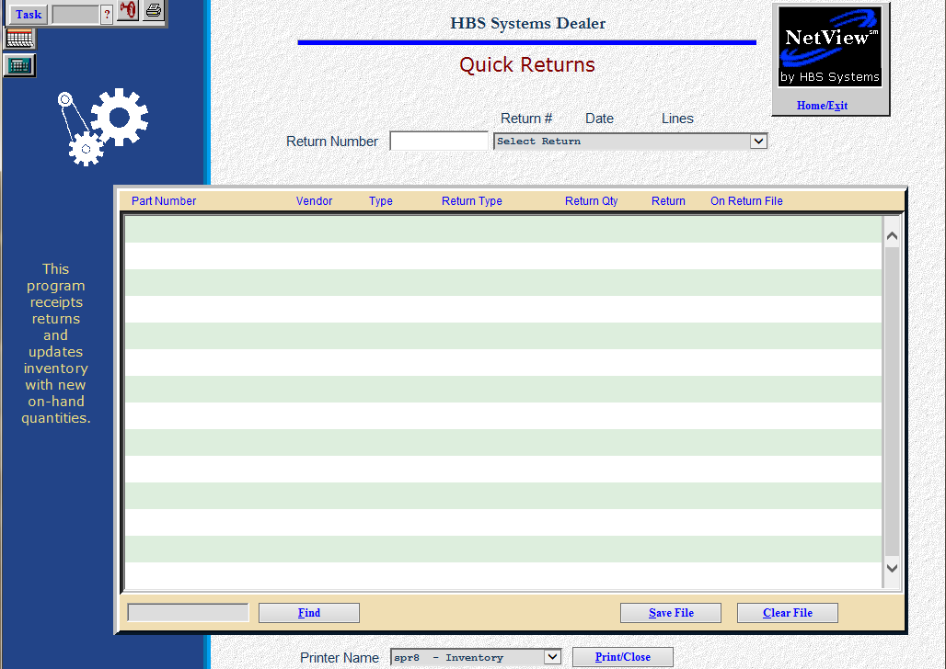

Quick Returns (QRET) lets you make quick adjustments to any outstanding Return and then receipt/record it.

- To access this function, you can either:
  - Select “Inventory” from the menu. Choose the “Returns” submenu and click “Quick Returns.”
  - Type “QRET” in the Shortcuts Bar.

Field Definitions

Return Number: Enter the requested Return Number here. You can either select a return number from the drop-down menu or type in one.

Return: This is the quantity that has been selected for return. You can press “Enter” to accept this amount or enter a different quantity as needed.

On Return File: If you enter a quantity other than the original quantity, this field displays the quantity that is left open on the return. This means this return will remain active until either all the quantities have been selected for return or the return is cancelled. You may also clear this difference out if the return is completed and does not need to stay active.

Delete/Restore: Press this key to remove the line from the Return. When it shows “Restore,” you may click on it again to put it back on the Return.

Find (Alt F): This tool is useful if you have a large return and you want to find a specific part within the return. Type the part number into this field and it will be highlighted.

Save File (Alt S): Pressing this button will save the changes to the current return.

Clear File (Alt C): This button clears the screen.

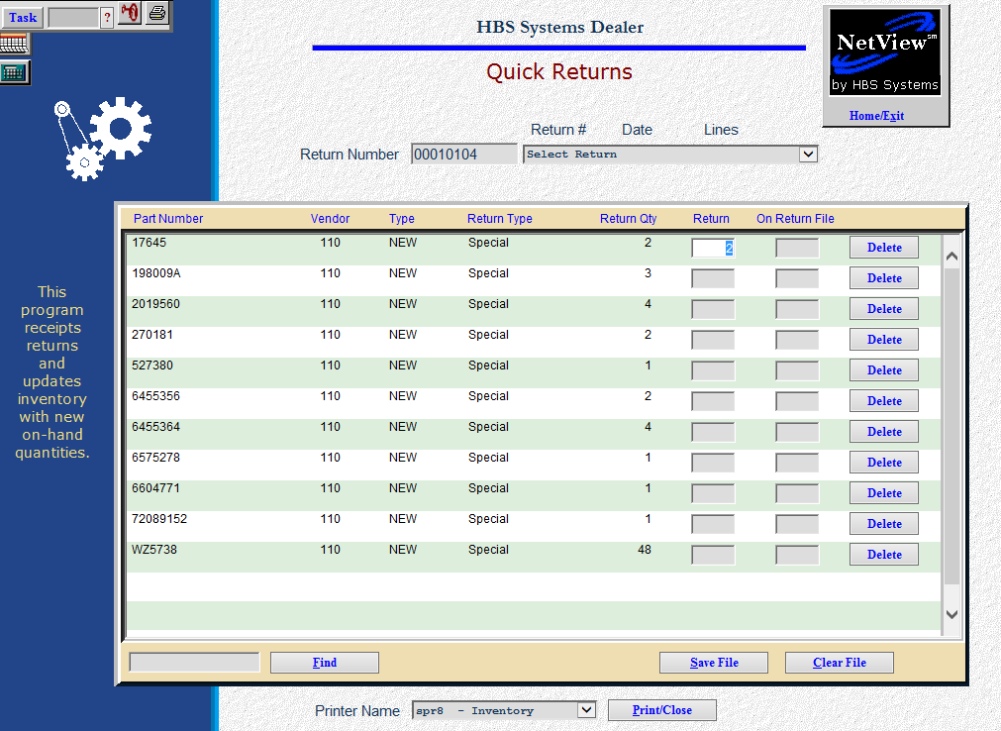

QRET displays the following information about the Return Number selected:

Part Number: This is the Part Number on the return.

Vendor: Here you will find the Vendor Number for the part number listed.

Type: This is the part Type for the part number:

New

Used

Reman

Core

Memo

Return Type: This field shows the Return Type:

Annual

Closeout

Special

Dealer Trade

Return: This is the Quantity that has been selected to be returned.

Quick Returns Tips

Record Total Quantity of Part Number Returned: When you are recording the full return quantity of the part number on the line where the cursor is positioned, simply press “Enter” at the Return column to acknowledge the return of the entire quantity.

Record Partial Quantity of Part Number Returned: When you record a partial or different quantity of the part number on the line where the cursor is, enter the returned quantity in the Return column and press “Enter.” The system will place the difference in the On Return File column. NOTE: If you need to permanently change the Return quantity, you will need to zero any amount placed in the On Return column by the system. Any amounts left in this column will remain on this return.

No Quantity Returned, Cancel the Return for this Item: When none of the returned quantity will be sent back and you do not want to keep this item on the return, enter “0” in the Return column and “0” in the On Return File column.

No Quantity Returned, Leave Remaining Quantity on the Return: When none of the returned quantity has been sent back, but will be in the future, you may enter “0” in the Return column and the system will put the entire return quantity in the On Ret File column. This means that this item will remain on the Return until some time in the future.

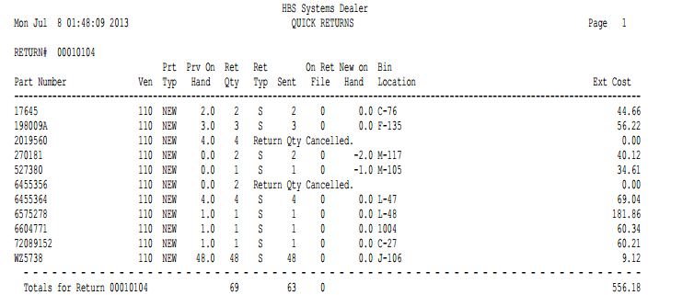

Quick Returns Report

Part Number: This column lists the Part Number.

Ven: This column lists the Vendor Number.

Prt Typ: This column lists the Part Type:

New

Used

Reman

Core

Memo

Prv On Hand: This column lists the quantity on hand prior to this return receipt.

Ret Qty: This column lists the original Return Quantity.

Ret Typ: This column lists the Return Type:

A=Annual

S=Special

C=Close Out

T=Dealer Trade

Sent: This column lists the amount returned (quantity sent back).

On Ret File: This column lists the remaining quantity still pending on the return for this part.

New On Hand: This column lists the quantity on hand after this return receipt.

Bin Location: This column lists the Primary Bin Location of the part.

Ext Cost: This column lists the extended cost for the items returned (returned quantity x individual item cost).

