Rental Class Maintenance (RCM)

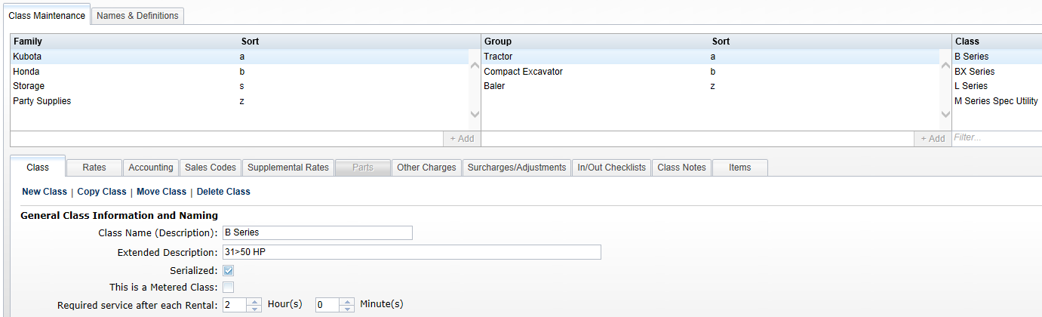

This maintenance screen houses two types of information: definitions of the Family/Group/Class structure, and Names & Definitions for various components within the Rental system. These definitions are grouped together in tabs for easier navigation.

To access this function, you can either:

- Select “Rental” from the menu and click on “Rental Class Maintenance.”
- Type “RCM” in the Shortcuts Bar.

NOTE: If you are a multi-store dealership with a Consolidated location, the majority of this screen will only be available in the Consolidated location (exceptions will be noted).

Names and Definitions: This section defines the names for Rate Types and Supplemental Types, plus the Other Charges and Surcharges/Adjustments, that can be used in any Family/Group/Class structure you create.

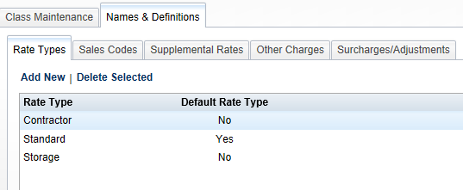

Rate Types: This list identifies the different rates types you will use in the Rental System. There can be many or few here, depending on how your business in structured. For example, you may have just two rates: Standard and Preferred. Other businesses may have many variations: Standard, Walk-In, Contractor, Preferred, Long Term, Special, etc.

Edit an existing rate: Simply double-click on the Rate Type name or Default Setting. Make your changes, and when you leave that field, the changes are saved.

Delete an existing rate: Highlight the desired choice and click on Delete Selected to remove it.

Add a new rate: Click on Add New to display this entry box.

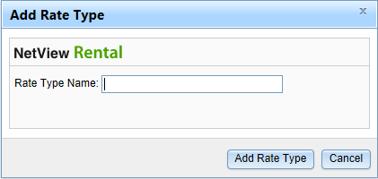

Type in the name for the Rate Type and click on the Add Rate Type button. Once it has been added, you can identify it as the default rate if necessary by clicking on that column of your new rate.

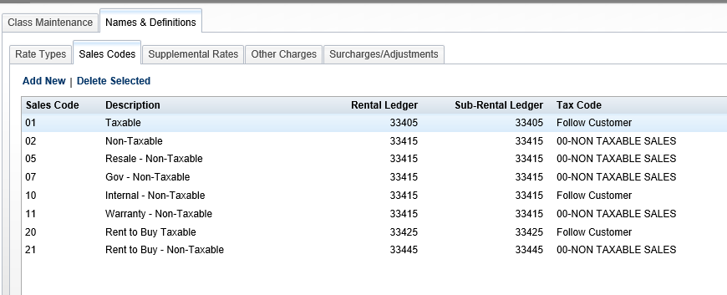

Sales Codes: This tab lists all Sales Code references available for Rental.

Add New Sales Code: Click Add New to create a new Sales Code reference.

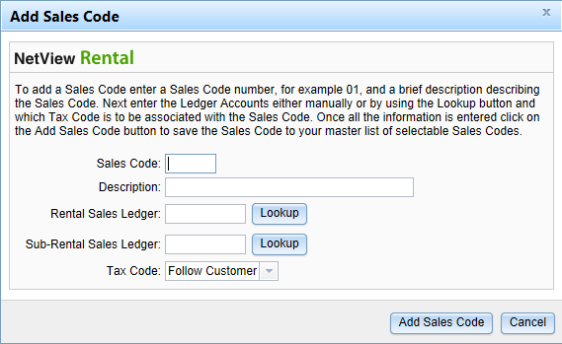

Sales Code: Fill in the numeric Sales Code here. The sales codes need to represent the ones presently used on customers in Enter Customer Information (ECI). Some typical ones might include 01-Customer Rental Taxable, 02-Customer Rental Non-Taxable, 07-Govt Rental Non-Taxable, and 10-Internal Rental Non-Taxable.

Description: Fill in a description of the Sales Code.

Rental Sales Ledger: Identify the G/L account when the Rental Income should go. Type in the account number or use the lookup button to find it.

Sub Rental Sales Ledger: Identify the G/L account when the Sub Rental Income should go. A Sub Rental is a replacement unit from an outside source. Type in the account number or use the lookup button to find it.

Tax Code: This field lets you set how the sales tax on the class can be handled.

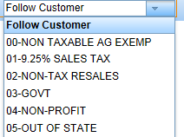

Choose Follow Customer if the tax on the rental will follow the customer’s tax status. Otherwise, choose a tax code from the drop-down menu to set its taxable nature.

Click on “Add Sales Code” to add the record.

Edit an existing Sales Code: You may double click on the entry in any column except Sales Code to change the value in that field.

Delete an existing Sales Code: Highlight the sales to be deleted and click on Delete Selected to remove it.

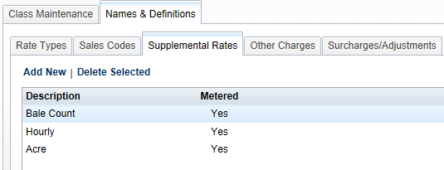

Supplemental Rates: This list identifies any additional rates you will use in Rental. Typically, these are rates that supplement or are in addition to the primary rental rate. For example, you might add supplemental rates for Bale Counts, Hour Meter, Acre Count, etc.

Edit a Supplemental Rate: To edit an existing rate, simply double-click on the Supplemental Description or Metered setting. Make your changes, and when you leave that field, the changes are saved.

Delete Selected: To delete a rate, highlight the desired choice and click on Delete Selected to remove it.

Add New: To add a new rate, click on Add New to display the entry box.

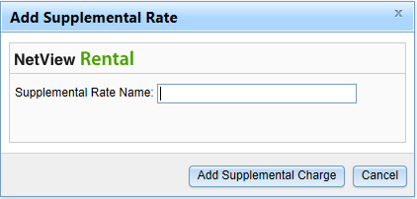

Type the name for the Supplemental Rate and click on the Add Supplemental button. Once it has been added, you can edit if it is metered by clicking on that column of your new supplemental rate.

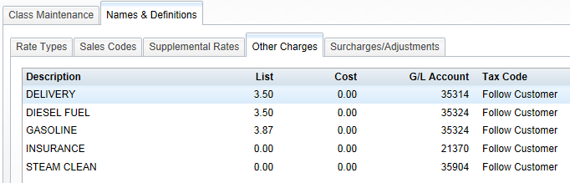

Other Charges: This list shows Other Charges that can be added to any of the Rental Classes. It reads from available entries tagged for Rental in Other Charge Maintenance (OCM). All the information—Description, List, Cost, G/L Account, and Tax Code—is read from OCM. For more details on how to add Other Charges to Rental, see “Rental Setup—OCM.”

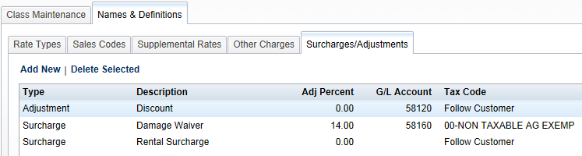

Surcharges/Adjustments: This section is used to define any percentage-based surcharges or adjustments to the rental contract. For example, you might add Adjustments for Discounts, Weather Delay, Maintenance, etc. The adjustments can add or deduct from the charges on the invoice based on a percentage of any portion of the items being billed. Likewise, the surcharge is percentage-based and is selectable by any portion of the items being billed. Examples of a surcharge would include Damage Waiver, Insurance, or a state-imposed Rental Surcharge.

Edit an existing adjustment or surcharge: Simply double-click on the field to be changed. Make your changes, and when you leave that field, the changes are saved.

Delete an adjustment or surcharge: Highlight the desired choice and click on Delete Selected to remove it.

Add a new adjustment or surcharge: Click on Add New to display the entry box.

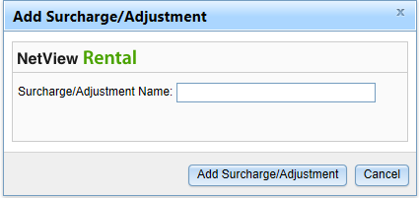

Type the name for the Surcharge/Adjustment and click on the Add Surcharge/Adjustment button. Once added to the main tab, you can fill in the remaining details using the entry fields in the columns.

Type: Double-click in this field to choose Surcharge or Adjustment.

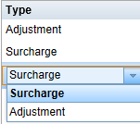

Description: Double-click in this field to edit the name for the surcharge/adjustment.

Adj Percent: Double-click in this field to enter the percentage (+ or -). You can leave it blank if it varies.

GL Account: Double-click in this field to enter or look-up the G/L account to receive this surcharge/adjustment.

Tax Code: This field lets you set how the sales tax on the surcharge/adjustment can be handled.

Choose Follow Customer if the tax on the surcharge/adjustment will follow the customer’s tax status. Otherwise, choose a tax code from the drop-down menu to set its taxable nature.

Rental Family/Group/Class structure: There are three layers of structure to organize your serialized and non-serialized rental units. Listed below are several examples of this structure to give you some ideas how they might work for you.

Example 1

Family Group Class
Ag Tractor 0-40 HP
Ag Tractor 41-59 HP
Ag Tractor 60-99 HP
Ag Tractor 100-139 HP
Ag Tractor 140+ HP
Ag Baler Square Baler
Ag Baler Round Baler
Construction Crawler Dozer
Construction Crawler Loader
Construction Crawler Crane
Construction Forklift Counterbalance
Construction Forklift Reach

Example 2

Family Group Class
Kubota Tractor B Series
Kubota Tractor BX Series
Kubota Tractor L Series
Honda Generator 100 HP
Honda Generator 100+ HP
NH Baler Round
NH Baler Square

Example 3

Family Group Class
Party Supplies Tents 20x20
Party Supplies Tents 30x20
Party Supplies Chairs Wood
Party Supplies Chairs Metal
L&G Handheld Chainsaw
L&G Handheld Edger
L&G Handheld Blower
L&G Mower Walkbehind
L&G Mower Riding

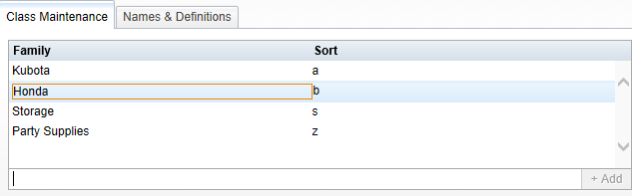

Class Maintenance – Family: Begin the structure by defining the Family. Type the Family Name on the blank line provided below the listed names and click the +Add button on the right. The name you entered now shows in the left column. The Sort column gives you the ability to have the Family Names sort in an order other than alphabetical. Type in a character to choose its position in the desired sorting order.

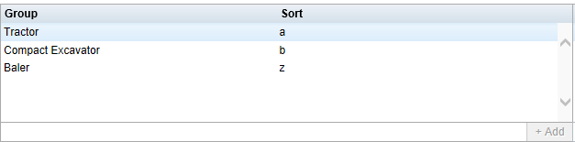

Class Maintenance – Group: The next step in the structure is the Group. Type the Group Name on the blank line provided below the listed names and click the +Add button on the right. The name you entered now shows in the left column. The Sort column gives you the ability to have the Group names sort in an order other than alphabetical. Type in a character to choose its position in the desired sorting order.

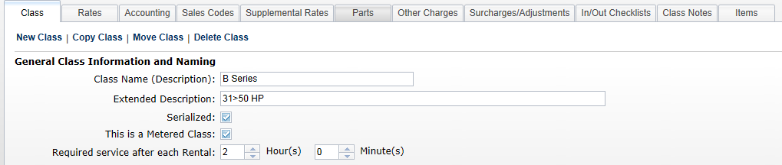

Class Maintenance – Class: The third and final layer in the structure is the Class. This definition holds all the specifics about that Class in Rental. Numerous tabs organize this information for each Class.

Class:

Add a Class: To create a new class, click the New Class button on the Class tab.

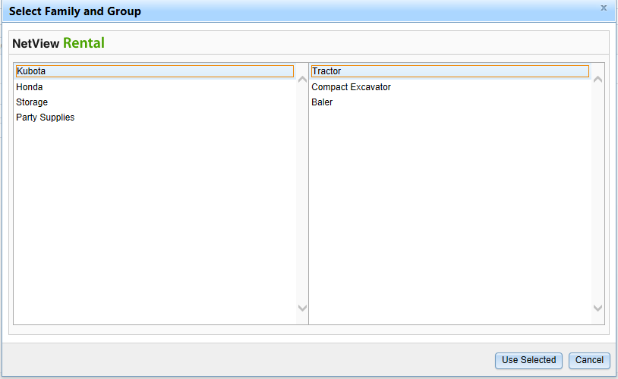

Click on the Family and Group where it belongs, and click the Use Selected button at the bottom of the box. After completing this selection, fill in the tab fields:

Class Name: Fill in the name in the Class Name field.

Extended Description: Use this area to provide further information about the Class.

Serialized: Check this box if the class holds serialized units. Uncheck the box if the class holds non-serialized Rental parts. NOTE: If the class can have a meter, it will automatically be marked as serialized, and you will be unable to uncheck the box.

This is a Metered Class: Check this box when the class has a meter. The meter may or may not be used to determine the rental rate.

Require Service: These two fields can be used to indicate that the unit needs to be in the shop when it returns from a rental. Use the Hours and Minutes settings to indicate how long it needs to be there.

Copy Class: Select the Class from within the group and family it belongs to, and click on Copy Class.

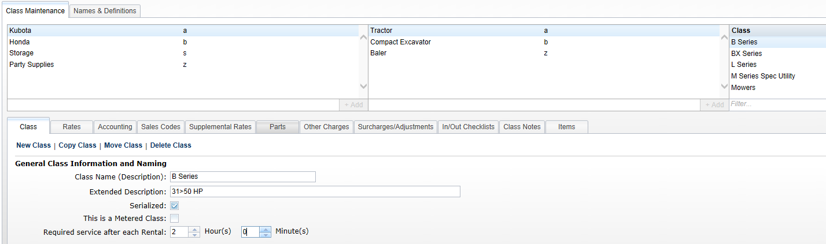

Then verify where it will be place from the Family and Groups shown.

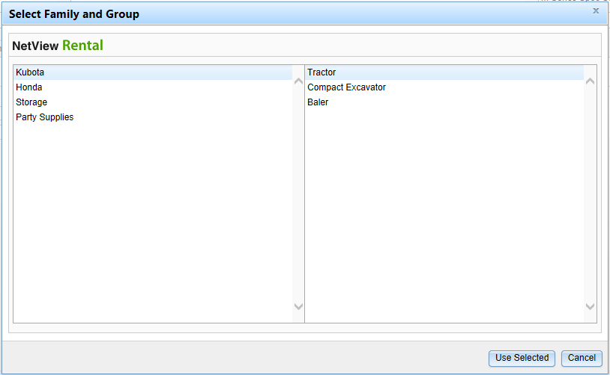

Click on Use Selected and a copy of the selected class is created.

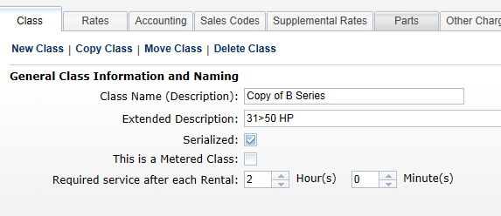

The process copies all associated information from all tabs of the copied class. Change the Class Name of the copy to the name of the new class and then adjust settings in the tabs as needed.

Move Class: Identify the class to move by highlighting it.

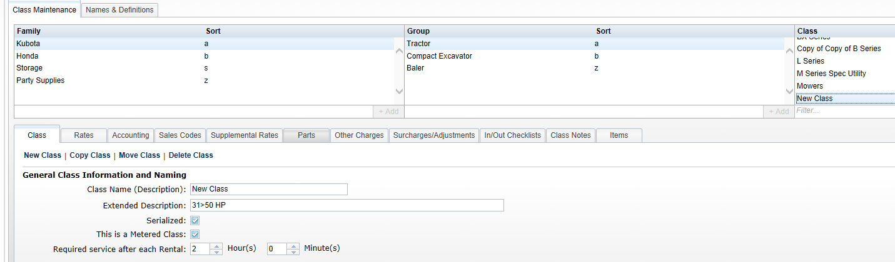

Click on Move Class to initiate the process.

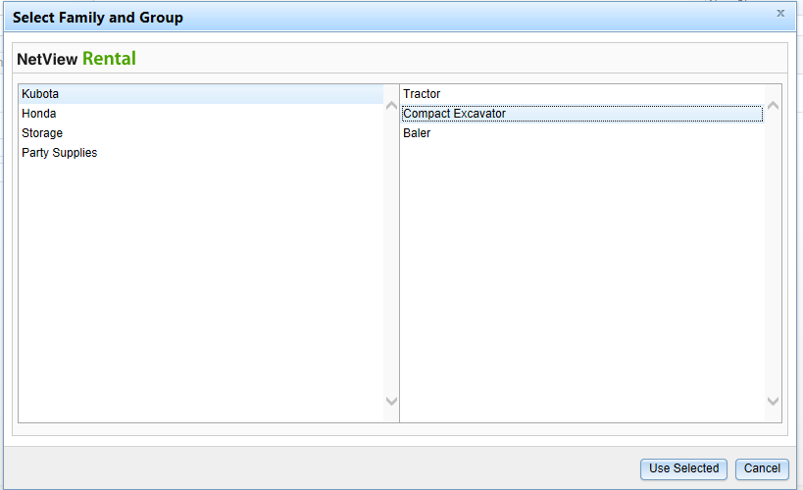

Choose the new place for the class from the list of Family and Group definitions. Click Use Selected to move the class to its new home.

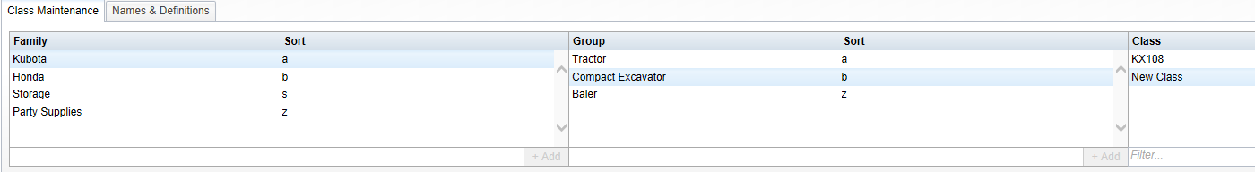

Delete Class: Highlight the class to be deleted. Click on Delete Class.

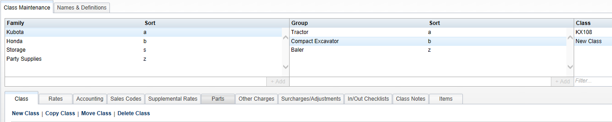

Confirm that you want to delete the class.

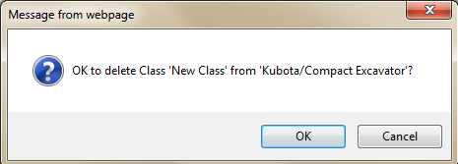

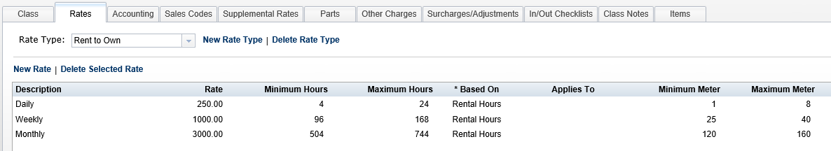

Rates: This tab holds the rates for the different rental periods.

Rate Type: This drop-down menu shows all the rate types currently selected for this class.

To add a rate type, click on New Rate Type, choose one from the list, and click on Add Selected. This list is generated from the selections added in the Names and Definitions section.

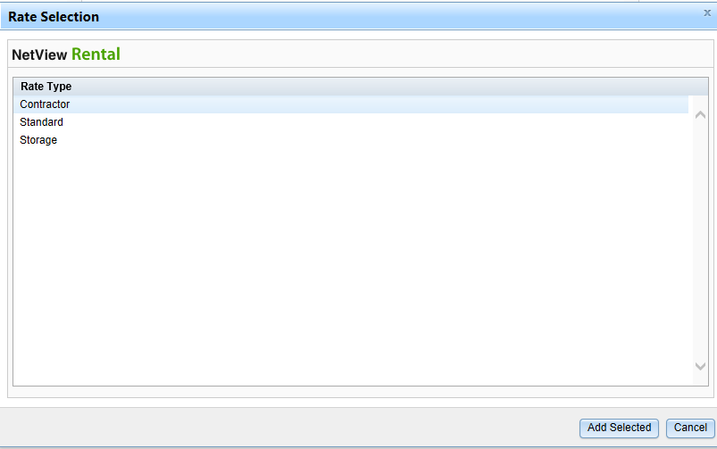

To delete a rate type, click on the type in the main list and then click Delete Selected Rate Type to remove it from this class.

Add a Rate: Click on New Rate to add one.

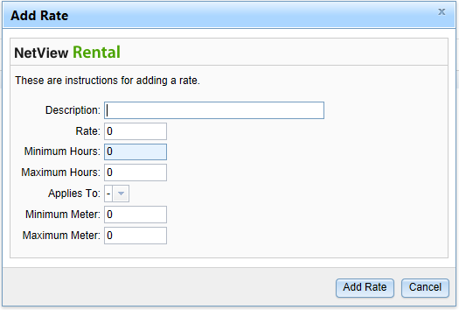

- Description: Fill in the description of the rate.
- Rate: Fill in the rate for this record.
- Minimum Hours/Maximum Hours: Enter the minimum and maximum hours for this rate. For an hourly rate, the minimum and maximum would be 1. For others, the fields would hold a range of numbers.
- Applies to: If the rate applies to a specific day of the week, choose it from the drop-down menu.
- Minimum Meter/Maximum Meter: Enter the minimum and maximum meter for this rate, if applicable. These fields might be used for a metered rental rate.

Click “Add Rate” to save the info.

Edit Selected Rate: Click on a rate and then double-click any field in the entry to edit it. Note that this is how you set whether the rate is based on Rental Hours or Calendar Month.

NOTE: Please select Calendar Month only for monthly rates and only for rates that require a true calendar month. Select Rental Hours for all others.

Delete Selected Rate: Click on a rate and then click Delete Selected Rate to remove it from this class/rate type.

Rate Examples:

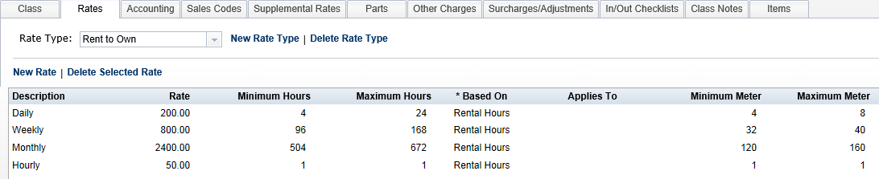

This setup example is for when the meter determines the rate.

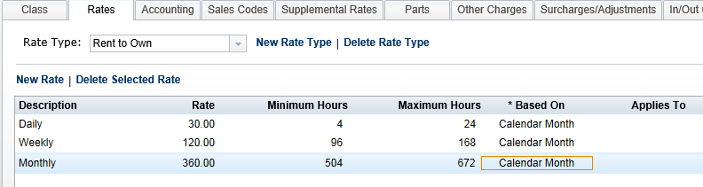

This setup example is for a rate is based on a calendar month billing, i.e. storage buildings, rental properties, etc.

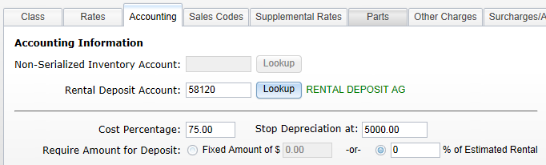

Accounting Information: This tab holds information about some accounting preferences for the tab. NOTE: All fields in this tab will be disabled unless a class is selected at the top of the screen.

Non-Serialized Inventory Account: This field holds the G/L account number for any non-serialized items in this class. These are items that will be rented from Parts, so it is likely that the account number will be in the 14xxx series. You can type in the account number or press the Lookup button to search for it. NOTE: If the class is serialized, this lookup will be disabled.

Rental Deposit Account: This field identifies the G/L account where deposits will be placed for units/items in this rental class. You can type in the account number or press the Lookup button to search for it.

Cost Percentage: This field is used for depreciation based on the amount of rental income for serialized units. When a percentage is entered here, it is factored against the rental income billed on the invoice and that percentage becomes the “cost” of the transaction. The Journal entry that is created with this percentage will debit (+) the cost of sale and credit (-) the inventory of the serialized unit.

Stop Depreciation at: This field holds a stopping point for depreciation on serialized units. The system will continue to apply the credits of depreciation against the rental unit until it reaches the amount entered here. For example, if 1.00 is placed in this field, the system calculates and applies depreciation credits based on the amount of rental income until the value of the unit reaches the amount shown.

Require Amount for Deposit: A required deposit can be defined as a fixed amount or as a percentage of the estimated rental. Choose the appropriate setting, and enter either a fixed amount or the percentage to calculate the deposit amount.

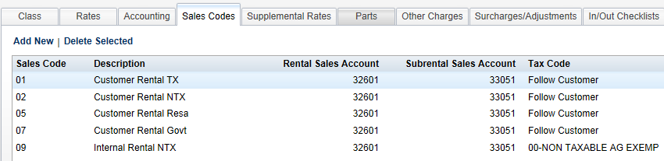

Sales Codes: This tab maintains the Sales Codes associated with the Rental Class.

Add a New Sales Code: Click Add New to create a new Sales Code reference.

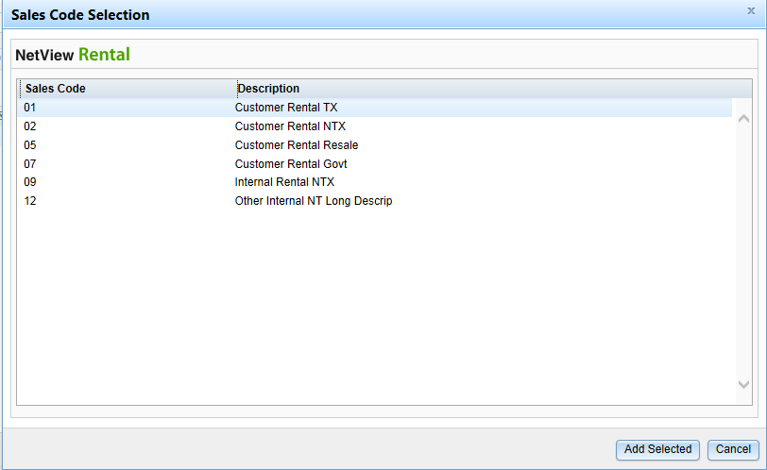

Highlight the Sales Code and click Add Selected to add it to this class.

Delete a Sales Code: Highlight the Sales Code and click Delete Selected to remove that sales code from this class.

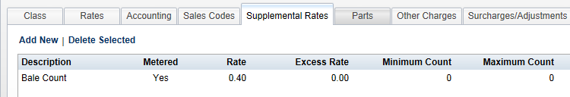

Supplemental Rates: This tab lists any supplemental rates for the class, in addition to the rental rate.

Add New Supplemental Rate: To add a new rate, click Add New. Choose a rate from the list and click Add Selected. This list is generated from the selections added in the Names and Definitions section.

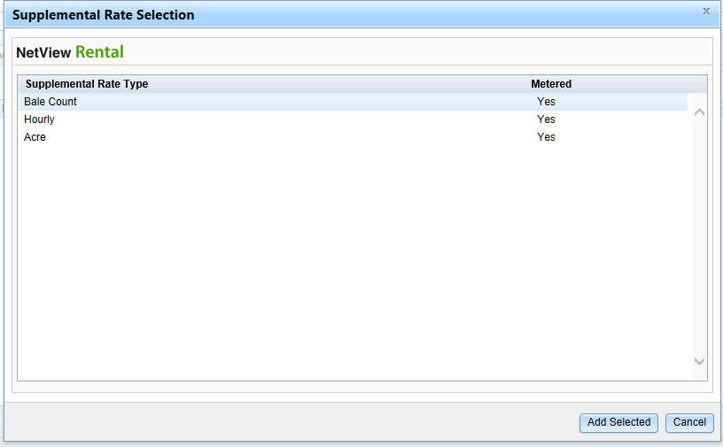

Delete Selected: Select a supplemental rate and click Delete Selected to remove it from the class.

Edit Existing Supplemental Rate: Select a rate and click in its fields (except Description and Metered) to edit them.

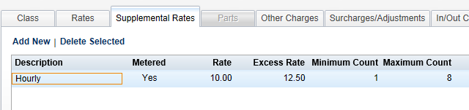

Rate: Enter the supplemental rate here. The value can hold numbers with 2 decimal places.

Excess Rate: Enter the excess rate here. This rate is used when a rental continues beyond the value in the Maximum Count.

Minimum Count/Maximum Count: If there is an excess rate, enter the minimum and maximum count for this supplemental rate. If the rental exceeds the maximum count, the excess rate is then charged on the rental.

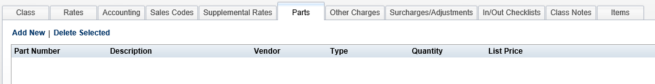

Parts: The Parts tab is available in each dealership location. For multi-location dealerships, the Parts tab is not accessible in the Consolidated location.

This tab holds information about any parts that need to be sold with a rental unit from this class. These can represent consumable items that are necessary for the use of this equipment (i.e. chainsaw oil, tie downs, chain, hitch ball, tent stakes, etc.)

Add a Part: Click on Add New.

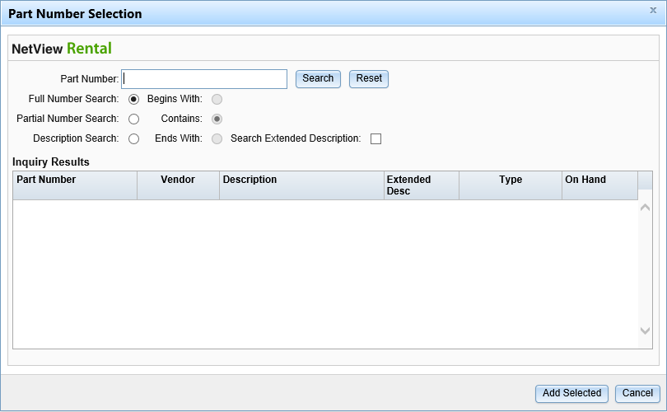

Part Number: Enter the full/partial part number or the full/partial part description here, depending on what search type you selected.

Full Number Search: Select this option to search for the part using its full part number.

Partial Number Search: Select this option to do a partial part number search. You must also choose which portion of the part number to search by:
  - Begins With
  - Contains
  - Ends With

Description Search: Click here to search by the part’s description. You must also choose which portion of the description to search by:
  - Begins With
  - Contains
  - Ends With
You can optionally search the Extended Description at the same time.

Click Search to view a list of matching results.

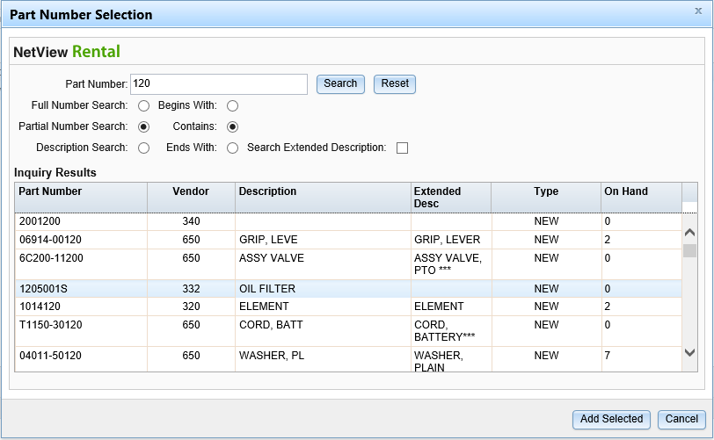

Select the desired part and click Add Selected to put it on the Parts list for this class.

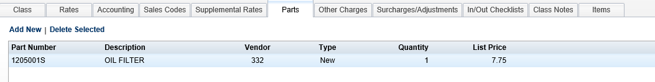

You may double-click on the Quantity field to change it as needed.

Delete Selected: Click on a part number and then click Delete Selected to remove it from this class.

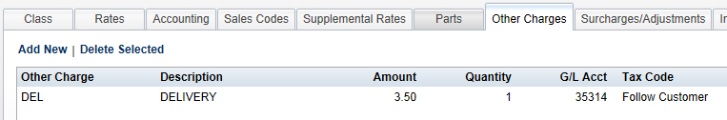

Other Charges: Use this section to include any Other Charges that belong to the rental class/rate type.

Add an Other Charge: Click on Add New to add an Other Charge that has been tagged for Rental.

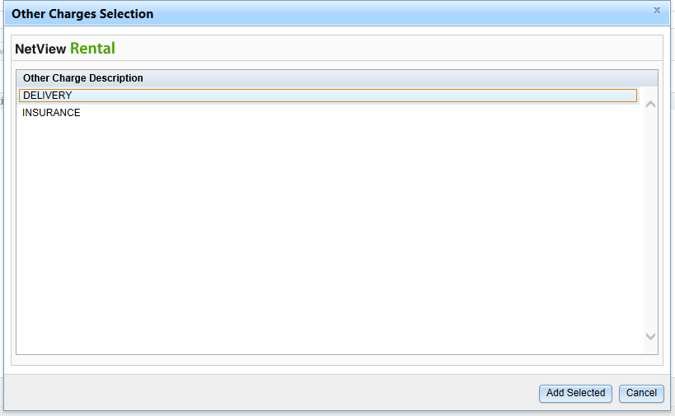

Highlight the other charge and click Add Selected.

Delete Selected: Click on a charge and then click Delete Selected to remove it from this class.

Edit Other Charges: You may edit the Description, Amount, Quantity, and Tax Code fields to adapt the Other Charge to the rental class.

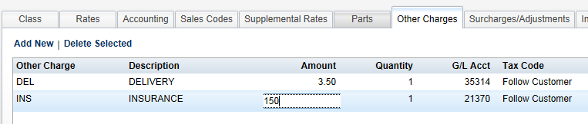

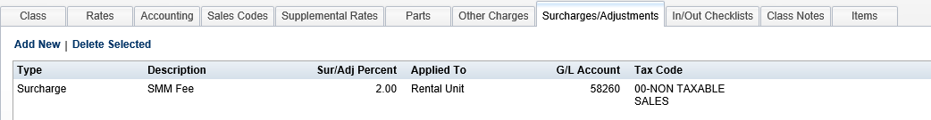

Surcharges/Adjustments: Use this section to include any Surcharges or Adjustments that are needed for this rental class.

Add a Surcharge or Adjustment: Click on Add New to add a Surcharge or Adjustment that has been tagged for Rental.

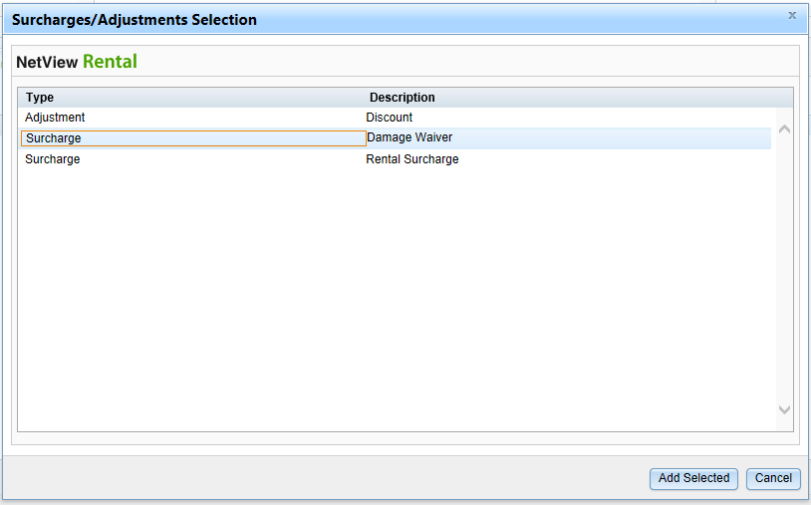

Highlight the Surcharge or Adjustment, and then click Add Selected.

Delete Selected: Click on a Surcharge or Adjustment, and then click Delete Selected to remove it from this class.

Edit Surcharges/Adjustments: You may edit the Description, Sur/Adj Percent, Applied to, GL Account, and Tax Code fields to adapt the Surcharge or Adjustment to the rental class.

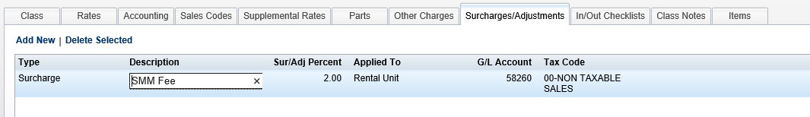

In particular, the Applied to Column let you specify which part of the rental invoices is subject to the percentage-based Surcharge or Adjustment. Double-click on the line field to view and select your options: Rental Item, All Parts, or All Other Charges.

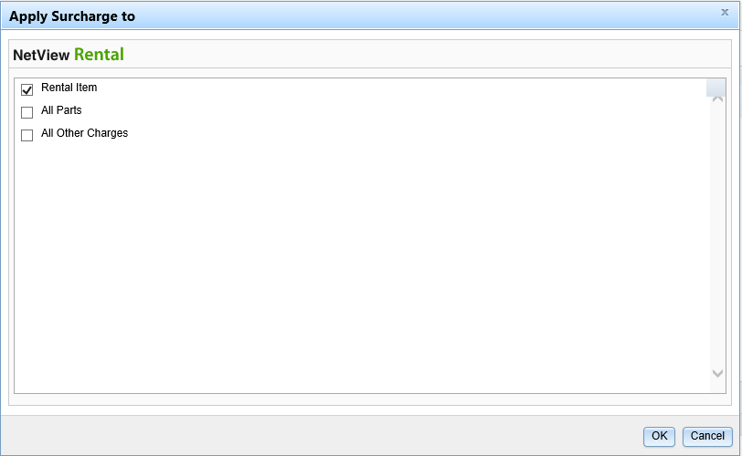

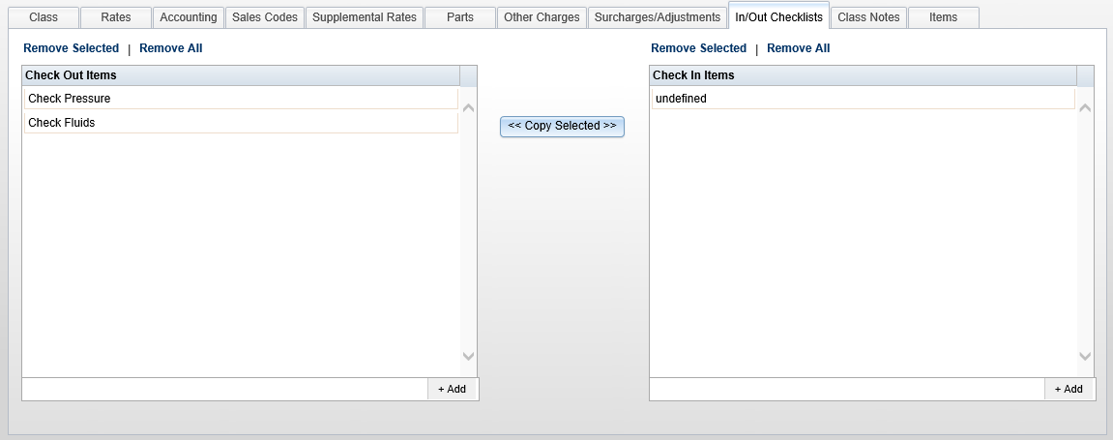

In/Out Checklists: This tab provides the option to create a list of tasks that need to be done when a rental unit belonging to the class is checked out, as well as a list for when the unit is checked back in.

Add Task: Add tasks to the lists using the entry field at the bottom of the list box. Simply type in the desired task and click the +Add button on the right. If you want the newly created task to be in different position on the list, click on it and hold the mouse button down while you drag it to the preferred position, then release the mouse to place it.

Remove Selected: Highlight one or more of the tasks on the Check Out or Check In list, and click Remove Selected to clear them from the list.

Remove All: Click Remove All to clear ALL items on the Check Out or Check In list.

Copy Selected:

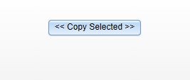

This button, shown between the Check Out List and the Check In List, allows you to copy items from one list to the other. Highlight the items on one list or the other and press the button to copy them to the other list.

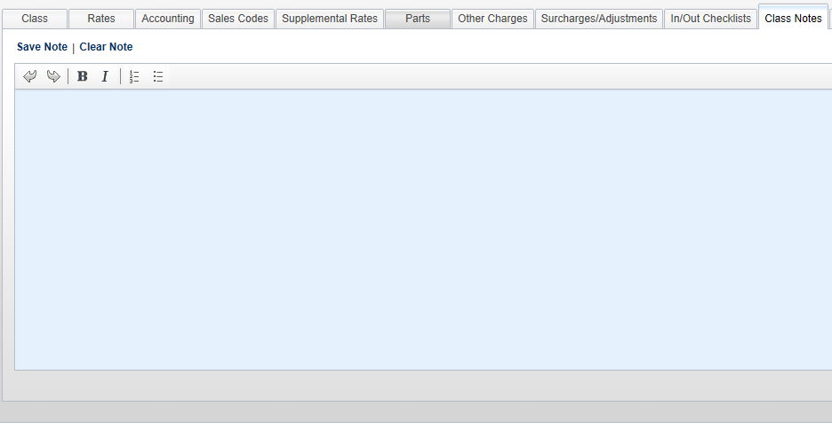

Class Notes: This section provides space to add notes to the rental class. These notes will appear on all class items. They could be maintenance items that the customer is responsible for, reminders about how some feature on the rental unit works, or other information to be shared with the customer. The toolbar on the top has buttons for Undo, Redo, Bold, Italic, Numbering, and Bullets.

Save Note: Click Save Note when all text has been entered for the Class Note.

Clear Note: Click Clear Note to remove all text in the Note tab.

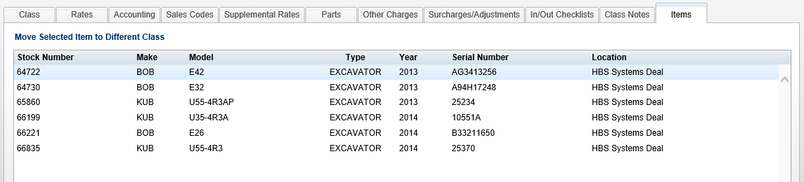

Items: This tab shows a list of the rental units that belong to this class. The information includes the stock number, make, model, type, year, serial number, and location. You can use the Move Selected Item to Different Class option to transfer the unit within RCM. NOTE: This tab active for editing in all location types (Consolidated and otherwise).

