Bank Reconciliation Transaction Maintenance (RCMN)

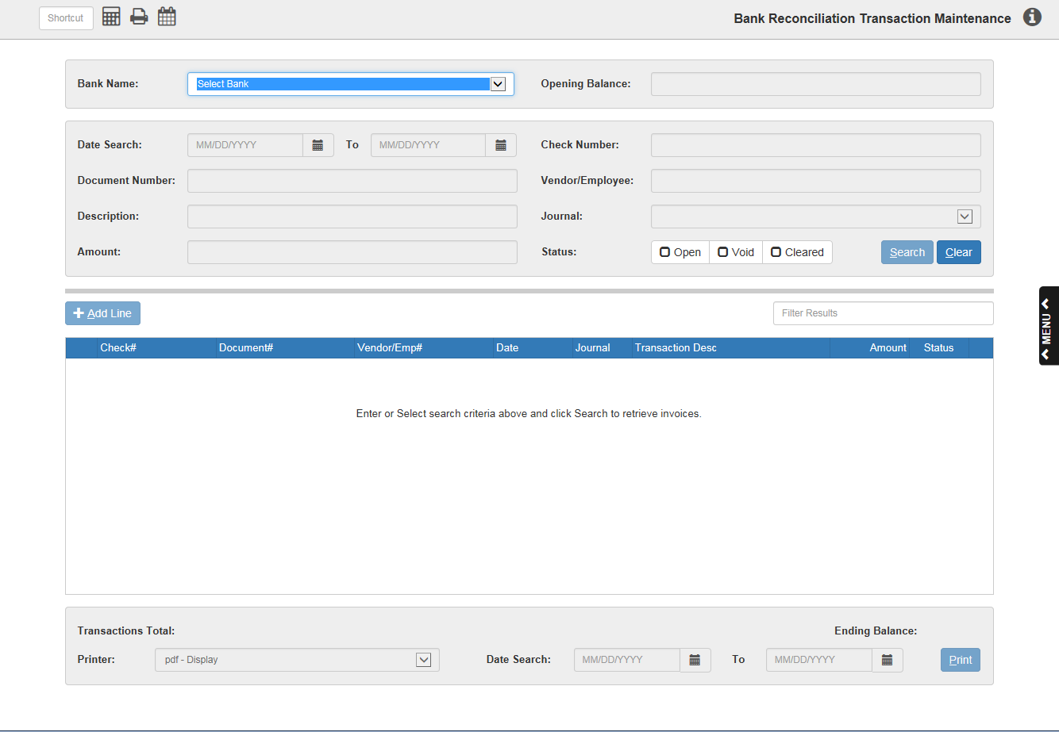

Bank Reconciliation Transaction Maintenance (RCMN) lets you, when accessing the Bank Reconciliation programs for the first time, “build” the outstanding transactions at the time of setup. Some dealers find it easier to set it up and wait 30 days or so to let the system collect the information for reconciliation to the next bank statement. There will likely be many less transactions to enter in this mode when the past month’s activities have been collecting here.

To access this function, you can either:

- Select “General Ledger” from the menu. Choose the “Bank Reconciliation” submenu and click “Transaction Maintenance.”
- Type “RCMN” in the Shortcuts Bar.

Bank Name: Select the Bank Identifier to maintain from the drop-down menu.

Opening Balance: This field is primarily for reference except during setup. You may press “Enter” past the amount shown here in most cases.

Transactions Total/Ending Balance: These fields show the total amount of the transactions and the ending balance of the transactions. Ideally, these two amounts are identical.

Search Fields:

Date Search: Use these 2 fields to search for transactions dated within a certain range of time. You can either:

- Enter the starting and ending dates in the fields.
- Select them using the Calendar icons next to each field.

Check Number: Use this field to search for transactions by check number. Type in the number you want and hit Search.

Document Number: Use this field to search for transactions by document number. Type in the number you want and hit Search.

Vendor/Employee: Use this field to search for transactions by vendor or employee. Type in the vendor/employee number and hit Search.

Description: Use this field to search for transactions by their description. Type in part or all of the description and hit Search. NOTE: The more complete the description you type in, the more likely you are to get the results you want. Typing in only a letter or two will yield a list of every transaction that includes that letter or letters in its description.

Journal: Use this field to search for transactions by their Journal type. Select the Journal you want from the drop-down menu and hit Search.

Amount: Use this field to search for transactions by their amount. Type in the amount desired and hit Search.

Status: Choose from these options to search for transactions by their status.

- Open means the check hasn’t cleared.
- Void means the check was voided.
- Cleared means the check has cleared.
- You can select up to all three statuses as search criteria.

Search: Click the “Search” button after entering search criteria to begin a search. The results will populate the Results Box below.

Clear: Click the “Clear” button to clear the page.

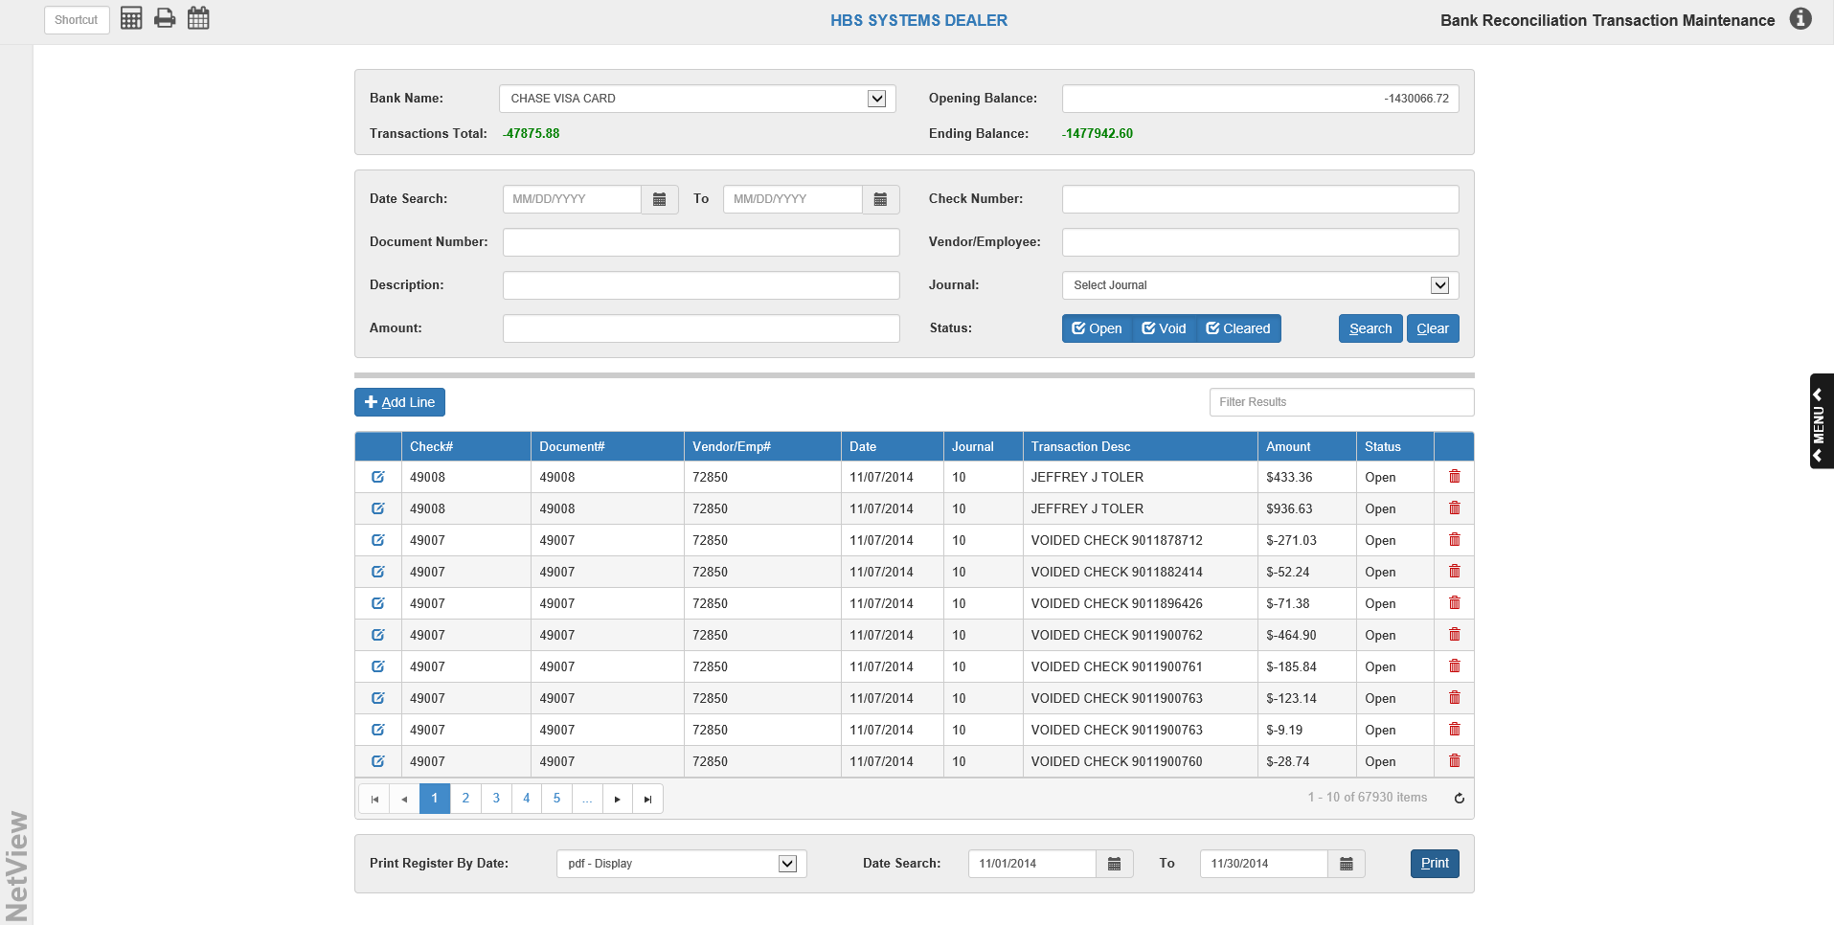

Results Box: The results of your search will populate this box.

Filter Results: Use the Filter Bar to filter the results of your search by entering in further information that may be displayed in one of the column headers. The results will filter even with partial information typed into the bar, like part of a name or half of a check number. See “Sortable Headers” below for descriptions of the columns.

Sortable Headers: Use the column headers to order the results differently in order to more easily find your desired result. The columns and their sorting methods are:

- Check#: Sorts in ascending or descending numeric order by check number.
- Document#: Sorts in ascending or descending numeric order by document number.
- Vendor/Emp#: Sorts in ascending or descending numeric order by vendor or employee number.
- Date: Sorts in chronological or reverse-chronological order by date.
- Journal: Sorts in ascending or descending numeric order by journal number.
- Transaction Desc: Sorts in alphabetic or reverse-alphabetic by the first letter of the description.
- Amount: Sorts in ascending or descending numeric order by the amount of the transaction.
- Status: Sorts in alphabetic (Cleared, Open, Void) or reverse-alphabetic (Void, Open, Cleared) order by status.

Add Line: You might add new transactions or outstanding entries as you are building the initial reconciliation data file. Click this button to bring up the Add Transaction box, where you can enter information about the new line. The line will be added to the Results Box after you save it.

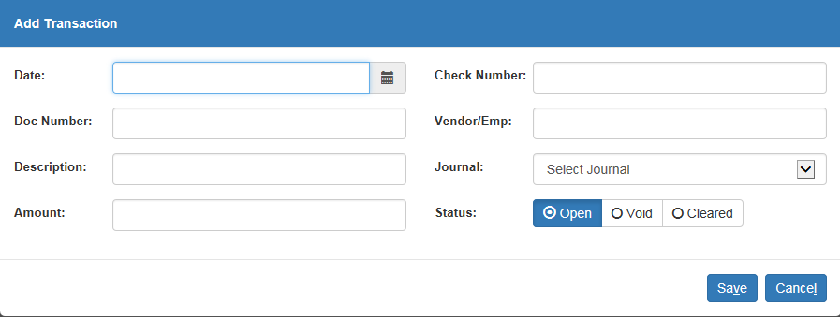

Date: Enter the date of the check or document entry. You can either:

Type a date in the field.

Select a date using the Calendar icon next to the field.

Check Number: Enter the check number or deposit reference. Be sure to use only the actual document number itself (i.e., "1550", not "CK 1550" or "#1550") when entering a new number.

Doc Number: Enter the check number or deposit reference in this field as well. When adding a new transaction, be sure to enter the number in this field and the Check Number field.

Vendor/Emp: Enter either an Accounts Payable vendor number or Payroll employee number, if appropriate. This field can also be left blank, as the information is optional when adding a transaction.

Description: Enter a brief description of the transaction, such as "Bank Deposit" or the name to which a check was written.

Journal: Enter the two-digit Journal Number. You may use any Journal for this field, but make sure you type BOTH digits of the number when adding a new transaction. The most common Journals used are:

10-Cash Disbursements

15-General and Standard Entries

13-Payroll Journal

08–Bank & Credit Card Deposits

Amount: Enter the amount of the transaction. If you are adding a credit to the account, be sure to type the minus sign ("-") before the dollar amount.

Status: Select the transaction’s status. When adding a new line, you can only select one status (as opposed to the Status search options).

Save: Click this button to save the new transaction.

Cancel: Click this button to cancel the new transaction.

Delete Line Icon: This icon appears in the last column of each line. Click on it if you want to delete that particular line. The following box will then appear:

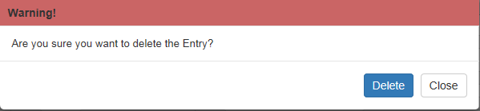

Click Delete to delete the line. If you decide you want to keep the line after all, click Close.

Edit Transaction Icon: This icon appears in the first column of each line. Click on it to bring up the Edit Transaction box, where you can edit the transaction as you wish.

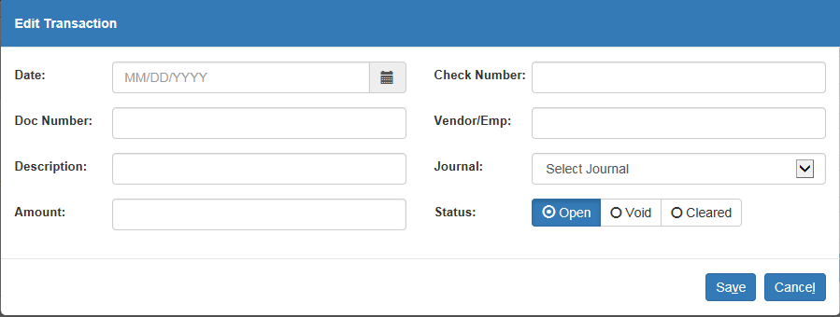

Print Register By Date: To print transactions, use this drop-down menu to select the type of printer you wish to use. If you want to preview the printout, select the pdf-Display printer.

Date Search: Enter beginning and ending dates for the printout into these fields. Any transactions made during those dates will appear on the printout. You can either:

- Type the dates in the fields.
- Select the dates using the Calendar icons next to each field.

Print: Click this button to print your selected transaction(s).

Detail Report Printout:

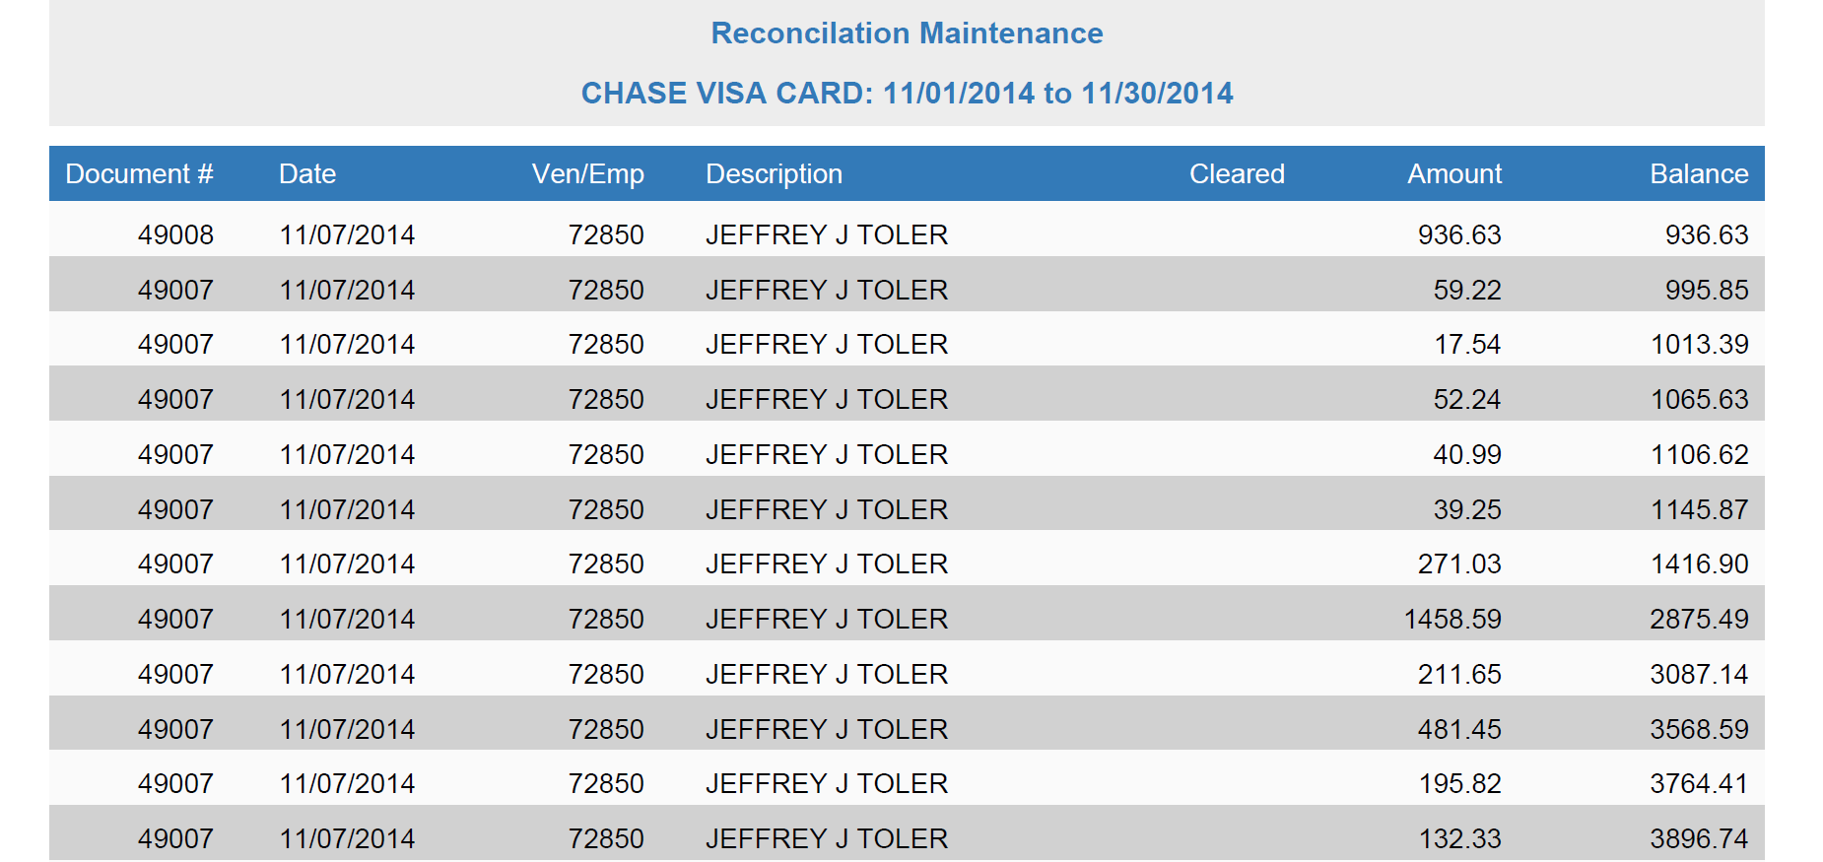

Document #: This column holds the check or document number entered for this transaction.

Date: This column holds the date of the transaction.

Ven/Emp: This column holds the vendor or employee number for the transaction, if applicable.

Description: This column holds the transaction description.

Cleared: This column shows the status of the check.

- If the column shows a V, then the document’s status is Void.
- If the column shows a Y, then the document’s status is Cleared.
- If the column is blank, then the status is Open.

Amount: This column shows the amount of the transaction.

Balance: This column shows the total report balance after the transaction line was added. For example, the amount shown in this column on the second line of the report is the transaction amount added to the balance from the first line.

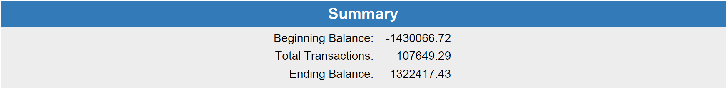

Summary: The Summary section prints at the end of the report. It shows the Beginning Balance amount for the bank account, the total amount of the transactions listed on the report, and the Ending Balance amount, which is the Beginning Balance plus the Total Transactions.

