Rental Conflict Report: The Rental Conflict Report in Rental Reports (RR) creates a list of Rental units being rented out that have conflicts within the time period covered by the report.

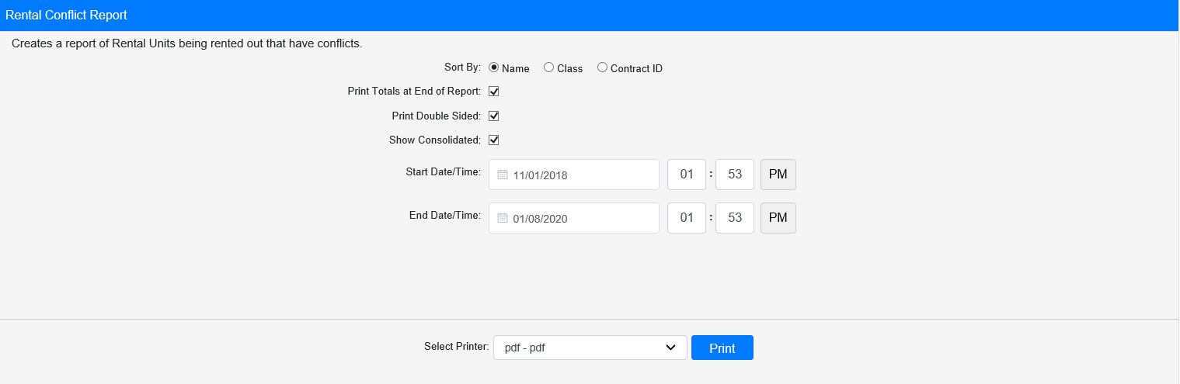

Field Definitions:

Sort By: Choose what to sort the report by:

- Name
- Class
- Contract ID

Print Totals at End of Report:

- Check this box to include a total count at the end of the report.
- Leave it unchecked to omit the totals.

Print Double Sided:

- Check this box to print the report pages double-sided.
- Leave it unchecked to print the report pages single-sided.

Show Consolidated: If you are a multi-location dealership with a Consolidated location, check this box to include the Consolidated location’s information on your report. Uncheck it to only print a report for your individual location. NOTE: If running the report in the Consolidated location, you must check this box to receive a report.

Start Date/Time: Select the start date/time for the report. All conflicts listed on the report occur at or after this point in time.

End Date/Time: Select the end date/time for the report. All conflicts listed on the report occur before or at this point in time.

Select Printer: Select the printer to receive the report. Use the pdf printer to preview the report.

Click “Print” to print the report.

Sample Report:

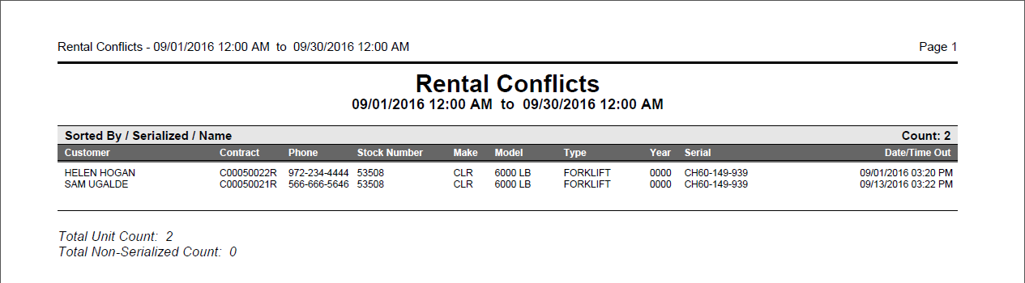

This example is sorted by Name. It lists the unit in conflict once for each customer who has it recorded on a contract, along with the relevant details concerning the rental.

If you chose to print Totals at the end of the report, you will see a total count for both the serialized and non-serialized units included on the report.

