Service Documents Pre-Journal (RDSS)

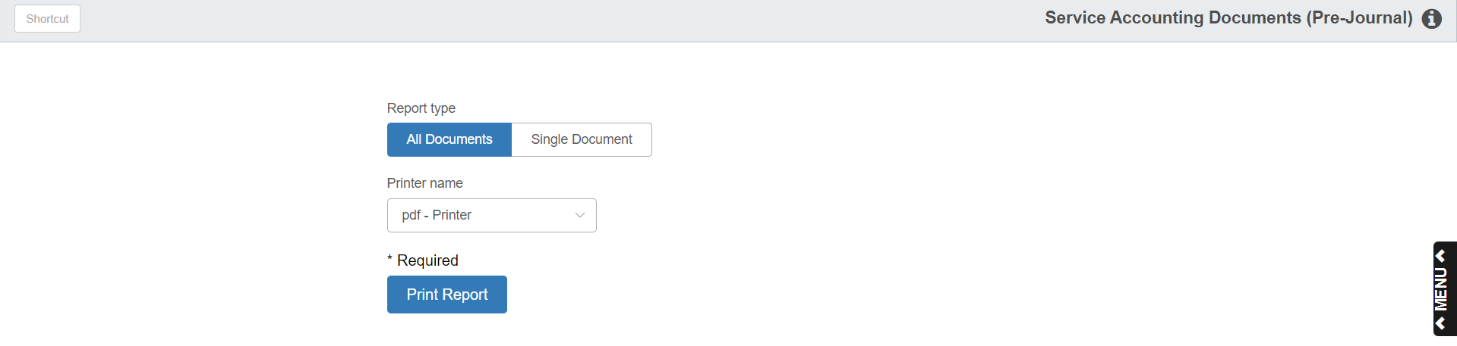

This program allows you to view and print a proof sheet of unposted service entries.

To access this function, type “RDSS” in the Shortcuts Bar.

Field Definitions:

Report Type: Choose whether to include All Documents on the report or just a Single Document.

Document Number: If you choose Single Document in the field above, this field activates. Type in the number of the document you want the report to focus on.

Printer Name: Select a printer with which to view/print the report. Use the pdf printer to view the document before printing it.

Print Report: Click this button to print the report.

Sample Report (All Documents)

