Rental Appendix A: Adjusting Quantity Billed

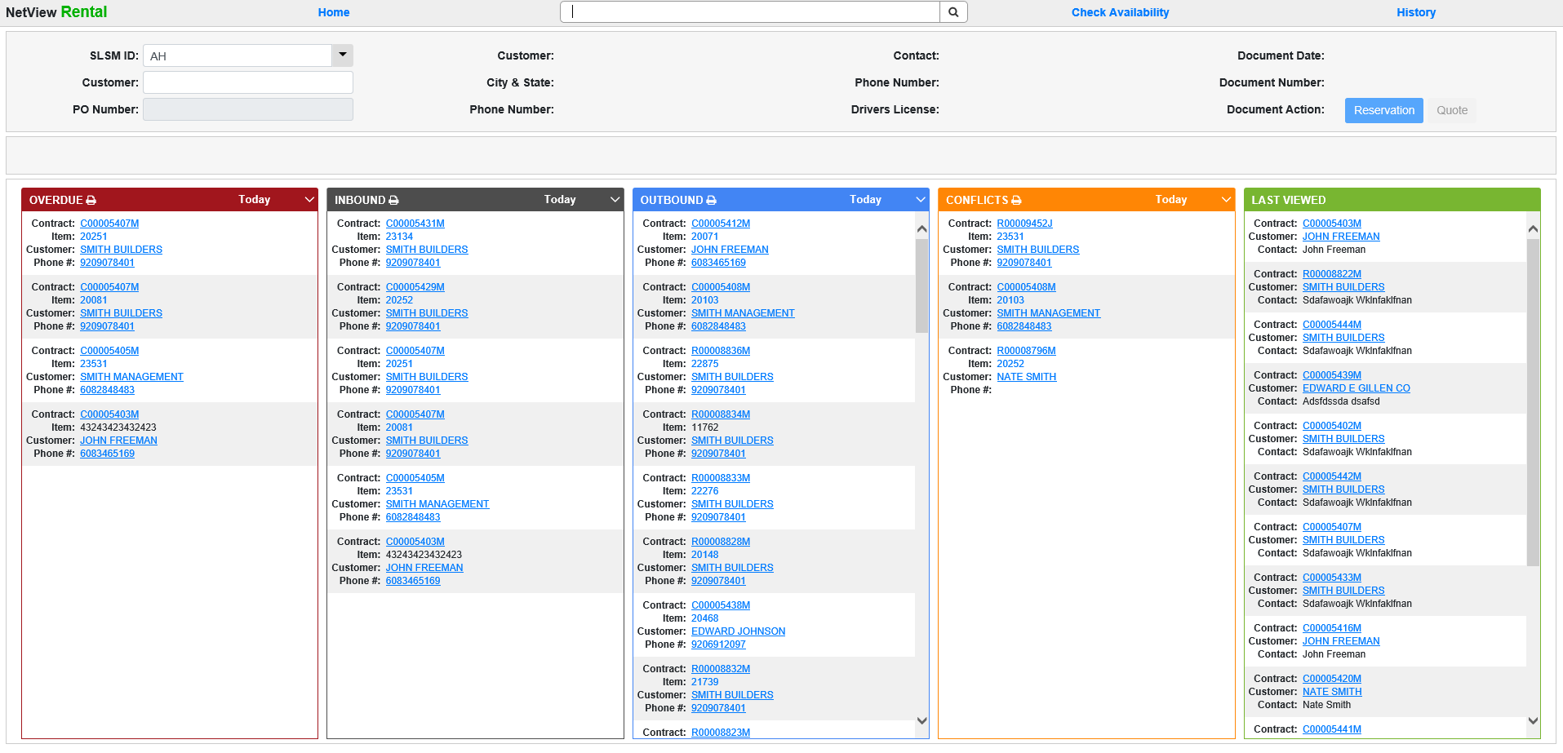

To adjust the quantity billed on a rental contract prior to the first invoice, open the contract segment in question and click on Rates.

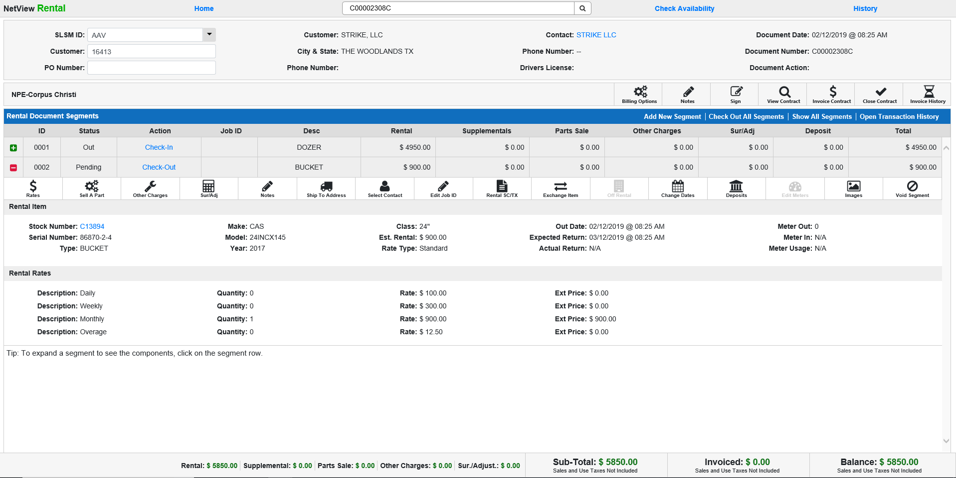

Change the quantity and then invoice the segment.

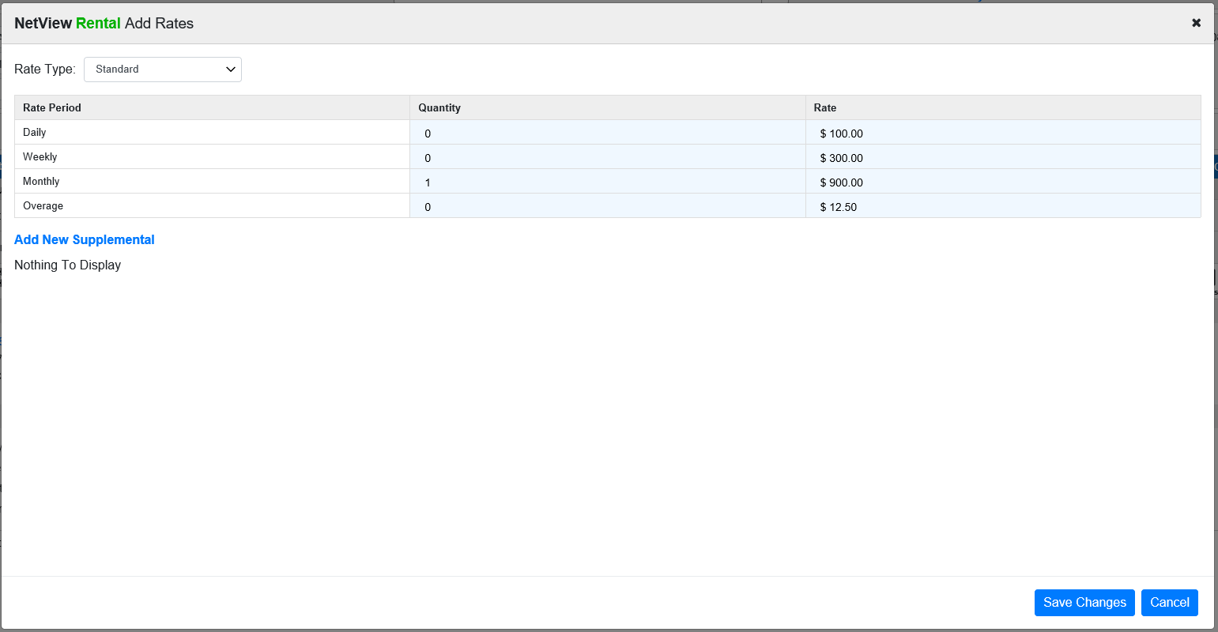

After the first invoice, adjust the quantity to generate a manual invoice (including after the unit has been returned).
Click on the Invoice Contract icon.

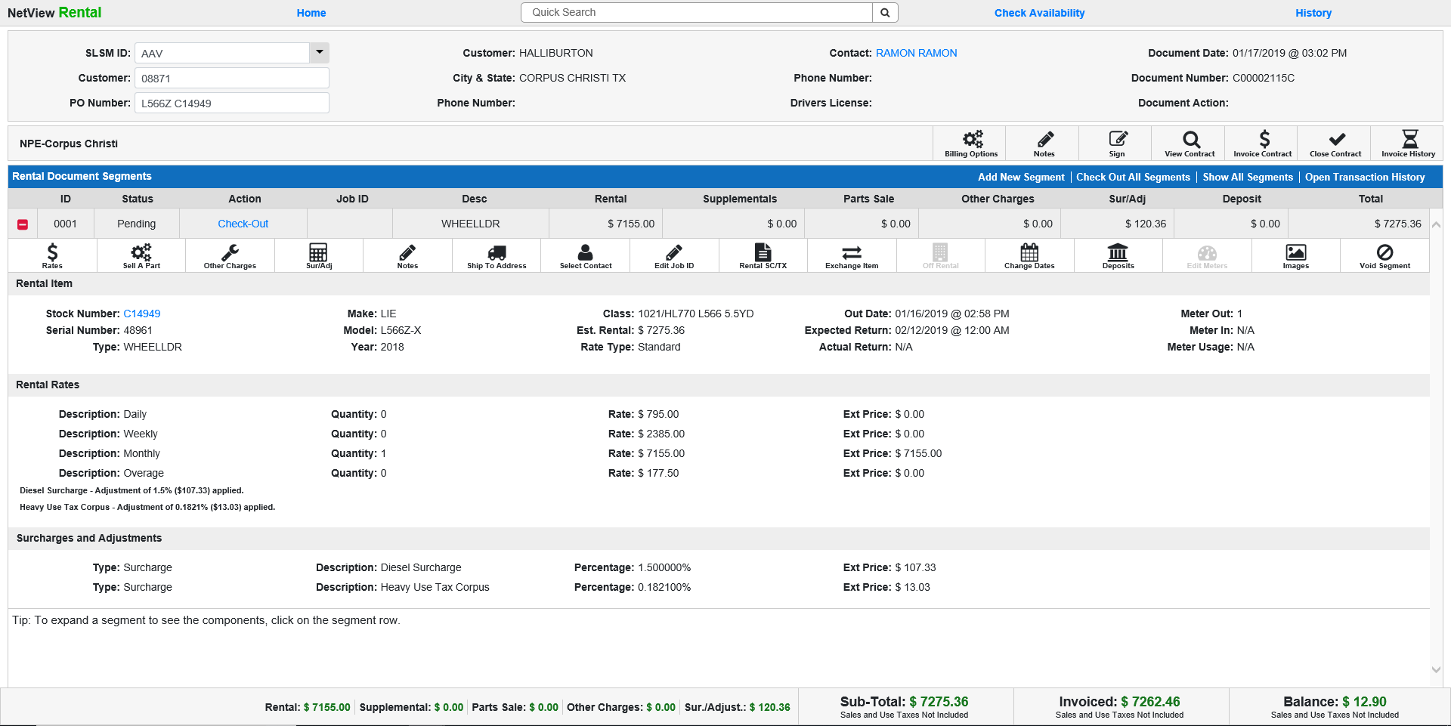

Click on the plus (+) sign next to the segment you want to adjust the billing for (by creating a credit or additional billing).

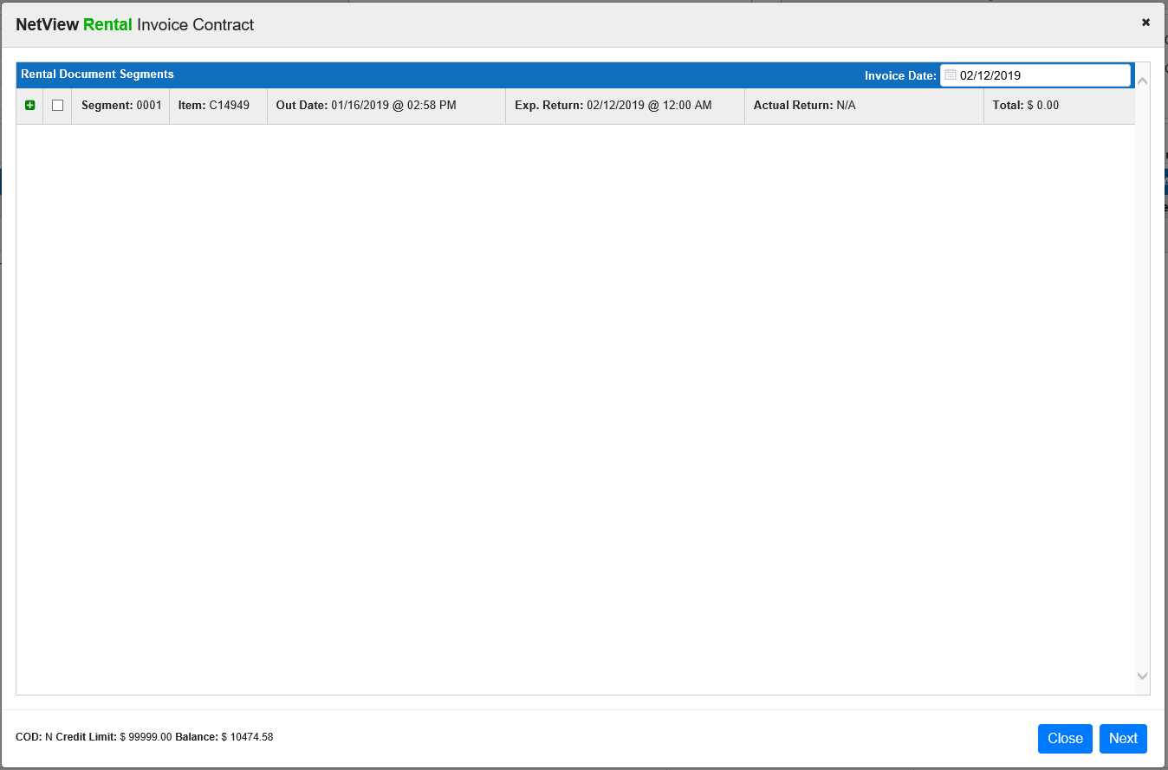

Place a check mark next to the rate you want to bill or credit and enter the desired quantity. Press the “Tab” key to have the program accept the quantity.

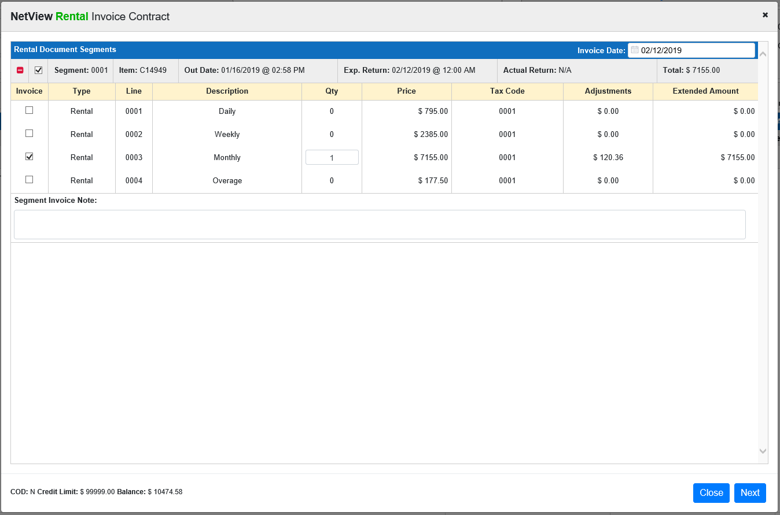

Click Next to preview the invoice. If it has the correct amount, process the method of payment, and click Finish. If you need to exit and start over, click Void.

