Rental Appendix B: Crediting a Segment

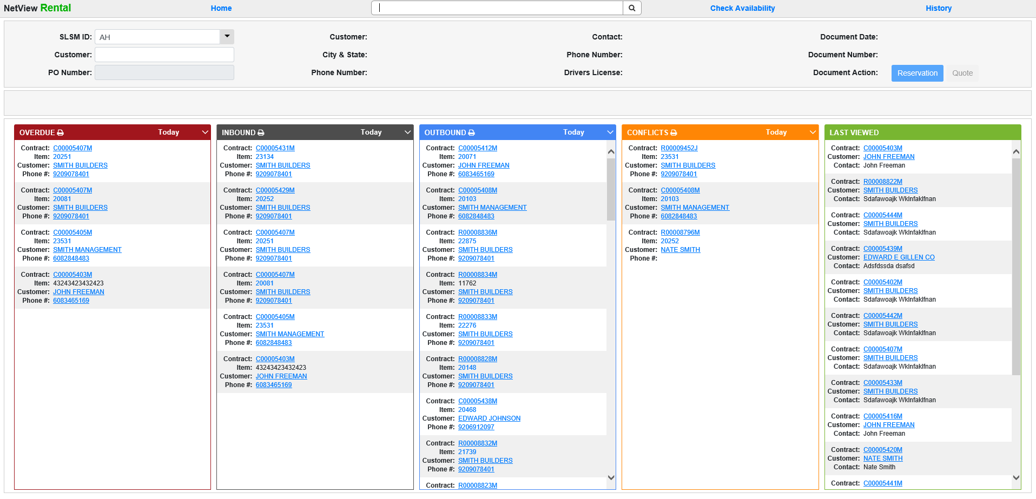

If an item has been invoiced and a credit needs to be issued to zero out the previously billed amount, do the following:

- Open Rental Reservations and Contracts (RENT).
- Locate the contract by either:
  - Using the Quick Search in the program header.
  - Entering in the customer name or number in the Customer field in the Document Header.
- After navigating to the contract, click on the Invoice Contract icon to open the pre-invoice window.

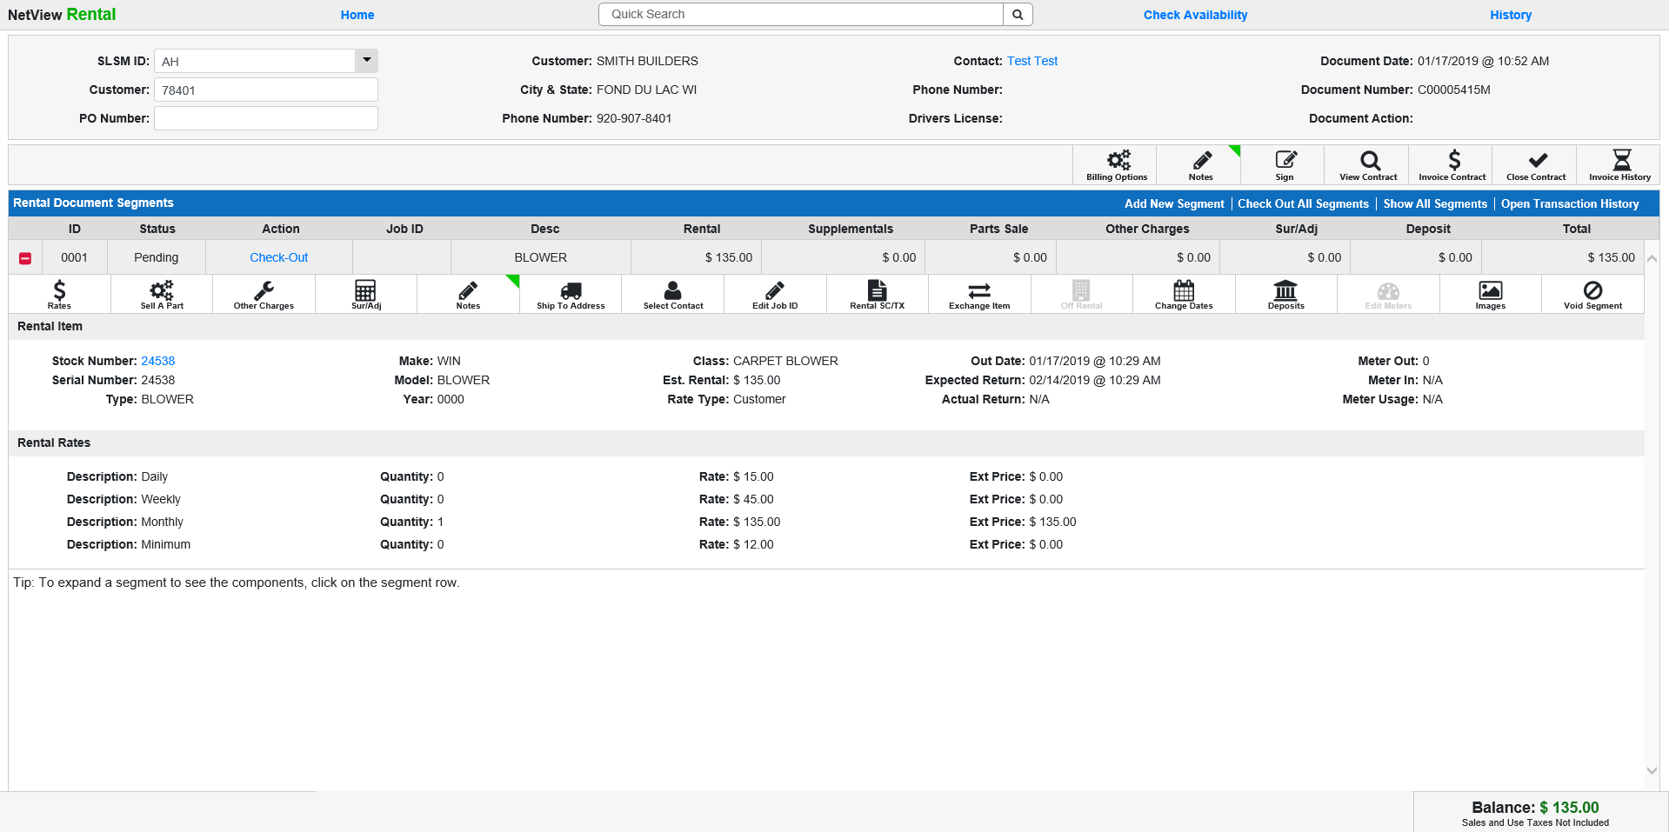

- In the pre-invoice window, select the segment(s) that need to be credited by clicking on the checkbox associated with the segment(s). Click on the green plus icon to expand the segment(s).

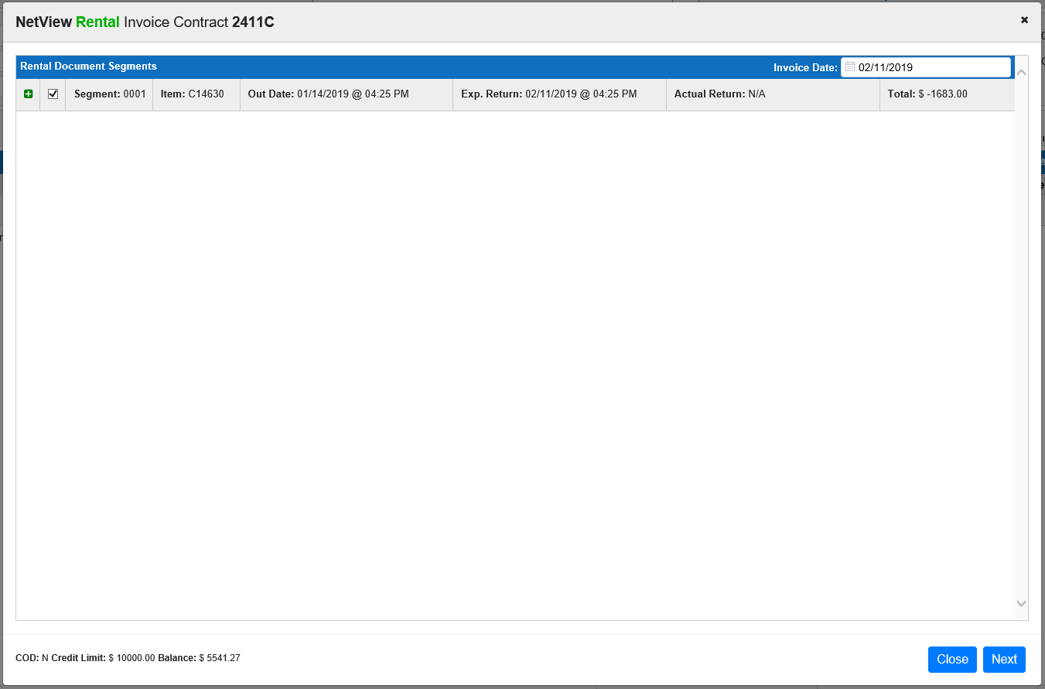

- If you want to credit for example, a month, ensure that the checkbox next to the rate period (in this case, Monthly) is selected.

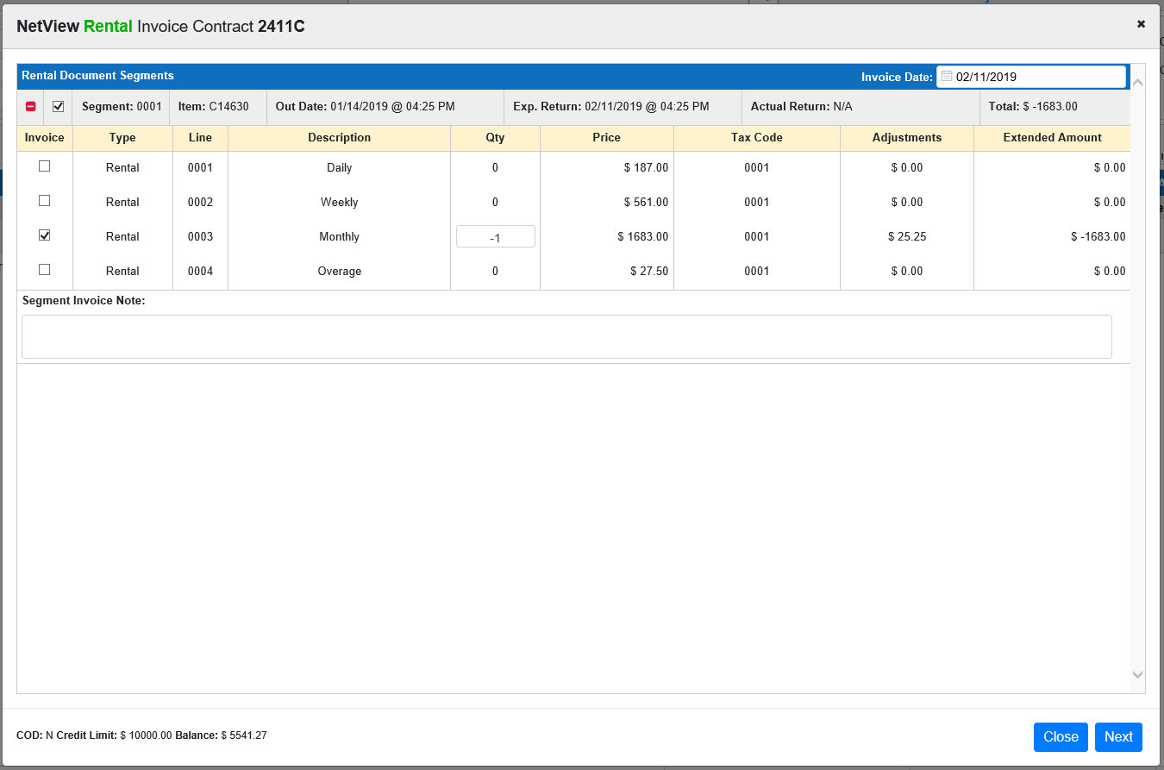

- Make sure the value in the Qty column is -1.
- Click the Next button in the bottom right of the pre-invoice modal to advance to the invoicing window.

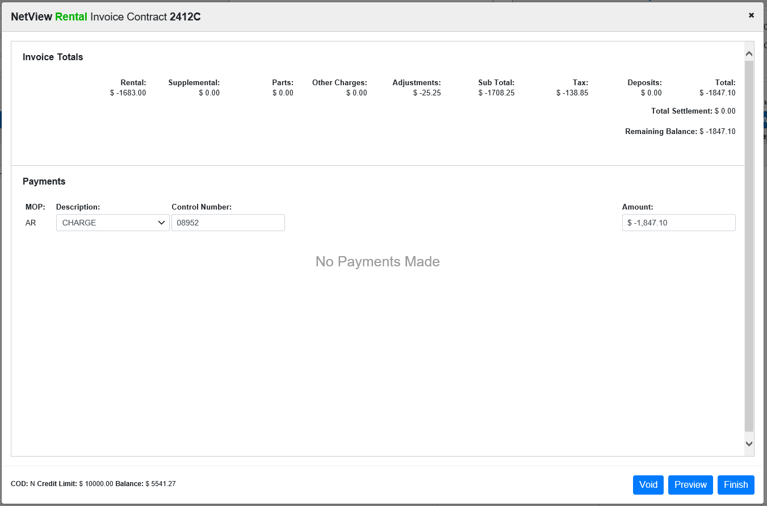

- After the invoice window has loaded, a credit with applicable sales tax should automatically display in the Amount field.
- Select the Method of Payment (MOP) using the dropdown select.
- Tab or click in the Amount field and press the “Enter” key to apply the credit.

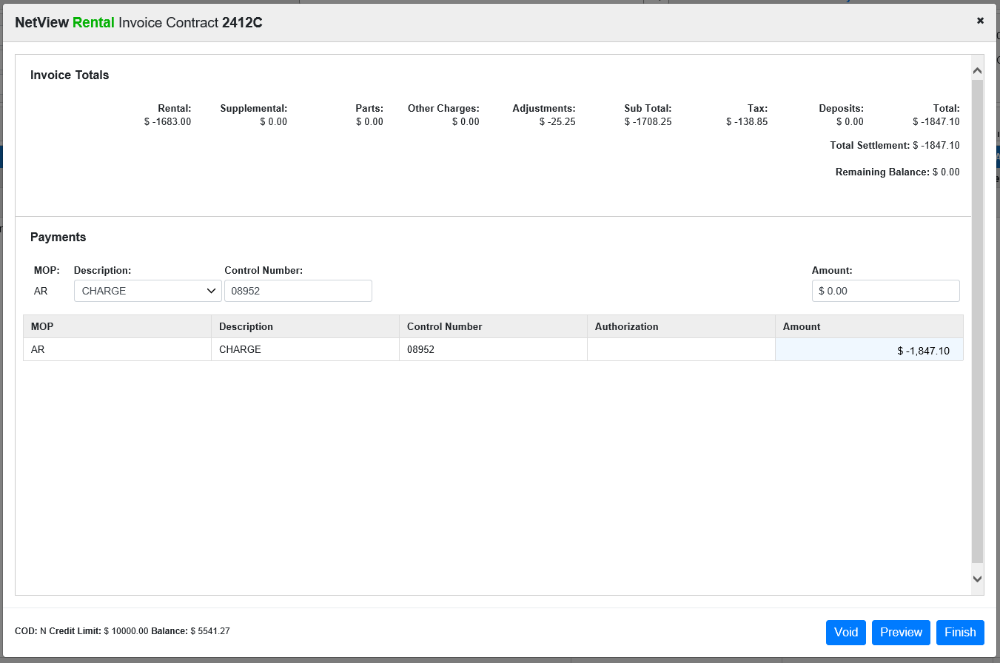

- Click the Finish button in the bottom right of the invoice window to complete the credit process.

