Reconcile Bank Balances (RECN): When you are ready to reconcile the bank entries to the statement you have received, use Reconcile Bank Balances (RECN).

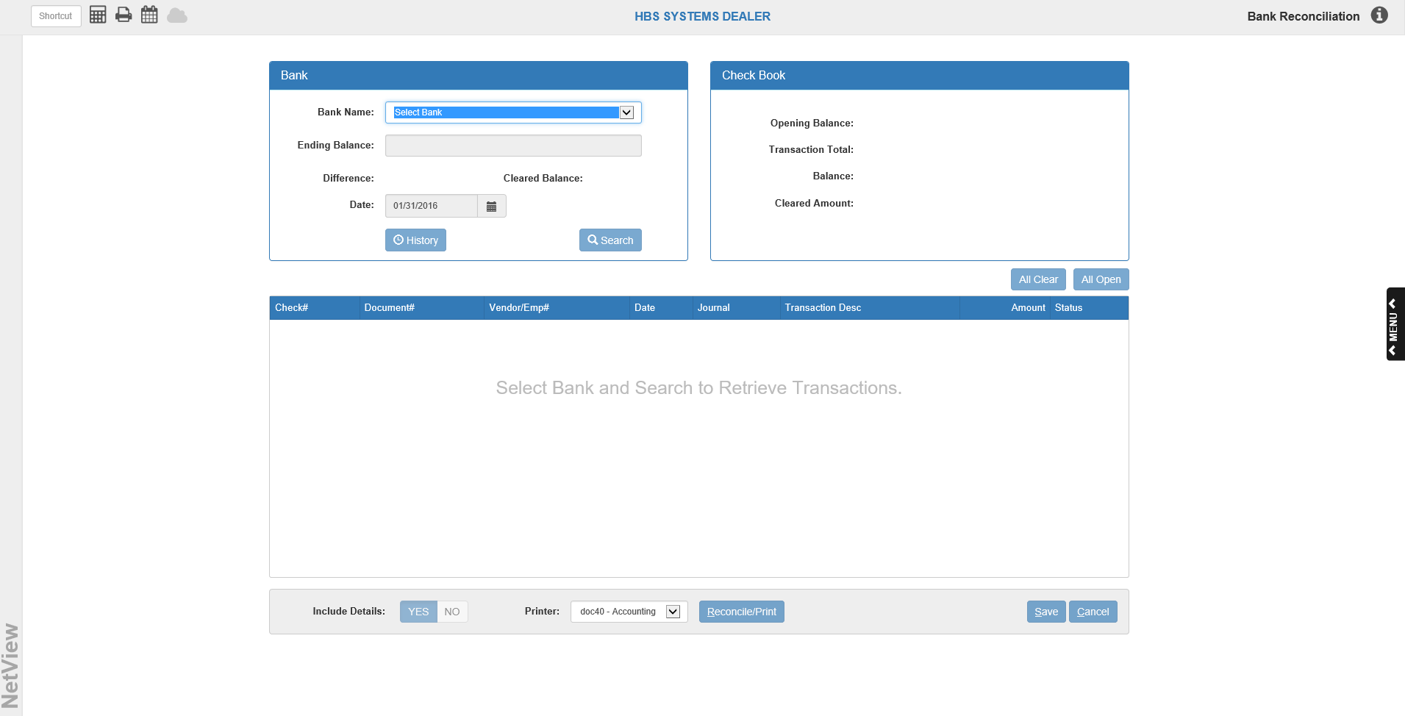

To access this function, you can either:

- Select “General Ledger” from the menu. Choose the “Bank Reconciliation” submenu and click “Reconcile Balances.”
- Type “RECN” in the Shortcuts Bar.

Account Balance Reconciliation Process: Use these simple steps to reconcile the transactions to your bank statement.

- In the “Bank” box, choose the Bank Name for the appropriate account from the drop-down menu in the Bank Name field.
- Click the Search button. The bank’s transactions will populate the grid on the lower half of the screen. The bank’s information, including the date of the month end period that you are performing the reconciliation for, will fill in the remaining fields in the box and the fields in the “Check Book” box.
- Note the statement’s Ending Balance amount. This is the amount you will be reconciling to your G/L entries. Also note that the last month’s Ending Balance is now known as the "Opening Balance" and displays in that field inside the “Check Book” box.
- Compare the transactions listed to your statement. Choose a status (Open or Clear) for each transaction identified on your statement by clicking on the Status column entry for the matching transaction in the grid. Click Save to save your changes.
  - Use the page numbers and arrow buttons at the bottom of the grid to move between the pages of the transaction list.
  - You can use the column headers to re-sort the transaction list if you desire.
  - To change all transaction statuses on the current page of transactions to Clear, click the All Clear button.
  - To change all transaction statuses on the current page to Open, click the All Open button.
- Once all the transactions have been compared and coded with an appropriate status, examine the display fields in the “Bank” box at the top of the screen. When the last transaction is cleared, the amount in the Difference field should be 0.00.
- When you are finished reconciling the account, choose a printer from the drop-down menu in the Printer Name field and select whether or not you want transaction details included on your printout (Yes or No). NOTE: Most of the time there will be other entries that are to be left open for the next statement’s reconciliation process.
- Press the Reconcile/Print button to complete the process and receive your printout.

If you selected not to print details on the report, the system will generate the regular summary report. If you selected to include details, the system will print the regular report plus a detail version that lists ALL of the cleared and open transactions within the Reconcile Data file. Samples of both reports are shown below.

Reconciliation Report

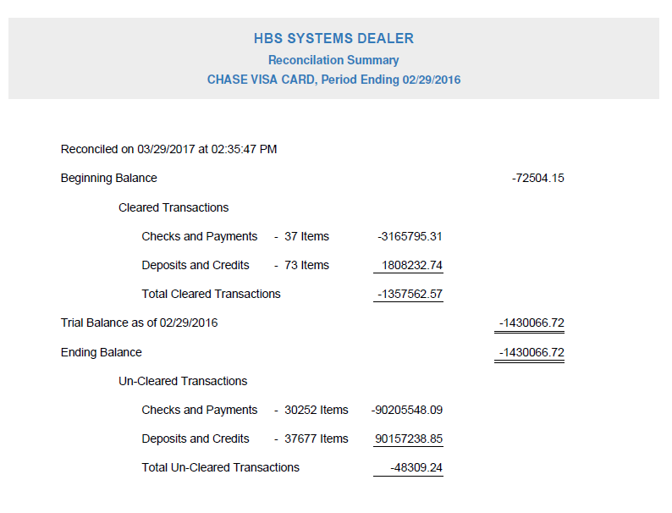

The Reconciliation Report summarizes your account balance and relevant transactions, as well as showing the number of accounts you cleared in order to reconcile the account with the Trial Balance (TB).

Reconciliation Detail Report

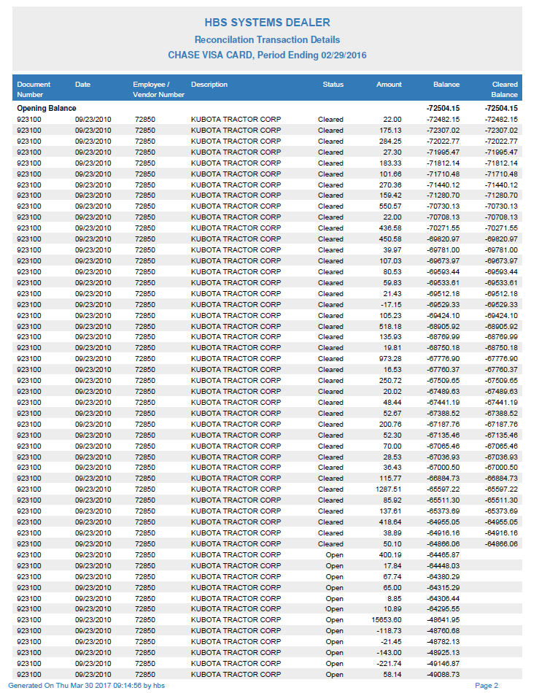

The Detail Report shows the Opening Balance at the beginning, and the Closing Balance, plus the total dollar amount of the listed transactions, at the end. The bulk of the report is the detailed list of all transactions currently listed on the account, open (outstanding) or cleared.

