Rental Setup—Department Names (DNAM)

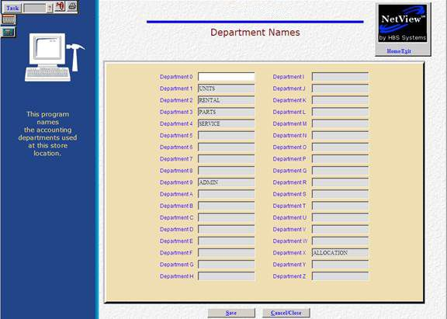

Rental setup will largely be handled by HBS Systems when the module is installed in your system.

The first step the dealership can perform is identifying the Rental department in Department Names (DNAM).

To access this function, you can either:

- Select “System Maintenance” from the menu and choose the “Company File” submenu. Click on “Department Names.”
- Type “DNAM” in the Shortcuts Bar

To create a department for Rental, enter “Rental” in the field next to the desired department number or letter. Any applicable accounts relating directly to the department will then end in that number or letter. In the example above, Rental is defined as Department 2, meaning all applicable accounts relating directly to that department would end in a 2.

