Rental Setup—Journal Names (JNAM)

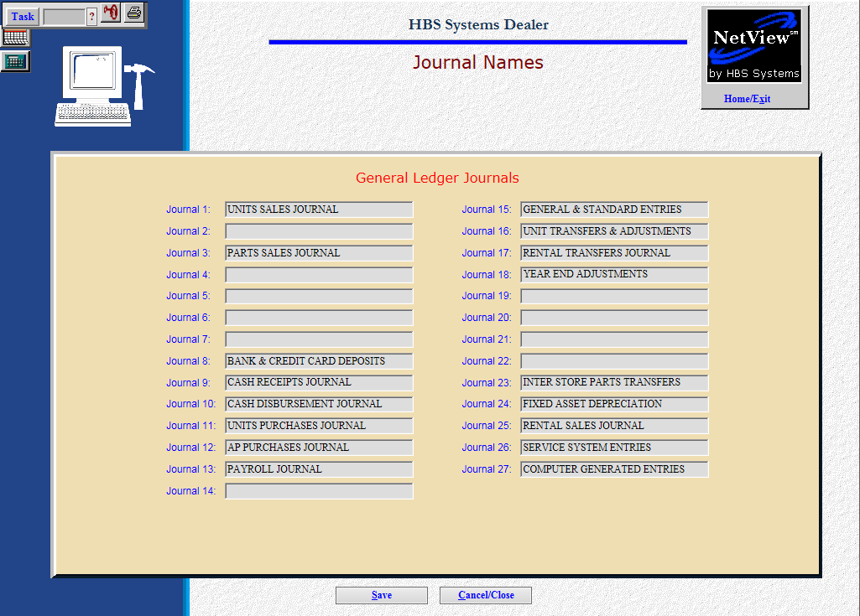

Next, use Journal Names (JNAM) to define the Rental Journal numbers to use in the system.

To access this function, you can either:

- Select “System Maintenance” from the menu and choose the “Company File” submenu. Click on “Journal Names.”
- Type “JNAM” in the Shortcuts Bar.

You will need to define both the Rental Transfers & Adjustments Journal and the Rental Sales Journal. To do so, simply enter the Journal name in an available space and click the Save button.

Note that Journal 17 is the default system Journal for Rental Transfers & Adjustments, so we recommend using this default rather than setting up a separate Journal for the purpose.

Also note that Journal 16 defaults to Unit Transfers & Adjustments, so avoid using it for a Rental Journal.

