Rental Equipment List: This report creates a list of the Rental units recorded in your system according to your specifications.

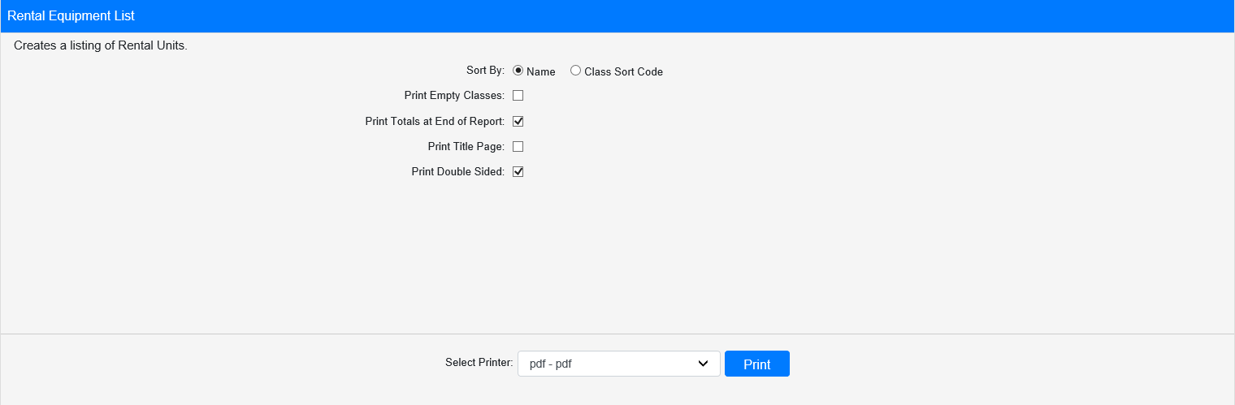

Field Definitions:

Sort By: Choose whether to sort the report by Name or Class Sort Code.

Print Empty Classes:

- Check this box to include Rental classes that currently have no units in stock on the report.
- Leave it unchecked to exclude those classes.

Print Totals at End of Report:

- Check this box to included total counts at the end of the report.
- Leave it unchecked to omit the totals.

Print Title Page:

- Check this box to include a title page in the report.
- Leave it unchecked to print the report without a title page.

Print Double Sided:

- Check this box to have the report print double-sided pages.
- Leave it unchecked to print the report single-sided.

Select Printer: Select the printer you want to receive the report from here. Use the pdf printer to preview the report.

Click “Print” to print the report.

Sample Report:

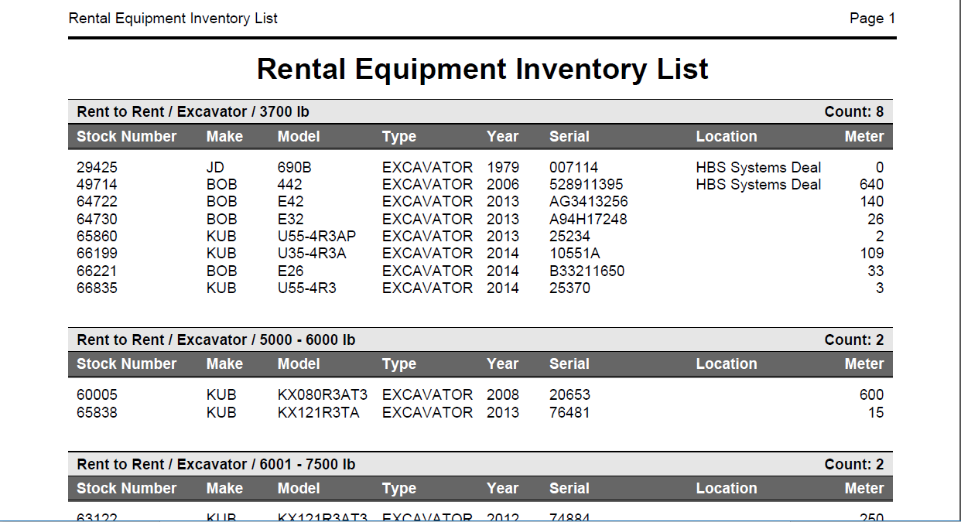

This example of the report is organzied by Name. Regardless of how they are sorted for printing, the units are grouped on the report by class, with the total count for each class display in the upper right-hand corner of the class section. The units are listed by stock number, along with the following:

- Make
- Model
- Type
- Year
- Serial number
- Location (if applicable)
- Meter

If you chose to print Totals at the end of the report, you will see a total count for each of the following on the report:

- Number of Family/Group/Class(es)
- Number of serialized units
- Number of non-serialized units

