Rental Setup—Method of Payment (MOP)

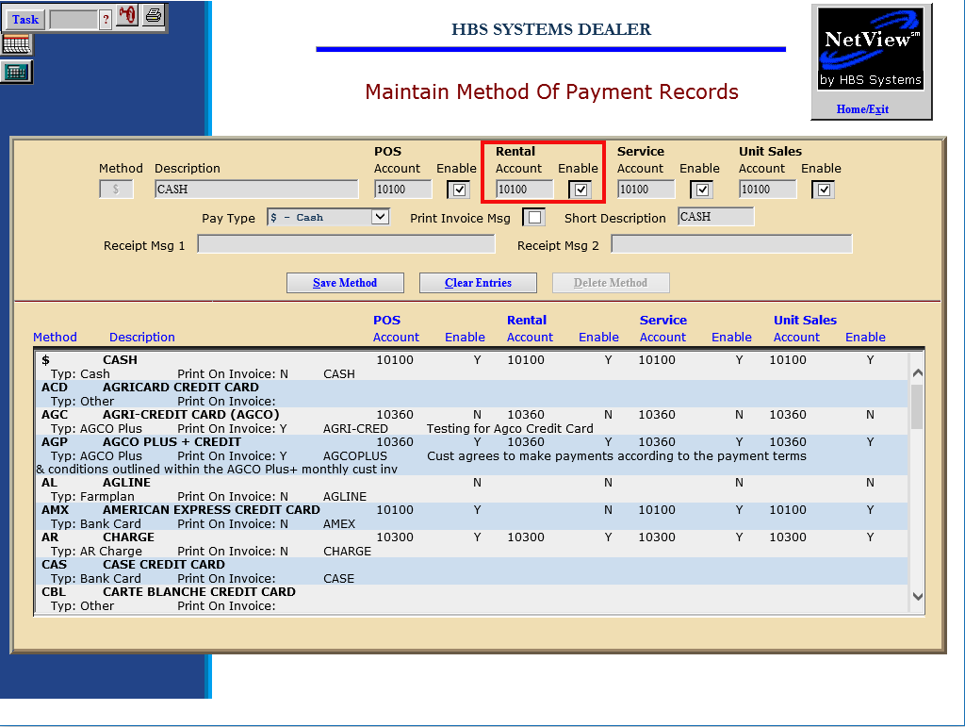

Use Method of Payment (MOP) to define the possible ways your customers settle or pay for their rentals. Examples: Cash, Checks, Customer Deposits, Charge (A/R), Credit Cards, Financing (Contracts), etc.

To access this function, you can either:

- Select “System Maintenance” from the menu and choose the “Company File” submenu. Click on “Method of Payment.”
- Type “MOP” in the Shortcuts Bar.

Field Definitions:

Method: This is a 3-character code for the method of payment defined. It is used for record maintenance and does not appear in the invoicing programs.

Description: This field holds the description of the method of payment that will print on the invoice.

Rental Account: This field defines the General Ledger account that will receive the amount specified for this method of payment. You must click on the Enable field to its right to activate it. Choose the appropriate General Ledger Rental account for this method of payment.

Enable Rental Account: Click on this field to the right of the Rental Account field to use it in the identified invoicing screen.

Pay Type: This field identifies the type of payment defined. The values for this field are shown in the drop-down menu. Several choices for this field trigger the selection to work with interfaces to the HBS system: B-Bank Card, D-Debit, F-Farmplan, U-AGCO Plus.

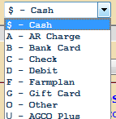

Print Invoice Msg: This choice is only checked if the payment is Farm Plan.

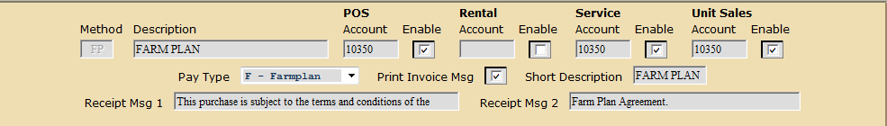

Short Description: This field holds a short version of the description that displays in selection boxes. You can enter up to 11 characters here.

Receipt Msg 1 & 2: These fields are only used if the payment is Farm Plan.

Press the “Save” button to save the record.

