Rental Reservations and Contracts (RENT)

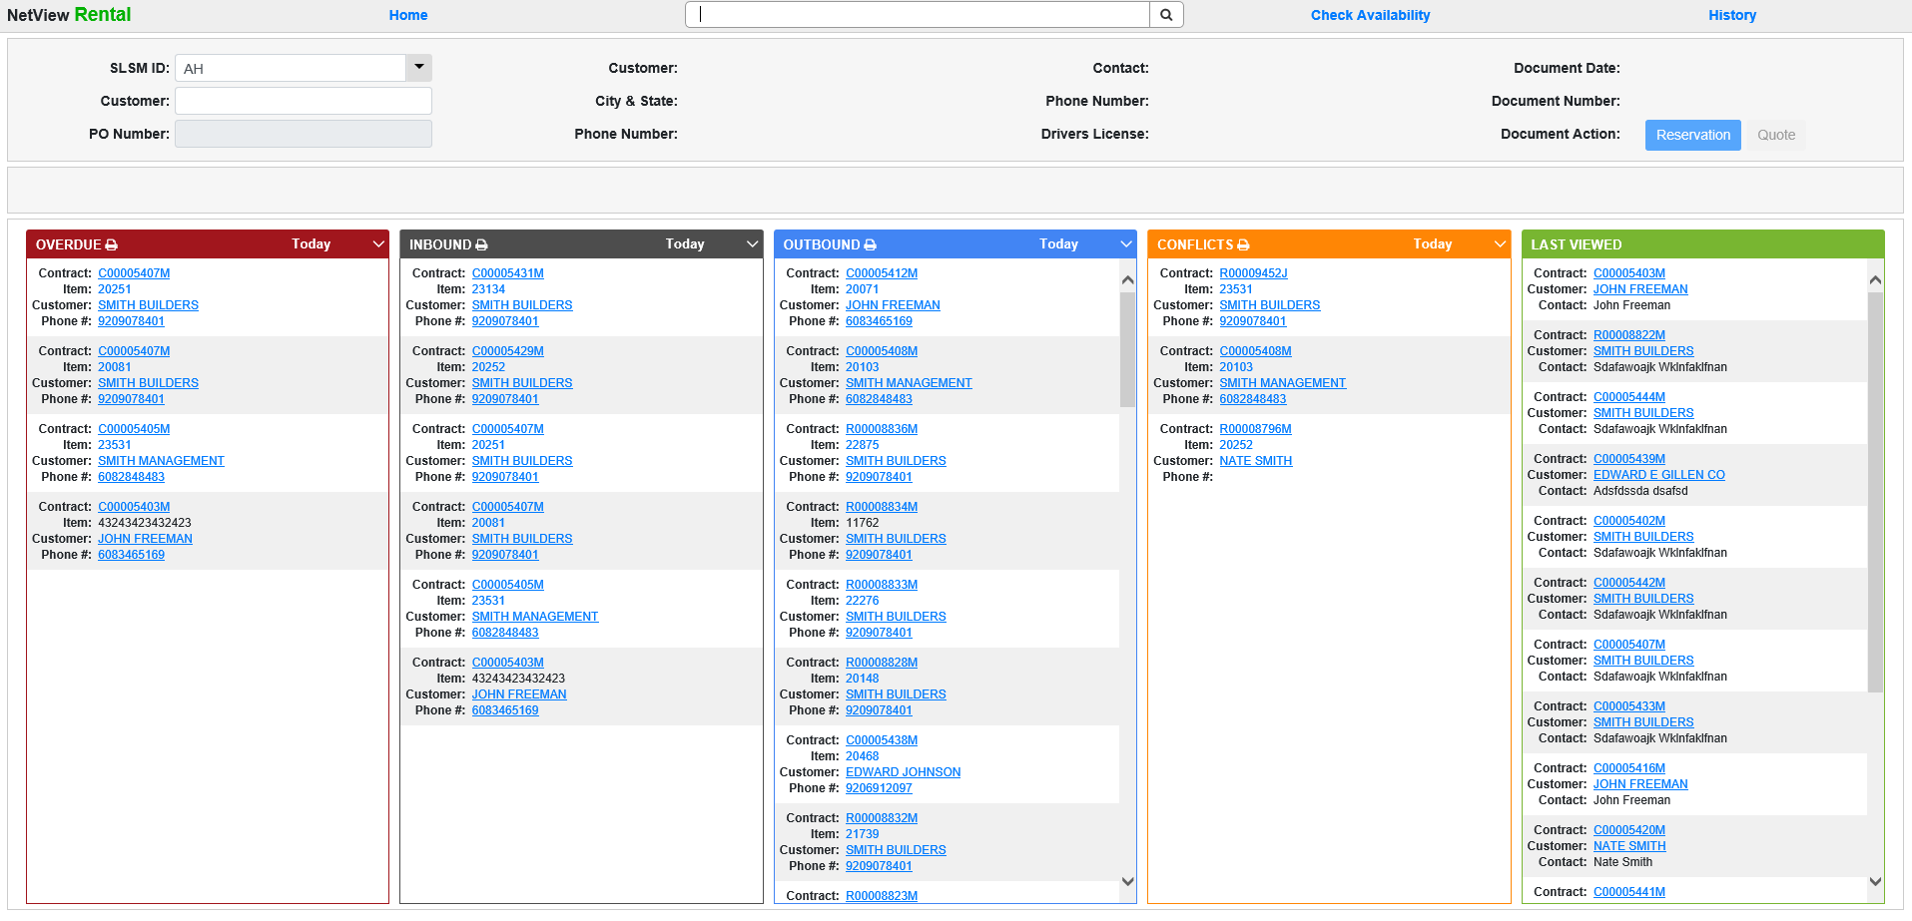

Rental Reservations and Contracts (RENT) is the main Rental program, from which you can create, maintain, and close rental reservations and contracts.

To open this program, you can either:

Select “Rental” from the menu and click “Rental Contract.”
- Type “RENT” in the Shortcuts Bar.

Initial functions on the RENT screen: When you reach the RENT screen, you may perform several functions before you select, begin, or continue working a reservation or contract.

Status Lists: The main RENT screen displays 5 lists that offer useful information on the statuses of your rental contracts. You can print any list by clicking the icon of a printer just under the header, with the exception of the Last Viewed list.

Overdue: The list beneath the red header shows rental contracts containing items that have passed their expiration dates. The list automatically displays the contract with the most overdue item first and ends with the contract listing the least overdue.

You can use the drop-down menu in the header to display items considered overdue by a certain point in time. The options are:

- Today
- 1 Week
- 2 Weeks
- 3 Weeks
- 4 Weeks
- 8 Weeks
- 12 Weeks
- 13+ Weeks

Inbound: The list beneath the black header shows rental contracts containing items that have upcoming expected return dates. The list automatically displays the contract with the earliest return date first and ends with the contract that has the farthest away return date.

You can use the drop-down menu in the header to display what items are expected to return within a certain period of time. The options are:

- Today
- Tomorrow
- 1 Week
- 2 Weeks

Outbound: The list beneath the blue header shows rental contracts containing items that are either about to or have begun their rental periods, but haven't been checked out yet. The list automatically displays the rental contract whose item(s) are most overdue for checkout first and ends with the contract whose items(s) have the longest period to wait before they can be checked out.

You can use the drop-down menu in the header to display what items are expected to get checked out within a certain period of time. The options are:

- Today
- Tomorrow
- 3 days
- 1 Week
- 2 Weeks

Conflicts: The list under the orange header shows rental contracts that have a conflict with another contract, for example overlapping rental periods. This list will rarely have entries, as the application will prevent you from creating or altering contract segments in ways that will create conflicts. However, if an entry does appear, we strongly recommend you fix the conflict as soon as possible.

You can use the drop-down menu in the header to display the conflicts currently set to occur in an approaching time period. The options are:

- Today
- Tomorrow
- 3 days
- 1 Week
- 2 Weeks

Last Viewed: The list beneath the green header shows the rental contracts and reservations that you have viewed most recently in the application. The list automatically displays the last 15 documents you have viewed. Once you have created or viewed a reservation/contract, it will appear at the top of the list when you return to the main screen.

Check Availability: Click at the top of the screen to view availability of various rental items.

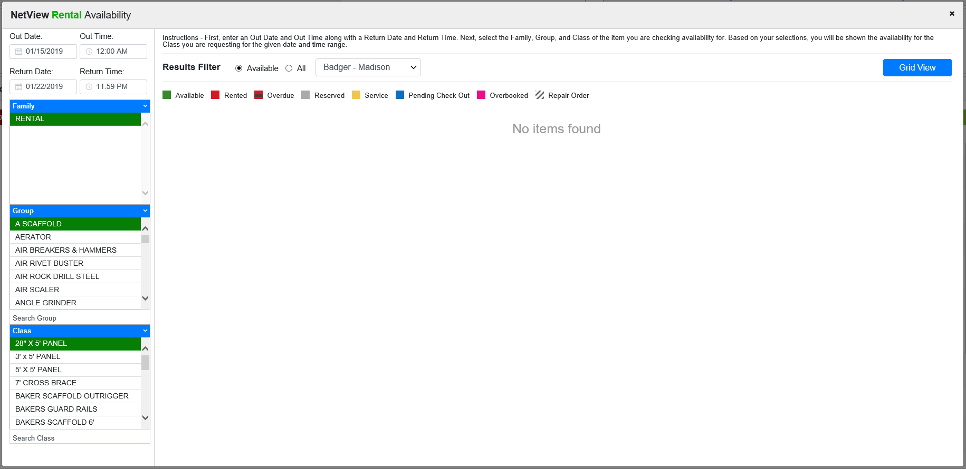

The default view is called Calendar View. Note that this view will differ between serialized and non-serialized Rental groups (see next page).

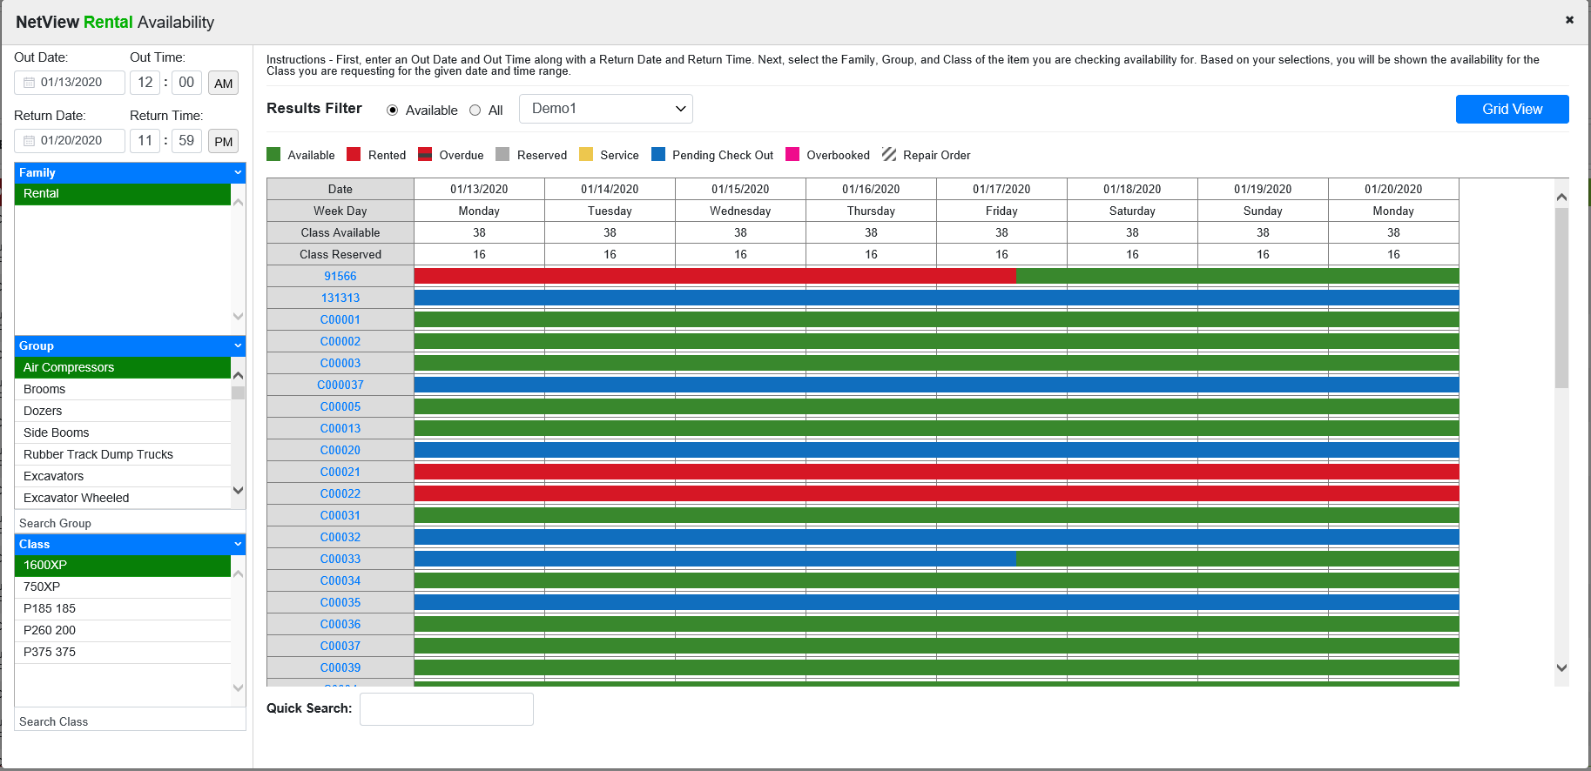

Serialized groups will have the calendar view shown above, which shows the availability during the calendar week of each individual unit in the selected Rental class.

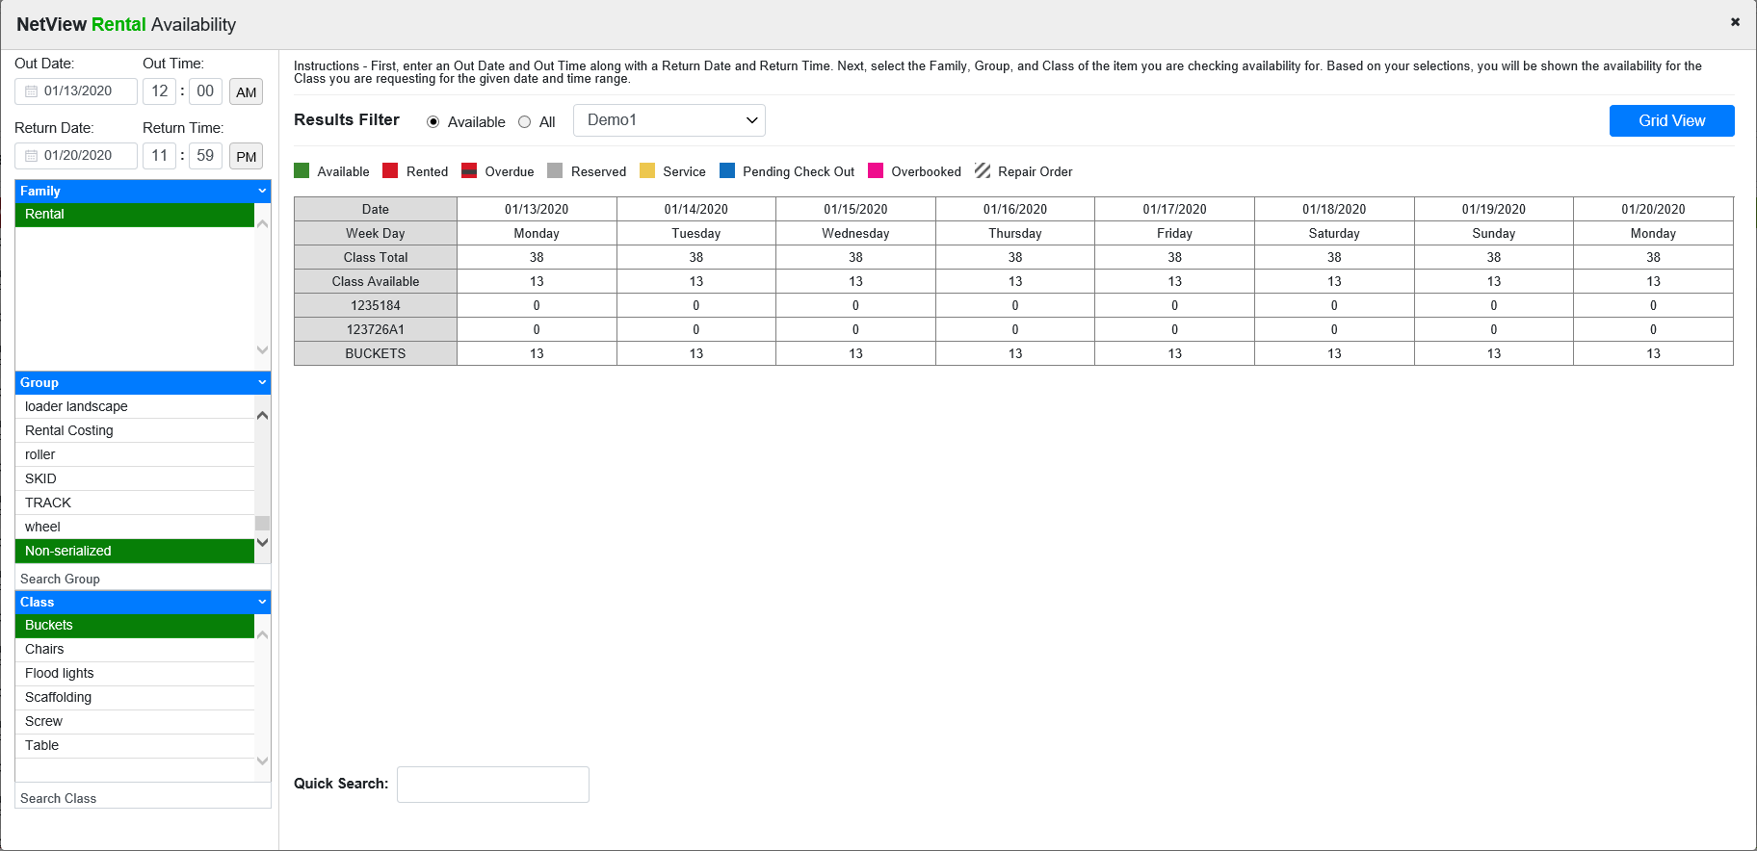

Non-serialized groups will only show the quantity of each part in the Rental class that is avaible on a certain day, as there can be multiple instances of the same part number available at one time.

You can also check the alternate Grid View (see below image) once you enter out/return dates/times and select the Family/Group/Class. If it’s a multi-location setup, you can select the location to review. NOTE: This screen will look the same for both serialized and non-serialized items, the chief difference being whether the “Serialized” box in the Class section shows a “N” (for non-serialized) or a “Y” (for serialized).

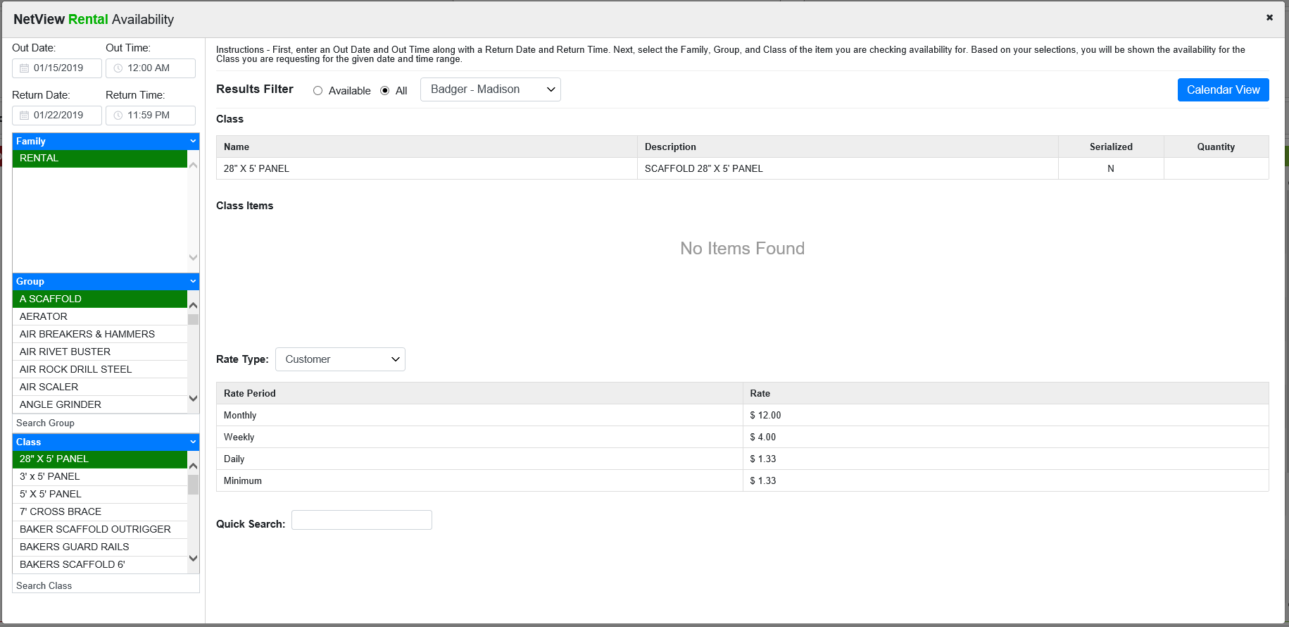

History: Click to to access historical Rental documents stored in the system.

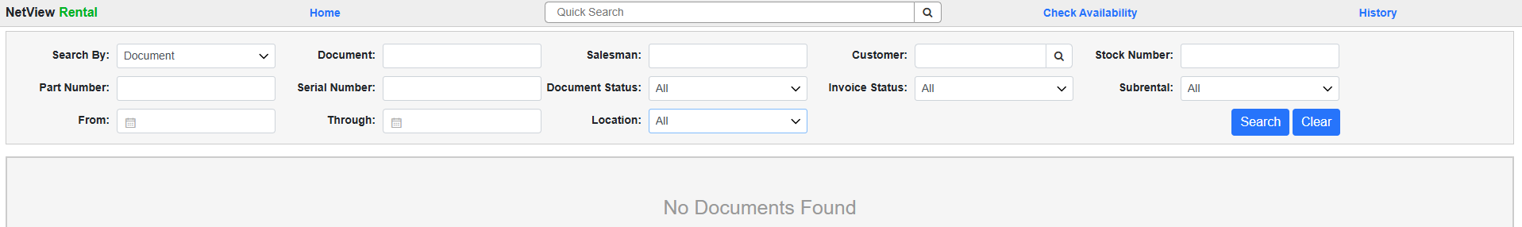

Search Fields: Use the search fields in the header to find your desired document or invoice.

- Search By: Select whether to search for documents or invoices.
- Document/Invoice: The title of this field will change depending on the selection in the Search By field. Enter part or all of a document or invoice number in this field to search by the specific number.
- Salesman: Enter all or part of a Salesman ID in this field to search for documents/invoices made by that salesperson. This particular detail is more likely to show up on rental documents. NOTE: The ID must be capitalized to trigger proper results.
- Customer: Enter the customer number in this field to search for documents/invoices associated with that particular customer. If you only know part of number or any part of the customer’s name, you can enter that in the field to look up the customer.
- Stock Number: Enter part or all of a stock number to view documents/invoices that include the item.
- Part Number: Enter part or all of a part number to view documents/invoices that include the item.
- Serial Number: Enter part or all of a serial number to view documents/invoices that include the item.
- Document Status: When searching for a document, use this field to filter your results by the document status. Choose one of the following:
  - All
  - Closed
  - Open
- Invoice Status: When searching for an invoice, use this field to filter your results by the invoice status. Choose one of the following:
  - All
  - Historical
  - Voided
- Subrental: Select whether to include, exclude, or only search for subrental documents/invoices using this field. Choose one of the following:
  - All
  - Subrental Only
  - Rental Only
- From/Through: To search for documents or invoices within a specific date range, enter the starting and ending dates in these fields. You can also select the dates from a calendar.
- Location: If you are working in a multi-location dealership, you can use this field to search for documents/invoices based on the location they were created in. You can view by location or select “All” to view all documents/invoices regardless of location.

Document Search Results: When you make a document search, the results will look like this:

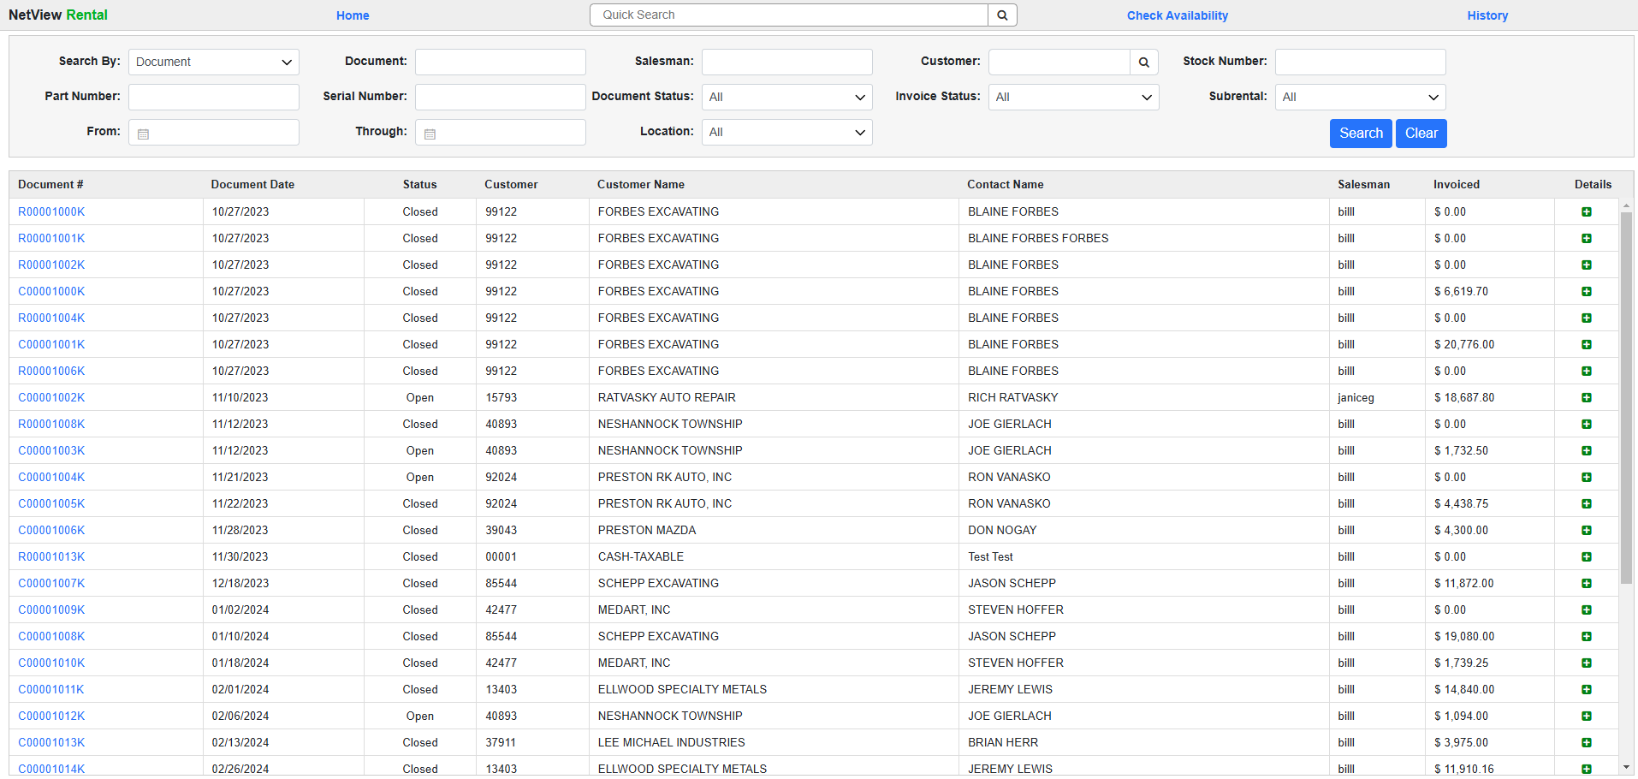

Click on the blue document number to view or print the document. Click the icon in the Detail column to view the document details.

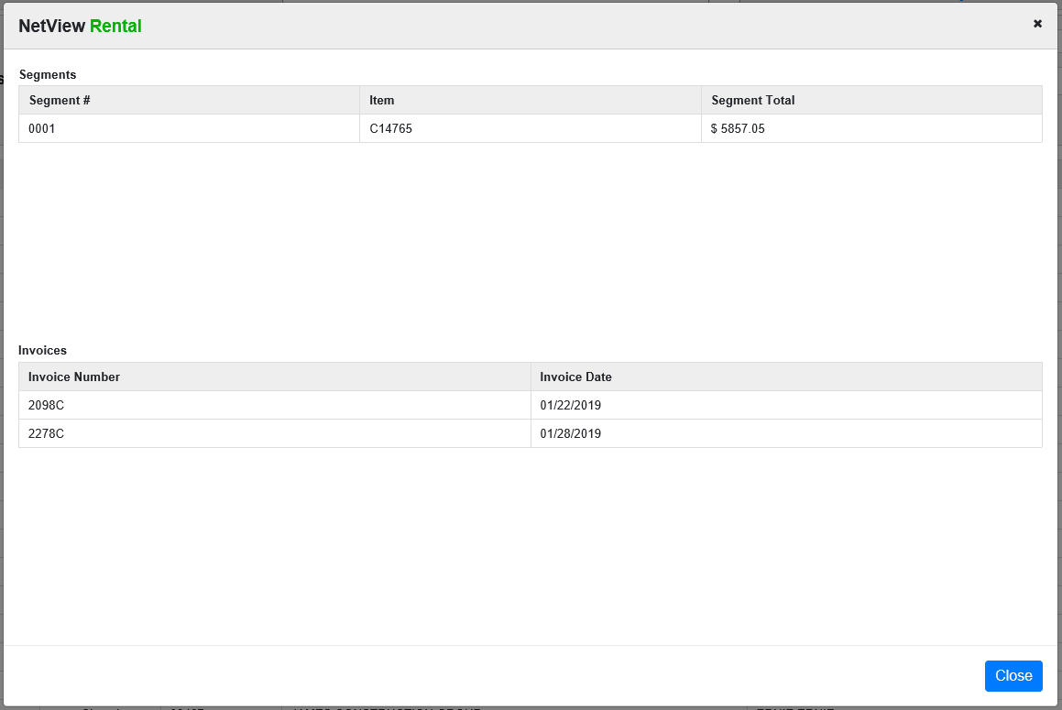

Invoice Search Results: When you make an invoice search, the results will look like this:

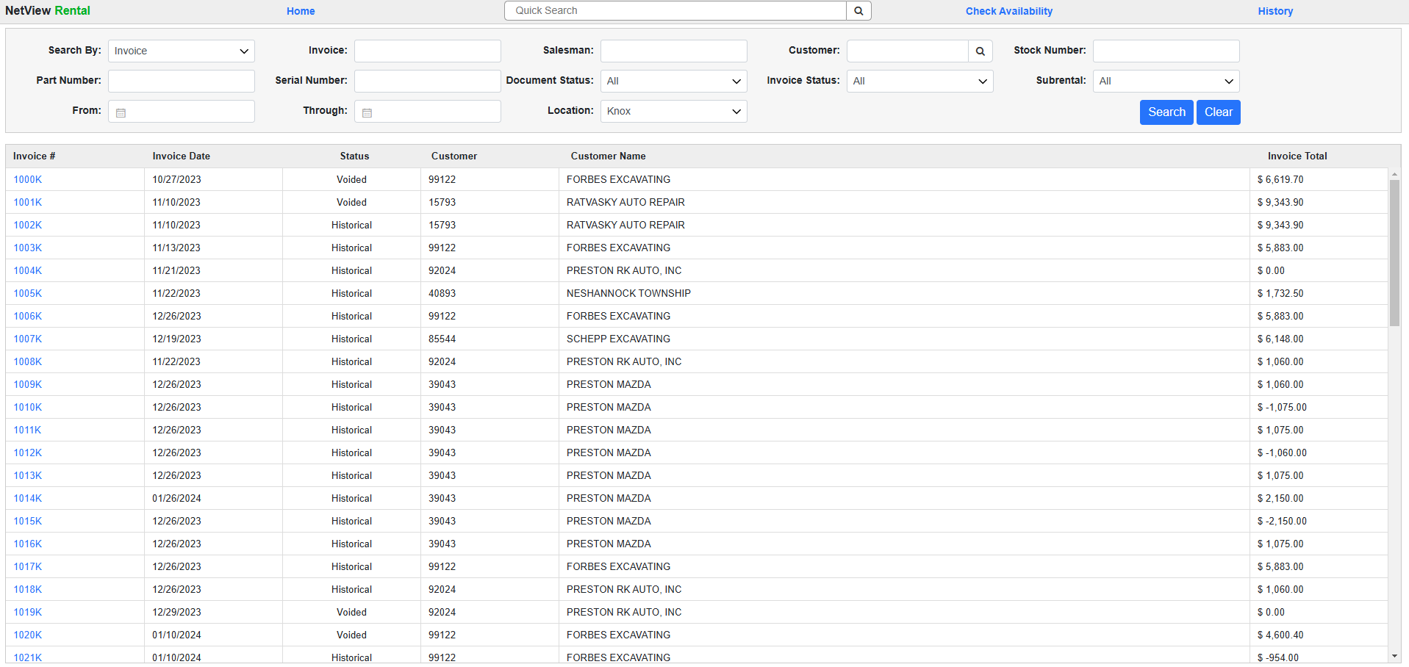

Click on the blue invoice number to view or print the document.

Start a New Rental Reservation: To begin a new rental reservation, make sure your Salesman ID appears in the header (it should appear by default). If you need to change the ID, use the drop-down menu to select a different one.

Enter the customer name or number in the Customer field, then hit the “Enter” key. The screen will change to display a list of customers with either a matching name or a matching number, depending on what you entered.

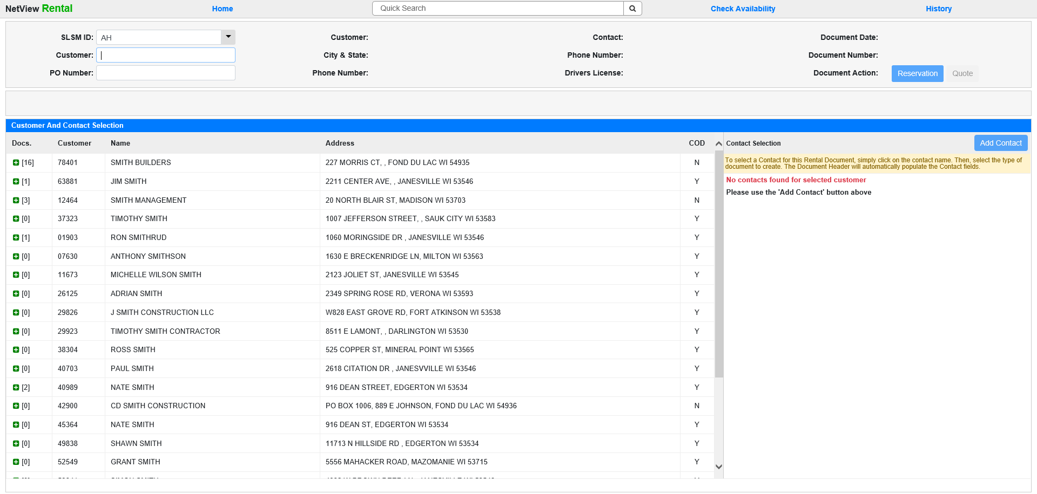

Select the desired customer by clicking on their entry.

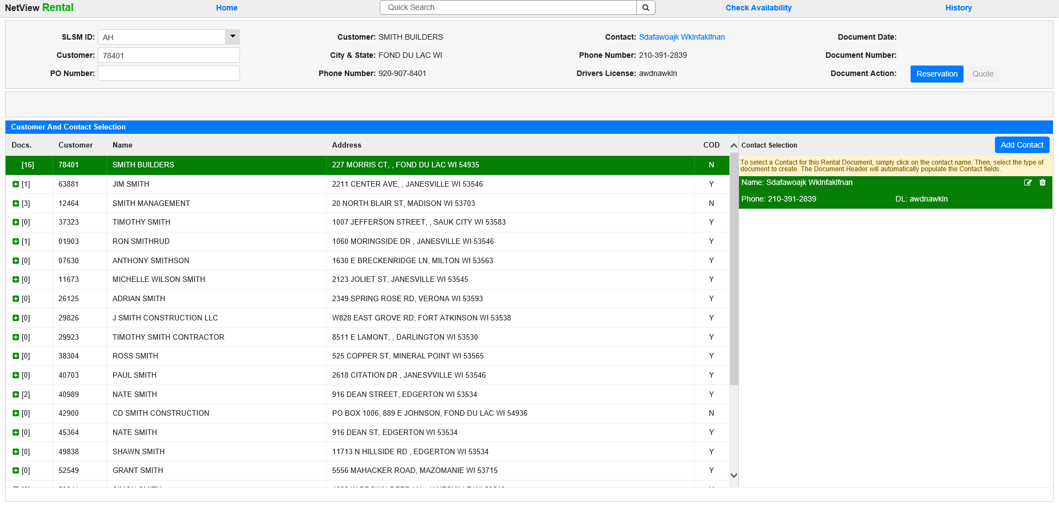

Make sure the customer has a contact assigned for the reservation. If the customer already has a contact listed in the Contact Selection box, it will automatically select along with the customer. If the customer has more than one contact, the program will automatically select the first one listed. To switch to a different contact for the rental, simply click on the desired one. NOTE: You can also edit and delete contacts from this screen using the icons in the upper-right corner of the contact entry.

If the customer does not have a contact listed, click Add Contact in the upper right-hand corner of the Contact Selection to add one.

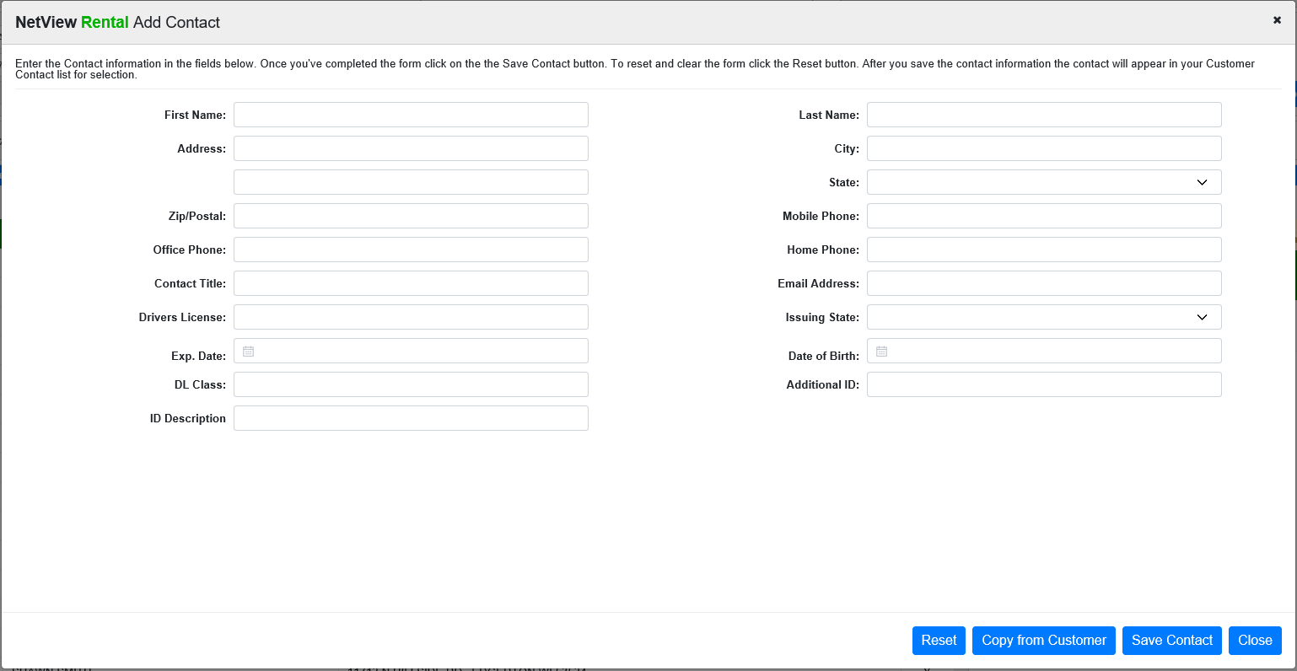

You can choose to copy the information from the customer’s Enter Customer Information (ECI) entry or manually fill in the fields. Press Save Contact when all info has been entered to add the contact.

Once you’ve selected your customer and contact, click on 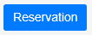 to begin. The following screen will appear:

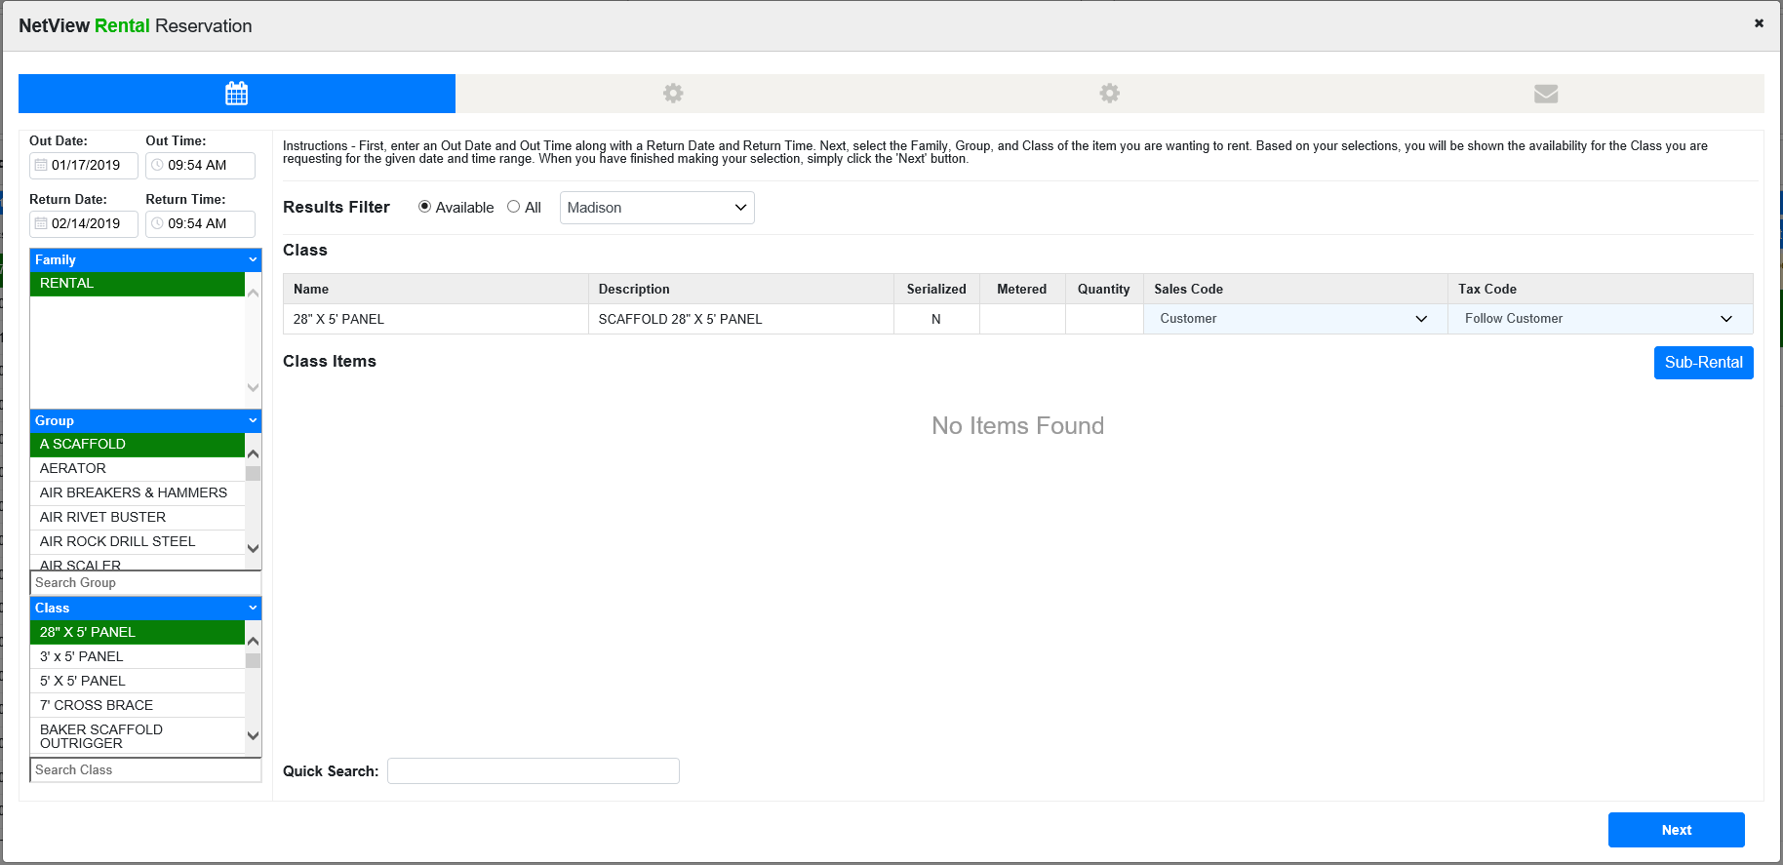

Choose the Out Date & Time plus the Return Date & Time. Then select the Family, Group, and Class of the item to rent. All items matching that criteria will display. You can reserve a specific item or reserve by class, in which case you will select the unit or part when the reservation becomes a contract. You can also adjust the Sales Code and Tax Code as needed using the drop-down menu in each field.

Select the rental item, or, if you don’t see it listed, use the available filter and search features to locate it:

- The Results Filters set whether to view all items in your chosen Family/Group/Class, or only those available for rent.
- If you are a multi-location dealership, you can look at other locations’ rental inventories by using the drop-down menu next to the Results Filter to select a different location.
- The Quick Search field lets you look for a specific stock or part number within your selection.

NOTE: If the reservation involves a subrental, click 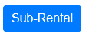 to access the necessary information fields. Fill the fields in as required.

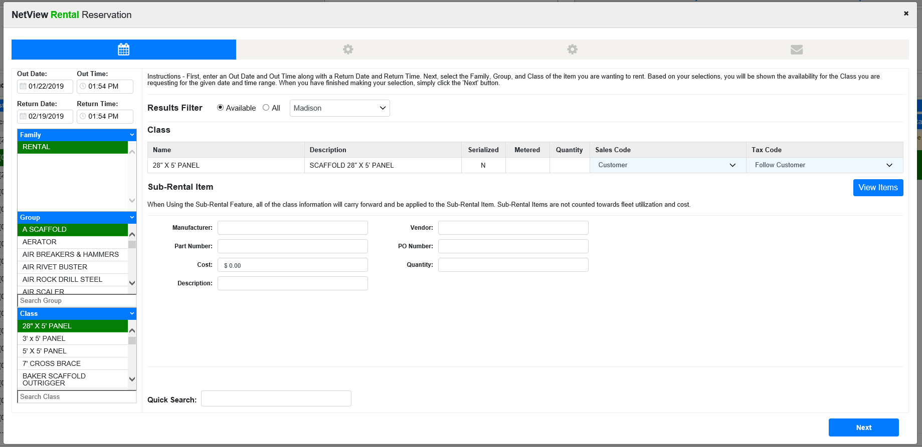

Once you have your item chosen, click Next. NOTE: You will not be able to make a reservation with an overdue unit unless overbooked.

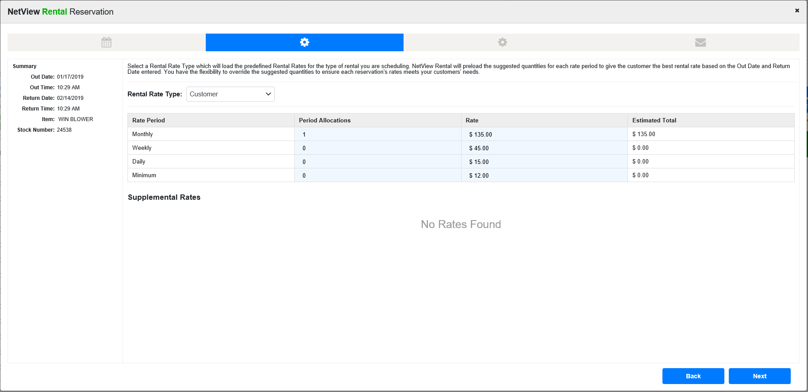

Choose the Rental Rate Type. It defaults to the preferred rate, but can be changed in the drop-down menu. The Rate Periods displayed are calculated from the Out/Return Dates you chose on the previous screen. You can adjust them as needed.

NOTE: If this Rental Category has any pre-defined Supplemental Rates, that information will show below the Rate Periods. These rates are in addition to the primary rate listed about them. They could be present on balers for a bale count, on a generator for an hour meter, and so on.

Click Next to continue.

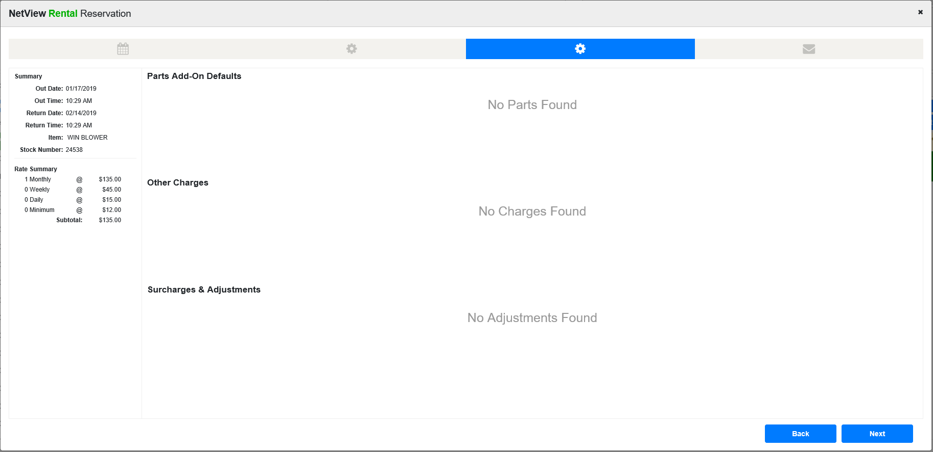

In this screen, you can manage any Parts Add-Ons, Other Charges, Surcharges, and Adjustments that are assigned to this Rental Category in Rental Class Maintenance (RCM). You will be able to adjust any default information provided, such as quantities, tax codes, or percentages, as needed for the specific rental.

Click Next to continue.

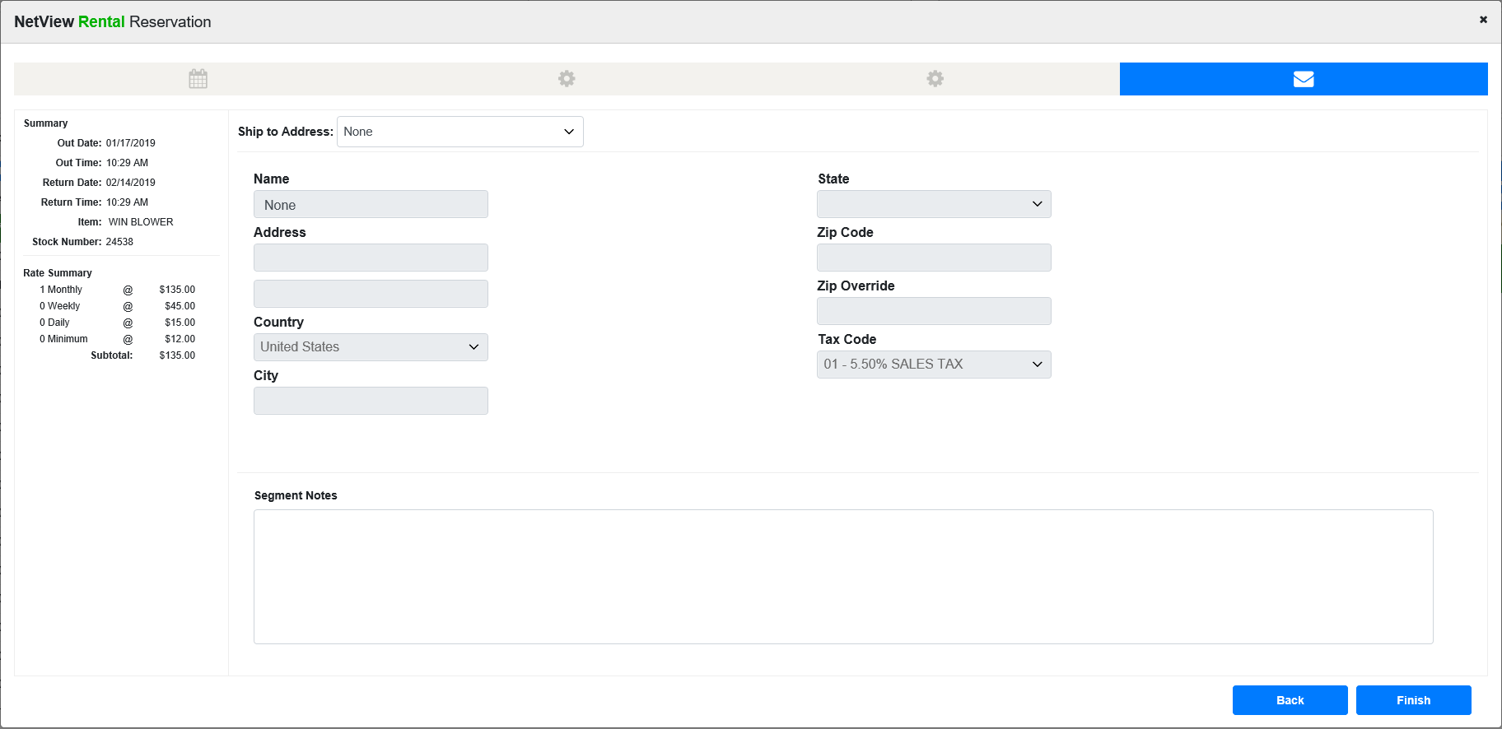

The Ship to Address panel is used to determine a different Sales Tax rate, if any, from the tax rate of the selected customer. You may choose from existing Ship To Addresses, the Billing Address, or fill in the fields with a new address. Adding an address in this screen will tell the Rental Invoicing routine to use the associated tax code or zip code (when an SST sales tax table is in place) to calculate the sales tax in lieu of charging the rate at the business.

The Segment Notes panel below holds information that pertains to the unit or item on the segment. It can be special instructions to the renter, maintenance required by the renter, etc.

Press Finish to complete the reservation.

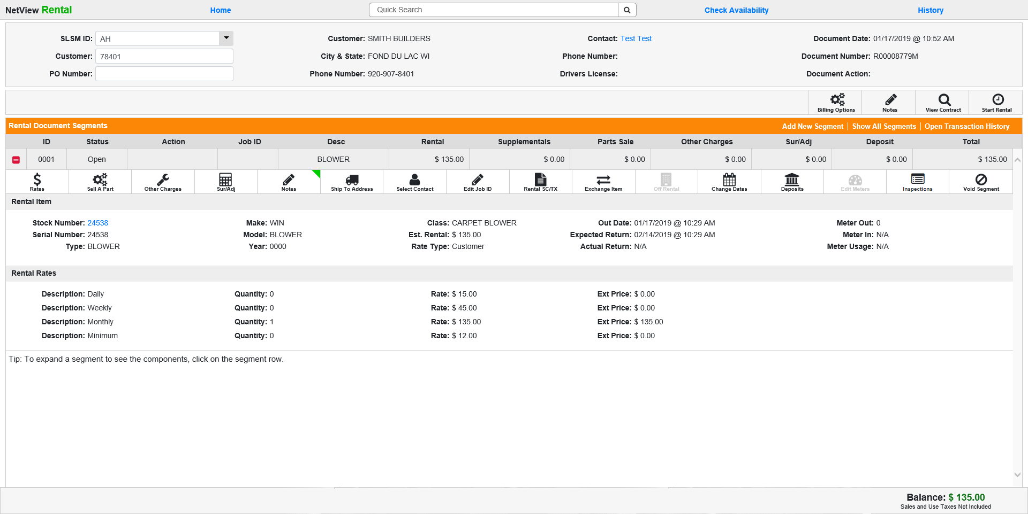

Rental Reservation Screen: At this point you have successfully created a reservation (indicated as such by the orange-colored header bar). Each segment of the reservation can be expanded to view the segment details. Click 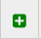 to expand the segment. Once it is expanded, click 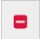 to collapse it again.

Balance: The balance displayed in the bottom right-hand corner of the screen shows the running amount due before sales tax from the contract (subtotal less any payments).

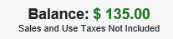

Unit Inquiry: If you are renting a serialized unit, click on the blue-colored stock number to view the unit details of the item from Unit Inquiry (UI).

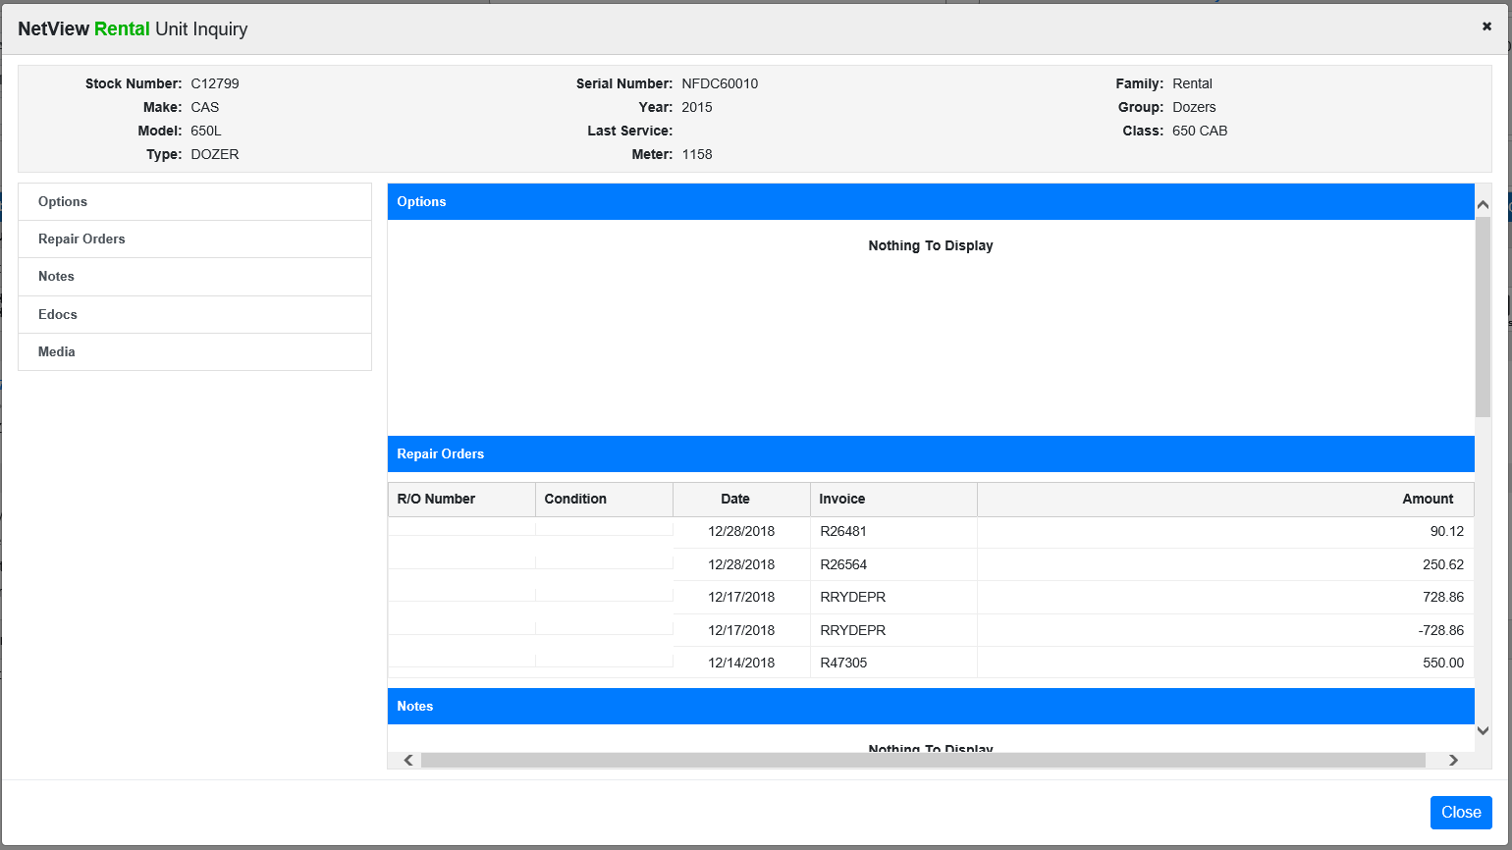

Reservation Actions: You can perform several actions on a reservation before converting it into a rental. NOTE: The individual Segment Actions will be covered separately, as they also appear for contract segments (see Segment Actions for more details).

Add New Segment: Choose this action to add a new segment to the reservation. Follow the steps above for starting a reservation to create the new segment.

Show/Hide All Segments: Choose this action to show or hide all segments on the reservation at once instead of expanding or collapsing them individually.

Open Transaction History: Choose this action to view the reservation’s transaction history. Click it again to hide the transaction history.

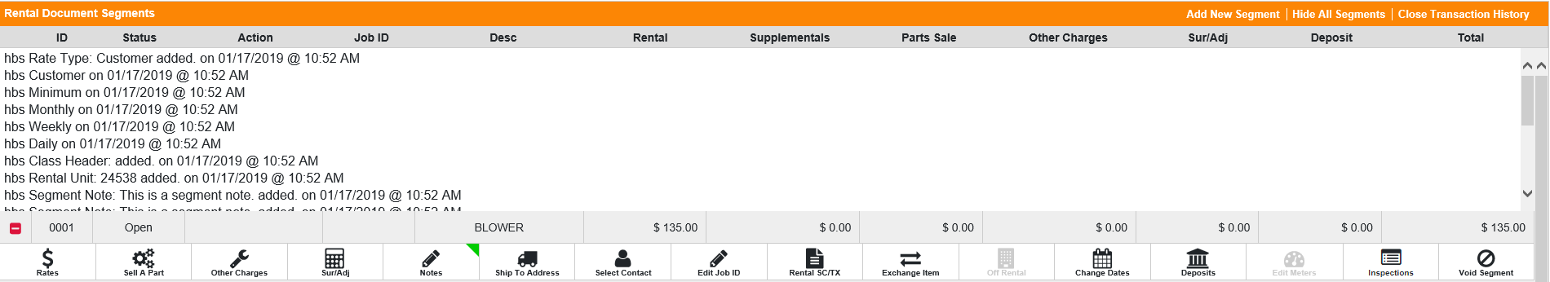

Billing Options: Choose 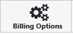 to adjust the billing settings for the reservation.

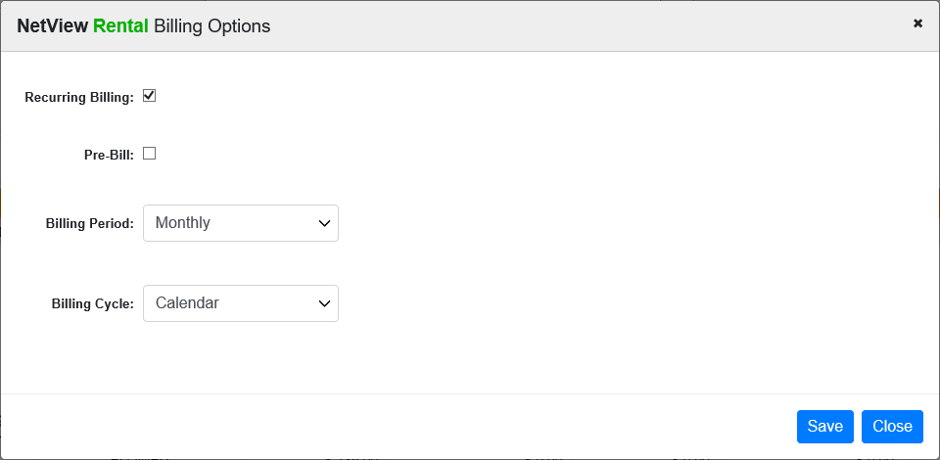

You can set whether the rental will have reoccurring billing or be pre-billed, as well as the billing period (how frequently the rental is billed) and the billing cycle. After making adjustments, click Save to apply them to the reservation.

Notes: Choose 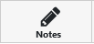 to add notes to the overall reservation, rather than a particular segment.

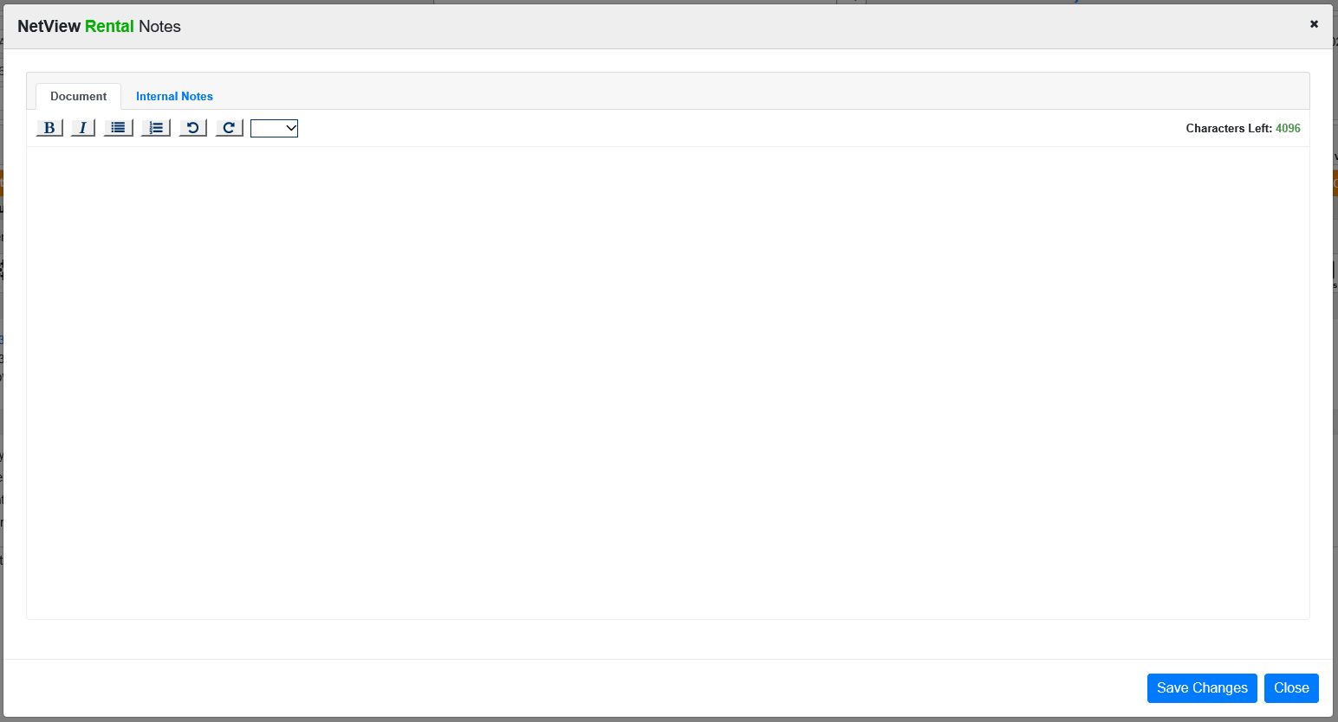

You can add public (appearing on the reservation documents) or internal (not available to customers) notes. The notes have a maximum character limit of 4,096, and the window will indicate how many characters you have left.

Click Save Changes to add the note. Once you do, the Notes icon will change to display a green indicator in the top right-hand corner 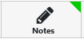 to let you know that notes exist for this document.

View Contract: Choose 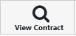 to preview the reservation document.

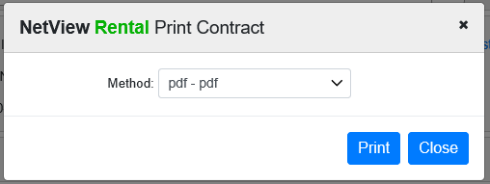

Select the printer to receive the document and click Print. Use the PDF printer(s) to preview the document on the screen.

Start Rental: To convert it to a contract, click 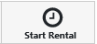. The following window will open:

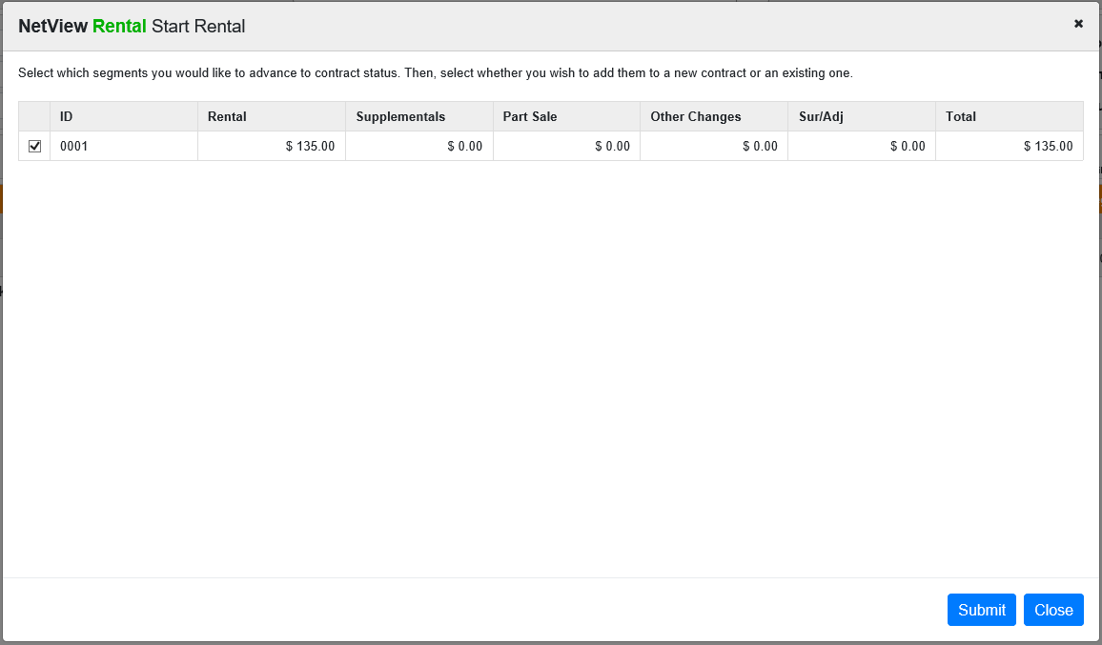

Choose which segments you want added to a contract and click Submit to convert the reservation into a contract.

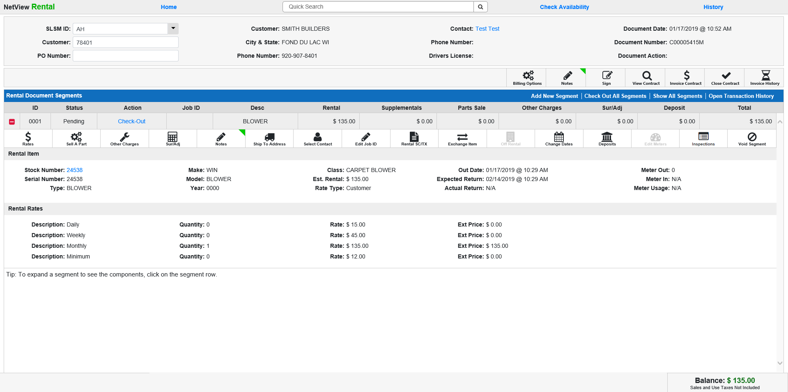

Several things have now changed:

- The Document Number in the header has been converted to a contract number (prefixed with a “C” instead of an “R”).
- The header color has changed from orange to blue (indicating a contract).
- The action options have changed.
- The status is now pending.
- The next action for the segment is Check-Out.

However, some features remain the same:

- The balance still appears at the bottom of the screen.
- The contract segments can still be expanded and collapsed as with a reservation.
- Clicking the blue stock number for a serialized unit will still open a Unit Inquiry window.

Check Out: Click on Check Out on the segment line to begin the check out process. You will repeat this process for all segments as needed. NOTE: You must check out the segment before the Expected Return Date; otherwise, you will not be able to check out the segment.

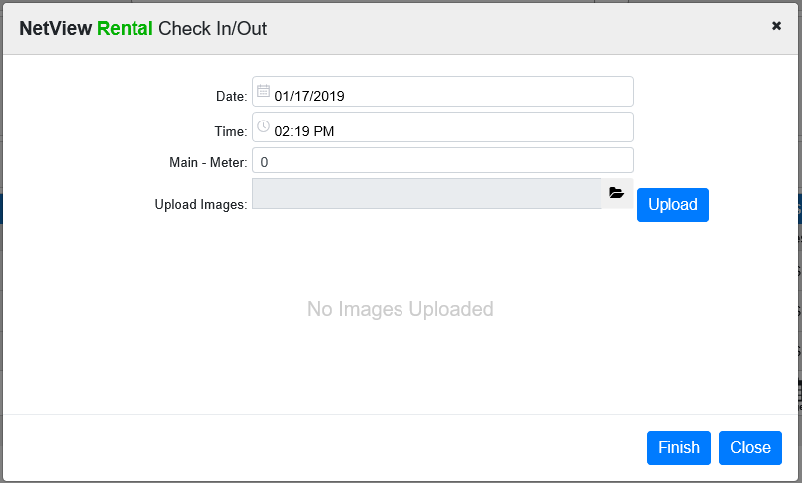

Confirm or edit the actual check out date and time. If the item is a serialized unit belonging to a metered class, then additional fields for the meter reading(s) will appear, and you can edit them as needed.

If you want to add an image to the contract, use the Browse feature to select an image file and then click Upload. A preview of the image will appear in the window.

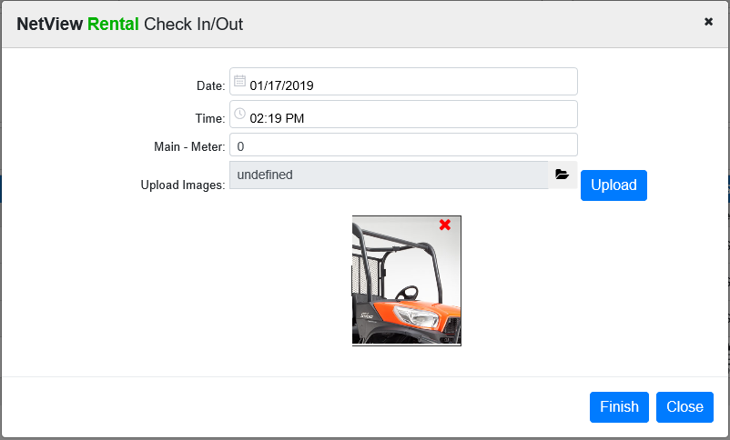

Click Finish. The unit/item has now been checked out and presumably has left the lot. The segment status will change to “Check-In” to reflect this.

Rental Contract Screen:
View Contract: You may now view or print the contract using 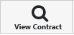. This Contract Action works identically to the View Contract action for rental reservations (see View Contract in the section for Reservation Actions).

Sample Contract

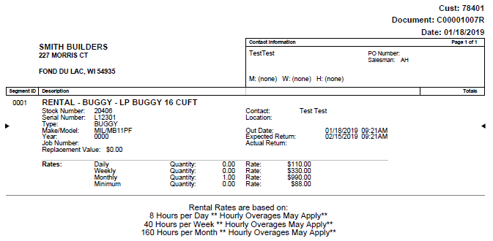

NOTE: The information printed on the contract will change depending on both what information you entered when starting the rental and the current status of the rental. The above sample represents a contract with a serialized item printed out immediately after segment checkout, with no Ship To address entered and no additional charges (surcharges & adjustments, parts charges, etc.).

Contract Actions: The contract screen also includes actions you can perform on the entire contract, so long as it remains open. NOTE: The individual Segment Actions will be covered separately, as they also appear for reservation segments (see Segment Actions for more details).

Add New Segment: Choose this action to add a new segment to the contract. The process is exactly the same as it is for adding a segment to a reservation.

Check Out All Segments: Choose this action to check out all segments on the contract. A window will open listing how many segments are eligible for this action:

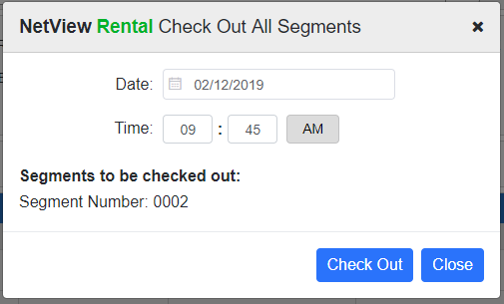

Click Check Out to check out the eligible segments.

Show/Hide All Segments: Choose this action to show or hide all segments on the contract at once instead of expanding or collapsing them individually.

Open Transaction History: Choose this action to view the reservation’s transaction history. Click it again to hide the transaction history.

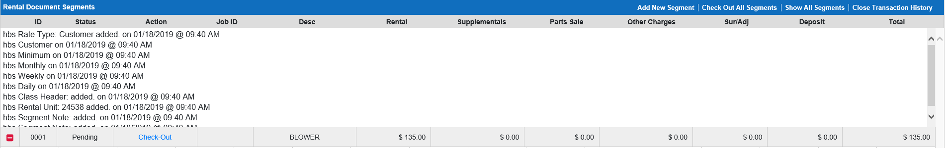

Billing Options: Choose to adjust the billing settings for the contract.

You can set whether the rental will have reoccurring billing or be pre-billed, as well as the billing period (how frequently the rental is billed) and the billing cycle. After making adjustments, click Save to apply them to the contract.

Notes: Choose to add notes to the overall contract, rather than a particular segment.

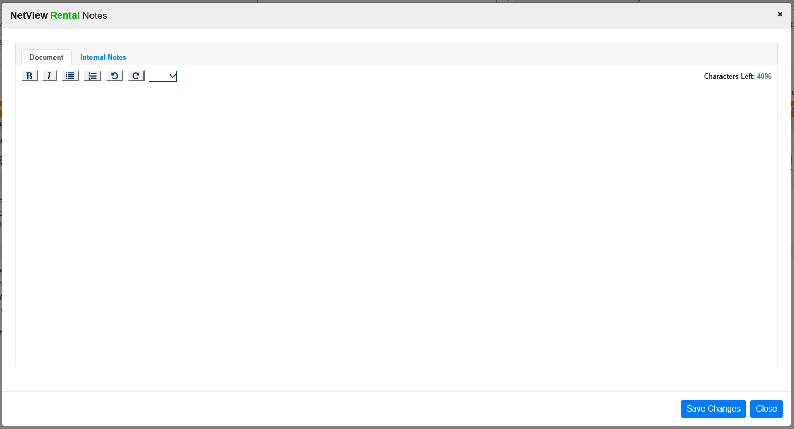

You can add public (appearing on the reservation documents) or internal (not available to customers) notes. The notes have a maximum character limit of 4,096, and the window will indicate how many characters you have left.

Click Save Changes to add the note. Once you do, the Notes icon will change to display a green indicator in the top right-hand corner to let you know that notes exist for this document.

Sign: Choose 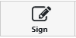 to add a personalized signature to the contract. The following window will appear:

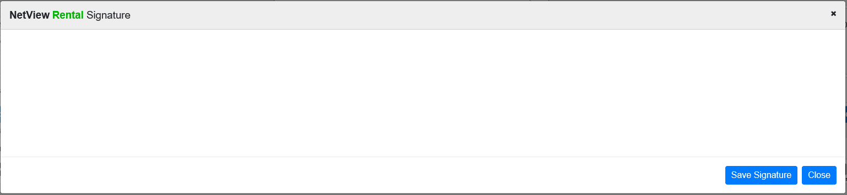

Have the customer sign via a mobile device (phone or tablet), a credit card processor with signature capture, or the computer (using the mouse). When you print a preview of the contract, the signature will automatically appear on the signature line on the bottom of the contract. NOTE: When adding a signature during the invoice process, you can only use a mobile device or a capable credit card processor.

Invoice Contract: Choose 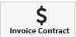 to make a payment on the contract. NOTE: You can make a payment at any point in the contract’s life cycle until it is closed.

The following window will appear:

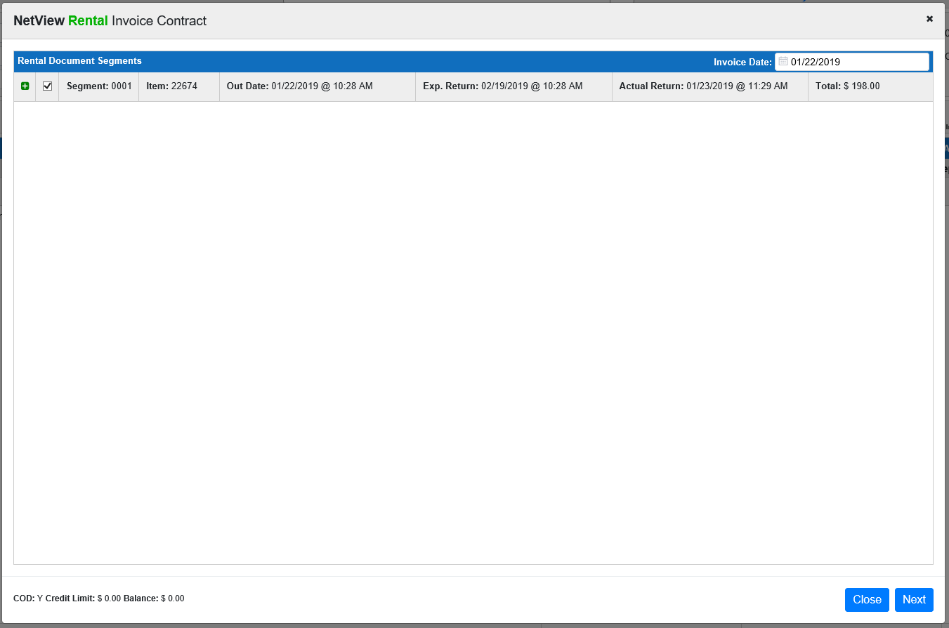

Select the segment(s) you want to make a payment on. You can expand the segment(s) shown to see the segment details.

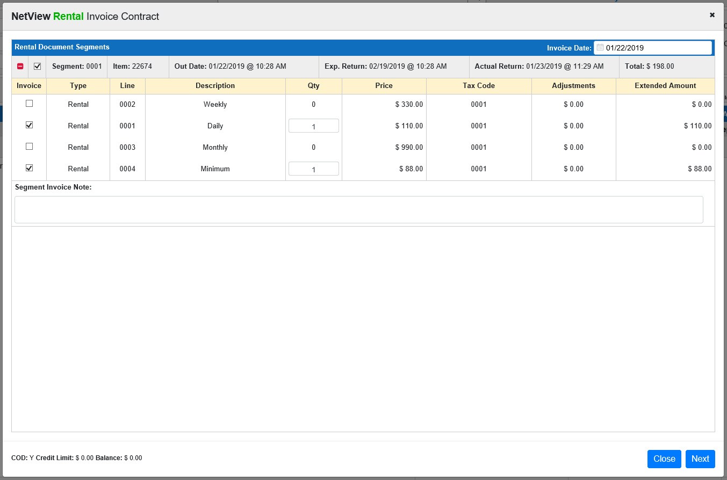

You can also adjust the invoice date if necessary, though you must make sure the date is in an open accounting month and does not exceed your system-set future date limit.

Click Next when you have reviewed/changed the segment charges.

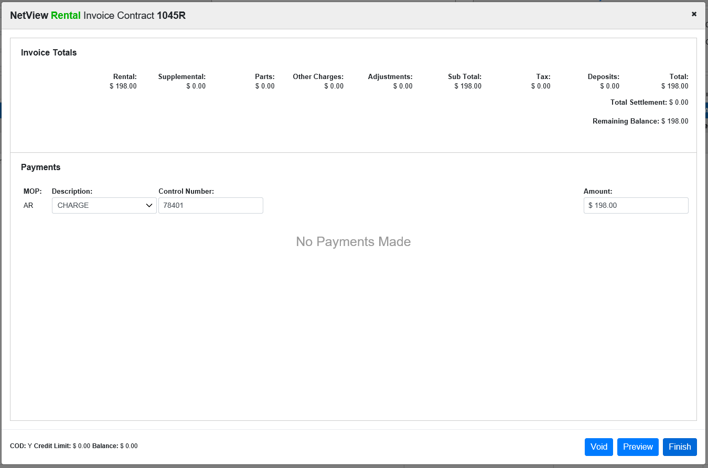

Select the method of payment from the next screen. You may choose multiple methods that equal the amount to be billed as needed (i.e. Check and Charge and Credit Card) or just one based on the situation. Enter the amount to be paid in the Amount field and hit the “Enter” key to record the payment. NOTE: If paying with a credit or debit card, the system will automatically activate EdgePay Input (EPIN) to process the payment.

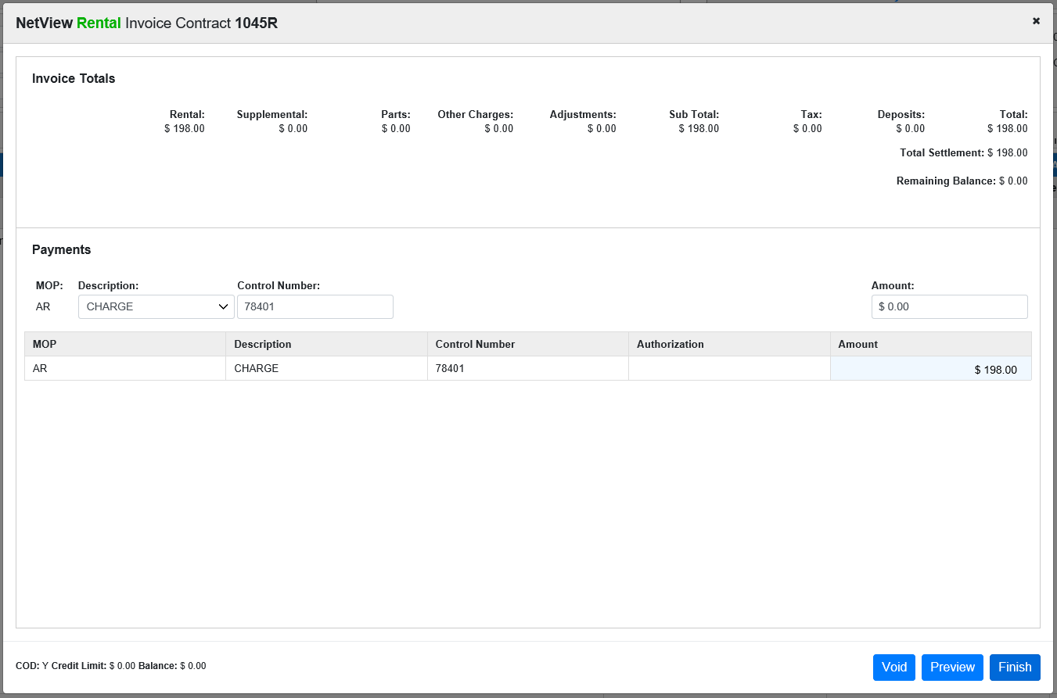

Click on Preview to examine the invoice before it is generated.

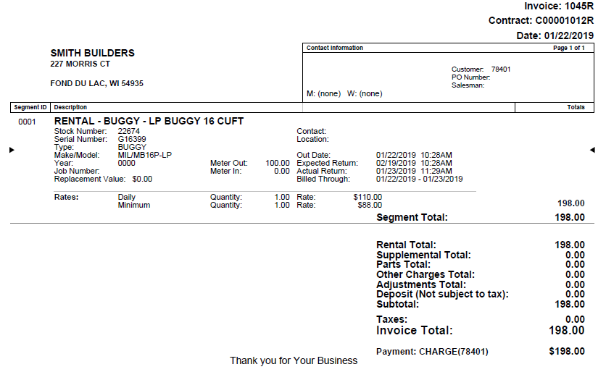

Click Void to void the invoice if you are unsatisfied with any detail. Click Finish to generate the invoice and make the payment. NOTE: See the Pending Invoices section for what happens if you begin invoicing a contract, but then close the window before finishing.

Invoice History: Choose 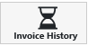 to access copies of rental invoices billed for this contract.

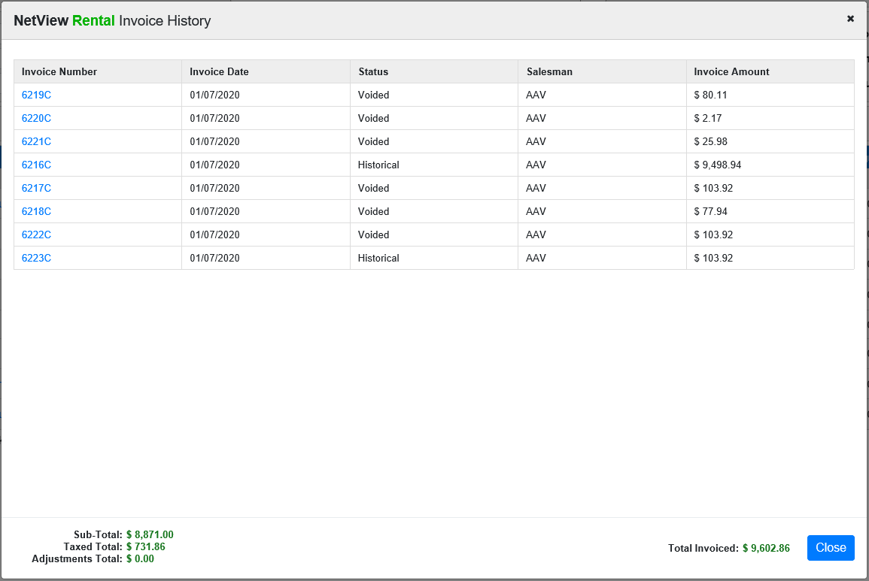

Click on an invoice to view or print it from this screen. You can also see totals related to the invoice payments at the bottom of the window: the sub-total of the rental charges, the total amount taxed, the total amount of adjustments, and the total amount invoiced overall.

Segment Actions: Reservation and contract segments share the same set of actions that affect only the specific segment instead of the entire document. However, certain actions are prohibited for certain stages of the reservation/contract life cycle, the details of which appear in the list of actions on the following pages. NOTE: These actions will be unavailable on a closed rental contract.

Rates: Click on 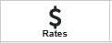 to see/edit the segment’s rate information.

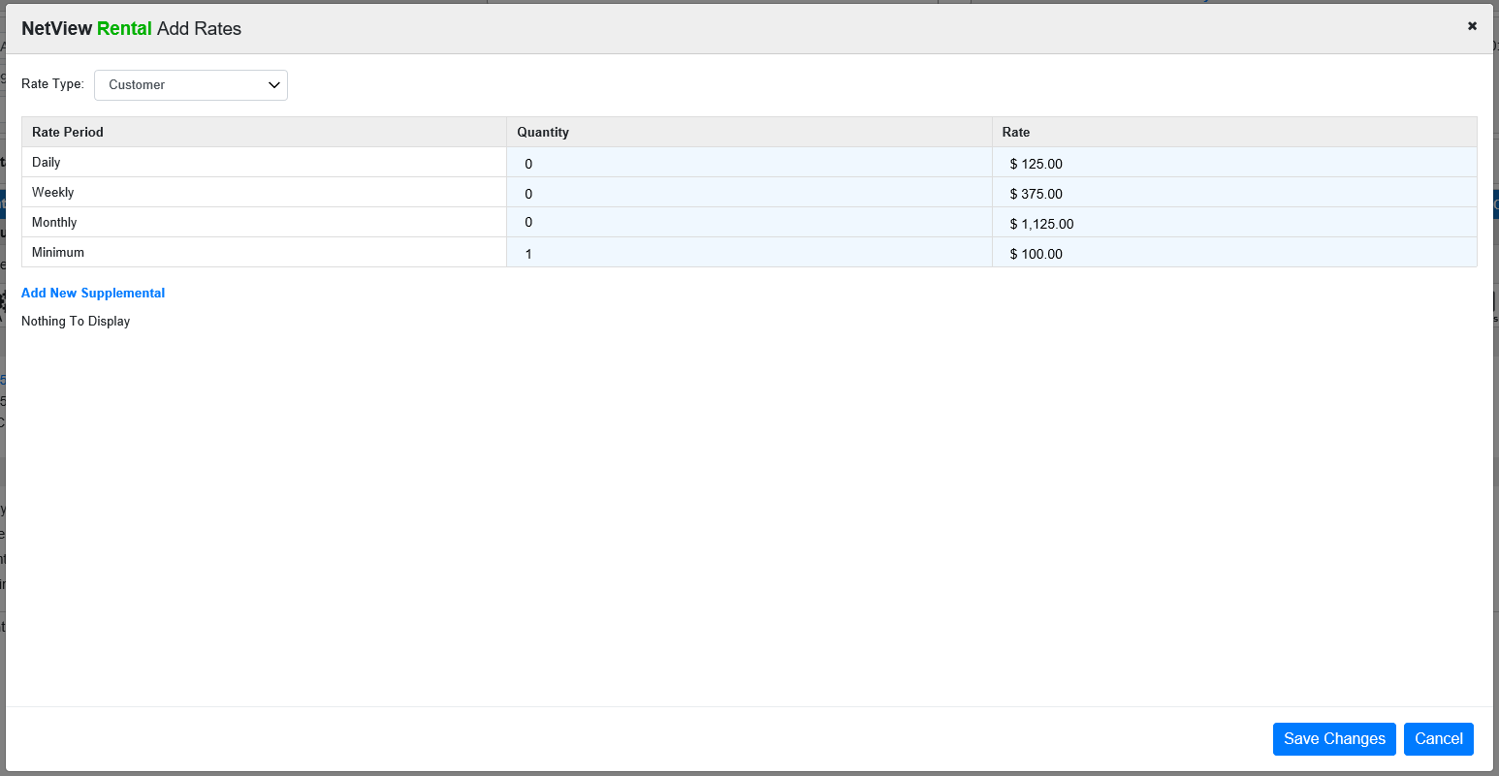

Here you see the rate type in use with the option to select another from the drop-down menu. The rate period info shown is based on the check-out/expected return dates entered. They can be changed as needed.

Any supplemental rates for this segment are shown in the bottom of the screen and can be changed as needed. You can also select “Add New Supplemental” to add a new supplemental rate to the contract.

Press Save Changes to apply any changes to the segment. Press Close to return to the segment.

Sell a Part: Click 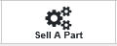 to manage parts sold on this segment.

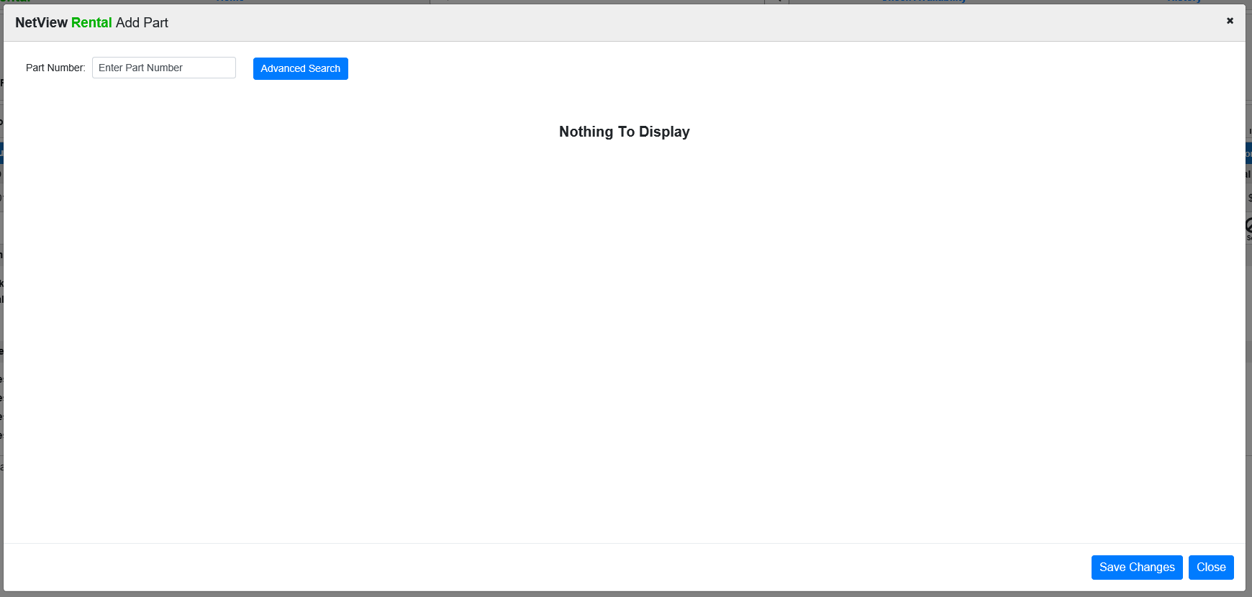

To add a part, you can type in a part number or use the provided button to do an advanced parts search.

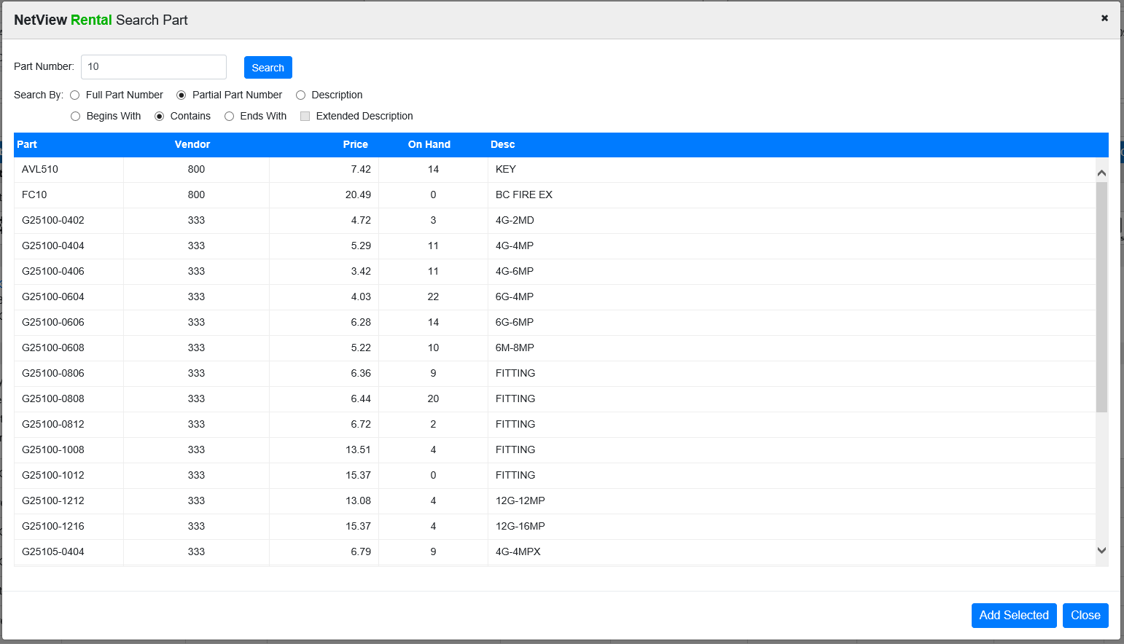

Select a part and click Add Selected to add the part.

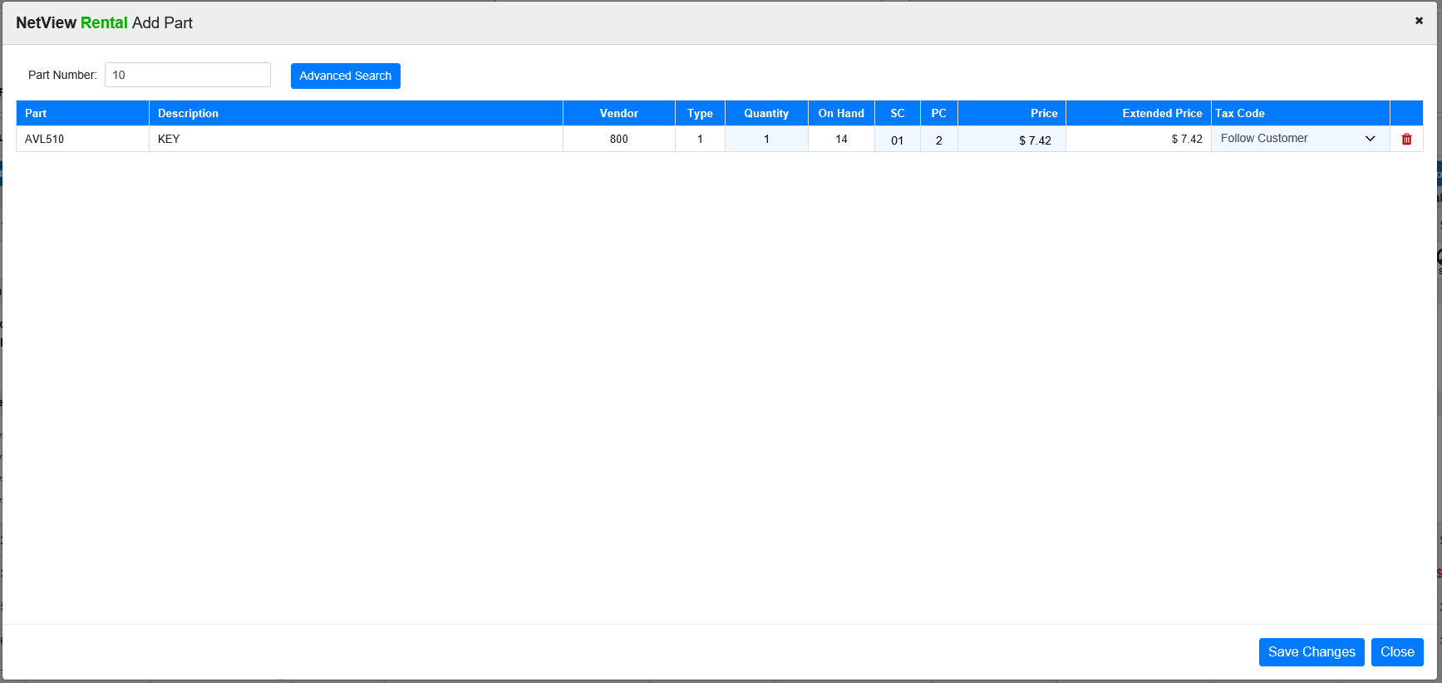

You can then use the Sell Part screen to view and edit all parts you add to the contract. Click Save Changes to save any added parts or new edits to the contract.

Other Charges: Click 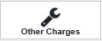 to add other charges to the segment (which don’t fall under any established charge category).

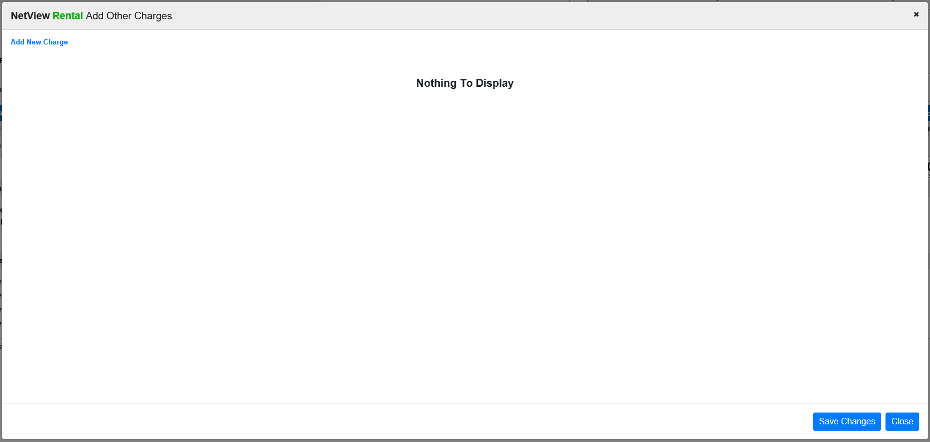

Click Add New Charge to see the available charges.

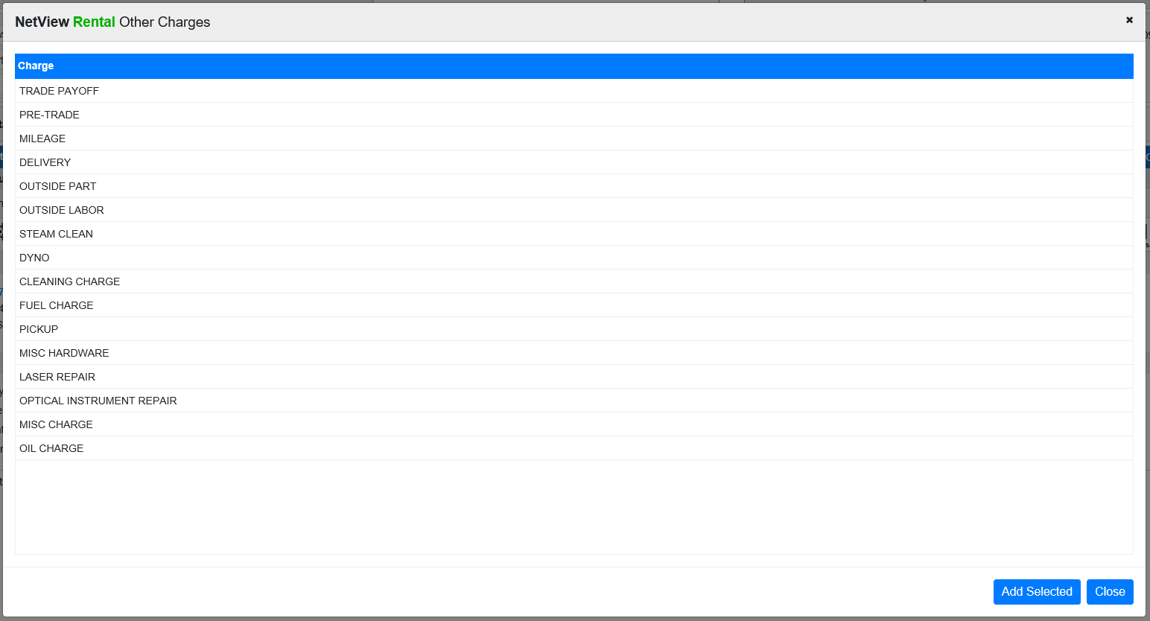

Select the charge and click Add Selected to have the charge display on the main window. Click Save Charges to add the other charges.

Sur/Adj: Click 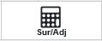 to review/change any percentage-based surcharges/adjustments on this segment. The following window will open:

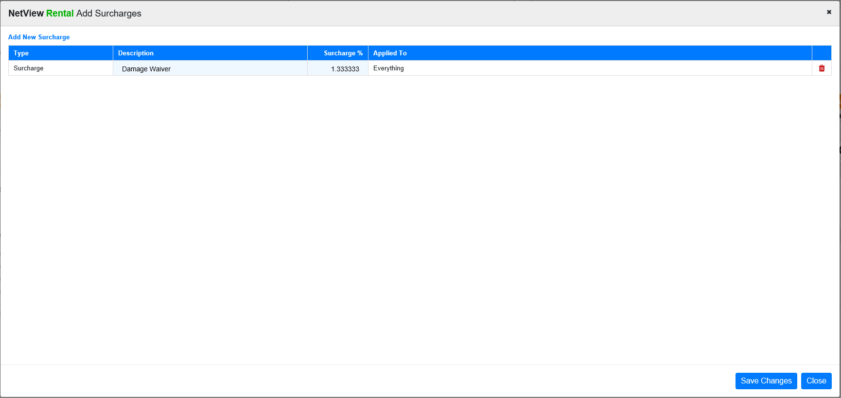

Use this screen to adjust existing surcharges.

To add new surcharges, click Add New Surcharge to view the list of available surcharges.

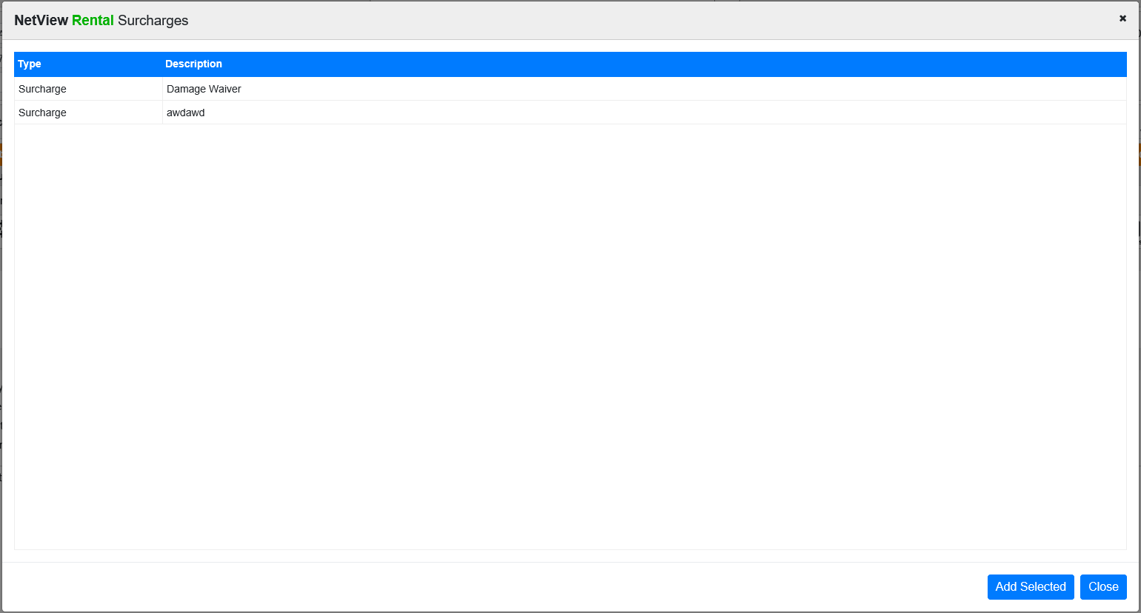

Choose the new surcharge and click Add Selected. Once you have your surcharges set, click Save Changes to add the new and/or adjusted surcharges.

Notes: Click 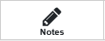 to review/change the segment notes.

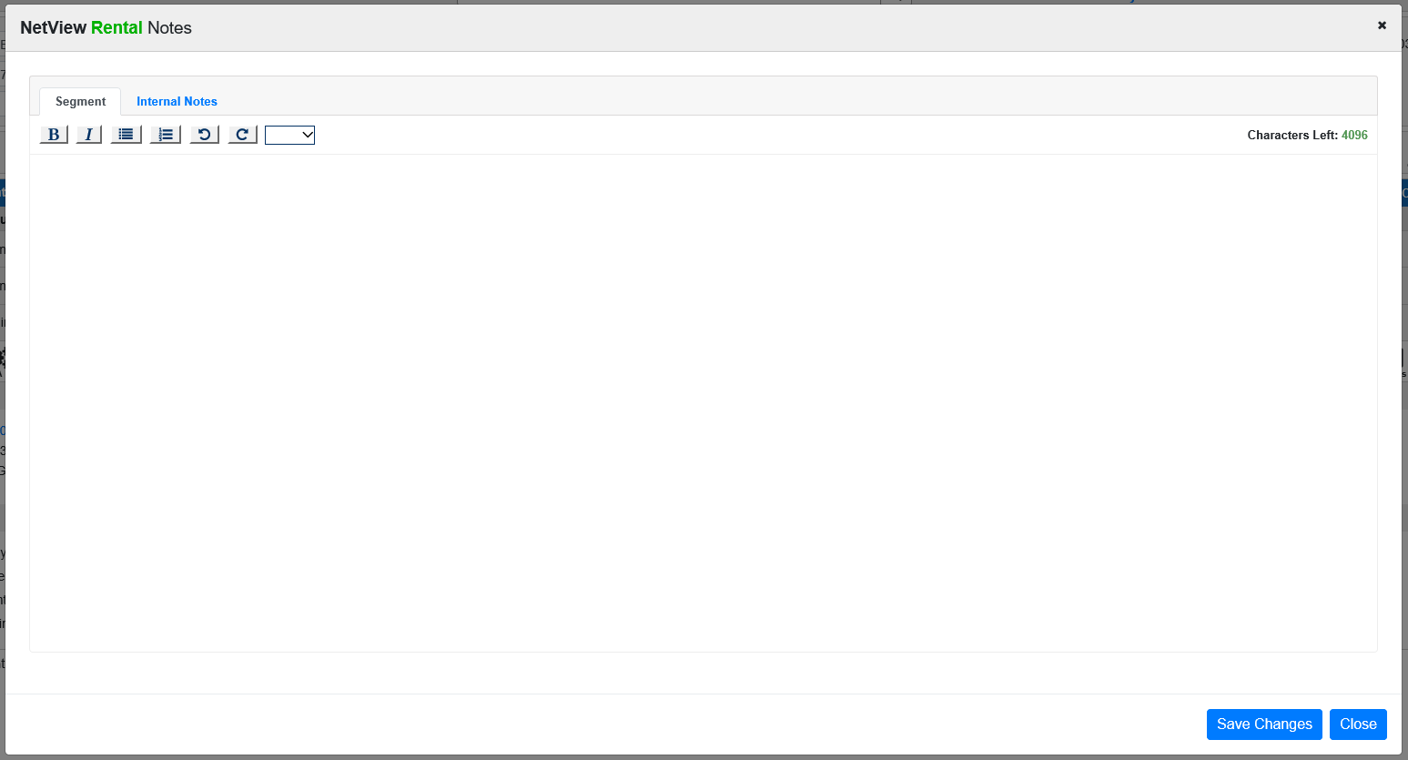

You can add public (appearing on the reservation documents) or internal (not available to customers) notes. The notes have a maximum character limit of 4,096, and the window will indicate how many characters you have left.

Click Save Changes to add the note. Once you do, the Notes icon will change to display a green indicator in the top right-hand corner 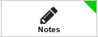.

Ship To Address: Click 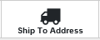 to edit the Ship To Address for the rental, or add an address if the contract lacks one. You can also add GPS coordinates for the address if it is your current location by clicking Capture Current Location, as well as view the history of GPS changes made by users by clicking Location History.

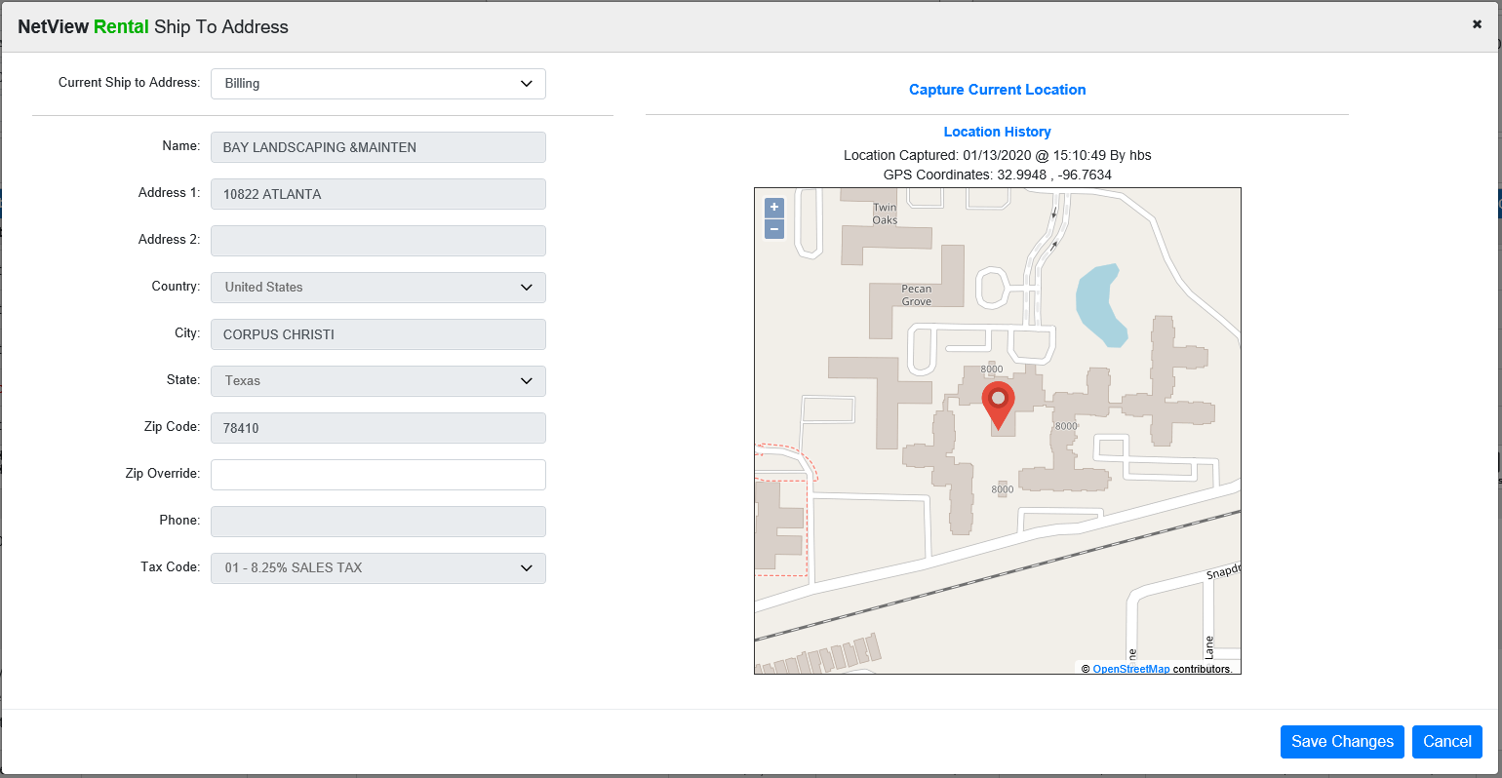

Select Contact: Click 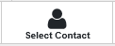 to edit the contact on the segment.

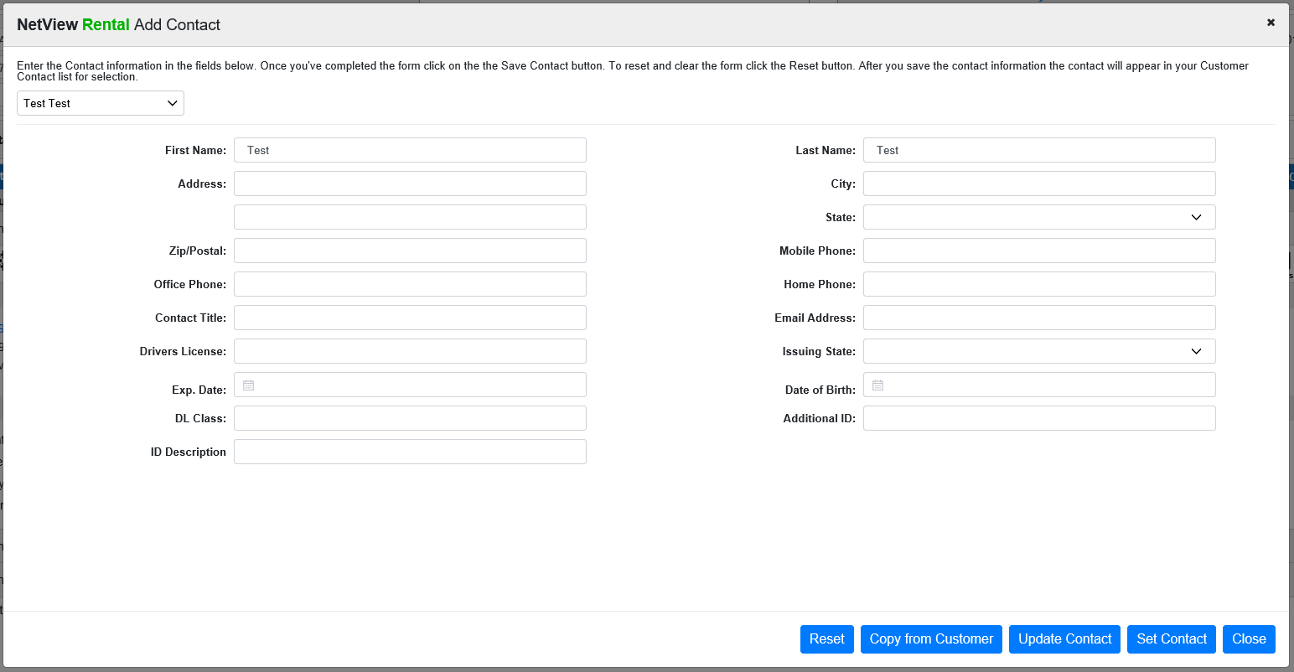

You can choose to copy the information from the customer’s Enter Customer Information (ECI) entry via the Copy from Customer button or manually edit the fields. Press Update Contact when all info has been entered to update the contact.

Edit Job ID: Click 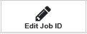to edit/change the Job ID on the segment.

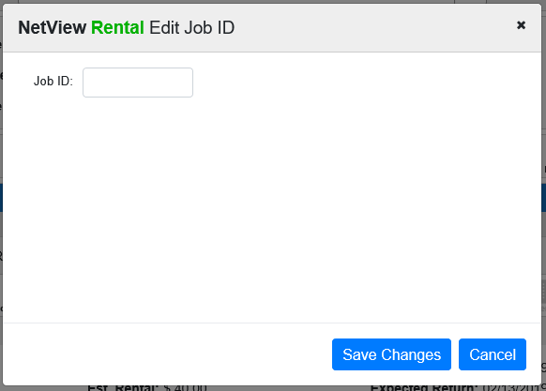

Rental SC/TX: Click 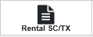 to adjust the sales tax rate and change the sales code to adjust where the accounting will post.

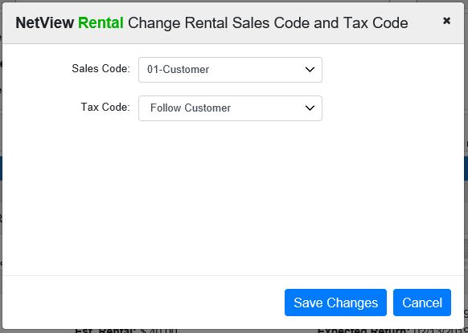

Exchange Item: Click 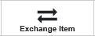 to exchange the segment item with another one. NOTE: If the segment’s status is Returned or the segment item is non-serialized, you cannot perform this action.

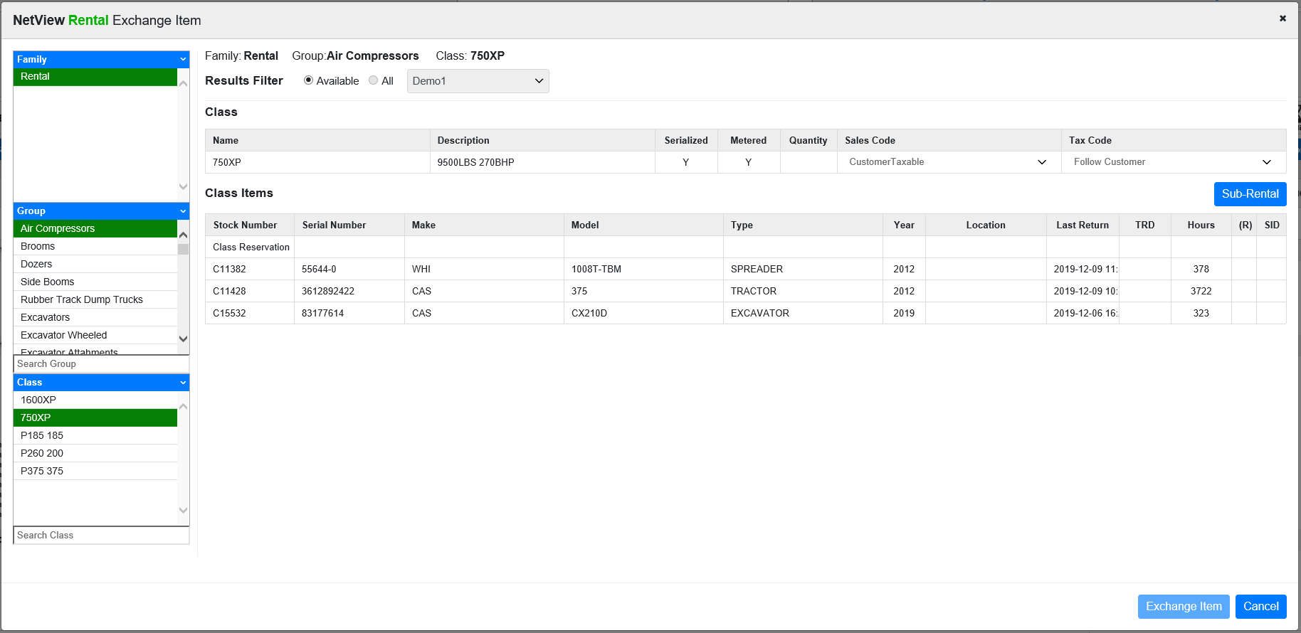

Select an available unit for exchange and click Exchange Item. You will be returned to the contract screen. If the exchanged item is not currently checked out, the exchange will occur automatically, and you will see the new item listed on the segment. However, if the item is currently checked out, the contract page will look like the image below:

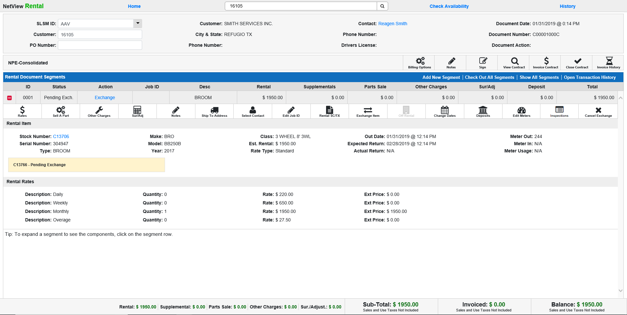

The segment’s status will now read “Pending Exch.,” the next available action will be “Exchange,” and a note will appear in the segment details indicating the pending exchange. Select the Exchange action to finalize the exchange.

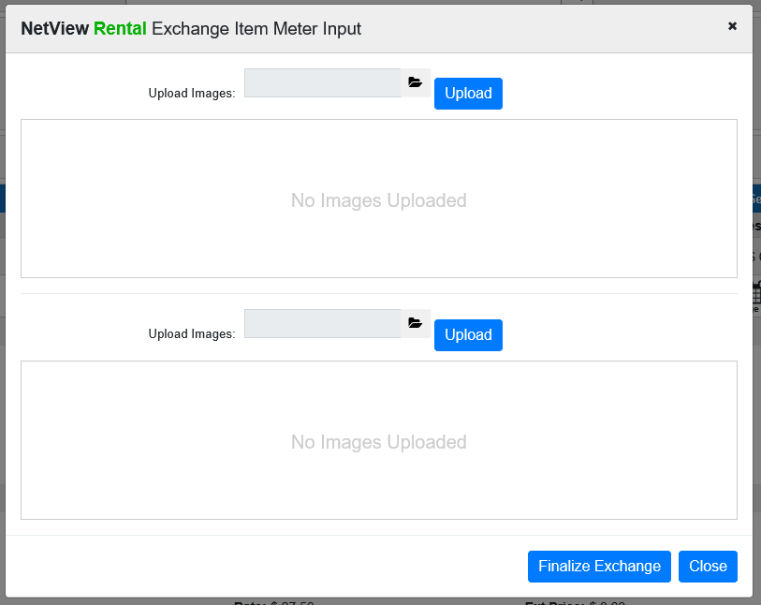

Cancel Exchange: This action only appears if the segment status is Pending Exch. Click this action to cancel a pending exchange. The following alert will appear:

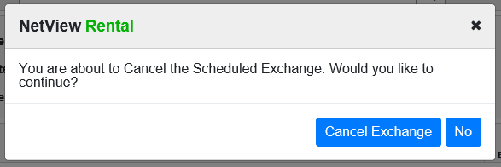

Select Cancel Exchange to complete the action.

Off Rental: Click 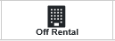 to take the segment item off rental, which would halt billing on the unit. NOTE: This feature is only active when the segment’s status is Out.

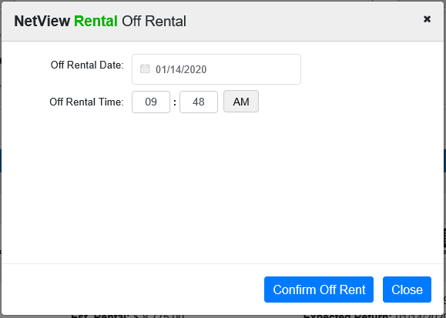

Change Dates: Click 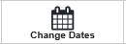 to change the start and end dates/times of the reservation/contract. NOTE: Once the rental is checked out, you will only be able to change the end date.

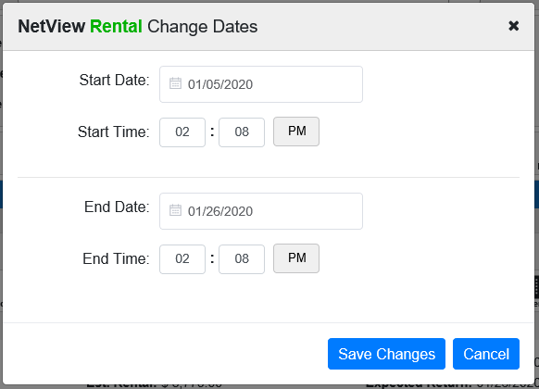

Deposits: Click 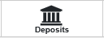 to add/edit a deposit on the segment.

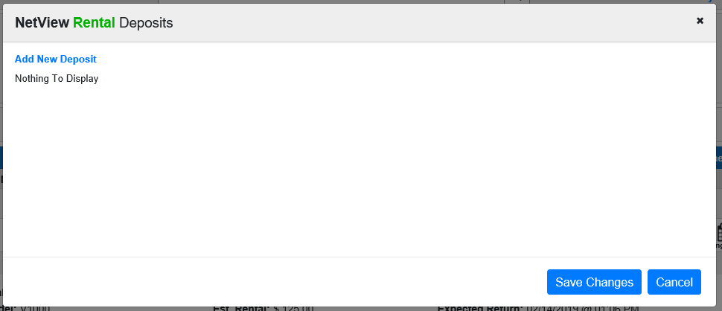

To add a new deposit, click Add New Deposit.

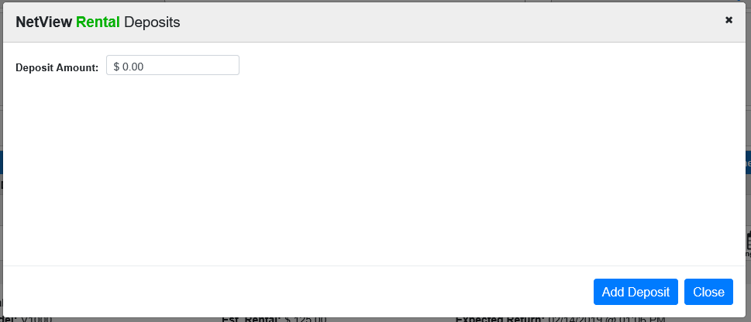

Click Add Deposit to add the deposit to the main screen. Click Save Changes to add the new or updated deposit amount to the contract/reservation.

Edit Meters: Click 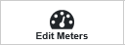 to edit any meter readings from the item. This action only appears on serialized units, only applies to metered units, and only becomes active after the unit has been checked out. You will be able to edit the Meter Out and Meter In as soon as you enter those values during Check In/Check out time, up until you settle the unit.

The image below shows a metered unit that has been checked out, thus showing only the Meter Out value.

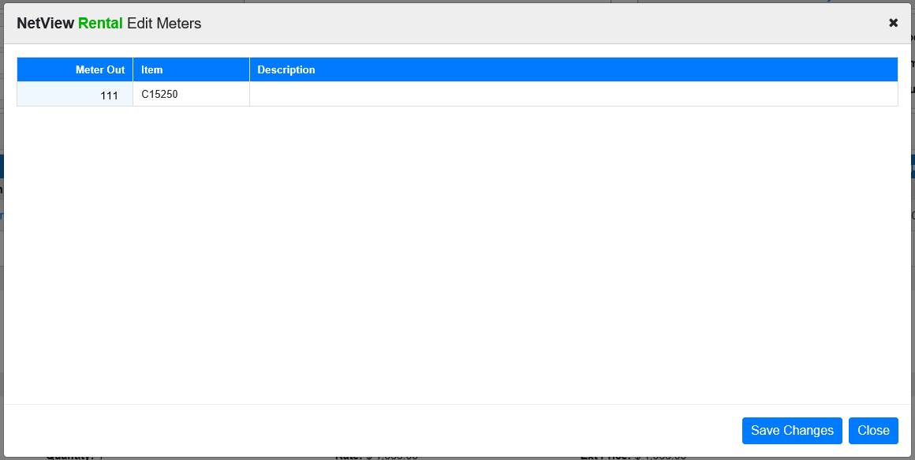

The main meter reading will appear by default, and secondary readings (such as for supplemental rates) will be added if they apply to the segment. You may also see a second meter reading if the unit was exchanged for another metered unit at any point after being checked out.

Partial Check-In: For non-serialized items, the Edit Meter action will be replaced by the Partial Check-In action. Click 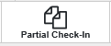 if you need to make a partial check-in and payment on a non-serialized rental segment. The following window will open:

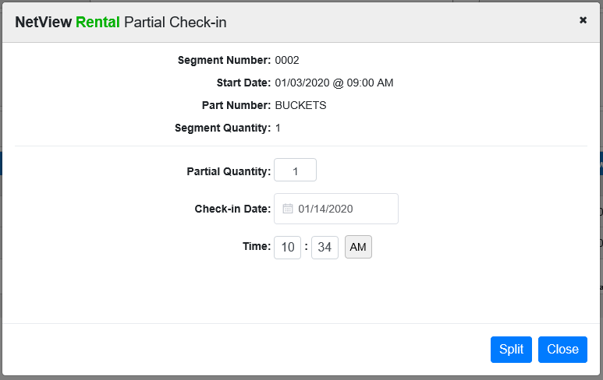

Enter the partial check-in quantity, as well as the check-in date and time, then click Split. You will receive a warning asking if you are sure you want to perform the partial check-in, as there is no way to reverse it. Click Yes to split the segment and make the partial check-in.

You will be returned to the contract screen, where you will see that a new, Checked-In segment has been added at the bottom of the contract for the partial quantity. The original segment will also have altered to show only the remaining quantity checked-out. You will then be able to invoice and close the segments separately.

Inspections: Click 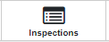 to open the Record360 login page.

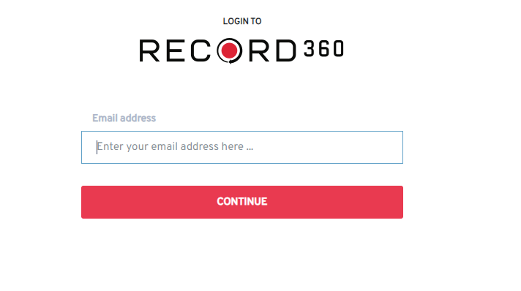
If you have an account, you can log in and view inspections information for the unit listed on the contract segment, courtesy of Record360’s InspectionsPro software.

Void Segment: Click 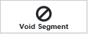 to void the segment. NOTE: The action will not appear on segments with a status of Out or Closed, but will be available for reservations and all other segment statuses.

The following window will appear:

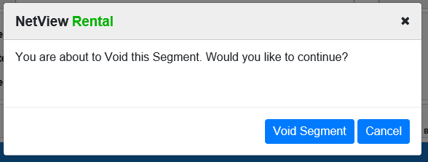

Click Void Segment to void the segment. NOTE: If the segment has been invoiced, you cannot void it.

Check-In Process: When the rental is returned, access the contract in RENT. Click Check-In on the appropriate segment line to begin. The following window will appear:

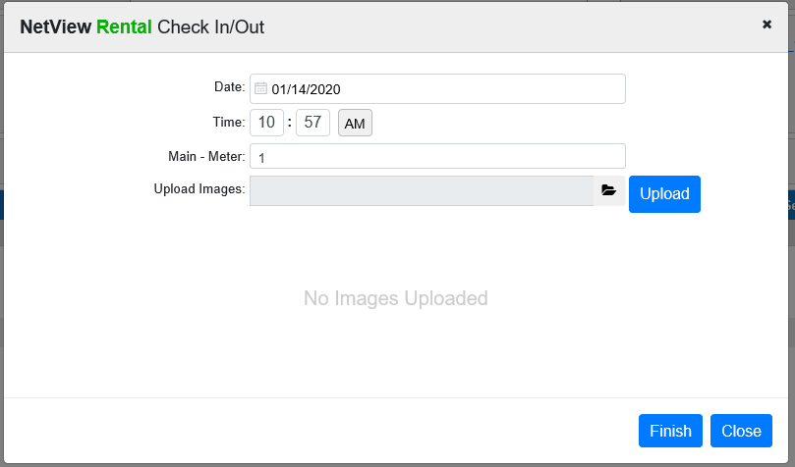

Review the check in date and time. If the rental has a meter, a prompt will appear for entry of the primary meter reading upon return. If there is a secondary meter on the rental, you will be prompted for its reading as well.

If you want to add an image to the contract, use the Browse feature to select an image file and then click Upload. A preview of the image will appear in the window.

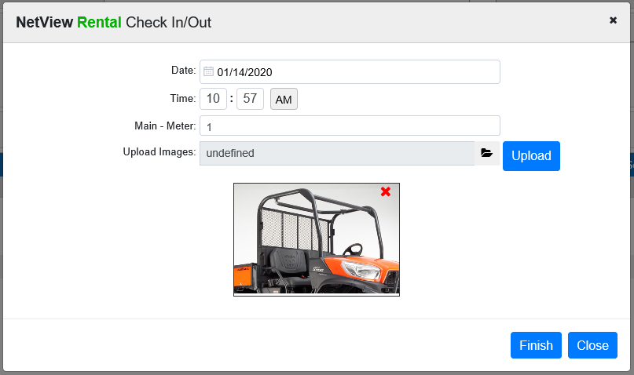

Click Finish. You are then returned to the contract and the rental item has now been checked in. Notice the Action field shows Settle now.

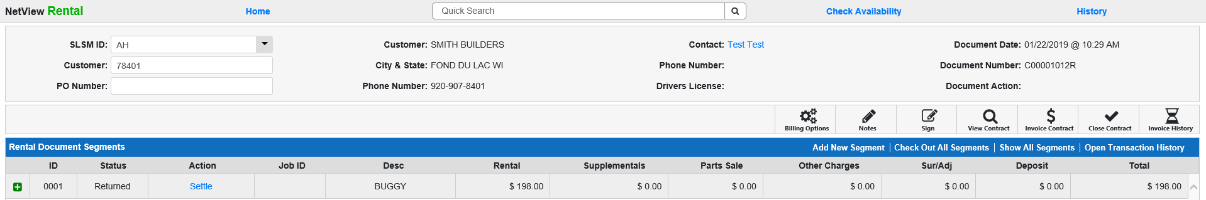

Settle Segment: Click Settle to bill and settle the segment. The following window will appear:

Unlike Invoice Contract, you will only be able to make a payment on the segment you are settling. You can expand the segment to see and adjust the segment details.

You can also adjust the invoice date if necessary, though you must make sure the date is in an open accounting month and does not exceed your system-set future date limit.

Click Next when you have reviewed/changed the segment charges.

Select the method of payment from the next screen. You may choose multiple methods that equal the amount to be billed as needed (i.e. Check and Charge and Credit Card) or just one based on the situation.

Enter the amount to be paid in the Amount field and hit the “Enter” key to record the payment.

Click on Preview to examine the invoice before it is generated.

Click Void to void the invoice if you are unsatisfied with any detail. Click Finish to generate the invoice and (provided you paid the full balance) settle the segment. The segment status will change to Returned and the Action column will be blank, as there are no further required actions for the segment.

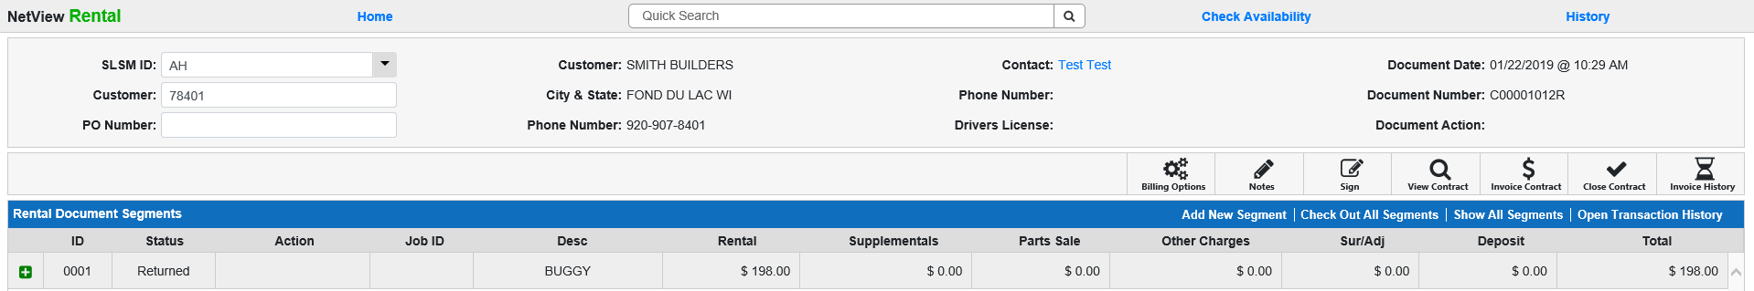

Pending Invoices: If you begin invoicing a contract, but close the window before finishing, that invoice will be added to a list of pending invoices that will appear when you initially open RENT:

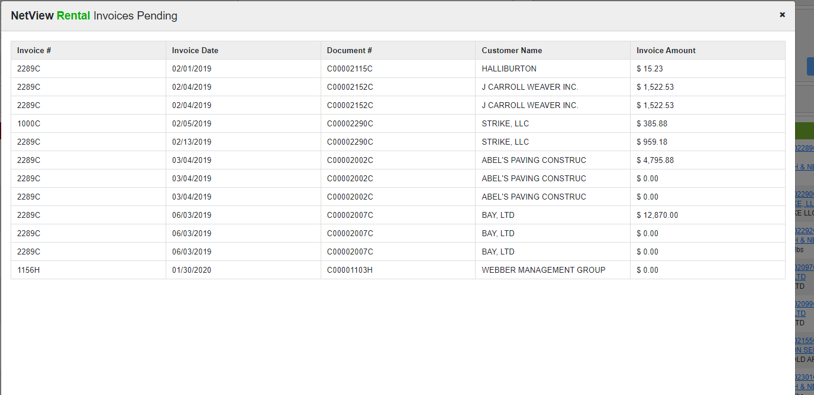

You can click on an invoice to complete it.

WARNING: Once you open the invoice here, you MUST finish processing it, or it will be VOIDED. Do not close the window without finishing the invoice, or you will risk voiding EVERY pending invoice.

Close Contract: When all units have been returned and billed, click 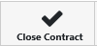 to close the contract. The following window will appear:

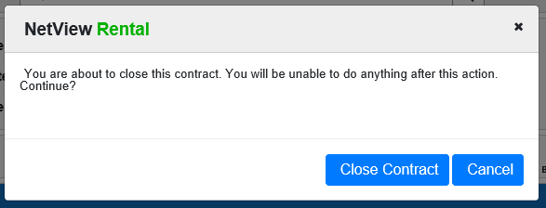

Click Close Contract to complete the action. This will suspend all billing currently occurring on the contract.

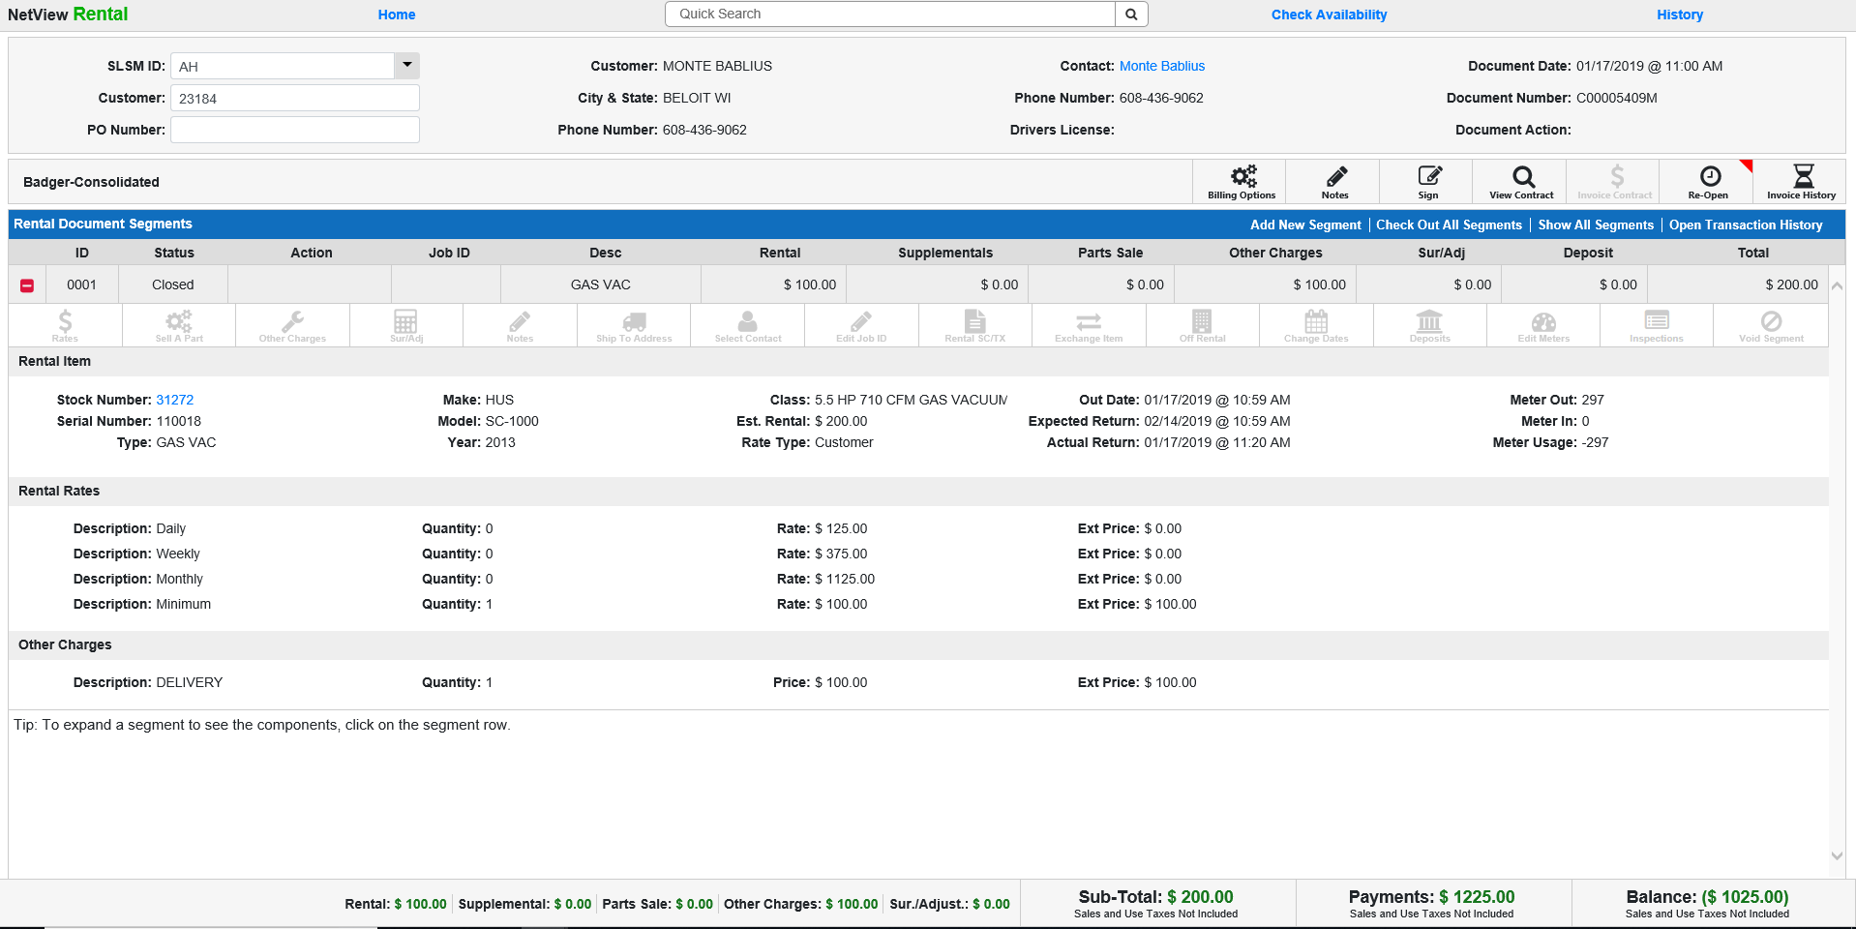

Several changes have occurred:

- The contract status has changed to Closed.
- All segment actions have been disabled.
- The Invoice Contract action has been disabled.
- The Close Contract action has changed to 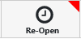.

Note that closing the contract is not permanent. You can always re-open it as needed by choosing the Re-Open action.

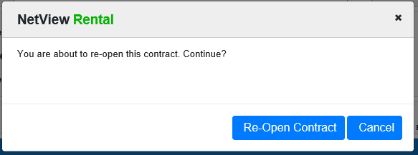

Click Re-Open Contract to return the contract to its status pre-closing.

