Rental Setup—Other Charge Maintenance (OCM)

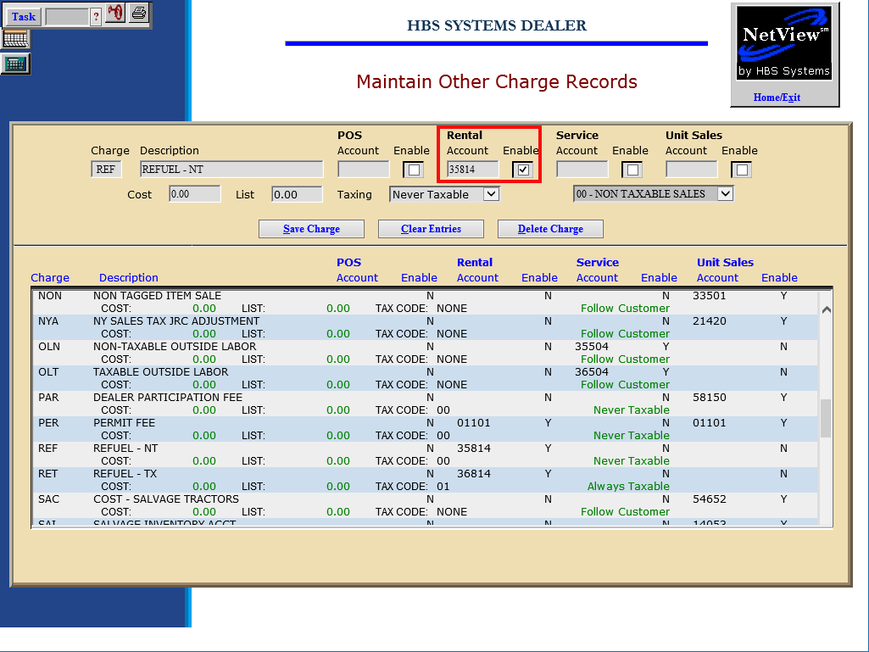

Finally, use Other Charge Maintenance (OCM) to define additional charges for Rental. These additional charges are line items that can be added to the invoice. Examples: Sales Tax, Delivery Fees, Fuel, Set-Up, UCC Fees, Extended Warranty, Trade Pay Off, etc.

To access this function, you can either:

- Select “System Maintenance” from the menu and choose the “Company File” submenu. Click on “Other Charge Maintenance.”
- Type “OCM” in the Shortcuts Bar.

Field Definitions:

Charge: This is a 3-character code for the other charge defined. It is used for record maintenance and does not appear on the invoice.

Description: This field holds the description of the other charge that will print on the invoice.

Rental Account:
This field holds the General Ledger account that will receive the amount for this charge. Click on the Enable field to its right to activate it. Choose the appropriate account for Rental for this charge.

Rental Enable: Click on this field to the right of the Rental Account field to use it in the identified invoicing screen.

Cost: This field can hold the cost of the Other Charge. It should only be filled in if the cost is ALWAYS the same.

List: This field can hold the selling price of the Other Charge. If the price of this Other Charge is always the same, it could be entered here.

Taxing: This field lets you set how the sales tax on the other charge can be handled.

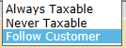

- Choose Always Taxable if it will be always taxable and choose the Tax Code that applies.

- Choose Never Taxable if it never is subject to sales tax and choose the Tax Code that applies.

- Choose Follow Customer if the tax on the other charge will follow the customer’s tax status.

Press the “Save Charge” button to save the record. All entries in OCM that are tagged as Rental will display in the Other Charges tab in Names and Definitions in Rental Charge Maintenance (RCM).

