Rental Setup—Unit Source Maintenance (USM)

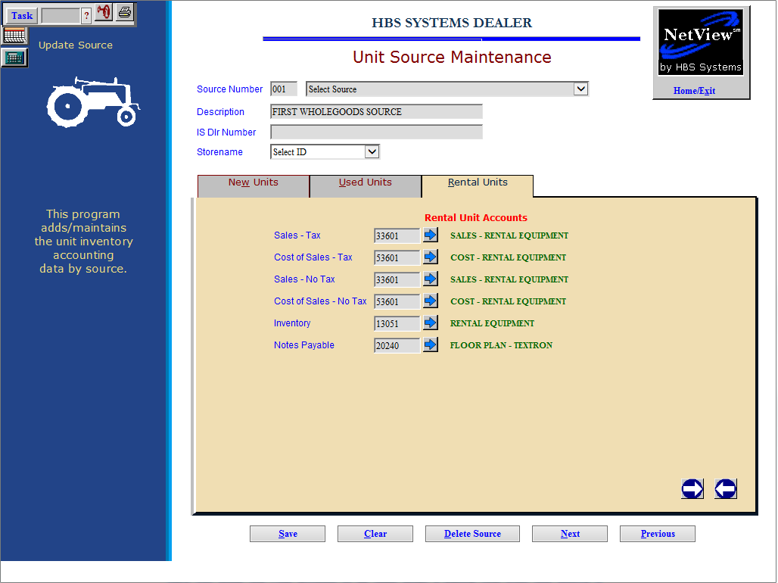

Use Unit Source Maintenance (USM) to add Rental Unit accounts to Unit sources that provide for your Rental department.

To access this function, you can either:

- Select “Units” from the menu and choose the “Data Entry” submenu. Click on “Unit Source Maintenance.”
- Type “USM” in the Shortcuts Bar.

Select the Unit source you wish to add Rental Unit accounts to, then click the Rental Units tab.

Field Definitions:

Sales Tax: This field functions exactly as it does for New or Used Equipment. Here you enter the Sale account to be used when a Rental unit from this source is being sold while in the Rental system, and the transaction is taxable. Type in the General Ledger account number or search for it using the arrow icon.

Cost of Sales – Tax: Here you enter the Cost account to be used when a Rental unit from this source is being sold while in the Rental system, and the transaction is taxable. Type in the General Ledger account number or search for it using the arrow icon.

Sales – No Tax: Here you enter the Sale account to be used when a Rental unit from this source is being sold while in the Rental system, and the transaction is nontaxable. Type in the General Ledger account number or search for it using the arrow icon.

Cost of Sale – No Tax: Here you enter the Sale account to be used when a Rental unit from this source is being sold while in the Rental system, and the transaction is nontaxable. Type in the General Ledger account number or search for it using the arrow icon.

Inventory: This field holds the General Ledger account number for the Inventory account where the value of the Rental units for this source is kept. Type in the account number or search for it using the arrow icon.

Notes Payable: This field holds the General Ledger account number for the Notes Payable account where the liability of the Rental units for this source is kept. Type in the account number or search for it using the arrow icon.

Click Save once you have filled in all the account fields. Repeat the procedure on all Unit sources associated with your Rental department.

