Rental History (RH)

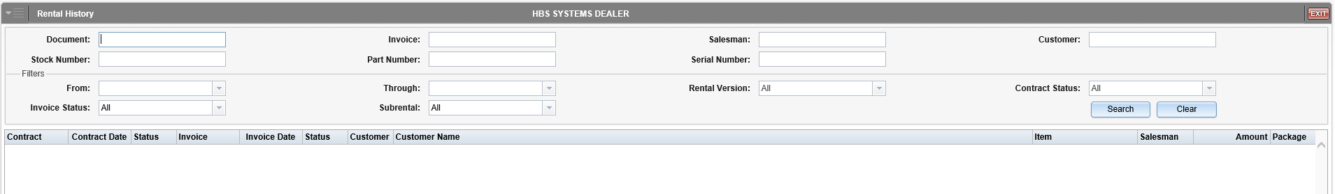

Rental History (RH) allows you to access historical Rental documents stored in the system.

To access this function, you can either:

- Select “Rental” from the menu and click “Rental History.”
- Type “RH” in the Shortcuts Bar.

To locate a document, use the search criteria and filters in the application header.

Header-Field Definitions:

Document: To search for a particular document, enter all or part of the document number in this field.

Stock Number: To search for documents concerning a particular unit, enter the unit’s stock number in this field.

Invoice: To search for an invoice and/or documents connected to it, enter the invoice number here.

Part Number: To search for documents concerning a particular part, enter the part number in this field.

Salesman: To search for documents concerning rentals made by a particular salesman, enter the salesman’s initials in this field.

Serial Number: To search for documents concerning a certain unit/part by its serial number, enter the number in this field.

Customer: To search for documents concerning a particular customer, enter the customer number in this field.

From/Through: To search for documents within a specific time period, either:

- Enter the starting and ending dates in these fields.
- Use the down-pointing arrows in the fields to select them from calendars.

Rental Version: To search for documents created in a specific version of NetView Rental (previous or current), select an option from the drop-down menu. Your choices are:

- All
- Old Rental
- New [Current] Rental

Contract Status: To search for rental contracts with a specific status, select an option from the drop-down menu. Your choices are:

- All
- Closed
- Open

Invoice Status: To search for invoices with a specific status, select an option from the drop-down menu. Your choices are:

- All
- Historical
- Voided

Subrental: To filter the search for documents involving subrentals, use the options on this drop-down menu. Your options are:

- All
- Subrental Only
- Rental Only

Search: Click Search to generate a list of results based on your choices.

Clear: Click Clear to clear the header fields of all entered search terms.

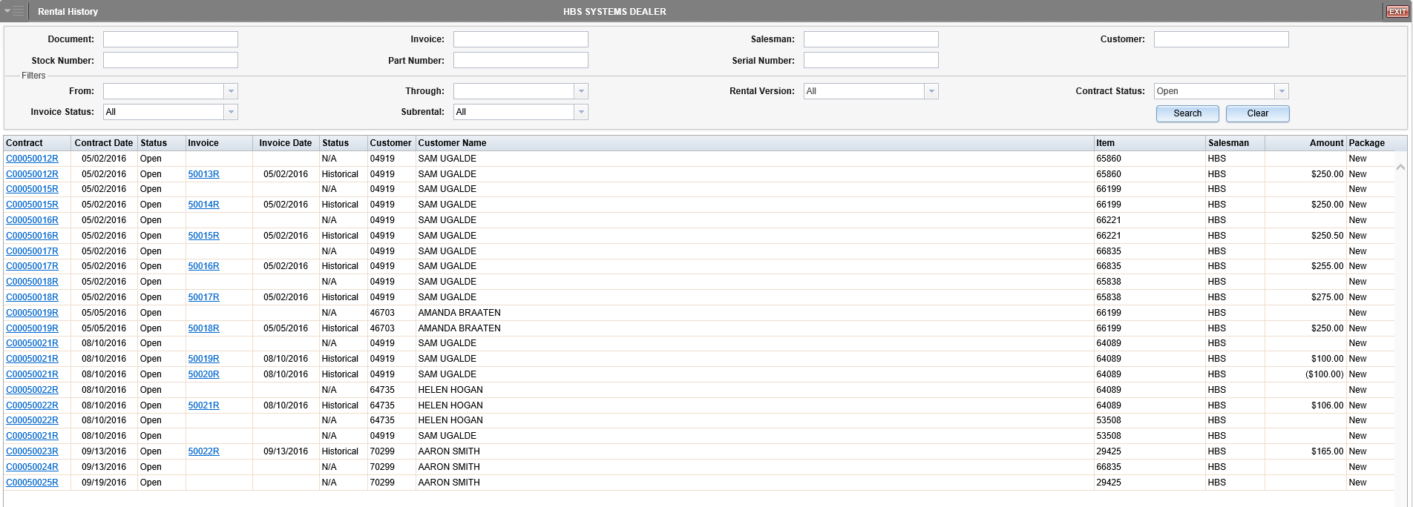

Search Results Detail: The results are listed by contract number. Each entry also includes the following information:

- Contract Date
- [Contract] Status
- Invoice (if applicable)
- Invoice Date (if applicable)
- [Invoice] Status
- Customer Number
- Customer Name
- Item Number
- Salesman
- Amount
- Package

Printing/Viewing Documents: If a contract or invoice number is colored blue and underlined, then you can print and/or view the document. Click the number to access the print option, which will read “Print Contract” or “Print Invoice” depending on the document type.

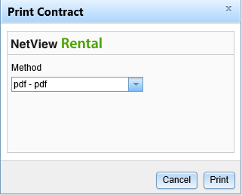

Select the printing method from the drop-down menu. To view the document, use the pdf printer. If you want to email the document to someone, use the E-Mail option.

Sample Contract

