Rental Inbound Report: The Rental Inbound Report in Rental Reports (RR) creates a list of rented units whose expected return dates fall within the time frame chosen for the report.

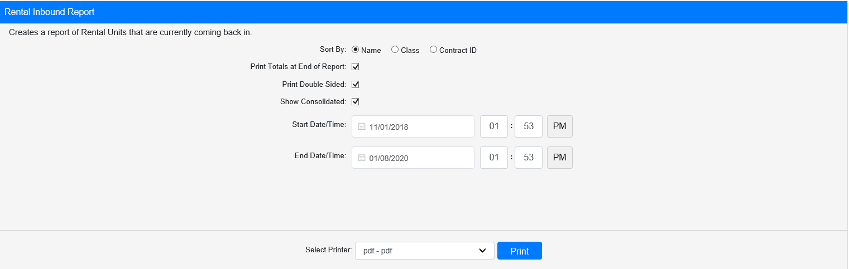

Field Definitions:

Sort By: Choose how to sort the report:

- Name
- Class
- Contract ID

Print Totals at End of Report:

- Check this box to print a total count at the end of the report.
- Leave it unchecked to omit the totals.

Print Double Sided:

- Check this box to print the report pages double-sided.
- Leave it unchecked to print the report pages single-sided.

Show Consolidated: If you are a multi-location dealership with a Consolidated location, check this box to include the Consolidated location’s information on your report. Uncheck it to only print a report for your individual location. NOTE: If running the report in the Consolidated location, you must check this box to receive a report.

Start Date/Time: Enter the start date/time for the report here. All units listed on the report will have their expected return date/time scheduled at or after that point in time.

End Date/Time: Enter the end date/time for the report here. All units listed on the report will have their expected return date/time scheduled before or at that point in time.

Select Printer: Select the printer to receive the report. Use the pdf printer to preview the report.

Click “Print” to print the report.

Sample Report:

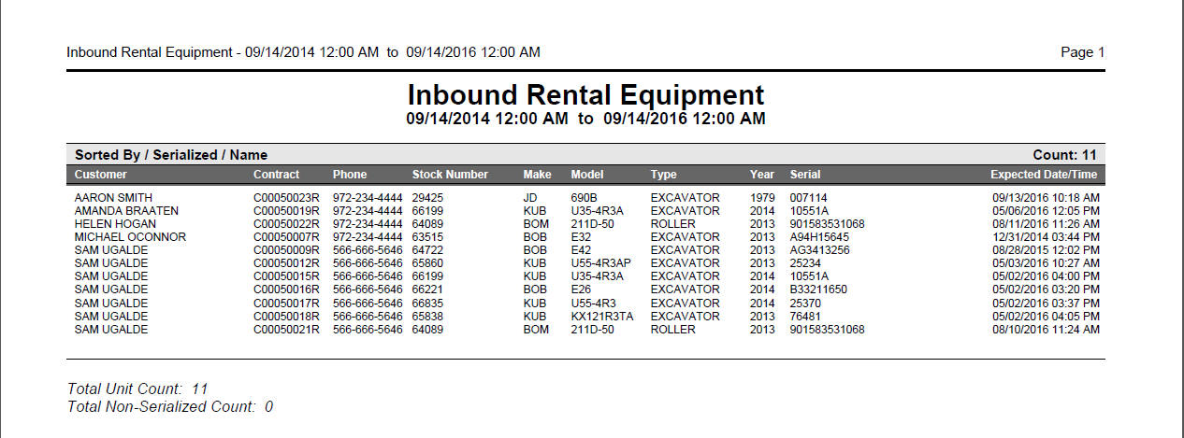

This sample report is sorted by Name. It lists the following information:

- Rental customer
- Contract number
- Contact phone number
- Stock number
- Make
- Model
- Type
- Year
- Serial number
- Date and time return expected

If you chose to print Totals at the end of the report, you will see a total count for both the serialized and non-serialized units included on the report.

