Rental Options and Defaults (ROD)

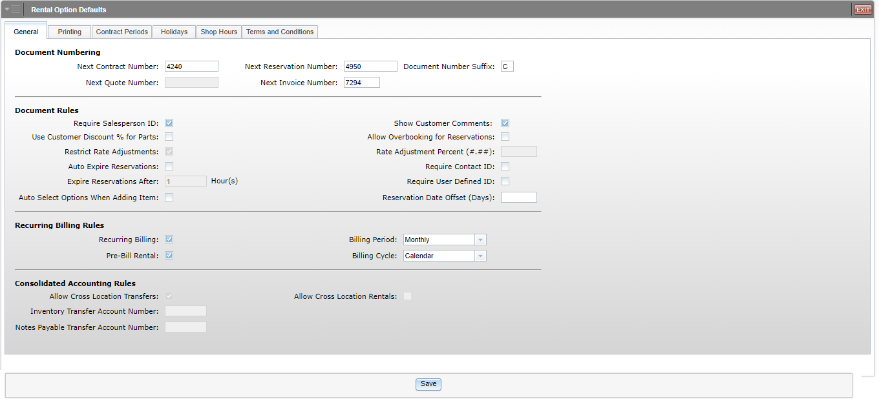

This screen provides the setup options and defaults for many of the Rental functions. Defaults are grouped together in tabs for easier navigation.

To access this function, you can either:

- Select “Rental” from the menu and click “Rental Options and Defaults.”
- Type “ROD” in the Shortcuts Bar.

General Tab:

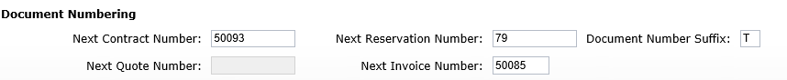

Document Numbering: This section provides fields to hold the next system-generated numbers for the following documents:

- Next Contract Number
- Next Quote Number
- Next Reservation Number
- Next Invoice Number
- Document Numbers Suffix (Typically used in multi-location setups)

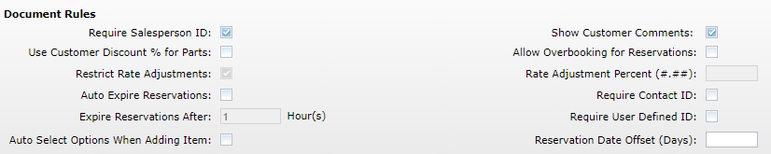

Document Rules: This section provides options to set general rules for some of the Rental functions on a reservation or contract.

Require Salesperson ID: Check this box if you want to require the Salesperson ID on a reservation or contract.

Show Customer Comments: Check this box to display customer comments, should they exist, every time you open a reservation or contract for a customer.

Use Customer Discount % for Parts: Check this box if you want to use the discount percent in Enter Customer Information (ECI) for the Rental parts on a reservation or contract.

Allow Overbooking for Reservations: This setting allows you to intentionally overbook Rental reservations, meaning you can overlap reservations that vie for the same time period.

Check the box to activate the option.

Leave it unchecked to prevent overbooking units for the same time period.

Restrict Rate Adjustments / Rate Adjustment Percent: These 2 fields offer the ability to control the adjustments of Rental rates in the reservation and contract process.

To set control over adjusting the rates, check the Restrict Rate Adjustments box and then indicate the amount (percent) of adjustment allowed in the Rate Adjustment Percent field. For example, 20.00% allows adjustment of the Rental rate up or down 20.00%.

Leave the Restrict Rate Adjustments box unchecked if the rates can be adjusted without any limits.

Auto Expire Reservations / Expire Reservations after __ hours: These 2 fields control the expiration of reservations.

A reservation can be set to auto-expire after the number of hours specified in the Expire Reservations after field by checking the Auto Expire Reservations box. For example, enter “4” to have reservations automatically expire if not converted into contracts within 4 hours of the intended start time.

Leave both blank if the reservations need not expire.

Require Contact ID:

- Check this field if you require a Contact ID (contact name) when entering a new reservation or contract.
- Leave it unchecked if no contact is required.

Require User Defined ID:

- Check this field if you require a User Defined ID (DL license, insurance card, etc.) when entering a new reservation or contract.
- Leave it unchecked if it is not required.

Auto Select Options When Adding Items:

- Check this box to have automatically select all available Surcharges, Adjustments, and/or Other Charges when you add an item to a Rental Reservation.
- Leave the box unchecked to prevent them from being automatically added to the reservation.

Reservation Date Offset (Days): Use this field to set a default document date range when creating a Rental reservation. Enter the number of days you want as the default Rental period when creating a reservation. The next time you put a Start Date in for a rental, the End Date will default to a date that number of days out from the Start Date. For example, if you put “10” in this field and set the Start Date of your next reservation to May 14th, the End Date will automatically default to May 24th.

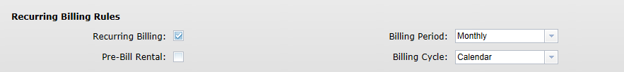

Recurring Billing Rules: This section provides options to set general rules for recurring billing on a contract.

Recurring Billing: Check this box to use recurring billing. Recurring billing can be engaged when a serialized or non-serialized unit is kept beyond its initial rental period/expected return. For example, if a customer rents a unit for a month and then needs to keep it for 2 additional months, recurring billing could kick in and bill for those additional rental periods as the contract comes up to the billing period.

Pre-Bill Rental:

- Check this box if your business routinely bills for a rental up front when the unit is checked out.
- Leave it unchecked to choose the option as needed when the rental contract is processed.

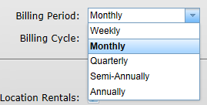

Billing Period: Choose an option from this drop-down menu to determine when Rental billing/invoices will be initiated/generated next. Choices include:

Weekly

Monthly

Quarterly

Semi-Annually

Annually

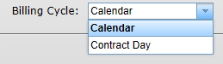

Billing Cycle: This drop-down menu offers 2 choices to specify when the billing date should be. Choose the one that fits your business.

Calendar billing means that the billing will occur on the first calendar day of the month, quarter, semi-annual, or annual period regardless of the actual day the rental started.

Contract Day means that the billing will be based on the day the rental started and will be incremented in calendar months, or 28-day months, for the month, quarter, semi-annual, or annual billing periods that follow.

Consolidated Accounting Rules: This section provides fields for multi-location dealerships and preferences for transfers and rentals between locations. Options here can only be changed in a Consolidated location. NOTE: If you do not have a consolidated location, you will not see this section.

Allow Cross Location Transfers:

- When checked, this field allows the transfer of serialized units across locations. It then allows the units to be transferred from Inventory to Rental from the consolidated location to another eligible location.
- Leave the field unchecked if no units are to be transferred between locations.

Allow Cross Location Rentals:

- When checked, this field allows the rental of serialized units across locations. In this case, a unit from a location can be rented by another location. The revenue generated from the rental stays with the renting store while the cost or depreciation will be passed back to the location that owns it.
- Leave the field unchecked if no units are to be rented across locations.

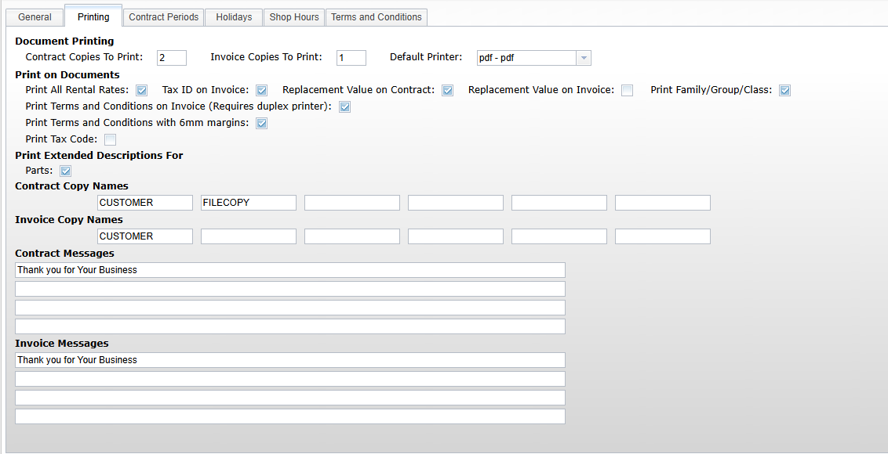

Printing Tab: This section lets you set printing preferences for Rental contracts and invoices.

Document Printing: Set the number of copies to print here. Enter the number of copies for both contracts and invoices.

Default Printer: Set the default printer for all Rental programs here. All printer selection fields in the Rental package will default to this printer.

Print on Documents: Choose the additional information to print on Rental invoices.

Print All Rental Rates: Check this box to include all Rental rates for the unit(s) being rented.

Tax ID on Invoice: Check this box to print the Tax ID from Enter Customer Information (ECI) on the Rental invoice.

Replacement Value on Contract: Check this box to print the unit’s replacement value on the Rental contract.

Replacement Value on Invoice: Check this box to print the unit’s replacement value on the Rental invoice.

Print Family/Group/Class: Check this box to print the unit’s Rental family, group, and class on the Rental invoice.

Print Terms and Conditions on Invoice (Requires duplex printer): This field is no longer in use.

Print Terms and Conditions with 6mm margins: This field is no longer in use.

Print Tax Code: Check this box to print the tax code for the Rental on the Rental contract.

Print Extended Descriptions For: Check the box to include the Extended Description for any parts sold on a Rental invoice.

Contract Copy Names: For each contract copy selected to print, enter the name to print on the bottom of that copy (i.e. Customer, Accounting, File).

Invoices Copy Names: For each invoice copy selected to print, enter the name to print on the bottom of that copy (i.e. Customer, Accounting, File).

Contract Messages: Enter the text for the message to print on all contract copies. Each of the 4 lines will handle about 80 characters of message text.

Invoice Messages: Enter the text for the message to print on all invoice copies. Each of the 4 lines will handle about 80 characters of message text.

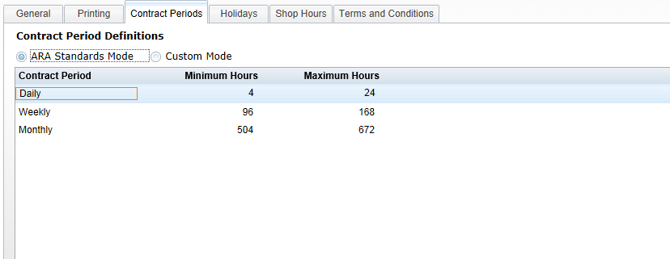

Contract Periods Tab: For this portion of the defaults, there are 2 modes: ARA Standards and Custom.

ARA Standards Mode: The ARA Standards mode uses the periods and definitions provided by the American Rental Association. These settings are not modifiable, as they are preset when this choice is selected. They define the minimum and maximum hours for the 3 ARA Rental periods. The minimums determine when the periods automatically become the next period. For example, notice that when 4 hours of rental have passed, it is considered a day’s rental. Likewise, when 4 rental days have passed, it rolls to a week. In a similar fashion, when 3 rental weeks have passed, it is considered a month.

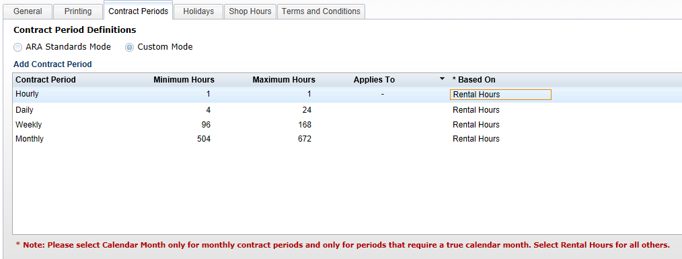

Custom Mode: In this mode, the setting for each contract period is configurable. The example above also includes an hourly contract period for a business that rents hourly.

Add Contract Period: Click “Add Contract Period” to add a new period to the system.

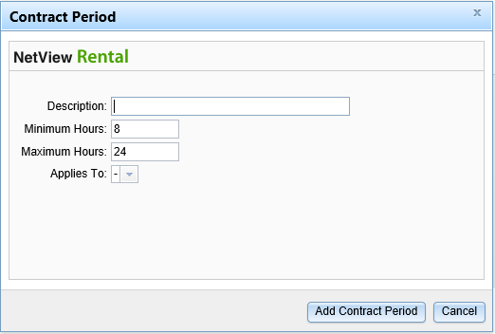

- Description: Enter the period’s description here, i.e. Daily, Weekly, Monthly, etc.
- Minimum/Maximum Hours: Enter the minimum and maximum hours that the contract period will cover.
- Applies To: Use the drop-down menu to specify if the period only applies to certain days of the week.

Column Settings:

Minimum/Maximum Hours: These columns can be set to how your business handles the automatic movement from one period to the next. In the above example, exceeding 4 hours moves to 1 day, exceeding 4 days moves to 1 week, and exceeding 3 weeks moves to 1 month.

Applies To: This column lets you specify if the contract period applies only to specific days of the week.

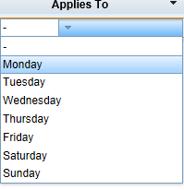

Leaving the column blank means it applies to any day of the week.

You can click on the column header to sort the contract periods in ascending or descending order alphabetically by the days they apply to.

An upward-pointing arrow next to the header title means they are sorted in ascending order.

A downward-pointing arrow means they are sorted in descending order.

Based on: This setting is typically set to Rental Hours for most circumstances.

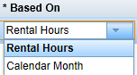

One exception is for calendar month rentals, when it should be set to Calendar Month ONLY for the monthly contract period.

You can use this column sort the contract periods by clicking on the column header.

An upward-pointing arrow next to the header title means they are sorted in ascending order (Calendar Month first, then Rental Hours).

A downward-pointing arrow means they are sorted in descending order (Rental Hours first, then Calendar Month).

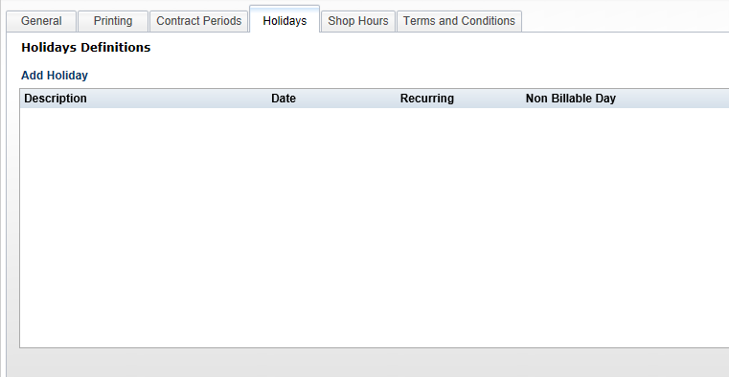

Holidays Tab: This portion of the defaults is used to define holidays where rent is not likely to be charged. For example, if your business does not charge rent on Thanksgiving or Christmas even when the unit is out, you could define that here.

Add Holiday: Click on Add Holiday to add one.

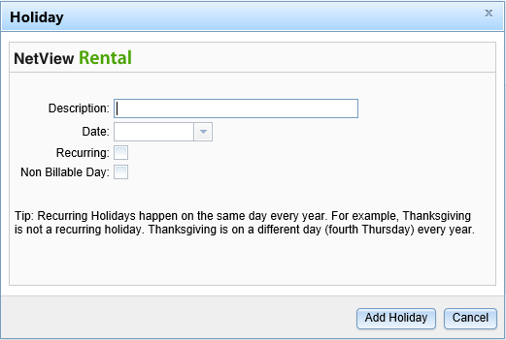

Description: Fill in the name of the holiday.

Date: Type in the date of the holiday (mm/dd/yyyy) or click on the arrow to choose the date from a calendar.

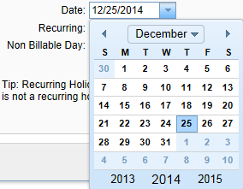

Recurring: Check the box if the holiday is ALWAYS on the same day each year. For example, Christmas is a recurring holiday as it always falls on December 25. However, Thanksgiving is not, as it falls on the fourth Thursday of November.

Non Billable Day: Check this box if the holiday should not be billed.

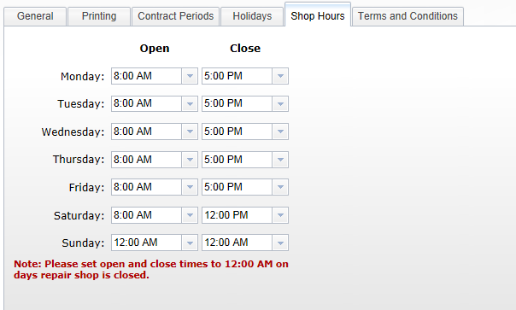

Shop Hours Tab: Define the hours the Service department is open. These hours are used when the Required Service fields are active in Rental Class Maintenance (RCM). Set the hours for each day of the week. If you are not open on a particular day, set the open and close times to 12:00 AM.

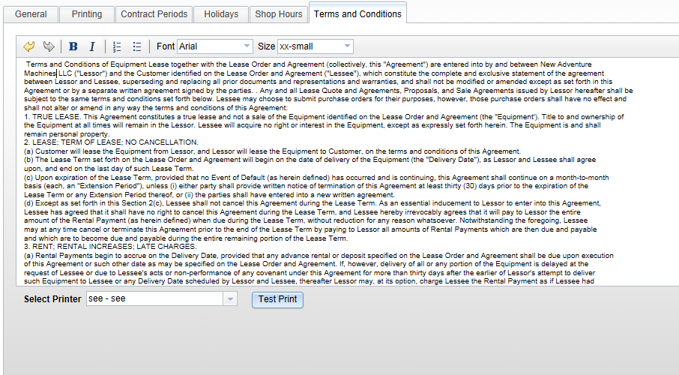

Terms and Conditions Tab: This tab holds the text of the Terms and Conditions to print on the back of the invoices and contracts. It supports Copy and Paste if you have electronic copy, or may simply be typed. You can also generate a test print using the button at the bottom of the screen.

The toolbar on the top has buttons for:

- Undo
- Redo
- Bold
- Italic
- Numbering
- Bullets
- Font
- Size

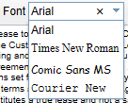

The Font selection has a drop-down menu with several choices.

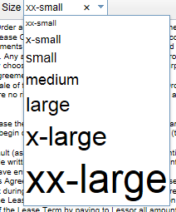

The Size selection has a drop-down menu with several choices.

