ROI Report: The Return on Investment, or ROI, Report in Rental Reports (RR) shows the cost of each rental unit at the dealer location alongside the unit’s time and financial utilization data. This allows you to determine if the unit has provided a return on your initial investment, i.e. if the unit’s profits since acquisition have exceeded the original cost. The utilization data additionally lets you see where you could better utilize the unit’s time to increase profits if a unit has not made a good return.

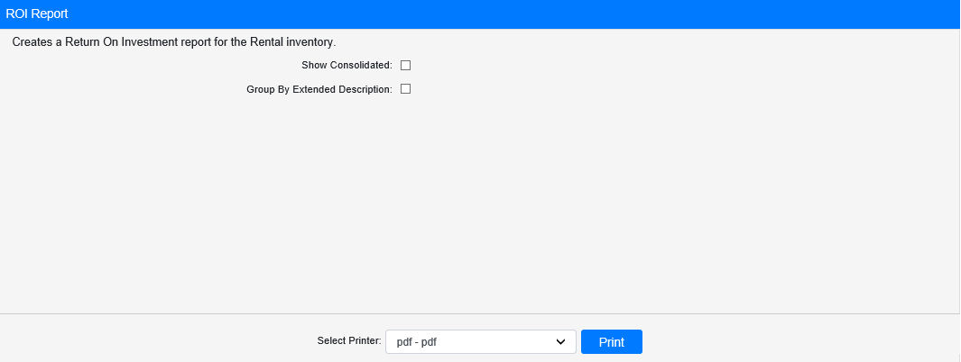

Field Definitions:

Show Consolidated: If you are a multi-location dealership with a Consolidated location, check this box to include the Consolidated location’s information on your report. Uncheck it to only print a report for your individual location. NOTE: If running the report in the Consolidated location, you must check this box to receive a report.

Group by Extended Description: Check this box to group the rental units on the report by their Rental Class’s extended description instead of by their Rental Group and Class.

Select Printer: Select the printer to receive the report. Use the pdf printer to preview the report.

Click “Print” to print the report.

Sample Report:

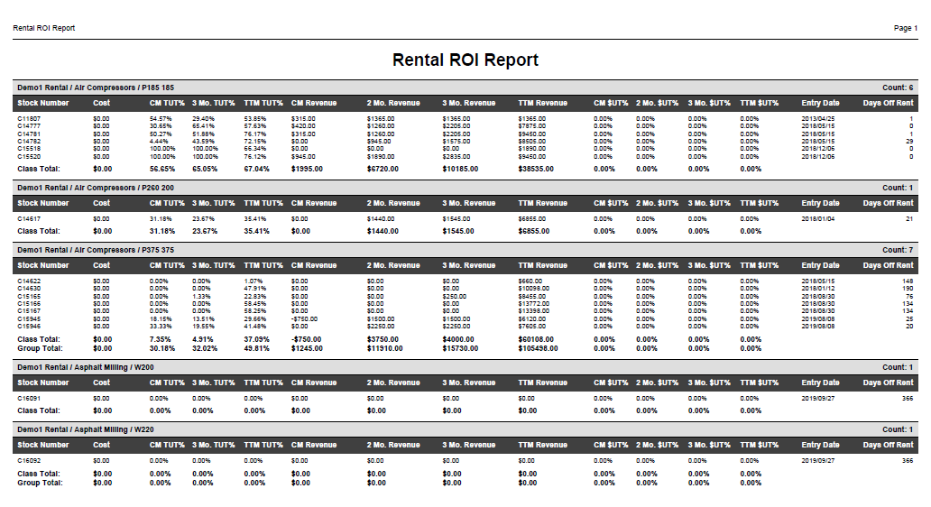

The report is divided into sections by first Rental Group, than Rental Class. The report calculates using the last date of the previous calendar month as its end date; for example, if today is 4/22, the “Current” Month period is 3/1-3/31, 3 Months is 1/1-3/31, etc.

Each line of the report represents 1 Rental unit in the location inventory, and lists the following details for each:

- Stock Number
- Cost
- Percent Time Utilized for Current Month
- Percent Time Utilized for Past 3 Months
- Percent Time Utilized for Past 12 Months (Trailing Twelve Months)
- Rental Revenue for Current Month
- Rental Revenue for Past 3 Months
- Rental Revenue for Past 12 Months (Trailing Twelve Months)
- Percent Financial Utilization for Current Month
- Percent Financial Utilization for Past 2 Months
- Percent Financial Utilization for Past 3 Months
- Percent Financial Utilization for Past 12 months (Trailing Twelve Months)
- Entry Date
- Days Off Rent (Days Since Last Rental Ended)

Totals for each Class appear at the end of each section. Totals for each Group appear after the last Class Total line for each Group.

Sample Report Grouped by Extended Description: If you check the Group By Extended Description box, the report will provide the same data for each unit. However, they will be organized by their Rental Class’s extended description, which will alter the Class Totals depicted, and the report will not provide Group Totals as a result.

