POS Screen—R/O (Repair Order) Info Tab

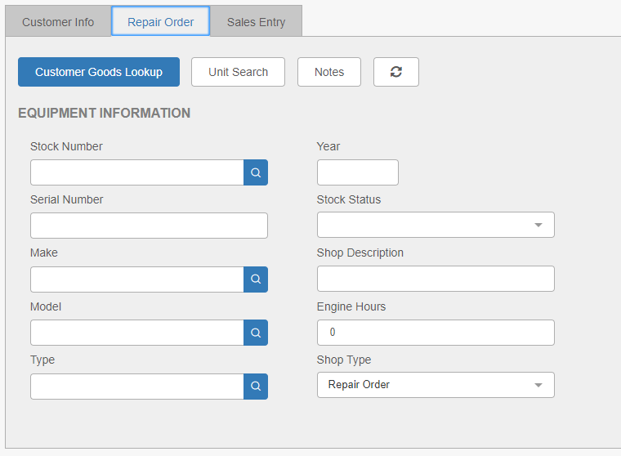

You can use the R/O Info tab to search for, create, and maintain shop tickets (or repair orders) by inputting information about maintenance or repair work on units and the parts used.

Field Definitions:

Stock Number: Enter the unit’s stock number in this field. If the customer has a unit to be repaired on file, you can pull it up using the Search icon attached to the field.

Serial Number: Enter the unit’s serial number in this field.

Make: Enter the unit’s make here or use the Search to look it up.

Model: Enter the unit’s model number here or use the Search to look it up.

Type: Enter the unit’s type here or use the Search to look it up.

Year: Enter the unit’s year in this field.

Stock Status: Select one of the following stock statuses from the drop-down menu:

- New
- Used
- Rental
- Sold
- Transfer
- History
- Order (New)
- Order (Used)

Shop Description: You can enter a shop description here.

Engine Hours: Enter the unit’s engine hours here, if applicable.

Shop Type: Choose a shop type from the drop-down menu:

- Repair Order
- Option

Customer Goods Lookup: If the customer has a unit to be repaired on file, you can press the Customer Goods Lookup button to search for the stock number.

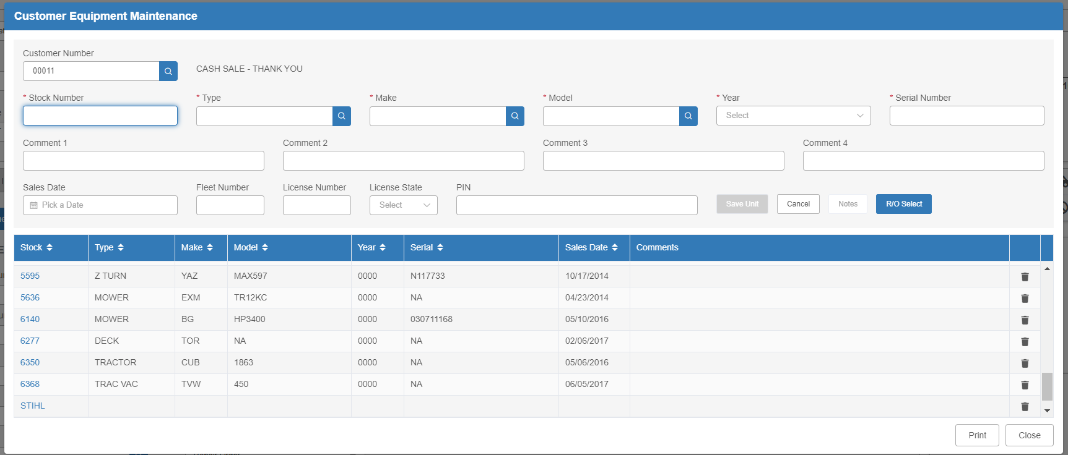

The Customer Equipment Maintenance (CEM) screen will open.

- If the equipment to be repaired displays on the screen, click its entry to select it, then press the RO Select button to add it to the repair order.
- If it does not appear on the screen, you can add it by completing the required fields. You can also add comments relative to the piece of equipment at this time. Press Save to enter the equipment into inventory.

Unit Search: The Unit Search button provides another way to find the unit. This works well when the unit may have been previously owned by someone other than the current customer.

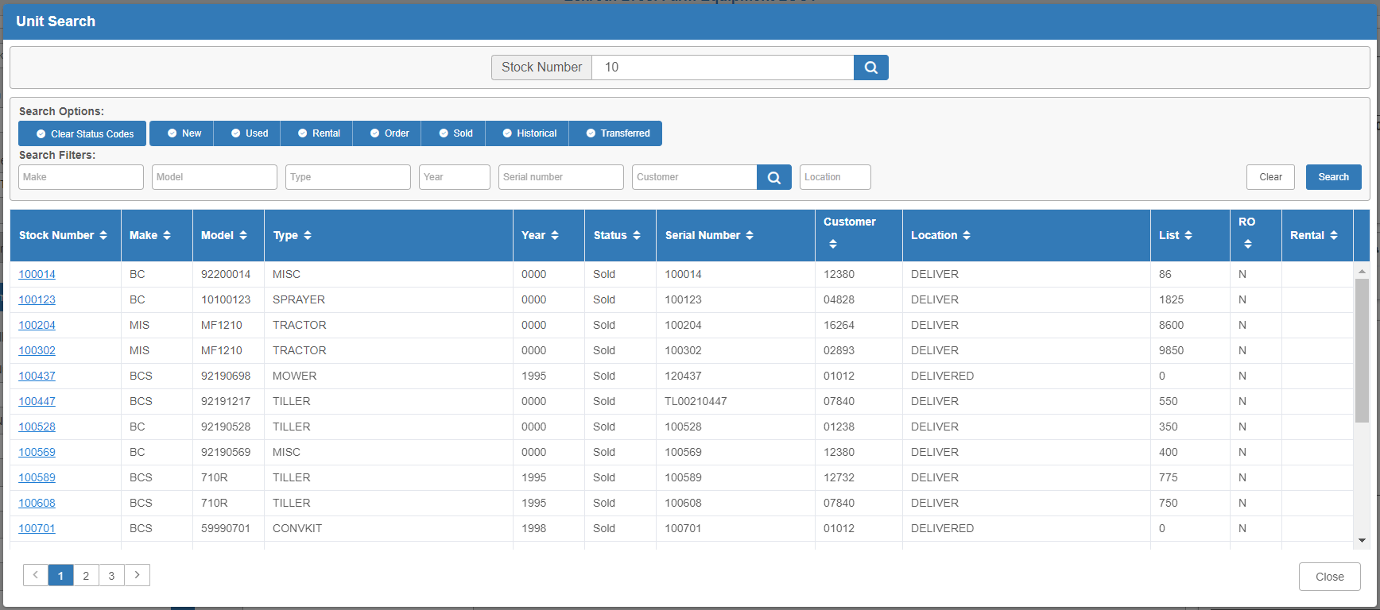

Select your search options and/or enter a full or partial stock number. Click either the Search icon by the Stock Number field or the Search button to get a list of results. Click on your desired entry to select it. The information for the selected piece of equipment will fill the Equipment Information fields.

Unit Notes: Enter or view notes on the unit by clicking the Unit Notes button.

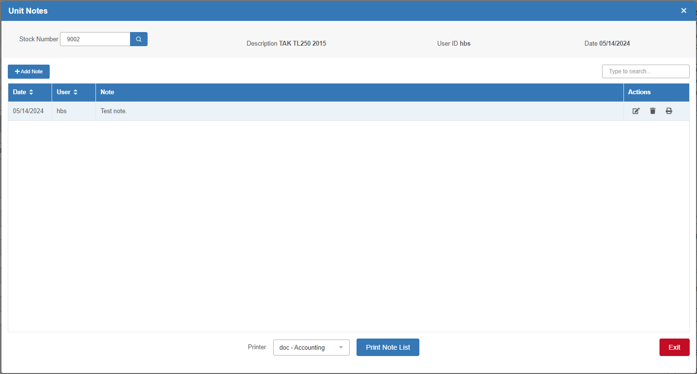

Refresh: Press this button to refresh the unit information so that the most up-to-date info on the unit displays.

