Rental Outbound Report: The Rental Outbound Report creates a report of Rental units being rented out.

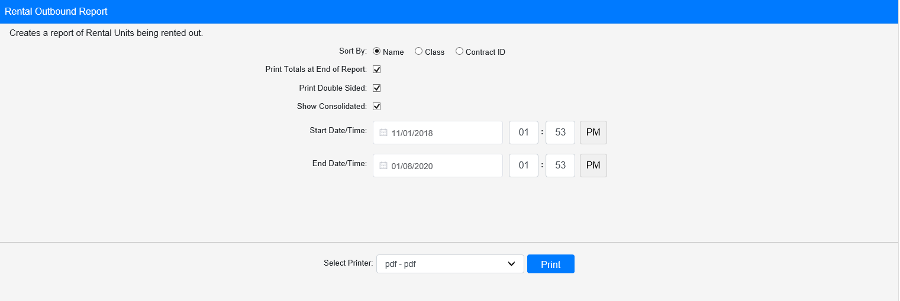

Field Definitions:

Sort By: Choose how to sort the report from the drop-down menu:

- Name
- Class
- Contract ID

Print Totals at End of Report:

- Check this box to include total counts at the end of the report.
- Leave it unchecked to omit the totals.

Print Double Sided:

- Check this box to print the report pages double-sided.
- Leave it unchecked to print the report pages single-sided.

Show Consolidated: If you are a multi-location dealership with a Consolidated location, check this box to include the Consolidated location’s information on your report. Uncheck it to only print a report for your individual location. NOTE: If running the report in the Consolidated location, you must check this box to receive a report.

Start Date/Time: Select the start date/time for the report. All units listed on the report will have been rented out at or after that point in time.

End Date/Time: Select the end date/time for the report. All units listed on the report will have been rented out before or at that point in time.

Select Printer: Select the printer to receive the report. Use the pdf printer to preview the report.

Click “Print” to print the report.

Sample Report:

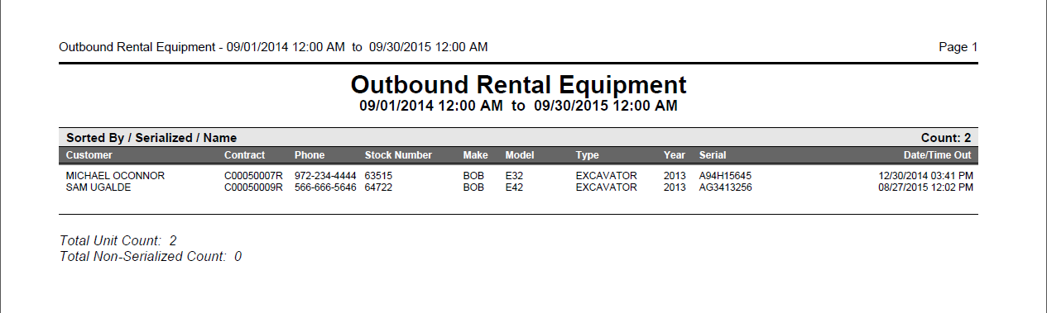

This example is sorted by Name with totals included at the end. Each entry shows the following:

- Rental customer
- Contract number
- Contact phone number
- Stock number
- Make
- Model
- Type
- Year
- Serial number
- Date and time rented out

