Rental Post Journal (RPJ)

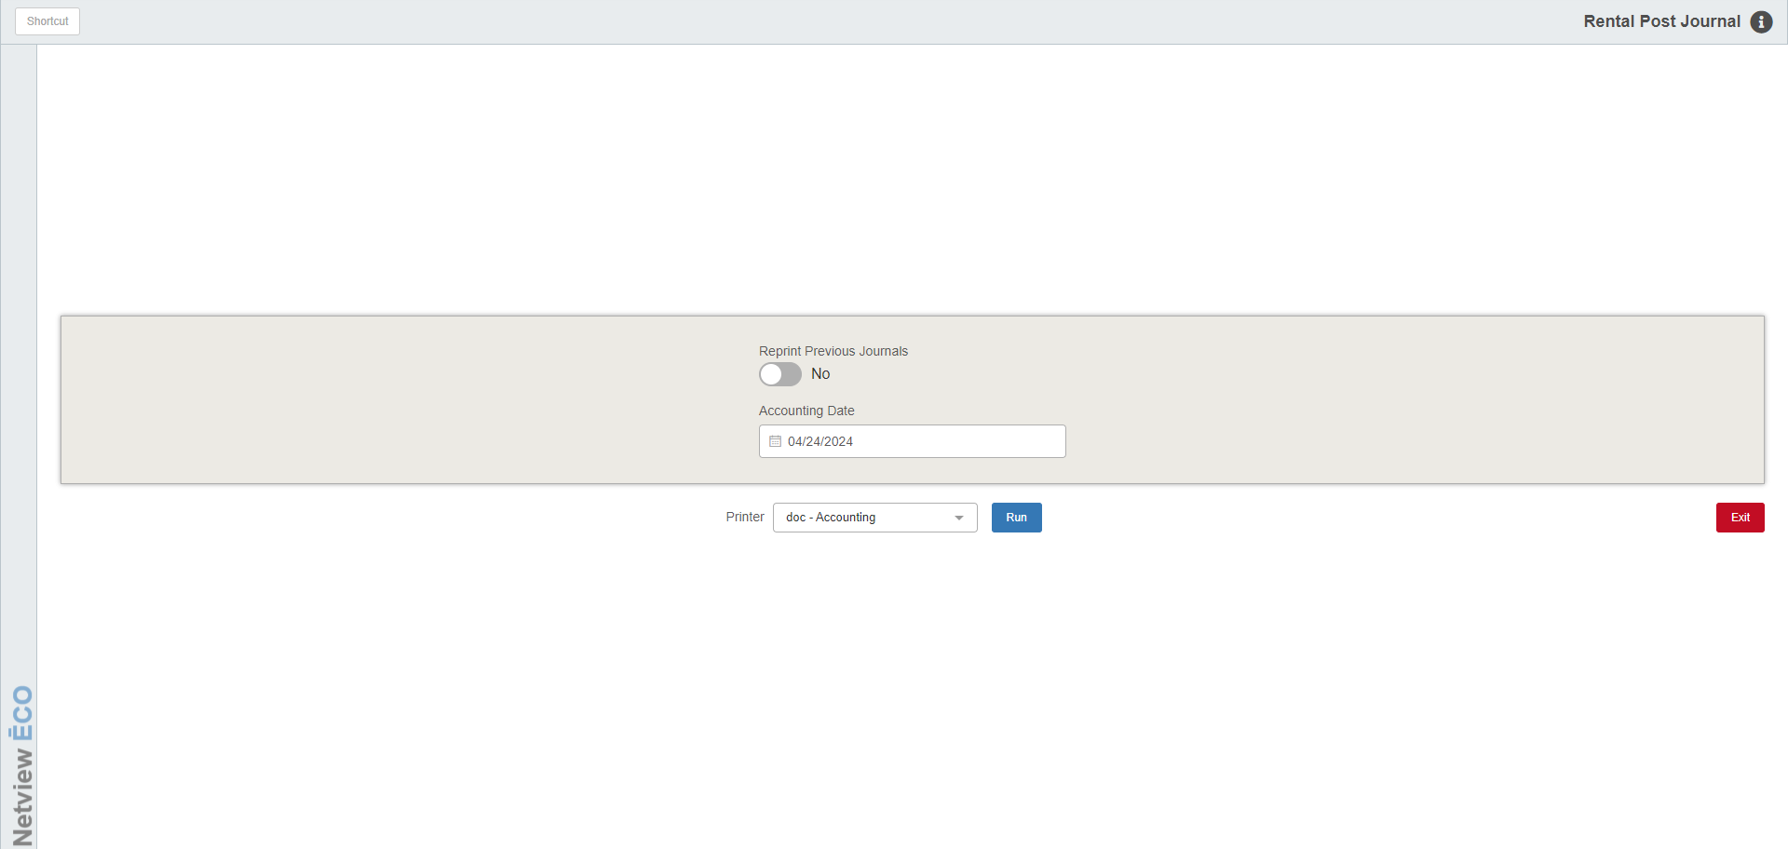

Rental Post Journal (RPJ) posts unit transfer transactions in Rental to the system.

To open this function, you can either:

- Select “Rental” from the menu and click “Rental Post Transfer Journals.”
- Type “RPJ” in the Shortcuts Bar.

Field Definitions:

Reprint Previous Journals:

- Set this option to Yes to reprint previous Journals.
- Set it to No to post the current Journal.

Accounting Date: Enter the accounting date or select it from a calendar. The current date fills as default.

Printer Name: Choose the printer to receive the Journals from. Use the pdf printer to preview the document.

Run: Click Run to post the Journals.

Sample Journal

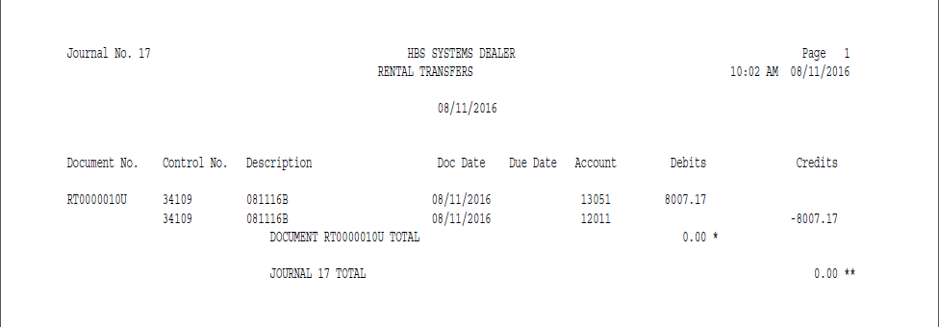

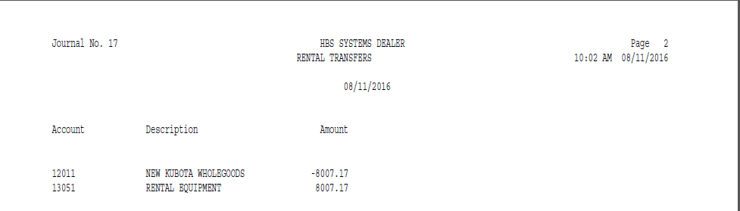

Exception Report: Sometimes, after running the Journal, the application will generate an Exception Report after the Journal is run. This occurs if there are documents that were unable to be journalized when the Journal ran. The following information will show on the report:

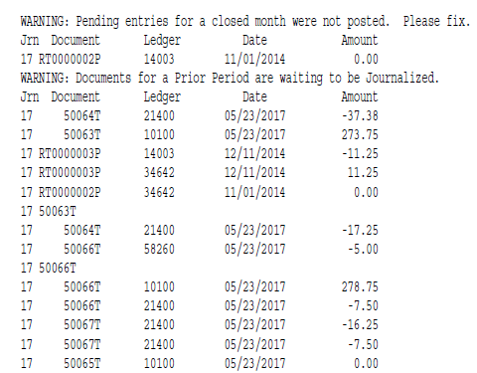

Jrn: This is the Journal number where the exception error occurred.

Document: This is the document number of the un-journalized document.

Ledger: This is the General Ledger account number associated with the document.

Date: This is the document date.

Amount: This is the dollar amount (debit or credit) of the document.

