Full Physical Inventory Steps

A full physical inventory at least once a year is our strongest recommendation. Ideally, the inventory would be completed while your business is not open. This section provides you with many ideas to make sure your inventory is in good shape before you begin. We recommend that you do all these steps BEFORE starting the inventory process.

This topic provides two lists of steps for Physical Inventory: one for partial inventories and one for a full inventory. The steps for a full physical inventory are identified as STEP 1, STEP 2, etc., throughout the following topics concerning physical inventory.

Step Description
1. Print the Negative On Hand Report
2. Print the Report Writer Report Parts With No Bin Locs
3. Print the On Order Report
4. Clean up your open Picking Tickets/Work In Progress
5. Print the Parts Value Report
6. Print Bin Count Sheets
7. Take the sheets and count
8. Enter the counts in Post Inventory Count
9. Print the Bin Variance Report
10. Run the Post Inventory Variances routine
11. Print a new Parts Value Report

Partial Physical Inventory Steps
These steps can be used for a partial physical inventory of a bin row, shelf, or other portion of your inventory.

Step Description
1. Clean up your open Picking Tickets/Work In Process
2. Print Bin Count Sheet
3. Take the count sheets and count
4. Enter the counts in Post Inventory Count
5. Print the Bin Variance Report
6. Run the Post Inventory Variances routine

STEP 1 - Print the Negative On Hand Report (NOHR)

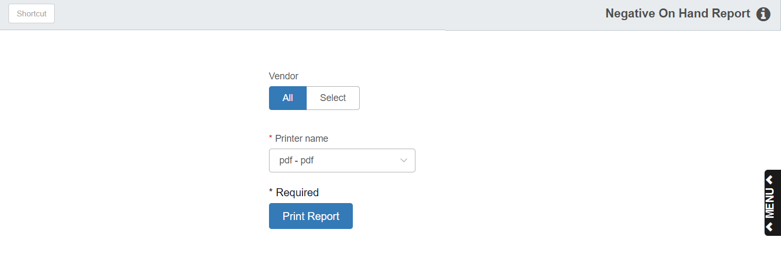

Verify that all orders have been receipted. No parts should have a negative on hand before running Bin Count Sheets. Be sure to run the report for all vendors when doing a full inventory. If a part has a negative on hand, the variance begins with zero and not the negative number.

Important: Correct all part records with negative on-hand quantities before continuing with the physical inventory.

- To access this report:
  - Select “Inventory” from the menu. Choose the “Reports” submenu and choose “Negative On-hand Report.”
  - Type “NOHR” in the Shortcuts Bar

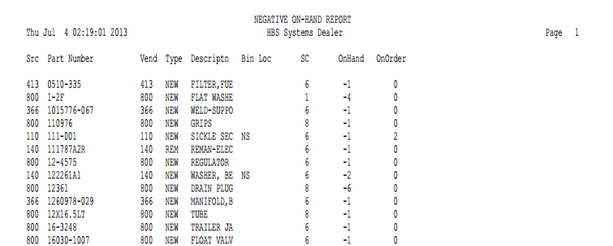

Report Fields

Src: This is the Source Code for the part number.

Part Number: This is the Part Number that has a Negative On hand quantity.

Vend: This is the Vendor Number for the part number.

Type: This is the part Type, which can be:

New

Used

Core

Reman

Memo

Descriptn: This is the Description of the part number.

Bin Loc: This is the primary Bin Location for the part number.

SC: This shows the Stock Class of the part number.

On Hand: This is the negative On Hand quantity the system shows for the part number.

On Order: This is the quantity for this part number that is on order.

STEP 2 - Print the Parts With No Bin Locs Report

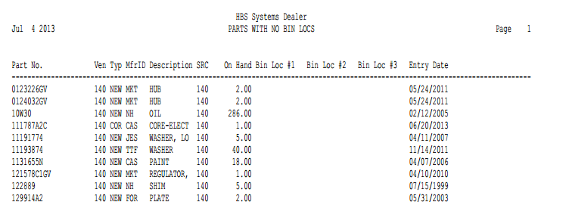

This report is a Report Writer report. Ideally, all parts should have a location before you run Bin Count Sheets.

Suggestion: When you add part numbers into the system, it always wise to have a bin location. Remember, you can have a default bin location when adding a part.

- To access this report, you can:
  - Select “Report Writer” from the menu and click “Print an Established Report.” Choose the “Parts with No Bin Locs” report.
  - Type “PER” in the Shortcuts Bar and select the report.

Report Detail

Part Number: This is the part number that does not have a bin location.

Ven: This field shows the Vendor Number for the part number listed

Typ: Here you will find the Part Type, which can be:

New

Used

Core

Reman

Memo

MfrID: If you have a Manufacturer ID on the part, it will appear here.

Description: This is the description of the part number.

SRC: This is the Source Code for the part number.

On Hand: This field shows the current quantity on hand.

Bin Loc #1: This is the primary Bin Location for this part. There will be no entries in this field.

Bin Loc #2: This is the first alternate Bin Location for this part. There may be entries in this field.

Bin Loc #3: This is the second alternate Bin Location for this part. There may be entries in this field.

Entry Date: This field shows the date the part was added to the system.

STEP 3 - Print the On Order Report

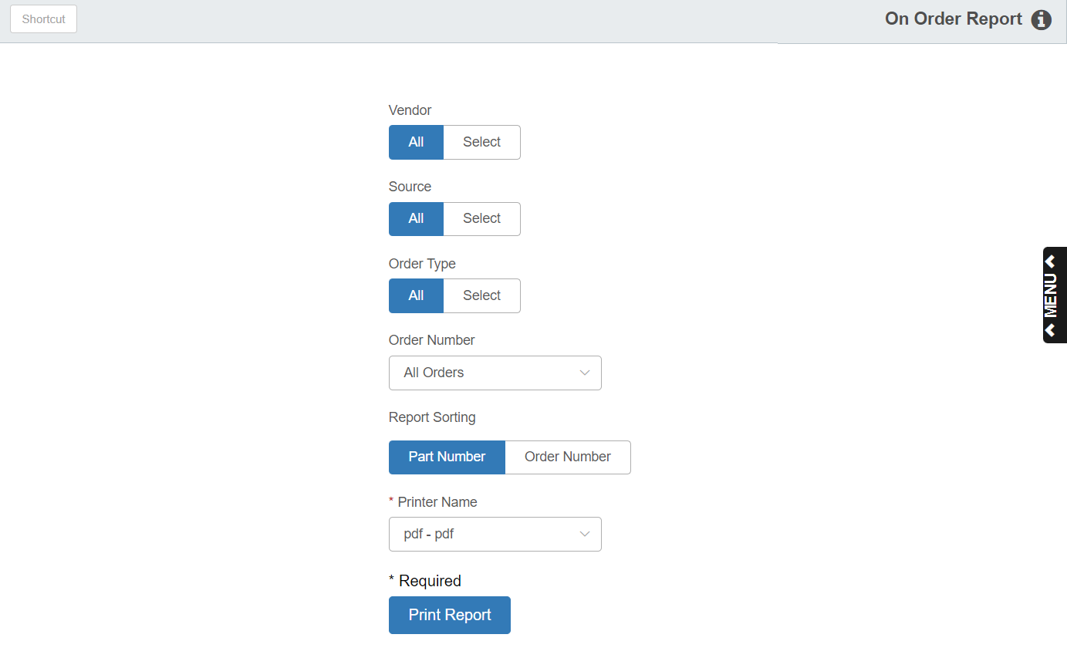

Verify that all orders have been receipted and that parts have been placed in the appropriate bin location. You can select this report to print in part number or order number sequence. For physical inventory you should run this report for ALL vendors, ALL sources, and ALL order types.

To access this report, you can:

- Select “Inventory” from the menu. Choose the “Reports” submenu and click “On Order Report.”
- Type “OOR” in the Shortcuts Bar.

Field Definitions

Vendors: Select All for all vendors or choose Select to specify individual vendors. For physical inventory, we recommend ALL vendors.

Sources: Select All for all sources or choose Select to specify individual sources. For physical inventory, we recommend ALL sources.

Order Types: Select All for all order types or choose Select to specify individual order types. For physical inventory, we recommend ALL order types.

Order Number: Select All Orders for all order numbers or select an individual order to only view its information. For physical inventory, we recommend ALL order numbers.

Report Sorting: Select By Part Number for a report sorted by part number. Select By Order Number to sort it by order number.

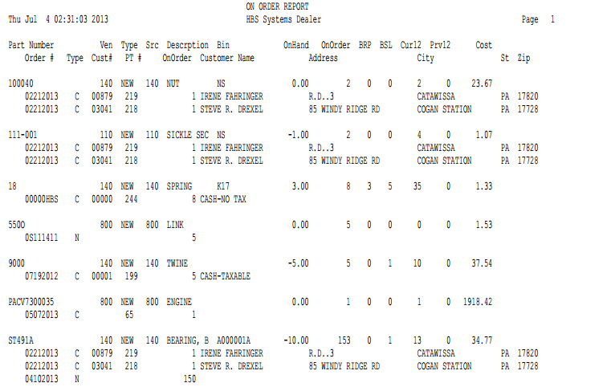

Report Detail

Part Number: This is the Part Number that has an On Order quantity.

Ven: This is the Vendor Number for the part number.

Type: This is the part type, which can be

New

Used

Core

Reman

Memo

Src: This is the Source Code for the part number.

Description: This is the Description of the part number.

Bin: This is the primary Bin Location for the part number.

On Hand: This is the On Hand quantity that the system shows for the part number.

On Order: This is the On Order quantity for this part number.

BRP: This is the Best Reorder Point set for this part.

BSL: This is the Best Stocking Level set for this part.

Cur 12: Current 12 is the sales quantity of this part number for the last 12 months (includes the current month).

Prv12: Previous 12 is the sales quantity of this part number for months 13-24 from the current month (a year ago).

Cost: This shows the factored cost for the part number.

Order #: Here is the Order Number that includes this part.

Type: This field shows the order type:

N=New

C=Customer

E=Emergency

B=Backorder

Cust#: If this order was for a customer, this is the Customer Number.

PT #: If this order was created in POS or ROM, this is the Picking Ticket Number/Repair Order Number.

On Order: This is the quantity of this part number on this customer order.

Customer Name: You will find the Customer Name here for a customer order.

Address: This is the customer’s address.

City: This is the customer’s city.

St: This is the customer’s state.

Zip: Here you will find the customer’s Zip Code/Postal Code.

STEP 4 - Clean up your open Picking Tickets

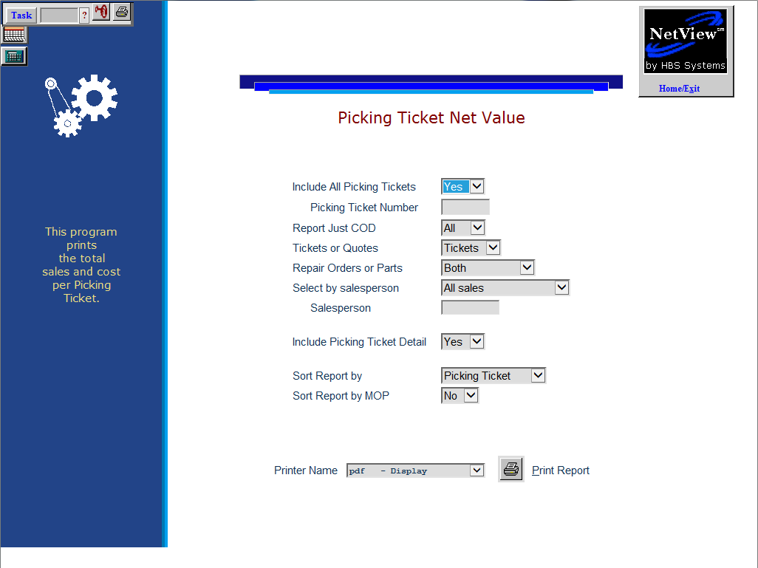

Print a Picking Ticket Net Value Report. Review all open Picking Tickets. If some of these files are accidents, use the Void feature (V) to remove them. Garbage Picking Tickets with part number entries tie up inventory information. As soon as the part number or picking ticket is deleted, the sales quantities transfer back to on-hand quantities.

- To access this report,
  - Select “Inventory” from the menu. Choose the “Reports” submenu and click “Picking Ticket Net Value Report.”
  - Type “PTNV” in the Shortcuts Bar

Field Descriptions

Include All Picking Tickets:

- Choose Yes for all picking tickets. We recommend “Yes” for physical inventory.
- Choose No to select the individual picking ticket.

Report Just COD:

- Choose COD to only include customers on COD on the report.
- Choose All to include all customers, regardless of status. Choose “All” for physical inventory.

Tickets or Quotes: Choose to include tickets, quotes, or both on the report. Choose “Tickets” for physical inventory.

Repair Orders or Parts: Choose to include repair orders (POS), parts picking tickets, or both. Choose “Both” for physical inventory.

Select by Salesperson:

- Choose All Sales to include all salespersons. Choose “All Sales” for physical inventory.
- Choose Select Salesperson to choose a salesperson.

Include Picking Ticket Detail:

- Choose Yes to include part number detail. Choose “Yes” for physical inventory.
- Choose No to produce a summary report of the open tickets.

Sort Report By:

- Choose Picking Ticket to produce a report sorted by picking ticket. Choose “Picking Ticket” for physical inventory.
- Choose Customer Name to sort the report by customer name.

Sort Report by MOP: Choose Yes to group the customers on the report according to their type of MOP.

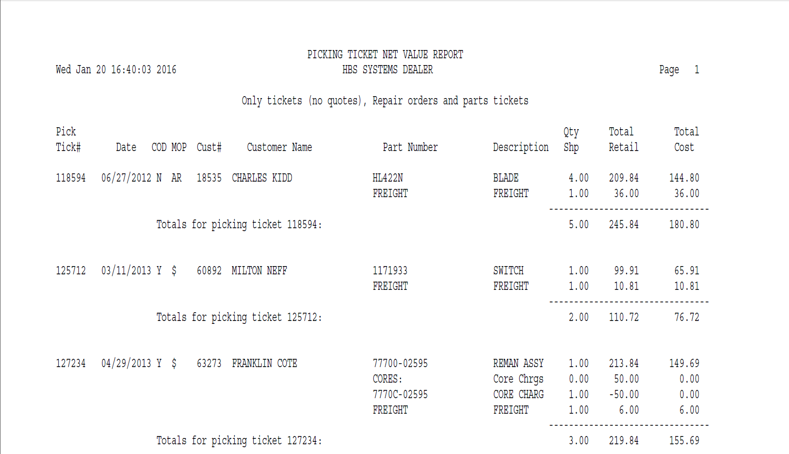

This report lists the Picking Ticket Number, open date, and customer info first. Each part number on the ticket is listed. The following fields of the Picking Ticket are included:

- Part Number
- Description
- Qty Shp – the quantity on the ticktet
- Total Retail - Extended List Price
- Total Cost – Extended Cost
STEP 4 - Work In Process Report

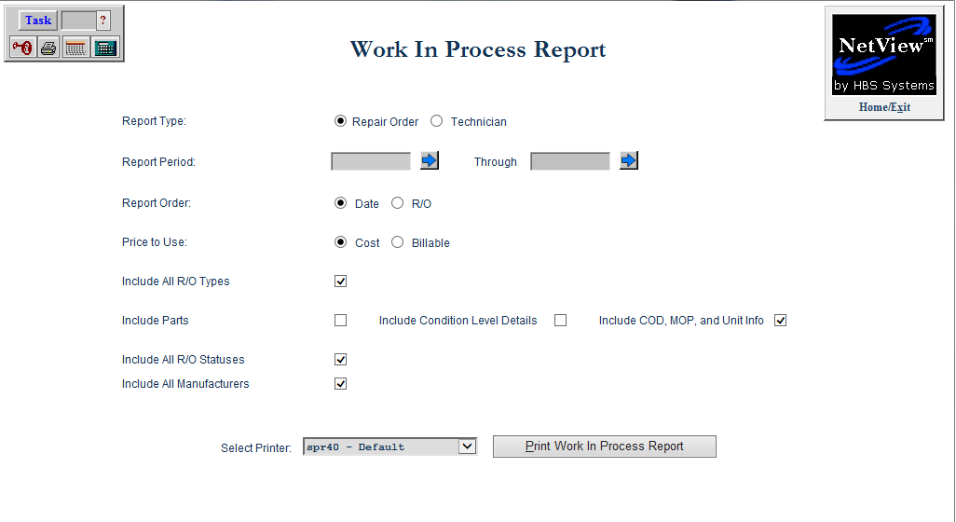

Print a Work In Process Report. Review all open Repair Orders to make sure they are valid.

- To access this report, you can:
  - Select “Service” from the menu. Choose the “Reports” submenu and click “Work In Process.”
  - Type “WIP” in the Shortcuts Bar.

Field Descriptions

Report Type:

- Choose Repair Order to base the report on Repair Order. For physical inventory choose “Repair Order.”
- Choose Technician to base it on Technician.

Report Period: Enter a range of RO open dates to include on the report. Leave the fields blank to include all open repair orders. For physical inventory, leave the fields blank.

Report Order:

- Choose Date to sort the report by Repair Order open date. For physical inventory choose “Date.”
- Choose RO to sort by RO number.

Price to Use:

- Choose Cost to show dollars in cost. For physical inventory choose “Cost.”
- Choose Billable to show dollars in Billable amount.

Include All RO Types: For physical inventory, include all RO Types.

Click on “All RO Types” to include all pay types on the report, such as:

Customer

Internal Warranty

Other

Remove the check to choose them individually.

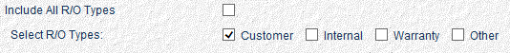

Include Parts: Click here to include part number detail on the report. Click on this for physical inventory.

Include Condition Level Details: Click here to include details for each condition on the report. This is automatically checked when you include parts on the report. Click on this for physical inventory.

Include COD, MOP, and Unit Info: Click here to include the COD, MOP, and Unit info on the report. Click on this for physical inventory.

Include All RO Statuses:

Click on “All RO Statuses” to include Working and Closed statuses on the report. For physical inventory choose all.

Remove the check to choose them individually.

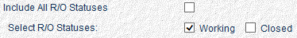

Include All Manufacturers:

- Click on “All Manufacturers” to all makes on the report. For physical inventory choose all.
- Remove the check to choose them individually.

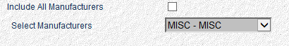

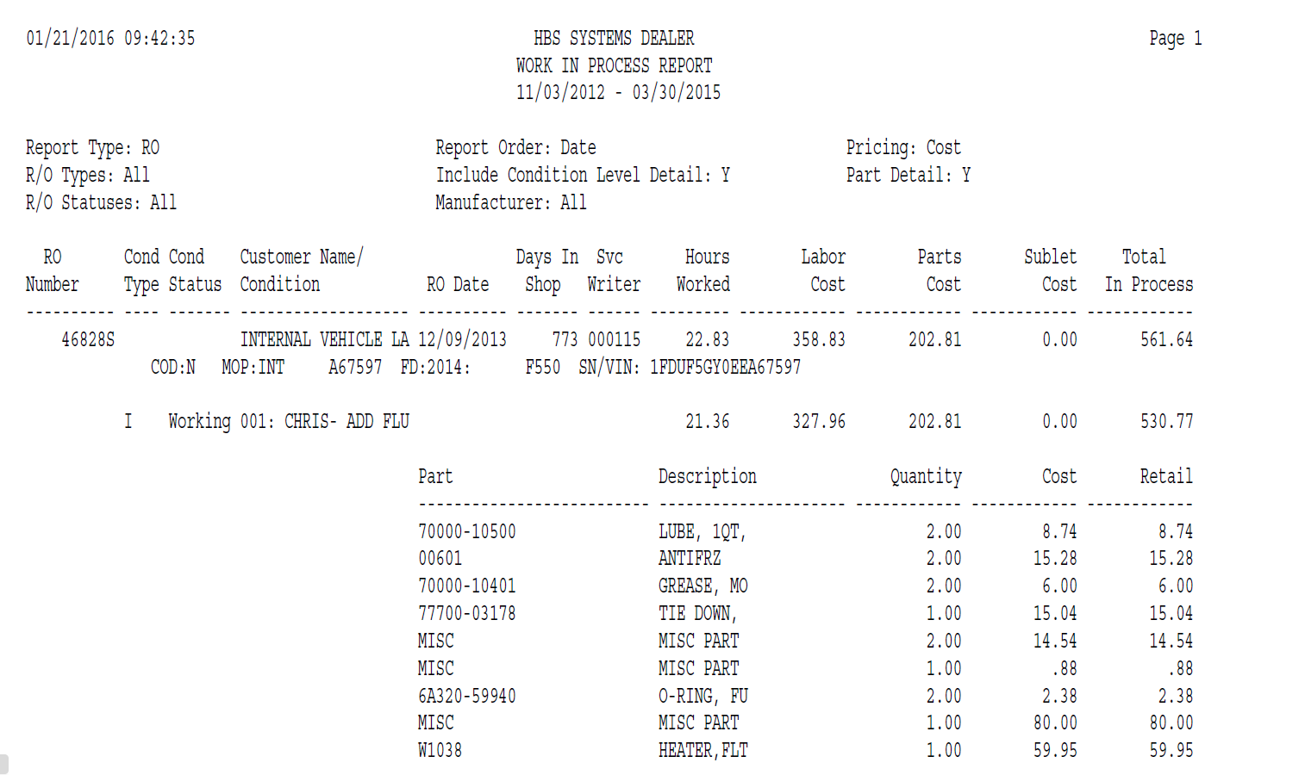

This report lists the following information:

- RO number
- Customer name
- RO open date
- Days in shop
- Svc writer
- Hours worked
- Labor cost
- Parts cost
- Sublet cost
- Total in process cost

The first detail line that follows lists the following:

- Customer information:
  - COD
  - MOP
- Unit information:
  - Stock Number
  - Make
  - Year
  - Serial Number

Each condition detail line is then listed. The condition detail line shows the following information for the condition:

- Condition type
- Condition status
- Condition description
- Hours worked
- Labor cost
- Parts cost
- Sublet cost
- Total in process cost

The part number detail follows the condition info and gives the following:

- Part number
- Description
- Quantity
- Extended cost
- Extended retail
STEP 5 - Parts Value Report

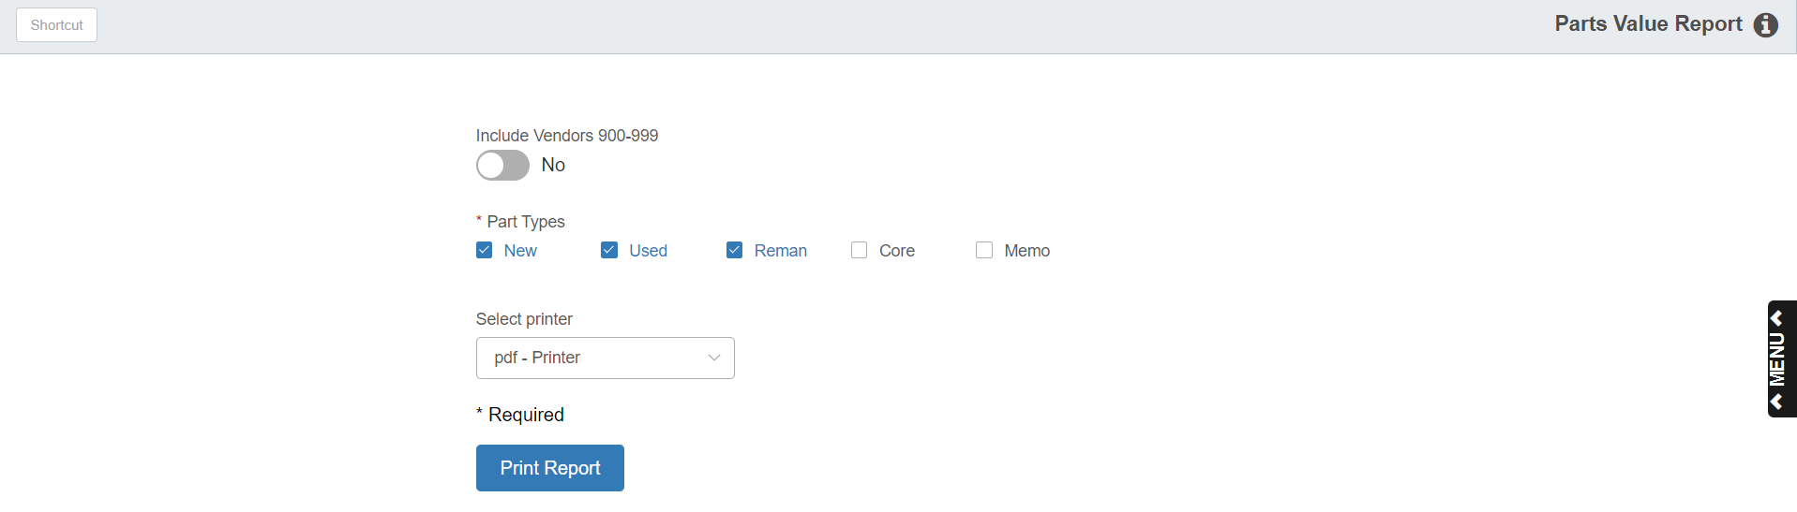

Print the Parts Value Report to show the value of your inventory immediately prior to running the physical inventory process.

- To access the Parts Value Report, you can:
  - Select “Inventory” from the menu. Choose the “Reports” submenu and click “Parts Value Report.”
  - Type “PVR” in the Shortcuts Bar.

Field Definitions

Include Vendors 900 – 999:

- If you want to include the vendor numbers (900-999) typically used for Labor, set this option to Yes.
- To exclude these vendors, choose No. For physical inventory, choose “No.”

Part Types/Selected: Select the Part Types you want to include on the report. The default selection is New, Used, and Reman, but you may select up to all 5 types. For physical inventory, use the default (New, Used, Reman).

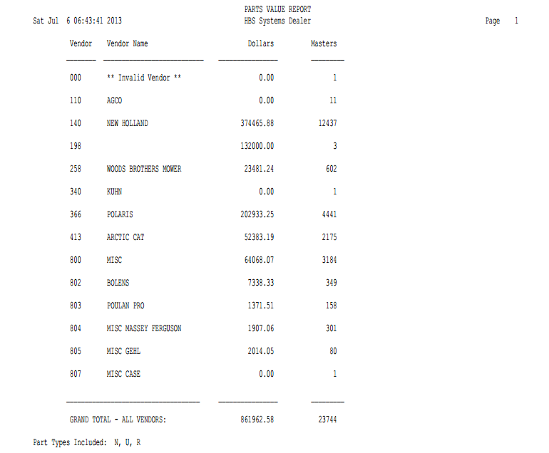

Report Detail: This report contains the following information:

Vendor / Vendor Name: Each vendor’s number and name is included as long as there is at least one part number present for that vendor.

Dollars: This is the total dollar value (cost) of the parts for the vendor identified.

Masters: This is the total number of unique part numbers that have the specified vendor number listed in the Parts Master.

Grand Total: Totals are provided for the dollar amounts and masters.

