ETA Example: Apply an Early Payoff Discount

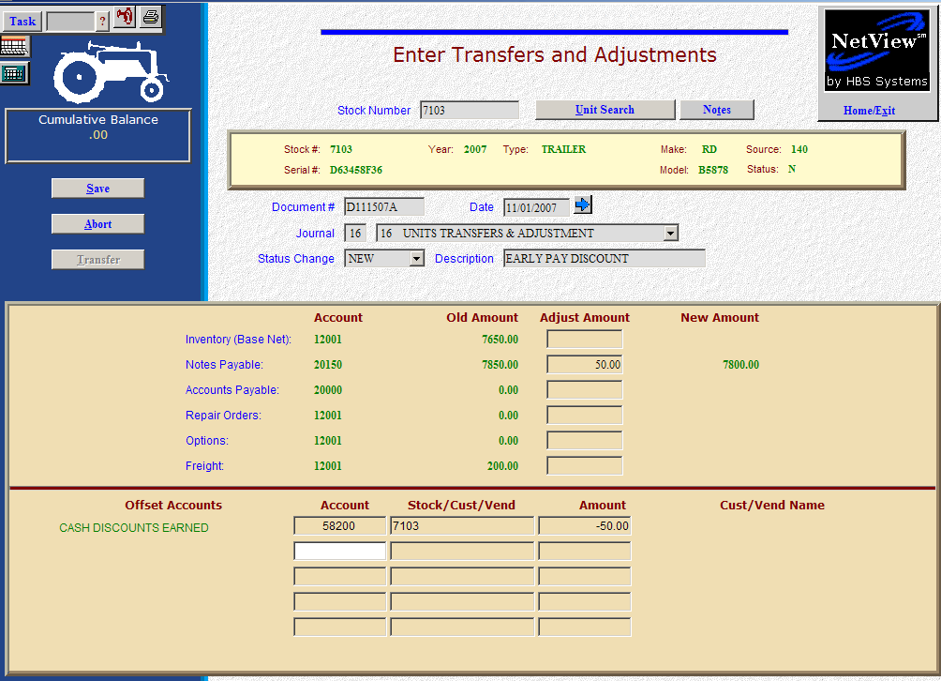

Here’s the scenario. You are eligible for a discount because you are paying off a note early. You want to show this early pay discount as a discount earned.

- Fill in the Stock #.
- Create the Document #. Here’s a document numbering idea:
  - D for discount
  - 053013 for the month (05)/day (30)/year (2013) of the discount
  - A for the first discount of the day, B for the second, and so on.
- Put the adjustment date in the Date field, provided it is within the open accounting periods on your system. Otherwise, use the first day of the oldest month open.
- Put in a good Description that mentions you are taking an early payoff discount.
- Leave the Status field as it is.
- On the Notes Payable line, fill in the discount amount. Enter a negative number as you are SUBTRACTING value. The system will convert the “subtraction” as a debit to the notes payable account.

- OR –

- If the discount applies to an invoice in Accounts Payable, simply do this process on the Accounts Payable line. Fill in the discount amount. Enter a negative number as you are SUBTRACTING value. The system will convert the “subtraction” as a debit to the accounts payable account.
  - You’ll be asked for the vendor number. There is a lookup in the vendor number field. Type in a few letters of the vendor’s name to look it up if you don’t know their number.
  - Also enter the due date, and the discount date and amount, if any.
- Fill in account number of your Discounts Earned account (58200 in our example).
- Fill in the stock number in the Stock/Cust/Vend field.
- Fill in the Amount. Enter a positive number as you are ADDING value. The system will convert the “addition” as a credit to the discounts earned account.
- Press Save (Alt S) to complete the transaction.
- When you press “Save,” the Units Master for the stock number is INSTANTLY updated. The transaction has been created and will be posted when Journal 16 is run. If it involved A/P, it will be available for selection in A/P when the journal has been posted.

