ETA Example: Apply a Program Discount—Before the Sale

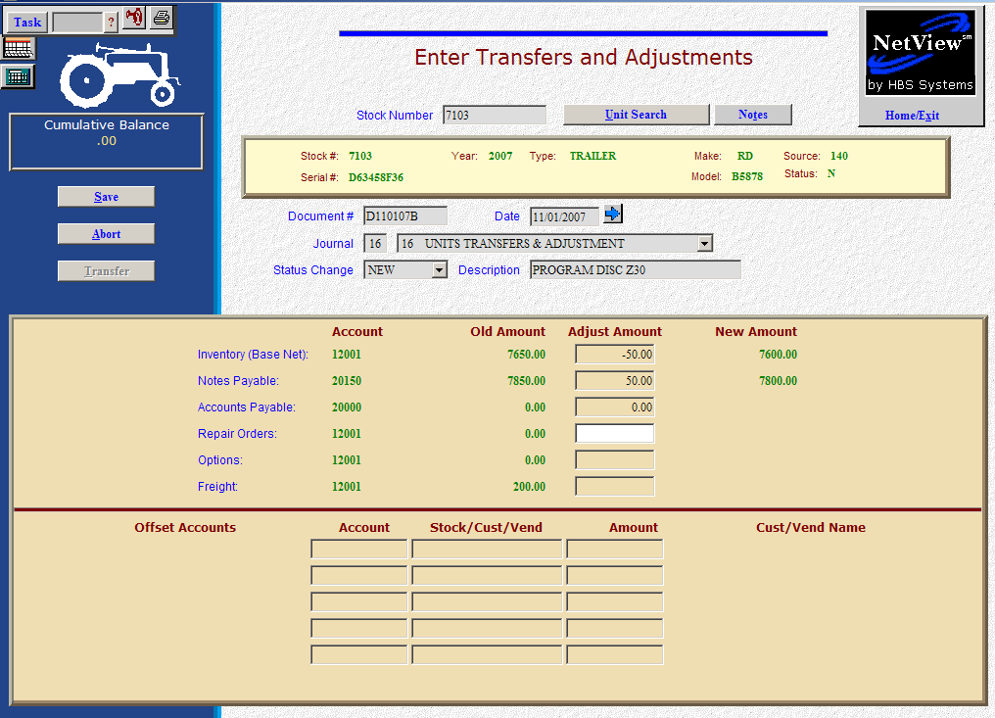

Here’s the scenario. You get a program discount or incentive because you are selling the unit. You are processing the discount before the sale, so the cost of the unit being sold shows the discount.

- Fill in the Stock #
- Create the Document #. Here’s a document numbering idea:
  - D for discount
  - 053013 for the month (05)/day (30)/year (2013) of the discount
  - A for the first discount of the day, B for the second, and so on.
- Put the adjustment date in the Date field, provided it is within the open accounting periods on your system. Otherwise, use the first day of the oldest month open.
- Put in a good Description to describe the program discount or number.
- Leave the Status field as it is.
- On the Inventory line, fill in the discount amount. Enter a negative number as you are SUBTRACTING value. The system will convert the “subtraction” as a credit to the inventory account. You could also make this adjustment to the options of the unit to keep the original base net intact.
- On the Notes Payable line, fill in the discount amount. Enter a negative number as you are SUBTRACTING value. The system will convert the “subtraction” as a debit to the notes payable account.

- OR -

- On the Accounts Payable line, fill in the discount amount. Enter a negative number as you are SUBTRACTING value. The system will convert the “subtraction” as a debit to the accounts payable account.
  - You’ll be asked for the vendor number. There is a lookup in the vendor number field. Type in a few letters of the vendor’s name to look it up if you don’t know their number.
  - Also enter the due date, and the discount date and amount, if any.
- Press Save (Alt S) to complete the transaction.
- When you press “Save,” the Units Master for the stock number is INSTANTLY updated. The transaction has been created and will be posted when Journal 16 is run. If it involved A/P, it will be available for selection in A/P when the journal has been posted.

