ETA Example: Apply a Program Discount—After the Sale

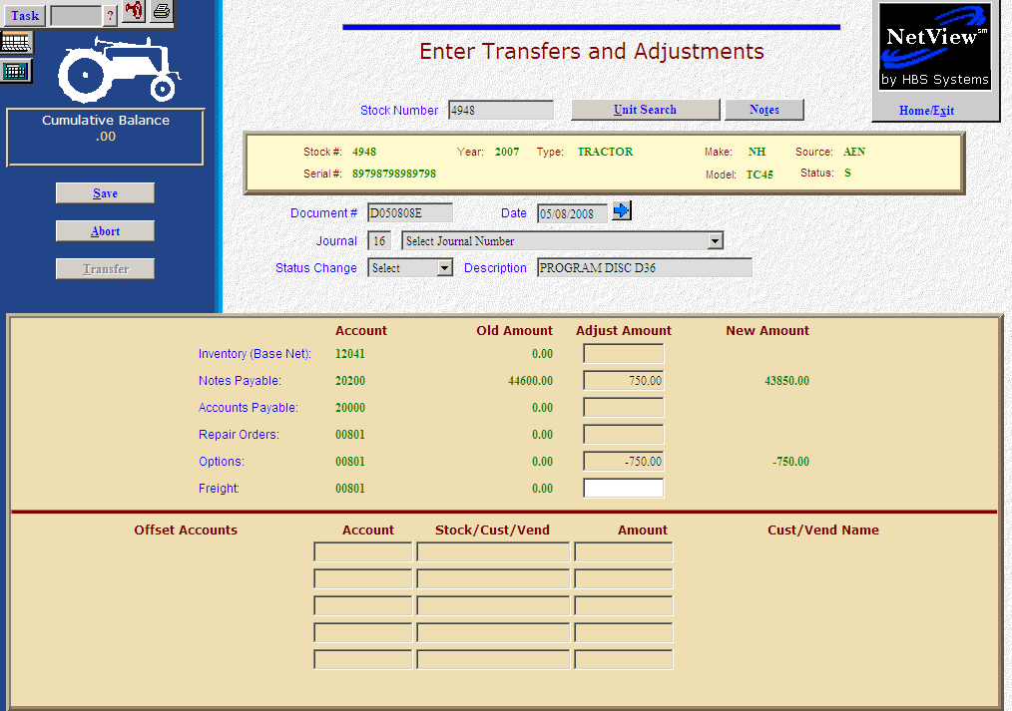

Here’s the scenario. You are eligible for a program discount or incentive because you have sold the unit. You are handling the discount after the sale has been processed.

- Fill in the Stock #.
- Create the Document #. Here’s a document numbering idea:
  - D for discount
  - 053013 for the month (05)/day (30)/year (2013) of the discount
  - A for the first discount of the day, B for the second, and so on.
- Put the adjustment date in the Date field provided it is within the open accounting periods on your system. Otherwise, use the first day of the oldest month open.
- Put in a good Description that mentions you are taking a program discount, and perhaps the discount program or number.
- Leave the Status field as it is.

EITHER:

- On the Notes Payable line, fill in the discount amount. Enter a negative number as you are SUBTRACTING value. The system will convert the “subtraction” as a debit to the notes payable account.

OR:

- On the Accounts Payable line, fill in the discount amount. Enter a negative number as you are SUBTRACTING value. The system will convert the “subtraction” as a debit to the A/P account. Type in the vendor number or look it up. Fill in the due date, discount amount and date, if applicable.

THEN

- Fill in the Amount on the Options line. Enter a negative number as you are SUBTRACTING value. The system will convert the “subtraction” as a credit to the cost of sales or after sales expense account.
- Press Save (Alt S) to complete the transaction.
- When you press “Save,” the Units Master for the stock number is INSTANTLY updated. The transaction has been created and will be posted when Journal 16 is run. If it involved A/P, it will be available for selection in A/P when the journal has been posted.

