ETA Example: Correct the A/P Vendor Number

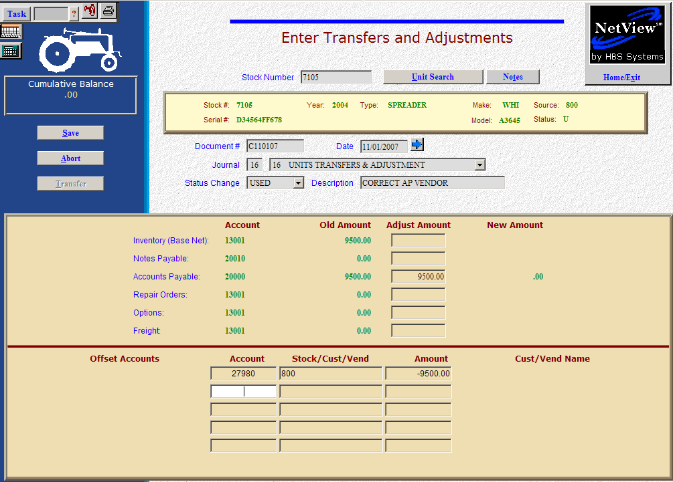

Here’s the scenario. You chose the wrong A/P vendor number when you purchased the unit into the system. It has been discovered, and you need to correct it.

- Fill in the Stock #.
- Create the Document #. Here’s a document numbering idea:
  - C for correction
  - 053013 for the month (05)/day (30)/year (2013) of the correction
  - A for the first correction of the day, B for the second, and so on.
- Put the adjustment date in the Date field, provided it is within the open accounting periods on your system. Otherwise, use the first day of the oldest month open.
- Put in a good Description that mentions you are correcting the A/P vendor number.
- Leave the Status field as it is.
- On the Accounts Payable line, fill in the entire amount owed. Enter a negative number as you are SUBTRACTING value. The system will convert the “subtraction” as a debit to the accounts payable account.
- Fill in the incorrect vendor number. There is a lookup in the vendor number field. Type in a few letters of the vendor’s name to look it up if you don’t know their number. Enter the due date, and discount date and amount, if any.
- Enter through the remaining fields until you reach the Offset Accounts section. Fill in the account number for the Unit invalid account (27980).
- Fill in the stock number in the Stock Number field.
- Fill in the Amount. Enter a positive number as you are ADDING value. The system will convert the “addition” as a credit to the invalid account.
- Press Save (Alt S) to complete the transaction.
- When you press “Save,” the Units Master for the stock number is INSTANTLY updated. The transaction has been created and will be posted when Journal 16 is run. If it involved A/P, it will be available for selection in A/P when the journal has been posted.

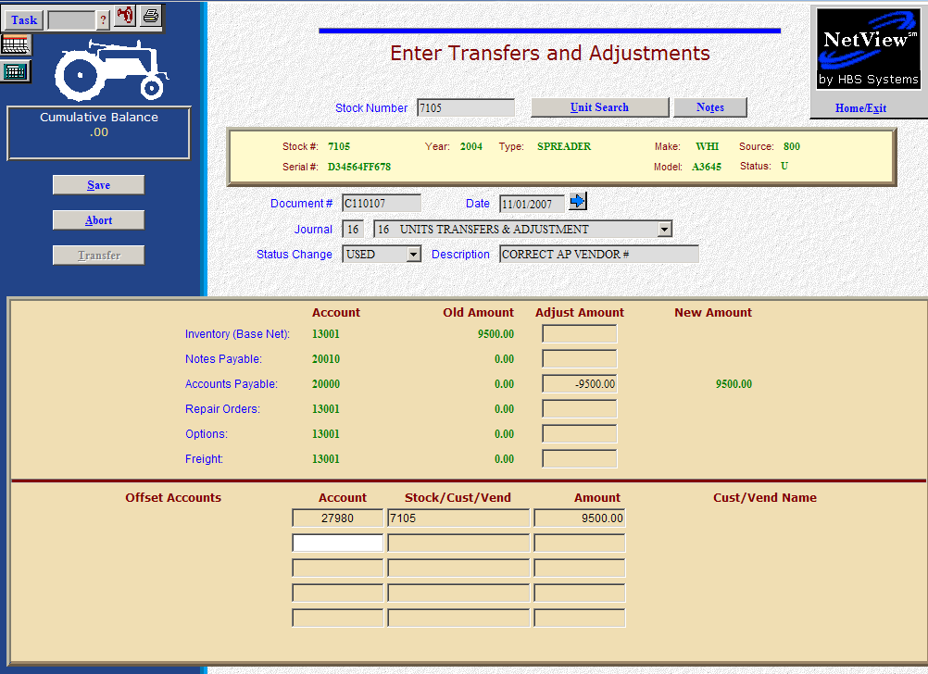

Now we will pull the A/P amount back out of the Units invalid account and identify the correct vendor.

- Fill in the Stock #.
- Create the Document #. Here’s a document numbering idea:
  - C for correction
  - 053013 for the month (05)/day (30)/year (2013) of the correction
  - A for the first correction of the day, B for the second, and so on.
- Put the adjustment date in the Date field, provided it is within the open accounting periods on your system. Otherwise, use the first day of the oldest month open.
- Put in a good Description that mentions you are correcting the A/P vendor number.
- Leave the Status field as it is.
- On the Accounts Payable line, fill in the entire amount owed. Enter a positive number as you are ADDING value. The system will convert the “addition” as a credit to the accounts payable account.
- Fill in the correct vendor number. There is a lookup in the vendor number field. Type in a few letters of the vendor’s name to look it up if you don’t know their number. Enter the due date, and discount date and amount, if any.
- In the Offset Accounts section, fill in the account number for the Unit invalid account (27980).
- Fill in the stock number in the Stock/Cust/Vend field.
- Fill in the Amount. Enter a negative number as you are SUBTRACTING value. The system will convert the “subtraction” as a debit to the invalid account.
- When you press Save (Alt S) the Wholegoods Master for the stock number is INSTANTLY updated. The transaction has been created and will be posted when Journal 16 is run. If it involved A/P, it will be available for selection in A/P when the journal has been posted.

