ETA Example: Apply Rental Income Against a Unit

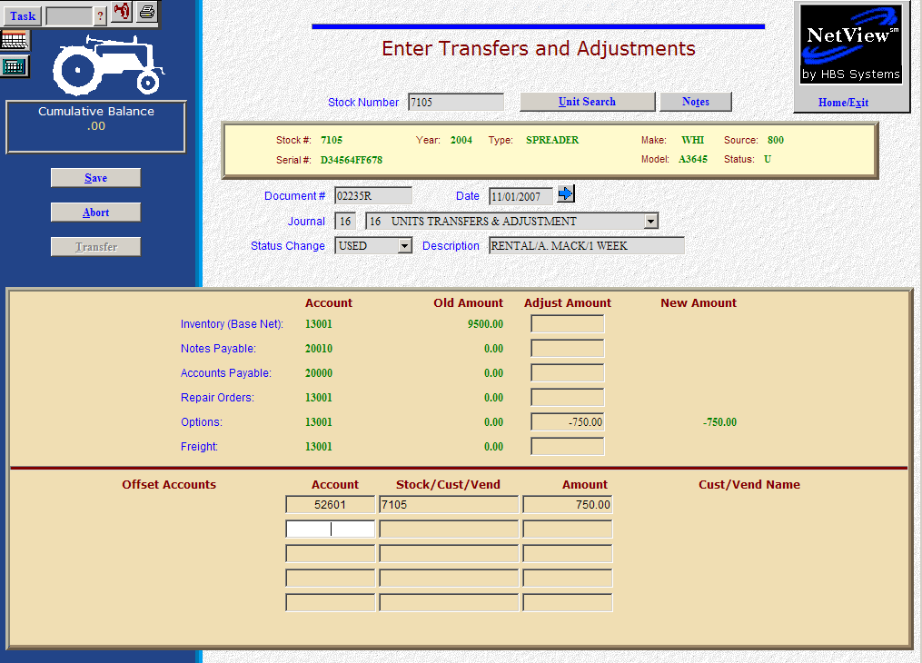

Here’s the scenario. You are currently handling your rental business through Point Of Sale (POS) invoicing. The Rental Income from these transactions is shown in the Sale of Rental Income account. You’d like to take a portion of that rental income and apply it back to the rental unit involved and reduce its value. We will use the Options line to collect this information on the rental unit. It will provide a running total of all rental tracked to the unit.

- Fill in the Stock #.
- Put the POS invoice number followed by an “R” in the Document # field.
- Put the POS invoice date in the Date field provided it is within the open accounting periods on your system. Otherwise, use the first day of the oldest month open.
- Put in a good Description that mentions the rental, who rented it and whatever other rental details you wish to include.
- Leave the Status field as it is.
- Fill in the portion of the rental amount on the Options line (enter as a negative number as you are SUBTRACTING the value). The system will convert this “subtraction” to a credit to the inventory account.
- In the Offset Accounts section, fill in the cost of sale for rental income account number (52601 in our example).
- Fill in the stock number in the Stock/Cust/Vend field.
- Fill in the Amount. Enter a positive number as you are ADDING value. The system will convert the “addition” as a debit to the rental income cost of sale account.
- Press to Save (Alt S) complete the transaction.
- When you press “Save,” the Units Master for the stock number is INSTANTLY updated. The transaction has been created and will be posted when Journal 16 is run.

