ETA Example: Used Inventory Write-Down

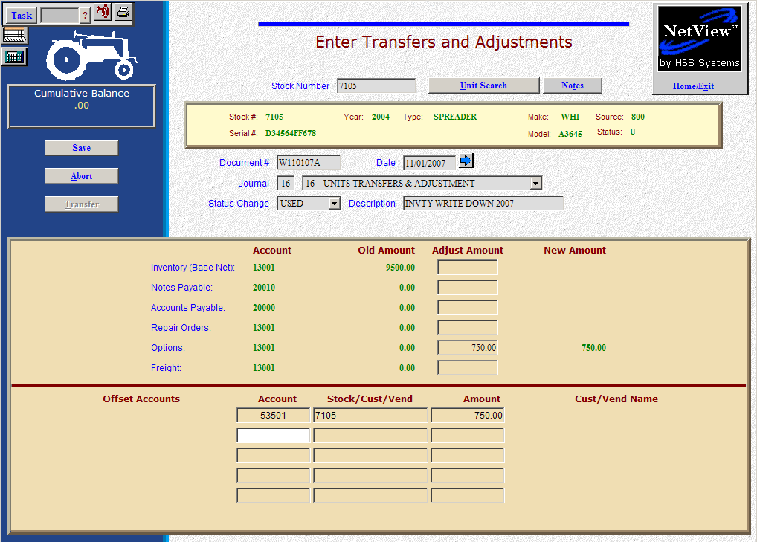

Here’s the scenario. You need to write down the value of a used unit in inventory.

- Fill in the Stock #.
- Create the Document #. Here’s a document naming idea:
  - W for write-down
  - 053013 for the month (05)/day (30)/year (2013) of the correction
  - A for the first correction of the day, B for the second, and so on.
- Put the adjustment date in the Date field, provided it is within the open accounting periods on your system. Otherwise, use the first day of the oldest month open.
- Put in a good Description that mentions what the entry is and what year it applies to.
- Leave the Status field as it is.
- On the Options line, fill in the write-down amount. Enter a negative number as you are SUBTRACTING value. The system will convert the “subtraction” as a credit to the inventory account.

- OR -

- On the Inventory line, fill in the write-down amount. Enter a negative number as you are SUBTRACTING value. The system will convert the “subtraction” as a credit to the inventory account.
- In the Offset Accounts section, fill in the account number for the used inventory write-down account (53501 in our example).
- Fill in the stock number in the Stock/Cust/Vend field.
- Fill in the Amount. Enter a positive number as you are ADDING value. The system will convert the “addition” as a debit to the write-down account.
- Press Save (Alt S) to complete the transaction.
- When you press “Save,” the Unit Master for the stock number is INSTANTLY updated. The transaction has been created and will be posted when Journal 16 is run. If it involved A/P, it will be available for selection in A/P when the journal has been posted.

