ETA Example: Contract Settlement/Proceeds—Dealership Owes

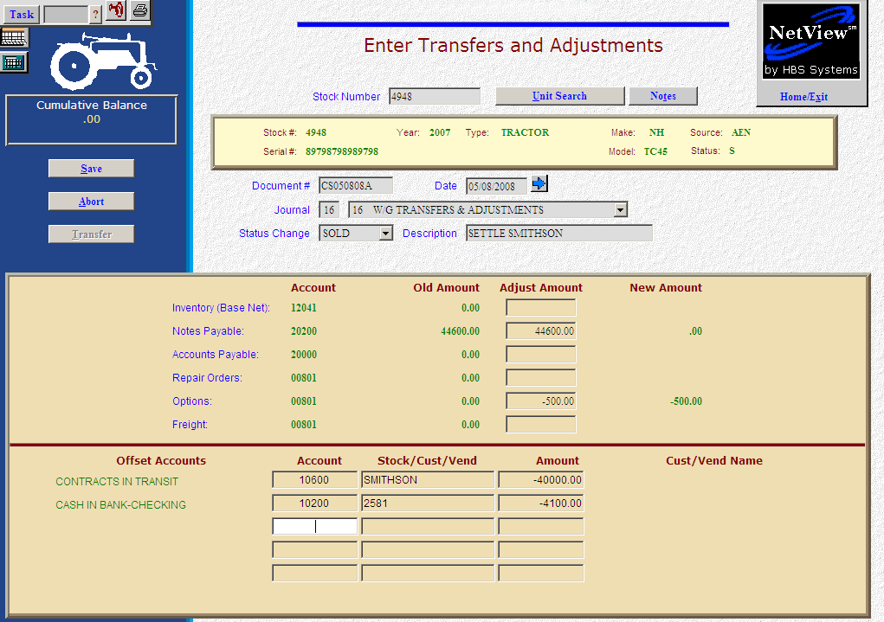

Here’s the scenario. The customer financed $40,000 on a contract. You now need to process the settlement for the sold unit. You have a $44,600 note to cover and are eligible for a $500 pin/dsa/discount. You will owe them $4,100. In this case, you are paying by a handwritten check.

- Fill in the sold Stock #.
- Create the Document #. Here’s a document numbering idea:
  - CS for contract settlement
  - 053013 for the month (05)/day (30)/year (2013) of the settlement
  - A for the first settlement of the day, B for the second, etc.
- Put the settlement date in the Date field, provided it is within the open accounting periods on your system. Otherwise, use the first day of the oldest month open.
- Leave the Status field as it is.
- Put in a good Description.
- In the Notes Payable field, fill in the full payoff amount. Enter a negative number as you are SUBTRACTING value. The system will convert the “subtraction” as a debit to the notes payable account.
- On the Options line, fill in the Amount of the pin/discount/dsa. Enter a negative number as you are SUBTRACTING value. The system will convert the “subtraction” as a credit to the account.
- In the Offset Accounts section, fill in the account number for Contracts in Transit (10600 in our example).
- Fill in the control number used at the time of the sale in the Stock/Cust/Vend field (SMITHSON in our example).
- Fill in the Amount. Enter a negative number as you are SUBTRACTING value. The system will convert the “subtraction” as a credit to the contracts account. Here we want to completely clear the amount originally placed where when we processed the sale. The customer financed $40,000, so that is what we are taking out of this account.
- Fill in the account number for the Checking Account (10200 in our example). Fill in the check number as the control number.
- Fill in the Amount. Enter a negative number as you are SUBTRACTING value. The system will convert the “subtraction” as a credit to the checking account. This is the amount of the check you wrote ($4,100 in our case).
- Press Save (Alt S) to complete the transaction.
- When you press “Save,” the Units Master for the stock number is INSTANTLY updated. The transaction has been created and will be posted when Journal 16 is run.

