ETA Example: Correct the Unit Source

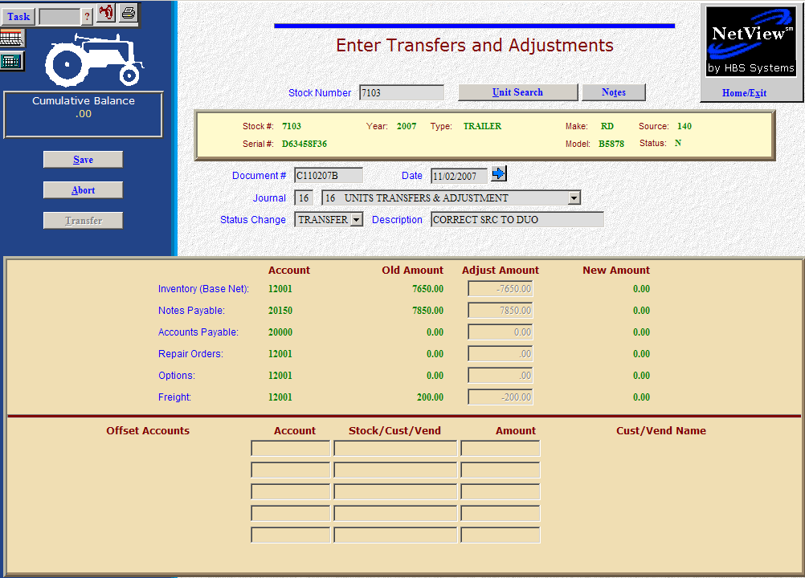

Here’s the scenario. You’ve entered a unit into the system (with or without dollar amounts). You discover that the Units source is incorrect.

- Fill in the Stock #.
- Create the Document #. Here’s a document naming idea:
  - C for correction
  - 053013 for the month (05)/day (30)/year (2013) of the correction
  - A for the first correction of the day, B for the second, and so on.
- Put the correction date in the Date field, provided it is within an open month. Otherwise, use the first day of the oldest month open.
- Put in a good Description.
- Select Transfer in the Status field.
- There are TWO kinds of transfers:
  - INTRA-COMPANY transfers are internal transfers within the company. They are commonly used to:
    - Make corrections to sources
    - Move units from one financing company to another
    - Transfer units between locations in a multiple location environment
  - INTER-COMPANY transfers are external transfers, meaning that the unit is leaving the dealership and your accounting figures. These are commonly used when the unit is transferred to another dealer.

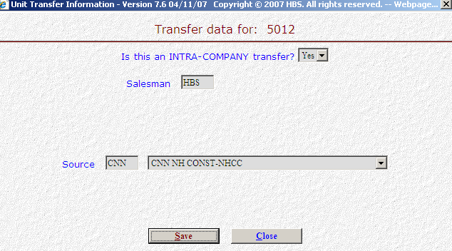

- Next you will see the “Transfer” question. Is this an INTRA-COMPANY transfer? In our case the correct answer is YES as this is an internal transfer.
- Fill in your initials.
- Enter the CORRECT Unit Source now or select it from the drop-down menu.
- Press the Save (Alt S) button
- Notice how the system has cleared out all dollar figures relating to this unit. The inventory, notes payable, accounts payable, repair orders, options, and freight will be cleared if they are present on the unit. Essentially what happens here is that the dollars are removed from the current accounts referenced in the original unit source. The system then creates an entry to “add” them to the appropriate accounts referenced in the NEW, CORRECT unit source.
- Press Save (Alt S) to complete the transaction.
- When you press “Save,” the Units Master for the stock number is INSTANTLY updated. The transaction has been created and will be posted when Journal 16 is run. If it involved A/P, it will be available for selection in A/P when the journal has been posted.

