ETA Example: Add Invoice and Liability

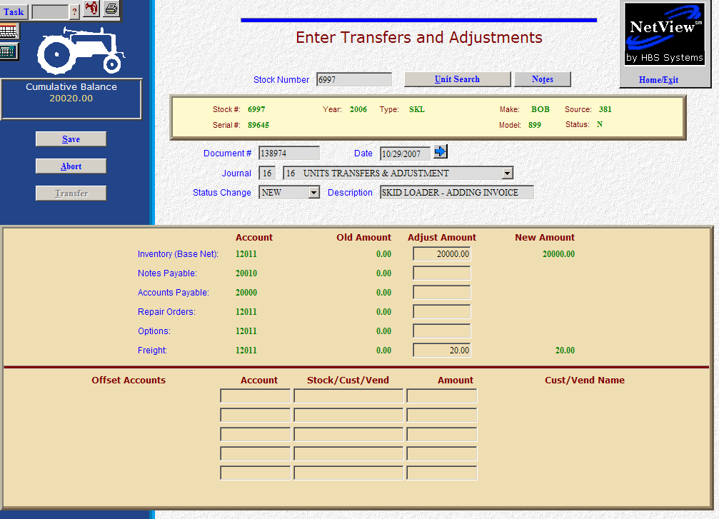

Here’s the scenario: You’ve previously purchased a unit before the invoice was available. Up to this point, there has been no dollar value on the unit. Today the invoice arrived and you want to put it in the system. The unit will be put on floor plan. This process is not appropriate for ordered units.

- Fill in the Stock #.
- Enter the invoice number in the Document # field.
- Put the invoice date in the Date field, provided it is within the open accounting periods on your system. Otherwise, use the first day of the oldest month open.
- Put in a good Entry Description that mentions you are adding the invoice, and perhaps the serial number, model number, etc.
- Leave the Status field as it is.
- On the Inventory line, fill in the invoice amount excluding freight and options (enter as a positive number as you are ADDING the value). The system will convert this “addition” to a debit to the inventory account.
- If the liability is eligible for floorplan, fill in the total amount owed on the Notes Payable line (enter as a positive number as you are ADDING the value). The system will convert this “addition” to a credit to the notes payable account.

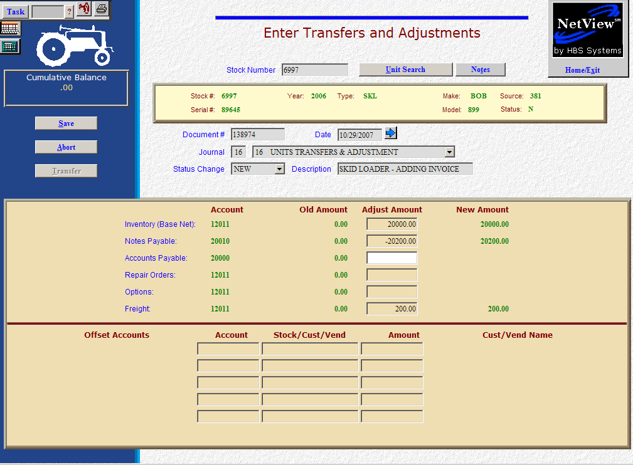

- If the liability or a portion of it is A/P, fill in the amount owed on the Accounts Payable line (enter as a positive number as you are ADDING the value). The system will convert this “addition” to a credit to the accounts payable account. If your invoice has itemized lines for freight and/or options, you may show those amounts on the lines provided (enter as a positive number as you are ADDING the value). The system will convert this “addition” to a debit to the inventory account. Be sure that you have included these amounts in the liability amounts for Notes Payable and/or Accounts Payable.
- When you press Save (Alt S), the units master for the stock number is INSTANTLY updated. The transaction has been created and will be posted when Journal 16 is run. If it involved A/P, it will be available for selection in A/P when the journal has been posted.

