ETA Example: Refinance a Unit—Direct Payoff

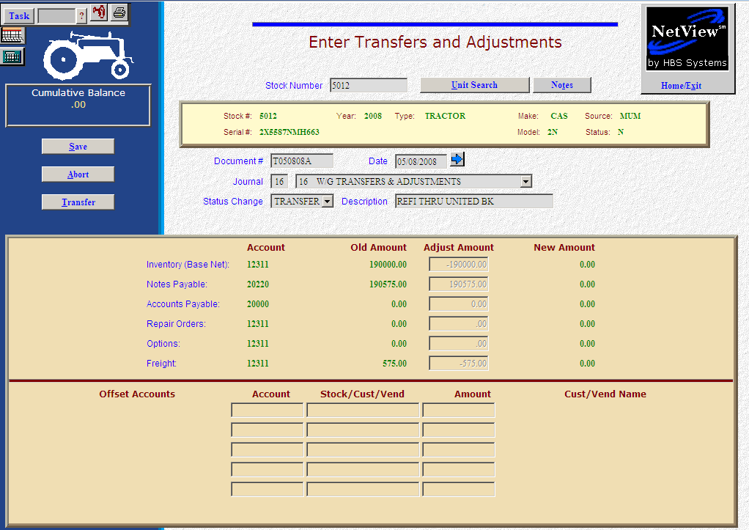

Here’s the scenario. You’ve decided to refinance the note on an existing piece in inventory. This process will only be successful if your units sources were built with multiple financing options. For example, if your dealership could finance its New Holland inventory either through New Holland or through ABC Bank, then you would have two wholegoods sources for New Holland. One would reference New Holland for Notes Payable and the other would refer to ABC Bank for Notes Payable. Our sample here will walk you through the very simple process of changing the finance source on an existing unit. This example also assumes that the new finance company will be paying off the old note directly.

- Fill in the Stock #.
- Create the Document #. Here’s a document numbering idea:
  - R for refinance
  - 053013 for the month (05)/day (30)/year (2013) of the entry
  - A for the first entry of the day, B for the second, and so on.
- Put the refinance date in the Date field, provided it is within the open accounting periods on your system. Otherwise, use the first day of the oldest month open.
- Put in a good Entry Description.
- Select Transfer in the Status field.
- There are TWO kinds of transfers:
  - INTRA-COMPANY transfers are internal transfers within the company. They are commonly used to:
    - Make corrections to sources
    - Move units from one financing company to another
    - Transfer units between locations in a multiple location environment
  - INTER-COMPANY transfers are external transfers, meaning that the unit is leaving the dealership and your accounting figures. These are commonly used when the unit is transferred to another dealer.
- Next you will see the “Transfer” question. Is this an INTRA-COMPANY transfer? In our case the correct answer is YES as this is an internal transfer.
- Fill in your initials.
- Enter the Unit Source for the refinance or select it from the drop-down menu.
- Press the Save (Alt S) button
- Notice how the system has cleared out all dollar figures relating to this unit. The inventory, notes payable, accounts payable, repair orders, options, and freight will be cleared if they are present on the unit. Essentially what happens here is that the dollars are removed from the current accounts referenced in the original unit sources. The system then creates an entry to “add” them to the appropriate accounts referenced in the unit source.
- Press Save (Alt S) to complete the transaction.
- When you press “Save,” the Units Master for the stock number is INSTANTLY updated. The transaction has been created and will be posted when Journal 16 is run. If it involved A/P, it will be available for selection in A/P when the journal has been posted.

