ETA Example: Refinance a Unit—Dealership Payoff

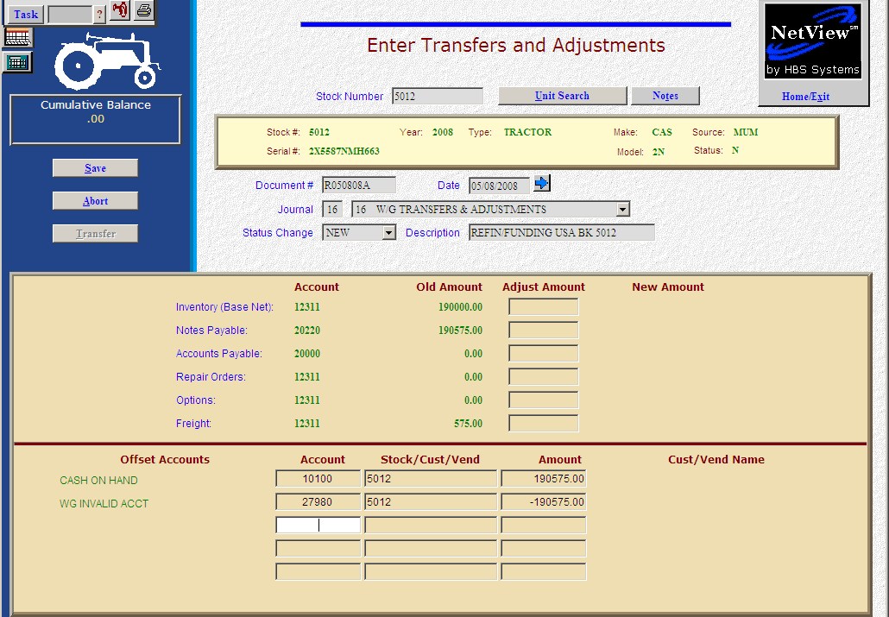

Here’s the scenario: You’ve decided to refinance the note on an existing piece in inventory. In this case your unit sources are already defined to handle multiple financing options. Our sample here will walk you through the process of changing the finance source on an existing unit. This time we will handle the original note payoff from dealership funds. It will take a series of transactions to accomplish this process. In reality, these transactions may occur over numerous different days, while our example shows them all occurring on the same day. For consistency, we are going to handle all of the steps in Enter Transfers and Adjustments (ETA). Some of these steps could be correctly handled in other programs, too.

Receipt of funding

- Fill in the Stock #.
- Create the Document #. Here’s a document numbering idea:
  - R for refinance
  - 053013 for the month (05)/day (30)/year (2013) of the refinance
  - A for the first refinance of the day, B for the second, etc.
- Put the refinance funding date in the date field, provided it is within the open accounting periods on your system. Otherwise, use the first day of the oldest month open.
- Put in a good Description. Perhaps you could use something like: “Refin/funding USA Bk 5012.”
- In this case, we are simply acknowledging the receipt of the funds from USA Bank which we will use to pay off the old note.
- In the Offset Accounts section, add the account and amount of the funds receipted to Cash on Hand as shown above (Account 10100). The other side of the entry is to the Units Invalid Account (Account 27980). We will use it temporarily as a storage place to hold the money we owe to USA Bank.
- Once the entry is balanced, press Save (Alt S) to complete the transaction.

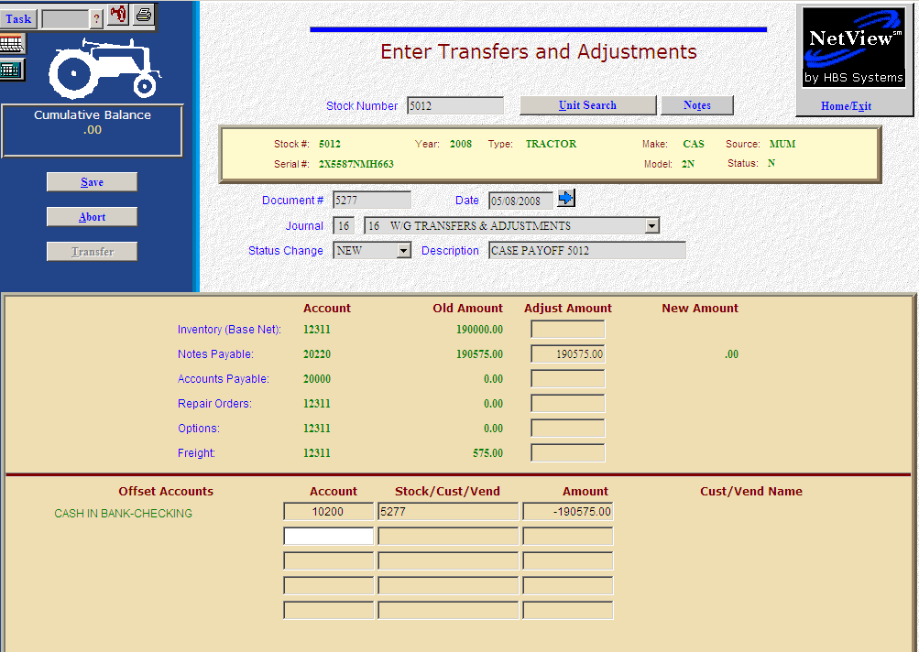

Payoff of original note

- Fill in the Stock #.
- We are paying the note off with a manual check, so we will put the check number in the Document # field. You also could pay this by running it through A/P or On-Demand Checks (ODC).
- Type the date of the check in the Date field.
- Put in a good Description. Perhaps you could use something like “Case Payoff 5012”.
- On the Notes Payable line, fill in the payoff amount. Enter a negative number as you are SUBTRACTING value. The system will convert the “subtraction” as a debit to the notes payable account.
- In the Offset Accounts section, fill in the account number of your checking account (10200 in our example).
- Fill in the check number in the Stock/Cust/Vend field.
- Fill in the Amount. Enter a negative number as you are SUBTRACTING value. The system will convert the “subtraction” as a credit to the checking account.
- Once the entry is balanced, press Save (Alt S) to complete the transaction.
- When you answer “Save,” the stock number is INSTANTLY updated. The transaction has been created and will be posted when Journal 16 is run. If it involved A/P, it will be available for selection in A/P when the journal has been posted.

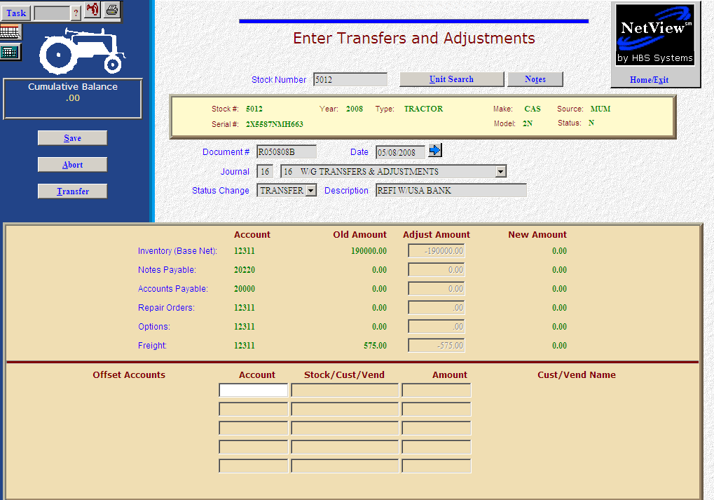

Transfer to New Source (Based on where the new note is owed)

- Fill in the Stock #.
- Create the Document #. Here’s a document numbering idea:
  - R for refinance
  - 053013 for the month (05)/day (30)/year (2013) of the entry
  - A for the first entry of the day, B for the second, and so on.
- Put the refinance date in the Date field, provided it is within the open accounting periods on your system. Otherwise, use the first day of the oldest month open.
- Put in a good Description.
- Select Transfer in the Status field.
- Next you will see the “Transfer” question. Is this an INTRA-COMPANY transfer? In our case the correct answer is YES as this is an internal transfer.
- Fill in your initials.
- Enter the Unit Source for the refinance or select it from the drop-down menu.
- Press the Save (Alt S) button
- Notice how the system has cleared out all dollar figures relating to this unit. The inventory, notes payable, accounts payable, repair orders, options, and freight will be cleared if they are present on the unit. Essentially what happens here is that the dollars are removed from the current accounts referenced in the original unit sources. The system then creates an entry to “add” them to the appropriate accounts referenced in the unit source.
- Press Save (Alt S) to complete the transaction.
- When you press “Save,” the stock number is INSTANTLY updated. The transaction has been created and will be posted when Journal 16 is run. If it involved A/P, it will be available for selection in A/P when the journal has been posted.

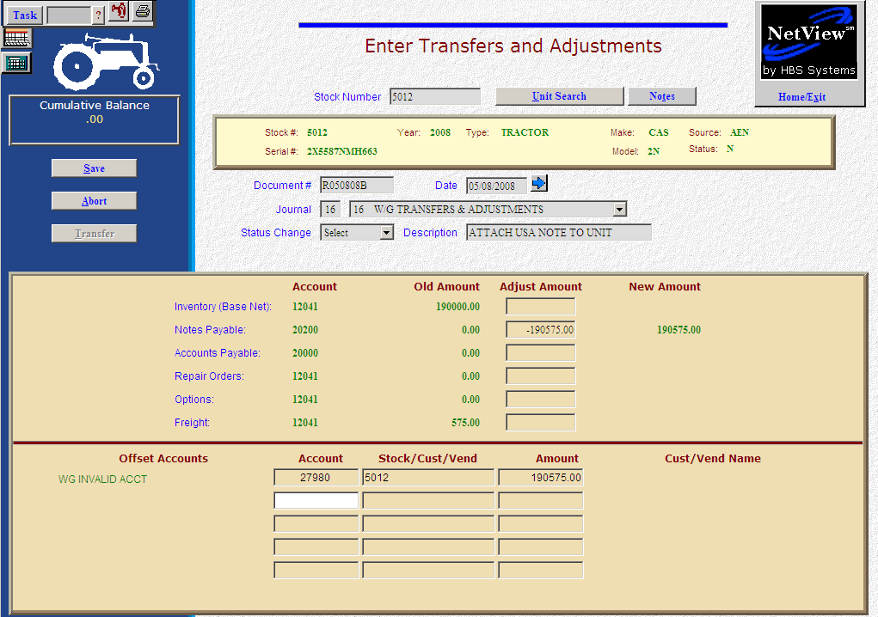

Attach New Note to Unit

- Fill in the Stock #.
- Create the Document #. Here’s a document numbering idea:
  - R for refinance
  - 053013 for the month (05)/day (30)/year (2013) of the refinance
  - A for the first refinance of the day, B for the second, and so on.
- Put the refinance funding date in the Date field, provided it is within the open accounting periods on your system. Otherwise, use the first day of the oldest month open.
- Put in a good Description. Perhaps you could use something like “Attach USA Note to Unit.”
- On the Notes Payable line, fill in the note amount. Enter a positive number as you are ADDING value. The system will convert the “addition” as a credit to the notes payable account.
- In the Offset Accounts section, fill in “27980” for the Unit Invalid Account number. Earlier, we placed the amount in the WG Invalid Account. Now we will take that amount to balance this transaction.
- Fill in the Stock Number in the Stock/Cust/Vend field.
- Fill in the Amount. Enter a negative number as you are SUBTRACTING value. The system will convert the “subtraction” as a debit to the Invalid Account.
- Once the entry is balanced, press Save (Alt S) to complete the transaction.
- When you press “Save,” the stock number is INSTANTLY updated. The transaction has been created and will be posted when Journal 16 is run. If it involved A/P, it will be available for selection in A/P when the journal has been posted.

