ETA Example: Transfer to Another Dealer—Money Due from Mfr

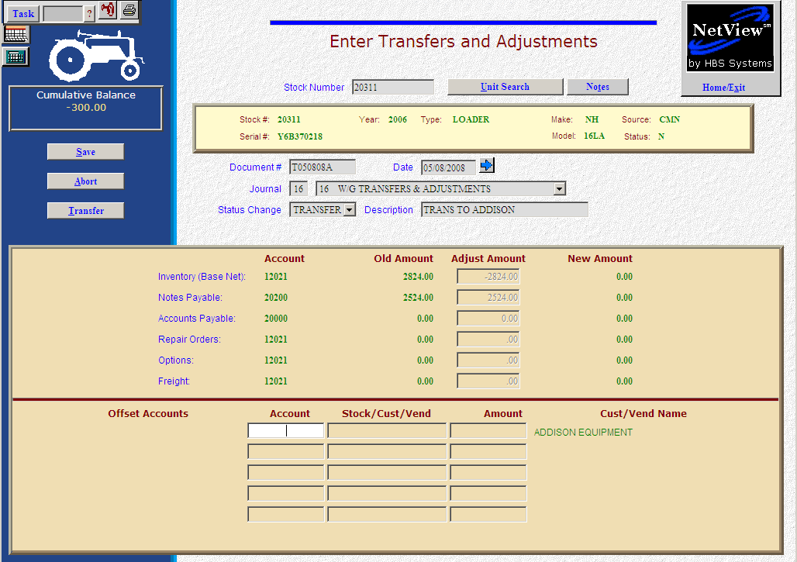

Here’s the scenario. You are transferring an existing unit in inventory to another dealer. You have previously made curtailments to the manufacturer. In addition, you are charging the dealer a transfer fee for the in-bound freight. Whenever you transfer units to another dealer, you will need to enter their customer number. So, before you initiate a dealer-to-dealer transfer, make sure the dealer has a Customer number. If this is a “one-shot” transfer and you really don’t expect to do any other transfers to this dealer, you could use a Miscellaneous Transfer customer number. It is strongly recommended that you create a customer number for EACH dealer you transfer goods to. The timing of the entry of the transfer is your call. Many wait until they receive the transfer acknowledgement from the manufacturer. Others process it immediately so the inventory is no longer available for sale.

- Fill in the Stock #.
- Create the Document #. Here’s a document naming idea:
  - T for transfer
  - 053013 for the month (05)/day (30)/year (2013) of the transfer
  - A for the first transfer of the day, B for the second, and so on.
- Put the transfer date in the Date field, provided it is within the open accounting periods on your system. Otherwise, use the first day of the oldest month open.
- Put in a good Description and include the name of the dealer receiving the unit.
- Select Transfer in the Status field.

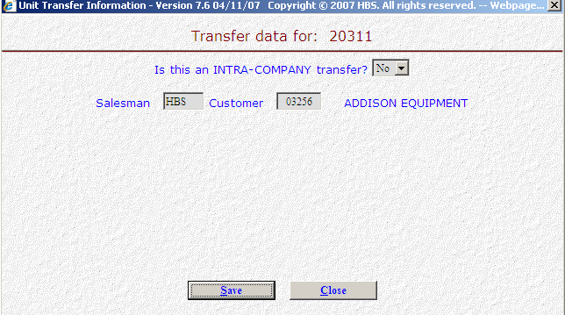

- There are TWO kinds of transfers:
  - INTRA-COMPANY transfers are internal transfers within the company. They are commonly used to:
    - Make corrections to sources
    - Move units from one financing company to another
    - Transfer units between locations in a multiple location environment.
  - INTER-COMPANY transfers are external transfers meaning that the unit is leaving the dealership and your accounting figures. These are commonly used when the unit is transferred to another dealer.
- Next you will see the “Transfer” question. Is this an INTRA-COMPANY transfer? In our case the correct answer is NO as it is NOT an internal transfer.
- Fill in the initials of the person approving the transfer.
- Enter the customer number of the dealer receiving the unit.
- Press the Save (Alt S) button
- Notice how the system has cleared out all dollar figures relating to this unit. The inventory, notes payable, accounts payable, repair orders, options, and freight will be cleared if they are present on the unit. The object here is to remove the unit and its value from the system. In our example, the remaining balance is $300.00.
- In the Offset Accounts section, fill in the accounts receivable account number (10300 in our example).
- Fill in the five-digit customer number of the dealer receiving the transfer in the Stock/Cust/Vend field.

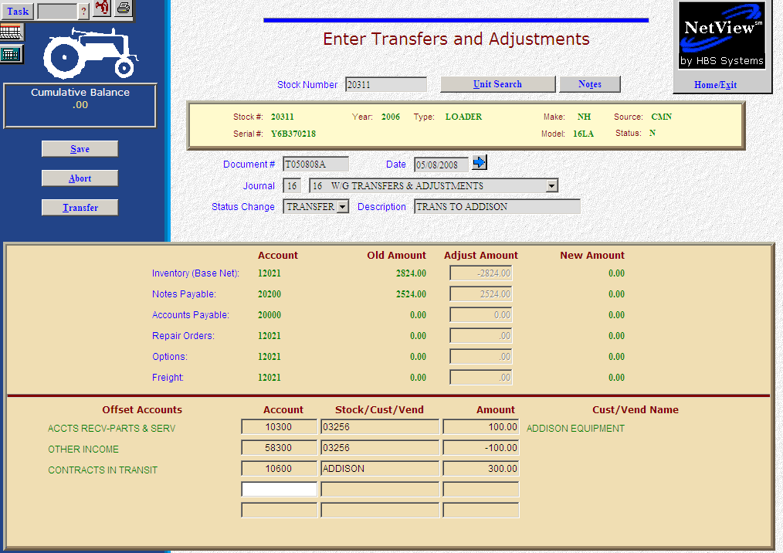

- Fill in the Amount. Enter a positive number as you are ADDING value. The system will convert the “addition” as a debit to the accounts receivable account. We’re putting the total $100.00 (the $100.00 transfer fee) on their account.
- On the next line, fill in the account number where the transfer fee should be shown (58300 in our example).
- Fill in the customer number or stock number in the Stock/Cust/Vend field.
- Fill in the Amount of the transfer fee. Enter a positive number as you are ADDING value. The system will convert the “addition” as a credit to the other income account.
- On the next line, fill in the account number for Contracts in Transit (10600 in our example). We’ll put the money here that we are to receive from the manufacturer.
- Fill in the stock number or another reference of your choice in the Stock/Cust/Vend field.
- Fill in the Amount. Enter a positive number as you are ADDING value. The system will convert the “addition” as a debit to the contracts in transit account.
- Press Save (Alt S) to complete the transaction.
- When you press Save, the stock number is INSTANTLY updated. The transaction has been created and will be posted when Journal 16 is run.

