ETA Example: Correct an Invoice and Liability Amount Error

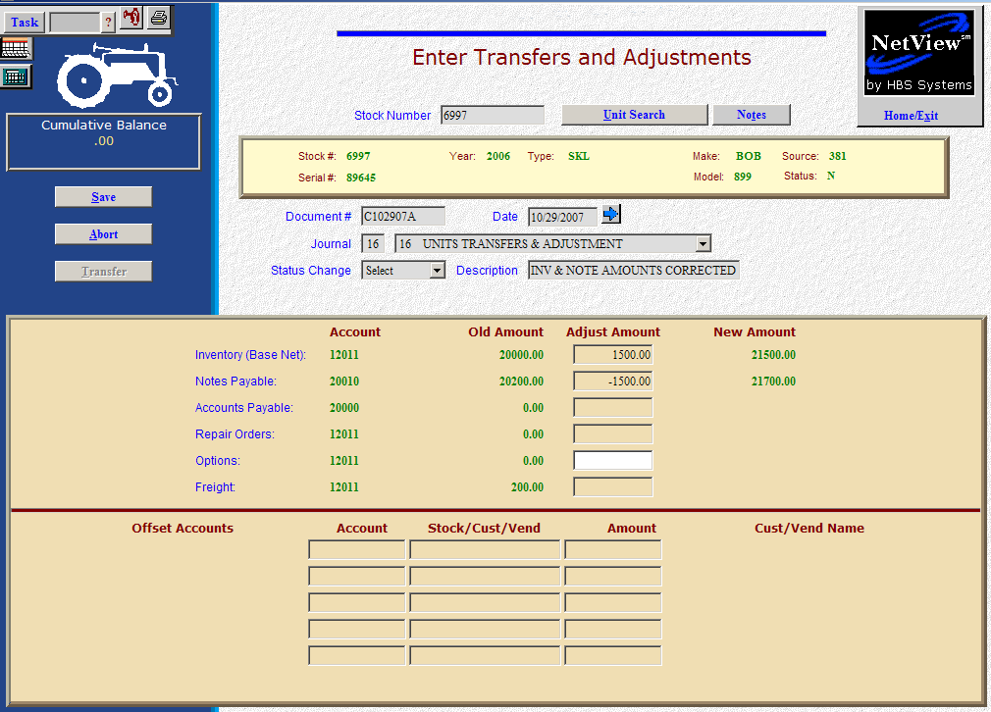

Here’s the scenario: You’ve purchased a unit in with invoice and note amounts. You’ve discovered now that the inventory and note amounts are incorrect.

- Fill in the Stock #.
- Create a Document # for the transaction. Here’s a document numbering idea:
  - C for correction
  - 053013 for the month (05)/day (30)/year (2013) of the correction
  - A for the first correction of the day, B for the second, and so on.
- Put the correction date or the original invoice date in the Date field, provided it is within the open accounting periods on your system. Otherwise, use the first day of the oldest month open.
- Put in a good Entry Description that mentions you are correcting the invoice and note amounts.
- Leave the Status field as it is.
- On the Inventory line, fill in the correction amount.
  - Enter a positive number if your inventory value was too low so now you are ADDING value. The system will convert the “addition” as a debit to the inventory account.
  - Enter a negative number if your inventory value was too high so now you are SUBTRACTING value. The system will convert the “subtraction” as a credit to the inventory account.
- On the Notes Payable line, fill in the correction amount.
  - Enter a positive number if your note amount was too low so now you are ADDING value. The system will convert the “addition” as a credit to the notes payable account.
  - Enter a negative number if your note amount was too high so now you are SUBTRACTING value. The system will convert the “subtraction” as a debit to the notes payable account.
- Press the Save (Alt S) button to write your document.
- When you press “Save,” the units master for the stock number is INSTANTLY updated. The transaction has been created and will be posted when Journal 16 is run. If it involved A/P, it will be available for selection in A/P when the journal has been posted.

