ETA Example: Add a Freight Invoice

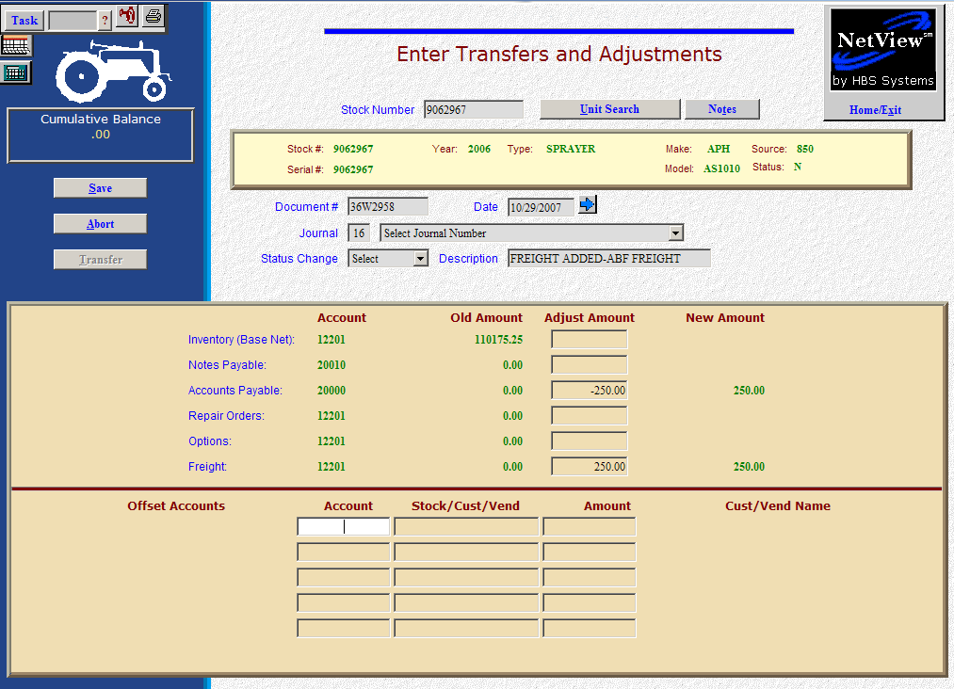

Here’s the scenario: You’ve just received a freight bill for an existing unit in inventory. It’s due within the next 30 days to the freight line.

- Fill in the Stock #.
- Put the freight invoice number in the Document # field.
- Put the invoice date in the Date field provided it is within the open accounting periods on your system. Otherwise, use the first day of the oldest month open.
- Put in a good Entry Description that mentions you are adding freight and perhaps indicate which freight line.
- Leave the Status field as it is.
- Fill in the invoice amount on the Accounts Payable line (enter as a positive number as you are ADDING the value). The system will convert this “addition” to a credit to the accounts payable account.
  - You’ll be asked for the following:
    - Vendor
    - Due date
    - Discount date/amount (if any)
  - There is a lookup in the vendor number field. Type in a few letters of the vendor’s name to look it up if you don’t know their number.

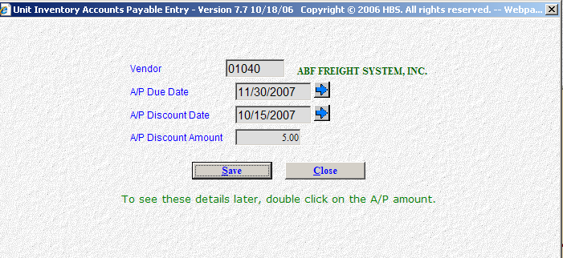

- On the Freight line, fill in the amount. Enter a positive number as you are ADDING value. The system will convert the “addition” as a debit to the inventory account.
- Press the Save (Alt S) button to write your document.
- When you press “Save,” the units master for the stock number is INSTANTLY updated. The transaction has been created and will be posted when Journal 16 is run. If it involved A/P, it will be available for selection in A/P when the journal has been posted.

