ETA Example: Add an Option

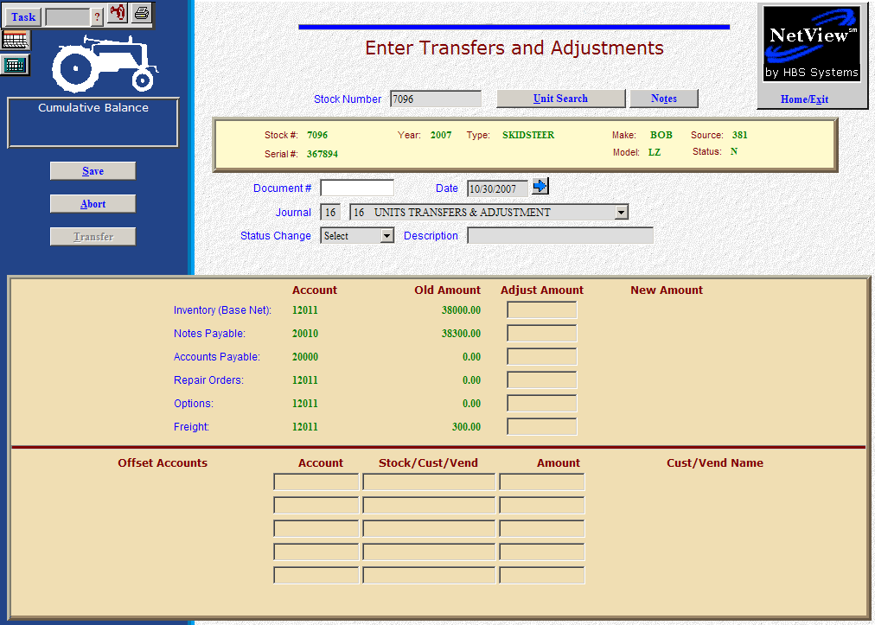

Here’s the scenario: You’ve just added an upgrade to tires on a Bobcat in inventory, so it needs to be added as an option. The general rule for options is that:

- If there is no labor involved, they may be attached in Enter Transfers and Adjustments (ETA).
- If there is labor involved in the addition, then the option would best be added via a repair order in Point Of Sale (POS) or in Service (ROM).

In our case, the tires magically attached themselves to the Bobcat and we have to pay for it within the next 30 days.

- Fill in the Stock #.
- Put the invoice number in the Document # field.
- Put the invoice date in the Date field, provided it is within the open accounting periods on your system. Otherwise, use the first day of the oldest month open.
- Put in a good Entry Description that mentions you are adding the bucket and perhaps indicate the size of the bucket.
- Leave the Status field as it is.

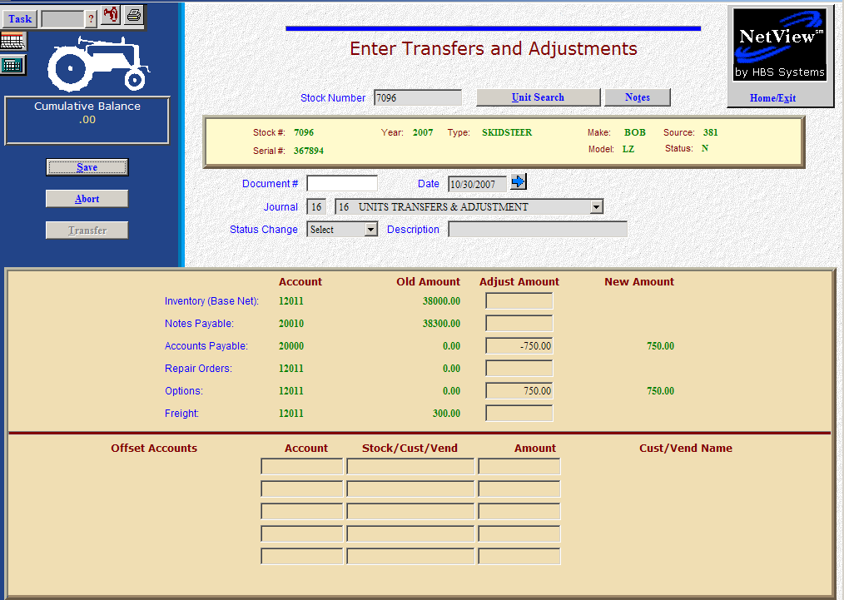

- Fill in the invoice amount on the Accounts Payable line (enter as a positive number as you are ADDING the value). The system will convert this “addition” to a credit to the accounts payable account. You’ll be asked for the following:
  - Vendor
  - Due date
  - Discount date/amount (if any)
- On the Options line, fill in the amount. Enter a positive number as you are ADDING value. The system will convert the “addition” as a debit to the inventory account.
- Press Save (Alt S) to write your document.
- When you press “Save,” the units master for the stock number is INSTANTLY updated. The transaction has been created and will be posted when Journal 16 is run. If it involved A/P, it will be available for selection in A/P when the journal has been posted.

