ETA Example: Remove an Option

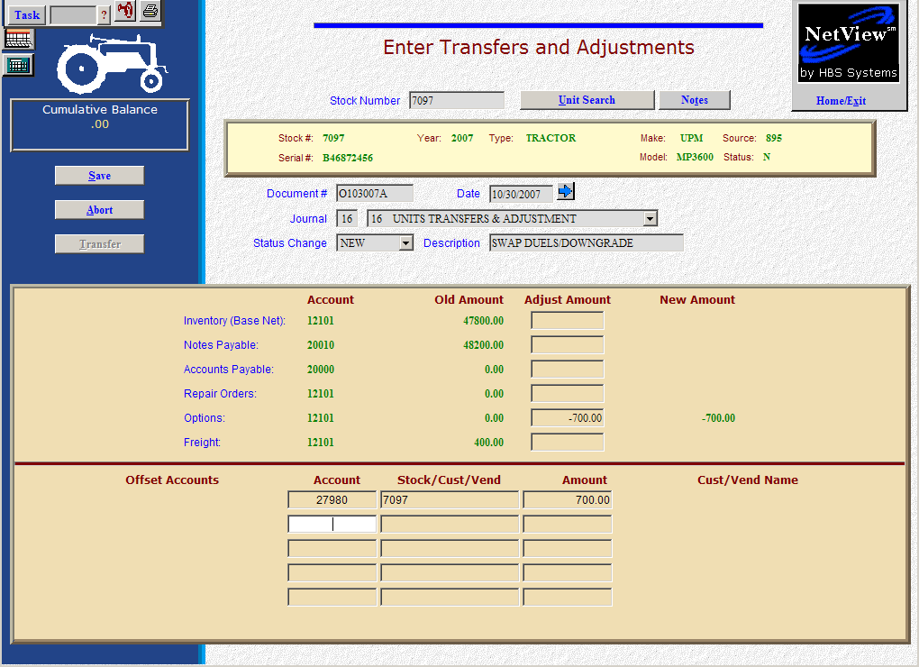

Here’s the scenario: You have a customer who is interested in the MP3600 Tractor. However, they don’t want the duals that are currently on it. They want a set of less expensive ones instead. We’re going to remove the duals from that unit, take the less expensive ones from another unit, and put the duals on the other unit. Again, the general rule for options is that:

- If there is no labor involved, they may be attached or removed in Transfers & Adjustments.
- If there is labor involved in the addition or removal, then the option would best be handled via a repair order in Point of Sale (POS) or in Service (ROM).

In our case, we are assuming there is no labor involved.

- Fill in the Stock #.
- Create a Document #. Here’s a document numbering idea:
  - O for option
  - 053013 for the month (05)/day (30)/year (2013) of the option
  - A for the first option of the day, B for the second, and so on.
- Put the option date in the Date field, provided it is within the open accounting periods on your system. Otherwise, use the first day of the oldest month open.
- Put in a good Entry Description that mentions you are removing the duals and perhaps what unit they are going on.
- Leave the Status field as it is.
- On the Options line, fill in the amount. Enter a negative number as you are SUBTRACTING value. The system will convert the “subtraction” as a credit to the inventory account.
- Enter through the remaining fields until you reach the Offset Accounts section. Fill in Account # 27980 (Unit Invalid Account). We’re going to use this as a “wash” account. We’ll temporarily put the value of the duals there until we attach them to the other tractor.
- Fill in the stock number of this unit in the Stock/Cust/Vend field.
- Fill in the Amount. Enter a negative as you are SUBTRACTING value. The system will convert the “subtraction” as a debit to the invalid account.
- Press Save (Alt S) to write your document.
- When you press “Save,” the Units Master for the stock number is INSTANTLY updated. The transaction has been created and will be posted when Journal 16 is run. If it involved A/P, it will be available for selection in A/P when the journal has been posted.

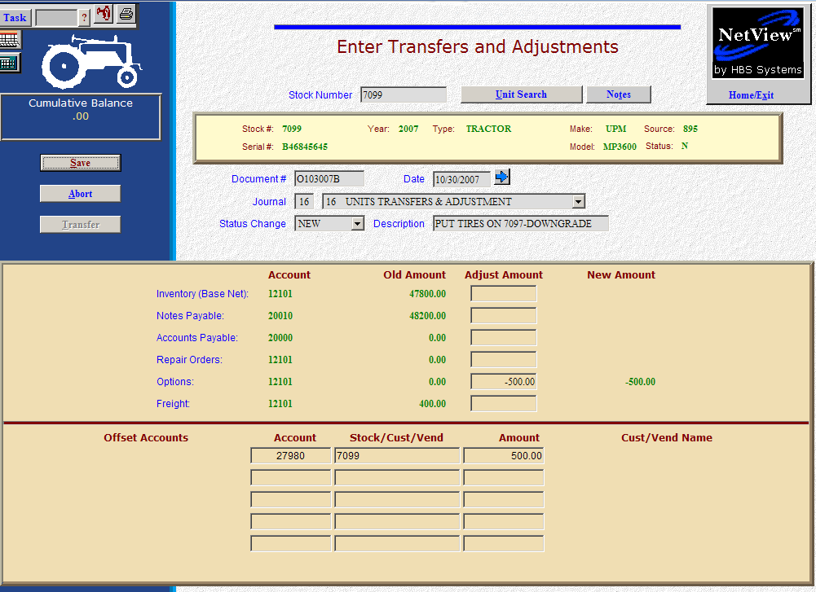

Now, we are going to remove the inexpensive wheels from the other unit.

- Fill in the Stock #.
- Create the Document #. Here’s a document numbering idea:
  - O for option
  - 053013 for the month (05)/day (30)/year (2013) of the option
  - A for the first option of the day, B for the second, etc.
- Put the correction date in the date field, provided it is within the open accounting periods on your system. Otherwise, use the first day of the oldest month open.
- Put in a good Entry Description that mentions you are removing the wheels and perhaps what unit they are going on.
- Leave the Status field as it is.
- On the Options line, fill in the amount. Enter a negative number as you are SUBTRACTING value. The system will convert the “subtraction” as a credit to the inventory account.
- Enter through the remaining fields until you reach the Offset Accounts section. Fill in Account # 27980 (Unit Invalid Account). We’re going to use this as a “wash” account. We’ll temporarily put the value of the wheels there until we attach them to the other tractor.
- Fill in the stock number of this unit in the Stock/Cust/Vend field.
- Fill in the Amount. Enter a negative as you are SUBTRACTING value. The system will convert the “subtraction” as a debit to the invalid account.
- Press Save (Alt S) to write your document.
- When you press “Save,” the units master for the stock number is INSTANTLY updated. The transaction has been created and will be posted when Journal 16 is run. If it involved A/P, it will be available for selection in A/P when the journal has been posted.

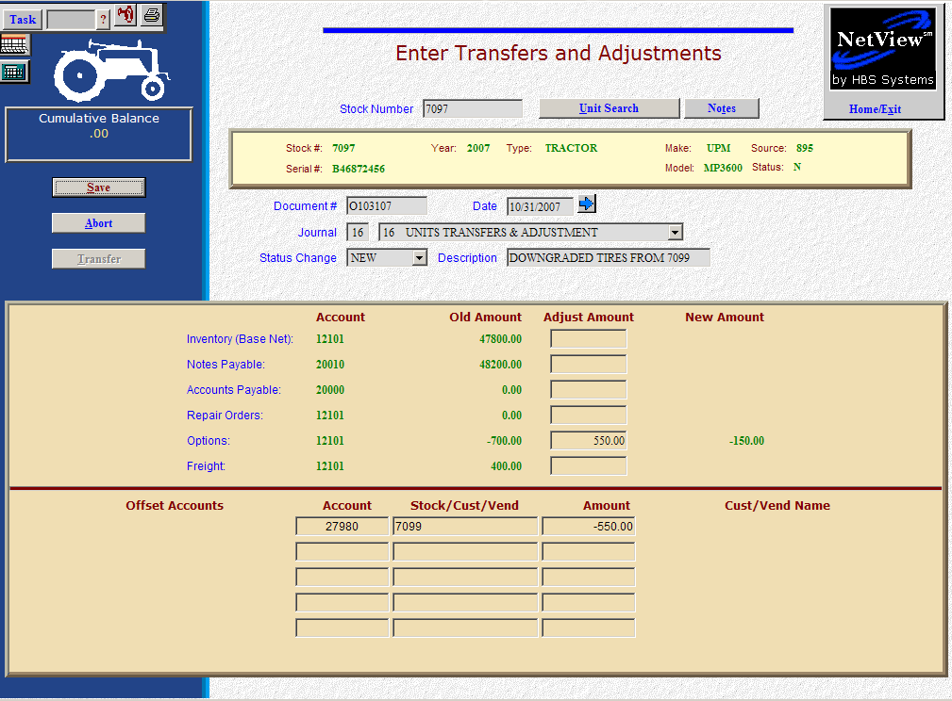

Now, we are going to add the inexpensive wheels to the unit being sold.

- Fill in the Stock #.
- Create the Document #. Here’s a document numbering idea:
  - O for option
  - 053013 for the month (05)/day (30)/year (2013) of the option
  - A for the first option of the day, B for the second, etc.
- Put the option date in the Date field, provided it is within the open accounting periods on your system. Otherwise, use the first day of the oldest month open.
- Put in a good Entry Description that mentions you are adding the inexpensive wheels and perhaps what unit they came from.
- Leave the Status field as it is.
- On the Options line, fill in the Amount. Enter a positive number as you are ADDING value. The system will convert the “addition” as a debit to the inventory account.
- Enter through the remaining fields until you reach the Offset Accounts section. Fill in Account # 27980 (Unit Invalid Account). We’re going to use this as a “wash” account. We’ll pull the value of the inexpensive wheels from there as we put their value here when we removed them from the other tractor.
- Fill in the stock number of the other unit in the Stock/Cust/Vend field.
- Fill in the Amount. Enter a positive number as you are ADDING value. The system will convert the “addition” as a credit to the invalid account.
- Press Save (Alt S) to write your document.
- When you press “Save,” the units master for the stock number is INSTANTLY updated. The transaction has been created and will be posted when Journal 16 is run. If it involved A/P, it will be available for selection in A/P when the journal has been posted.

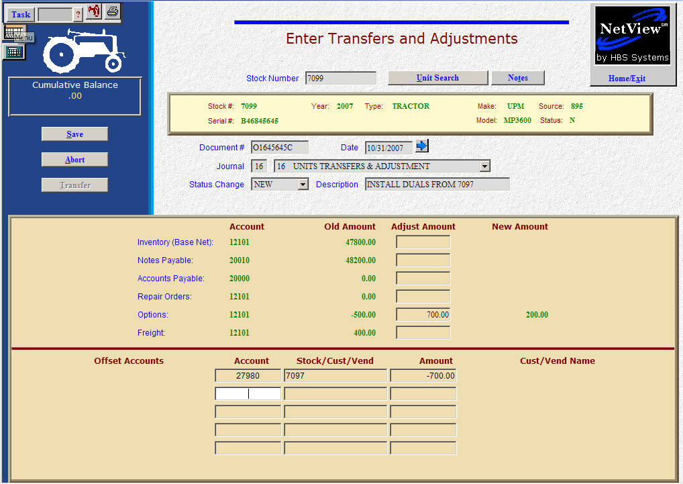

Now, we are going to put the duals on the other unit.

- Fill in the Stock #.
- Create the Document #. Here’s a document numbering idea:
  - O for option
  - 053013 for the month (05)/day (30)/year (2013) of the option
  - A for the first option of the day, B for the second, and so on.
- Put the option date in the Date field, provided it is within the open accounting periods on your system. Otherwise, use the first day of the oldest month open.
- Put in a good Entry Description that mentions you are adding the duals and perhaps what unit they came from.
- Leave the Status field as it is.
- On the Options line, fill in the amount. Enter a positive number as you are ADDING value. The system will convert the “addition” as a debit to the inventory account.
- Enter through the remaining fields until you reach the Offset Accounts section. Fill in Account # 27980 (Unit Invalid Account). We’re going to use this as a “wash” account. We’ll pull the value of the duals from there as we put their value here when we removed them from the unit to be sold.
- Fill in the stock number of the other unit in the Stock/Cust/Vend field.
- Fill in the Amount. Enter a positive number as you are ADDING value. The system will convert the “addition” as a credit to the invalid account.
- Press Save (Alt S) to write your document.
- When you press “Save,” the units master for the stock number is INSTANTLY updated. The transaction has been created and will be posted when Journal 16 is run. If it involved A/P, it will be available for selection in A/P when the journal has been posted.

